Literacy | Reading Task  Continue to pick reading challenges you have still not completed.  https://www.literacyideas.com/reading-activities-for-any-book/  Grammar  This week we are going to revise using commas in a list. There is a PowerPoint over on the blog to remind you of the rules when using commas in a list. There is then a word document for you to apply your knowledge. Red group if you could complete the first page. Blue group if you could complete the second and last page.  Phoneme Task - New phonemes for both groups  Blue group – u (push)  Create a phoneme bubble for your new phoneme, fill it with as many words as you can!  Fill in the gaps with the correct word.  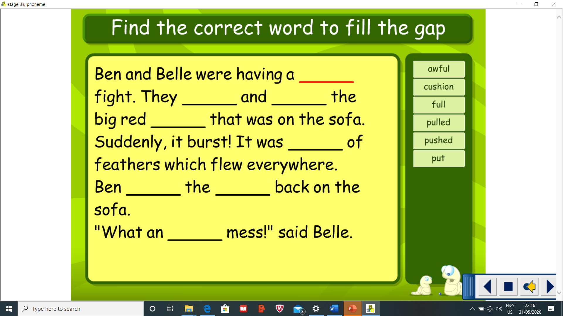  Red group – id (kid, lid, bid)  Complete the phoneme worksheet found over on the blog  Spelling task – *Please note there will be a spelling test posted on Friday as an audio video so keep practising your words throughout the week. It will be posted on teams for 9am.  Complete the following spelling strategies throughout the week:  Blue group – Find the tricky parts to each new spelling word. Then write sentences for each of your words. Make sure you make it a super sentence – include a connective like and, but or so.  Red group – You are on a consolidation week red group so revise the spelling words you are still finding tricky. Complete Bubble spelling and Fancy spelling.  Blue Group put, different, light, sentence, stop Red Group are, dad, not, your, by, only
Numeracy | Mental Maths  Complete some daily mental maths by completing Daily 10. You can choose which area in maths you want to focus on, keep the level low 1,2 or 3 is suitable.  https://www.topmarks.co.uk/maths-games/daily10  Data Handling  This week we are going to focus on data handling in maths. Within this topic we will be learning ways in which we can gather, record and present information.  We are going to start off with Bar charts. You should all know what bar charts are and how to draw them. Complete the activity sheet found on the blog. Once you have completed it, I would like you to gather your own information about a topic of your choice in your household. It could be what your families favourite Disney movie is, or favourite food. Once you have gathered the information, display it in a bar chart. To challenge yourself ask questions on the data you have gathered. A blank bar chart is on the blog for you to use.
HWB  . | The weather has been great make the most of it by getting outside as often as you can! Go for a walk, a run, a jog or a skip!  If you have not done so already make sure you check out the Heartstart programme and learn some first aid skills.  Time to reflect  It is a brand-new month and a great time to reflect. I would like you to create a Lockdown reflection poster. Get a piece of paper and divide it into 4 sections. I would like you to answer the four reflecting questions while being in Lockdown.  Section 1 – What have you enjoyed?  Section 2 – What have you missed?  Section 3 – What feeling have you had?  Section 4 – What have you learned?  You can include pictures/photos! Once finished you can share your posters over on teams.
Other | Topic – Scottish Inventors  Complete the reading activity on James Watt.  We have been learning about four important inventors: Alexander Graham Bell, John Logie Baird, James Watt and Alexander Fleming. Revise all four inventors as there will be a giant quiz next week to test your knowledge – make notes under each inventor.  Art  Pick a Scottish Inventor that we have been learning about and create a portrait of them. Remember start with a light sketch, add shadows, smudge them, and fine details come last.  Fundraising week  Miss Conway has very kindly organised for Ladywell Primary to host two challenges this week to raise funds for St. Andrew's Hospice.  Wear Yellow Week and Soak the Teacher.  All details will be found over on our twitter page @LadywellPrimary  Please get involved if you can!

