Literacy | Reading Task  You have a choice of two reading tasks this week. If you really want to challenge yourself try both!  - Write a short summary of your story so far. Remember a summary is a short paragraph containing the most important parts of the story. Pretend I have not read your book and I know nothing about it. Please remember to include full stops and capital letters. Use your book for tricky words.  2. Write the next chapter – wherever you are in your book make sure you have finished the chapter you are on and using the knowledge you have on the book already such as the characters, plot and setting can you write the next chapter. What would you make the characters do? Where would you take the story? Be as creative as you like!  Phoneme Task  Blue group – complete the wordsearch below looking for any oe words.  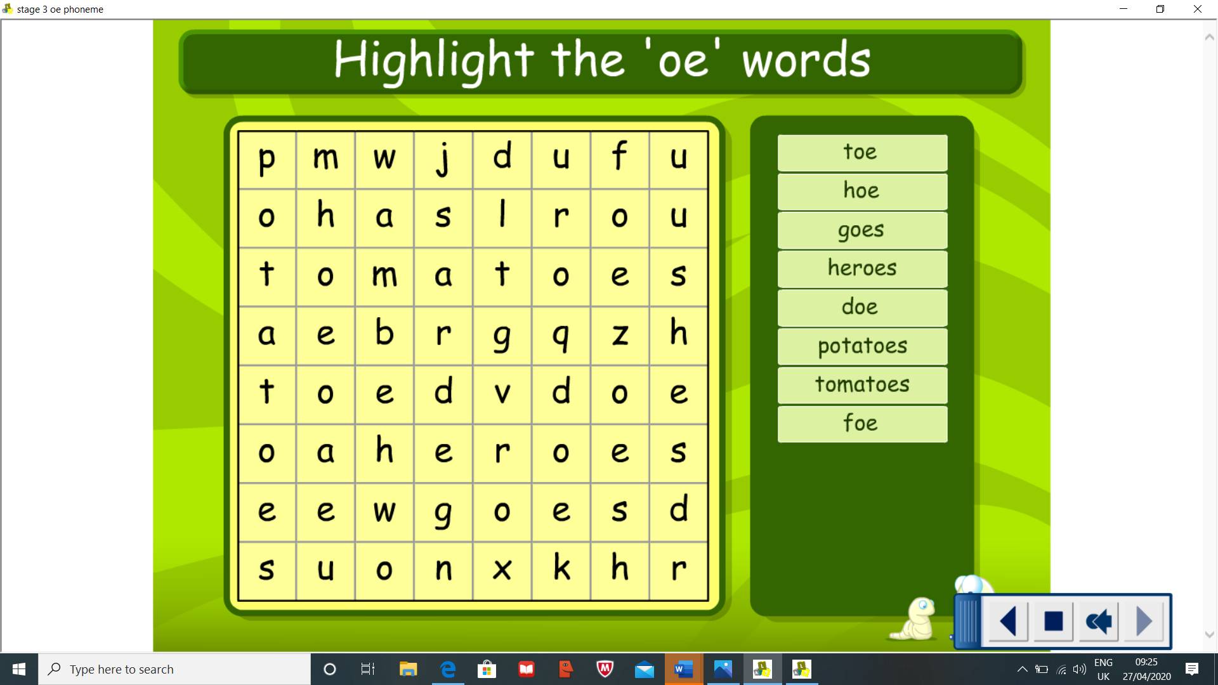  Red group – Please see worksheet on the blog  Spelling task  Blue group – Look for the tricky parts in your new words. write each word out 5 times circling the tricky part e.g write – the silent w, the wr phoneme is tricky.  Red group – write each of your words five times using the strategy rainbow spelling.  Blue Group- Phoneme – oe (toe) Common words- write, answer, began, heat, page Red Group- Sound – ot (pot, dot) Common words – have, just, to
Numeracy | This week we are going to revise fractions. You can use Topmarks and select fractions games throughout the week.  There is a new fraction task set as a link on the blog. On the sheet can you write your name and divide it into fractions, depending on how many letters are in your name. There is an example at the bottom. e.g. Lauren has 6 letters therefore can be divided into 6 equal parts. Then work out the fraction for how many vowels and constants are in your name.  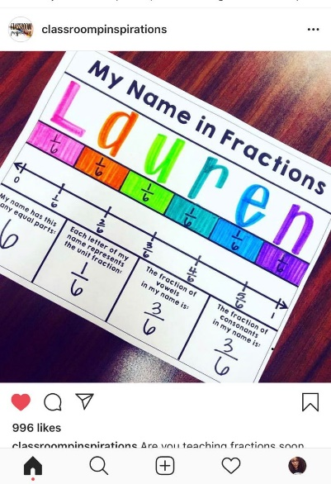
HWB  . | You all have been doing so well, it’s an unusual time but staying positive and happy is really important so for this week’s Health and Wellbeing task can you come up with an inspiring dance/workout routine to the following song? Present it to one of your family members and try and get them involved too! Or post some of your routine in the p3/4 Microsoft teams to inspire some of your classmates  - https://www.youtube.com/watch?v=WsidcB-24JU  Remember you are all superstars!
Other | New Topic  One of the many things I love to share with you all at the beginning of a new term is what our new topic will be. I love seeing your excitement and enthusiasm for new learning, so are you ready? (can we get our usual drum roll on the carpet?) Our new topic for term 4 is… Scottish Inventors!  This week I would like you to pick one of the following Scottish inventors and complete a research poster or PowerPoint on your chosen inventor.  Within your poster/PowerPoint you should include a picture of the inventor, the early life of the inventor (including date of birth, school life etc) a picture and description of the invention he is most famous for and any other key facts about them.  we will be studying;  John Logie Baird  Alexander Bell  James Watt  Alexander Fleming  Once you decide who you want to complete your research on there are many websites you can use. I have listed a few below;  https://www.famousinventors.org/10-great-scottish-inventors-and-their-inventions  https://www.scottish-at-heart.com/scottish-inventions.html  https://www.bbc.co.uk/programmes/p047xv9w  Remember when using google you can type ‘facts for kids’ after typing the inventor of your choice. You could also watch YouTube videos on your chosen inventor and listen for key facts (note taking is a skill we have practised several times in P3/4)  Enjoy!

