Literacy  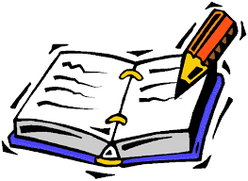 | I would like you to write a set of instructions explaining how to do something, make something or play something. A few examples could be;  - How to wash your hands properly to stop the spread of coronavirus  - How to make a cake you have made during lockdown  - How to play a game that you have played or made up during this time  - How to do a Tik Tok dance/challenge  Use the information I have attached to help you!
Numeracy  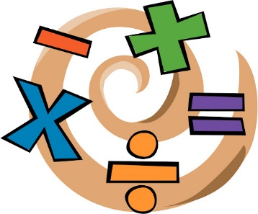 | We will looking at chance and uncertainty and probability.  If something has a low probability then it is unlikely to happen, e.g. Miss Stewart will dye her hair the colours of the rainbow. If something has a high probability it means that it is very likely to happen, e.g. tomorrow will be the 5th of June.  You can learn more here:  https://www.bbc.co.uk/bitesize/topics/zx9k7ty/articles/zqpxmnb  Complete the tasks that I have put on the glow blog
HWB | If you have not done so already make sure you check out the Heartstart programme and learn some first aid skills (see last weeks HWB task)  It is a brand-new month and a great time to reflect. I would like you to create a Lockdown reflection poster. Get a piece of paper and divide it into 4 sections. I would like you to answer the four reflecting questions while being in Lockdown.  Section 1 – What have you enjoyed?  Section 2 – What have you missed?  Section 3 – What feeling have you had?  Section 4 – What have you learned?  You can include pictures/photos! Remember to post your work on teams!
Topic | What is a journalist?  A journalist writes for newspapers, magazines, or news websites or prepares news to be broadcast.  I would like you to adopt the role of a journalist researching a story and interviewing witnesses. I would like you to create your own report and have a shot of “reading the news”. Have someone film you!

