Literacy   | This week I would like you to write a recount…  I would like you to write a recount of a day, a week or a time during lockdown which has been special to you. Below you will find a few examples:  - Learning a new Tik Tok dance  - A zoom call you enjoyed  - Your favourite daily challenge  Remember to write in detail about who, what, where, when and why!  I have attached a word document that will help you write your recount!  I can’t wait to read your recounts!
Numeracy  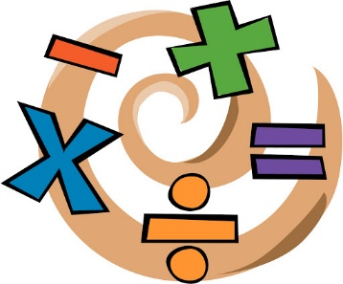 | We will be revising our 3D shapes this week. Watch this video to refresh your memory:  https://www.youtube.com/watch?v=2cg-Uc556-Q  I would like you to go on a 3D shape hunt! Tally how many you can find and then draw some of the objects you found!
HWB   | We are going to look at some content that we would have covered in term 4 from the Heart start programme. In primary 4 we learn about serious bleeding.  Please explore the following website ensuring you know how to deal with serious bleeding focusing on applying pressure and elevation.  https://firstaidchampions.redcross.org.uk/primary/first-aid-skills/bleeding/  Once you have the knowledge practise out your new first aid skills with a family member in a drama scenario. Good Luck! First aid is such an important life skill you never know when you will need it!
Art  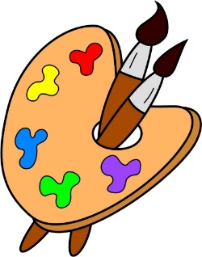 | Last week we were learning about how colours can make us feel. If you missed this learning look back on our class blog  Today we will be learning about a famous artist named Vincent Van Gogh. Watch this video to learn more about him https://www.bbc.co.uk/bitesize/clips/z8sy4wx  One of his most famous painting is of sunflowers.  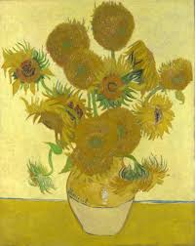  How does the colour make you feel and why?  I would like you to try and create your own copy of one of his masterpieces  This link will help you re-create his famous sunflowers https://www.youtube.com/watch?v=lZ__t656tnI  Alternatively, you could make your own paintings in the impressionist style – remember to capture those sweeping brush strokes to show movement and vibrant colours!

