In class we started to learn about the 24 hour clock. Below I have attached a picture to help you remember.

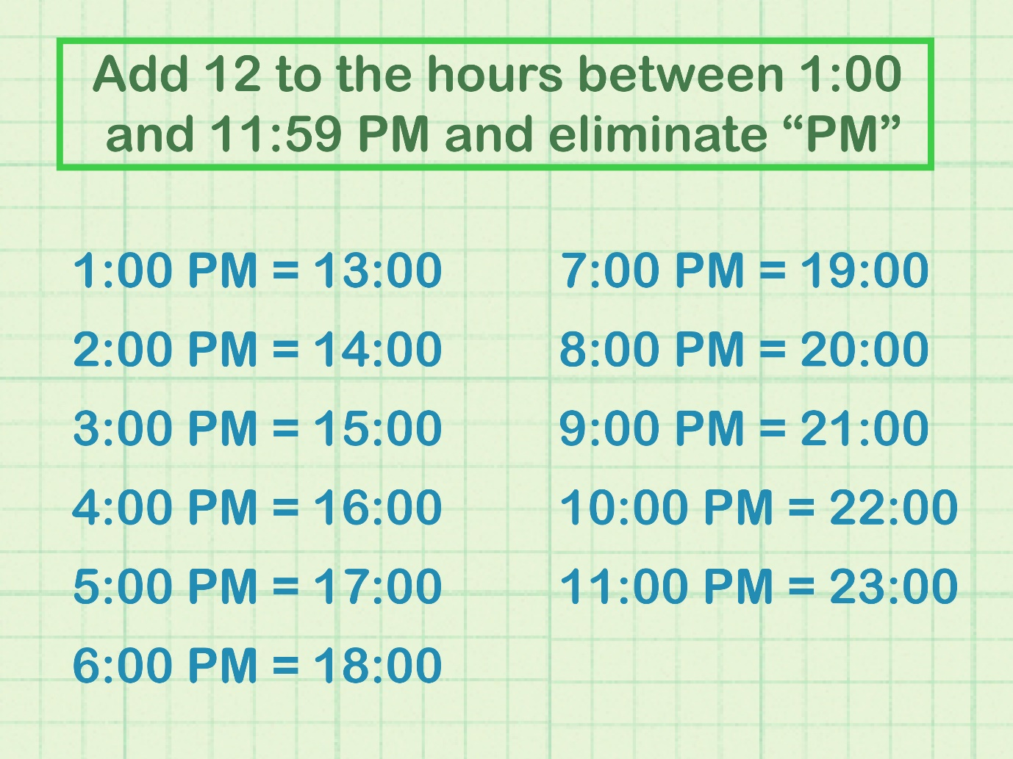

1. Use this to help you complete the sheets I have attached on our class blog.
2. Have an adult at home ask you times throughout the day and write them down on a piece of paper.
3. Make the interactive clock that I have attached on our class blog.