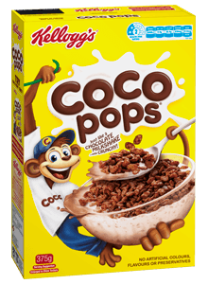Advertising

Our topic this term is about Media!

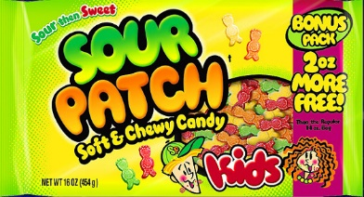

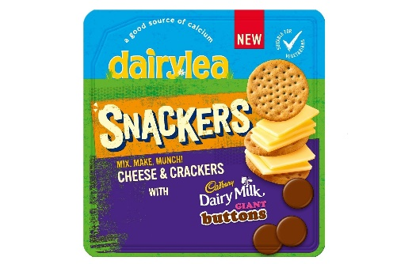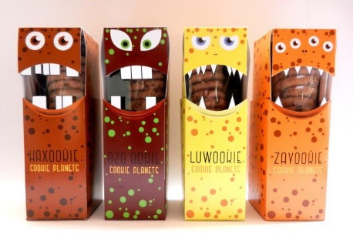

Discuss packaging and what makes you want to buy something with someone at home. Companies use ‘tricks’ to make their advertisement stand out (colour, free gifts, name, characters, size of box, prize etc).

**Task**

1. Look in your cupboards or online at some of your favourite foods packaging. Look for the “tricks”. Can you spot any?
2. Discuss packaging size and reasons companies use certain packaging (recyclable)
3. Design packaging for a breakfast cereal using the ‘tricks’

Have fun! Miss Stewart ☺