The Romans
Independent Learning
Poem/ Rap  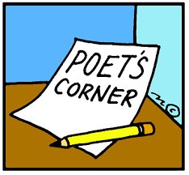  Write a poem about the Romans. It can be about any aspect of the Roman Empire (army, gladiators, emperors etc.) | Comic Strip    Design a comic strip telling the story of a major event in Roman history. It should include pictures and text. | Puzzle    Create either a word search or crossword based on the Romans
Poster  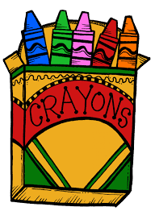  Create a poster showing the different events at The Games in the Coliseum or the Circus Maximus. You should use colour and images to enhance your message. | Biography  Research and produce a short biography of a significant individual. You can choose:  - Julius Caesar  - Spartacus  - Constantine the Great   | Research  Research a Roman town. You will need to present your findings in a town profile. You could choose:  - Rome  - Pompeii  - Herculaneum    - Colchester
Review  Read a book or watch a film/TV program about the Romans and write a review. You must include details about the content and decide what was good and not so good.   | Cooking  Find a Roman recipe. Create a step by step set of instructions for a primary school student to follow.    Have a go making the recipe! | A-Z  Create an A-Z of The roman Empire with a definition for each word e.g  - Amphitheatre: the centre of entertainment in Roman times  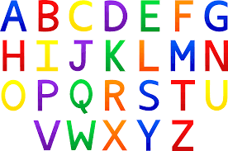  - Baths: public places where Romans went to wash and relax

