**Home Activites w/c 8 June 2020**

LI: Improve my accuracy when spelling.

LI: express and communicate my ideas, thoughts and feelings through art and design.

LI: Explore my environment and use it to inspire my creativity.

LI: Use technology throughout the curriculum.

**se (/ss/)**

cheese

noise

because

please

ease

pause

tease

technolgy

Spelling- se (/ss/sound)

Here are some activities you can do with your spelling list:

* Rainbow spelling
* Create a phoneme story
* Create sentences that have your spelling words in it
* Use Spellzone games. Click the link [here](https://www.spellzone.com/word_lists/list-957838.htm).
* Use your spelling words to practice your handwriting
* Recap on the rainbows of hope and the different colours of the rainbow. This week we are going to focus on pink.

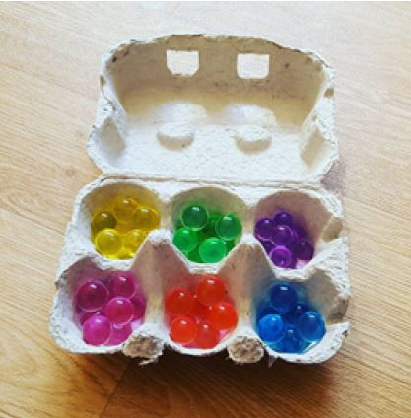

* Colour bingo - All you need is a piece of card or an eggbox with the chosen colours inside! Set a challenge to see who can be the first to find natural items of the same colour when you are out on their family walk or in the garden (always making sure that you only picks up items which are clean and suitable given the current restrictions).  Don’t forget to add in pink! I am sure there will be lots of flower petals or blossoms.  For ideas on how to make this, check out this [website](https://www.woodlandtrust.org.uk/blog/2020/05/nature-activities-for-kids-to-do-at-home-part-6/)
* When you are out,find as many different petals and blossoms as you can from different trees and bushes. [This blossom and tree ID Kit](https://www.woodlandtrust.org.uk/blog/2020/03/tree-id-kids/) will help them to identify the different trees in their area.
* Why not use what you have found to experiment with the Japanese art of Hapa-Zome? All you will need is leaves, berries and flowers and some material. The idea is to press the colour from nature to create beautiful patterns on the cloth.  For more detailed instructions, you can access this [website](https://outdoorclassroomday.org.uk/wp-content/uploads/sites/2/2018/09/The-japanese-art-of-hapa-zome-Final-version.pdf).
* Alternatively, you could do some flower pressing and make their own beautiful pastel pictures, cards or gifts.- <https://www.nhm.ac.uk/discover/how-to-press-flowers.html> or <https://www.redtedart.com/how-to-press-flowers/>.

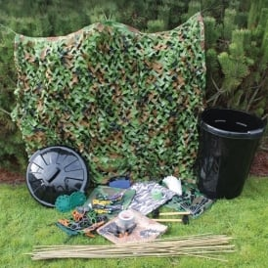

* Let’s keep the outdoor theme going and to build your own den, using a range of natural resources or alternatively some sheets and pegs. If the weather isn’t so good, you could still build a den indoors.  What magical space will they create and how will they decorate it?  Let your imagination run wild and share your creation with us on Teams…For some tips on den building, these websites might help: - <https://www.playfulchildhoods.wales/top-tips-for-dens-at-home> or <https://www.edenproject.com/learn/schools/lesson-plans/den-designers> or <https://www.woodlandtrust.org.uk/blog/2019/10/how-to-build-a-den/>
* When you have built your den, you might enjoy listening to the sounds round about you. If they lie quietly in the den, what can they hear?  Can they use everyday objects to recreate those sounds and make a sound journey or even some music of their own from these objects?  These websites might help with some ideas of what can help - <https://www.bbc.co.uk/bitesize/clips/zgfwhyc> or <https://arts.onehowto.com/article/how-to-make-musical-instruments-at-home-334.html> or <http://www.treetoolsforschools.org.uk/activities/pdfs/pdf_woodland_wind_chimes.pdf>
* Listen to the poem, ‘What is Pink?’ by Christina Rossetti – you can read it here - <https://www.poetrybyheart.org.uk/poems/what-is-pink/> or <https://www.tes.com/teaching-resource/poetry-what-is-pink-by-christina-rossetti-11206302> or listen to it being read here - <https://www.bbc.co.uk/bitesize/topics/z74n6v4/articles/zv7qwty>
* Create their own poem using the same format as ‘What is Pink?’.  Instead of writing on paper, you might want to become Pebble Poets and write their poems on stones.  Here are some examples of Pebble Poetry - <http://www.treetoolsforschools.org.uk/activities/pdfs/pdf_pebble_poems.pdf> or <https://unsplash.com/s/photos/pebble-bee-kind> or <https://www.scottishbooktrust.com/uploads/store/mediaupload/2463/file/How%20to%20make%20poetry%20stones.pdf>

Extra Activities

* There will be a SumDog challenge on Fractions
* Keep learning a new language on DuoLingo
* Join Joe Wicks for his daily exercise every morning at 9am
* Watch Newsround and write a recount about a story in the news
* Go to [www.knowledgeadventure.com](http://www.knowledgeadventure.com) and play one of the free games on that site