Home Learning Activities- W/C 18 May 2020
LI: identify symmetrical objects in the environment around me.
LI: identify how plants and animals depend on each other
LI: respond to the work of famous artists.
LI: use spelling rules to spell with accuracy.

This week’s spelling list

Here’s a list of words to practice this week! Here are some spelling activities to complete
-ck List
kick
sick
quick
flick
back
sack
track
neck
stick
lock
duck

- create silly sentences with your spelling words
- Draw a picture of the sentences you create
- Complete some handwriting practice with joins (remember to stay on the line and remember letter sizes)
- Complete the online homophone spelling activity found here

To recap what we have learned about butterflies from last week – can you recall some key facts? This symmetry song might be helpful.

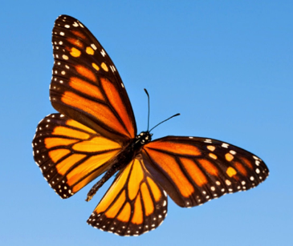
Explore symmetry in nature – can you find things which are (like butterflies) symmetrical in nature? You might want to look at some fruit and vegetables in the house. Here is a link to help

Using the fruit and vegetables from the experiment, you can explore the features of each half further through painting and print. Can you create a work of art from your symmetrical fruit?
Taking symmetry outside – find things which are symmetrical outside. You might want to do this as part of a family activity when out for a walk. For some examples of symmetry in nature. Don’t forget that rainbows can be symmetrical too!

Using the learning from symmetry in nature – building on the knowledge about plants which have symmetry, honeycombs and butterflies, think about how you could encourage more bees and butterflies into your garden or nearby park? Sunflowers might be idea to plant as you can also measure how tall they grow over time.

Why not draw a sunflower or a flower of your own choice? A step by step guide can be accessed here - Some images might also give you some ideas!
You could look at Van Gogh’s ‘Sunflowers’ also. To access a step by step guide to re-creating the ‘Sunflowers’, this drawing tutorial might be helpful in the initial drawing of the picture and looking at colour and texture of the piece. (Maybe save this for FRIDAY – hint, hint )

Take this creativity into the kitchen and learn how to cook tomato pizza. For a fun recipe, join Jamie Oliver, Petal and Buddy to make the family dinner. You might even make their pizza symmetrical!

Extra Activities:
- Try to exercise every day, whether it is outdoors (with supervision) or an indoor exercise
- Practice a new language with Duolingo
- Keep practicing your maths skills on Sumdog
- Learn a new game and play it with your family
- Watch Newsround

