**Home Learning Activities- W/C 11 May 2020**

LI: explore my environment using my senses.

LI: read with fluency and expression.

LI: observe and record my findings during an experiment.

LI: create a narrative story.

LI: explore a range of media and technologies to create images and objects.

* Recap on the rainbows of hope and the different colours of the rainbow. This week we are going to focus on red.
* Scavenger hunt - set a challenge to find as many things which are red through the day. This might even be when you are outside or going for a walk (always making sure that you only picks up items which are clean and suitable given the current restrictions). See if you can find or see any ladybirds or butterflies.
* Recap on the lifecycle of the butterfly – if you have a smaller brother or sister, you might want to read the story of the ‘Very Hungry Caterpillar’ to them or watch this short animated film together - <https://www.youtube.com/watch?v=75NQK-Sm1YY>. If you do not have a younger brother or sister, search Oxford Owl for stories of minibeasts or non-fiction stories about nature.

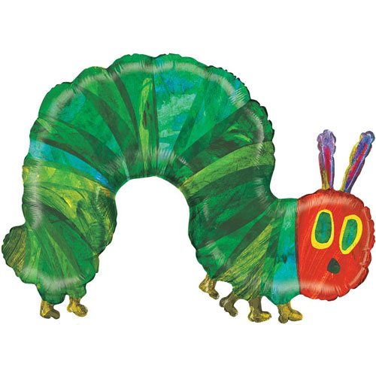

* Experiment: to attract butterflies into their garden with this short experiment using a saucer of sugar water. Stay a short distance away (close enough so that they can see but not so close that they will scare them away).  How many butterflies visit?  Can they make a tally chart to count the number that visit and to record butterflies of different colours? (To compare what attracts the butterflies more, they might want to put out a saucer of plain water and compare how many visitors come to each saucer.) This guide might help them to spot some of the different types of butterflies - <https://www.woodlandtrust.org.uk/trees-woods-and-wildlife/animals/butterflies/>. How many red butterflies can they find?
* Each side of a butterfly’s wings are exactly the same – this is **symmetry** in nature and in the things around us. Try some practical experiments using mirrors or paper shapes.  Some ideas for symmetry experiments can be found here - <https://earlyimpactlearning.com/symmetry-activities-for-kids/>
* Watch this short clip from the Literacy Shed which shows butterflies lighting up the environment - <https://www.literacyshed.com/butterflies.html>. Can you write a story in your own words based on this clip?
* Using the clip, think about the butterflies floating out of the book – can they think of some ‘wow’ words to describe them? Can you paint/colour the butterflies with these ‘wow’ words next to them?
* Invite the children to make their own butterflies – using whatever resources they have and prefer. This might be a 3D model, a chalk drawing or even a digital drawing.  Hang them next to their rainbows to cheer up those people who are out for a walk.  Some examples from the Woodland Trust can be found here - <https://www.youtube.com/watch?v=UDNFQ7z4Wcs>