**Inside Triangles**

Here is a four by four dotty grid:  
  
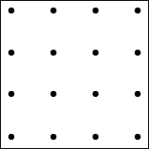  
  
I have joined three dots on the grid to make a triangle which has one dot inside it:  
  
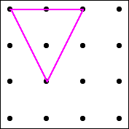

How many different triangles with one dot in the middle can you draw?

How do you know have found them all?