Sounding Out Words
Practise sounding out 2 and 3 lettered words
1. Your child should know all their letter sounds quickly in each word.
Practise saying each sound each letter makes
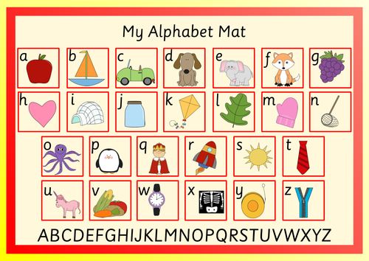

2. Then practise blending 2 letter words:
Have your children drag out the vowel and quickly add on the ending. You might need to help your children to this several times until they get good at hearing the word.
on is
up if
in us
as egg
at off

3. Then blend 3 letter words:
Encourage your child to say the first sound loudly and clearly and drag out the middle and then add on the ending.
e.g h aaaaaa t

Again you might have to show your child how to blend each word before they can tell you what is being said. Run your finger under the word slowly.
sat wet
red map
lip bus
hot pig
run job
Sound out each word and find the correct picture:
Check they can do it by themselves
