First Level Maths & Numeracy Home Activities
Create a repeating pattern using a variety of 2D shapes or 3D objects.  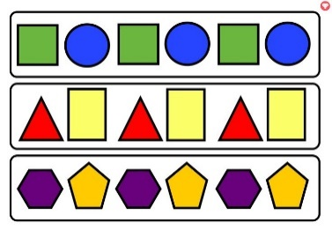 | Create an addition/subtraction board game. Play it with your family.  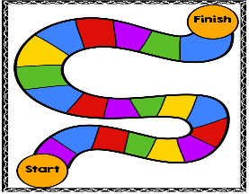 | Find as many different examples of numbers within the environment as you can.  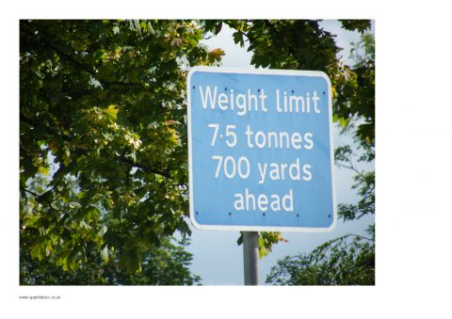 | Use a calendar to plan out some events for your family throughout the year. How many days or weeks are between events?  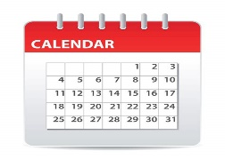
Estimate the length of different items in your house. Measure them with a ruler and check if you were correct.  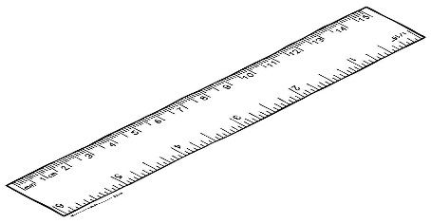 | Log on to Sumdog. How many questions can you answer correctly? | Carry out a survey on a subject of your choice. E.g. favourite TV programme, favourite chocolate, eye colour. Display the information using a graph.  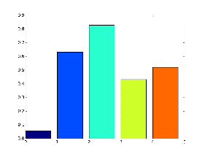 | Get someone to give you random numbers. Practise saying the number before and the number after.  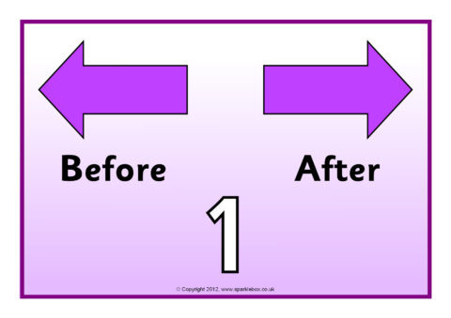  99
Imagine you have £10. Choose three sweets to buy. Work out the total cost and how much change you would have. | Draw/paint a picture which has at least one line of symmetry. | Practise time tables facts. Focus on the times tables that you find most challenging.  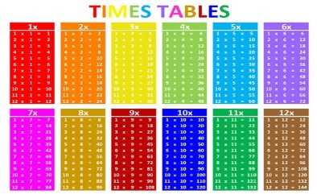 | Gather some items from your house. Sort them from lightest to heaviest.

