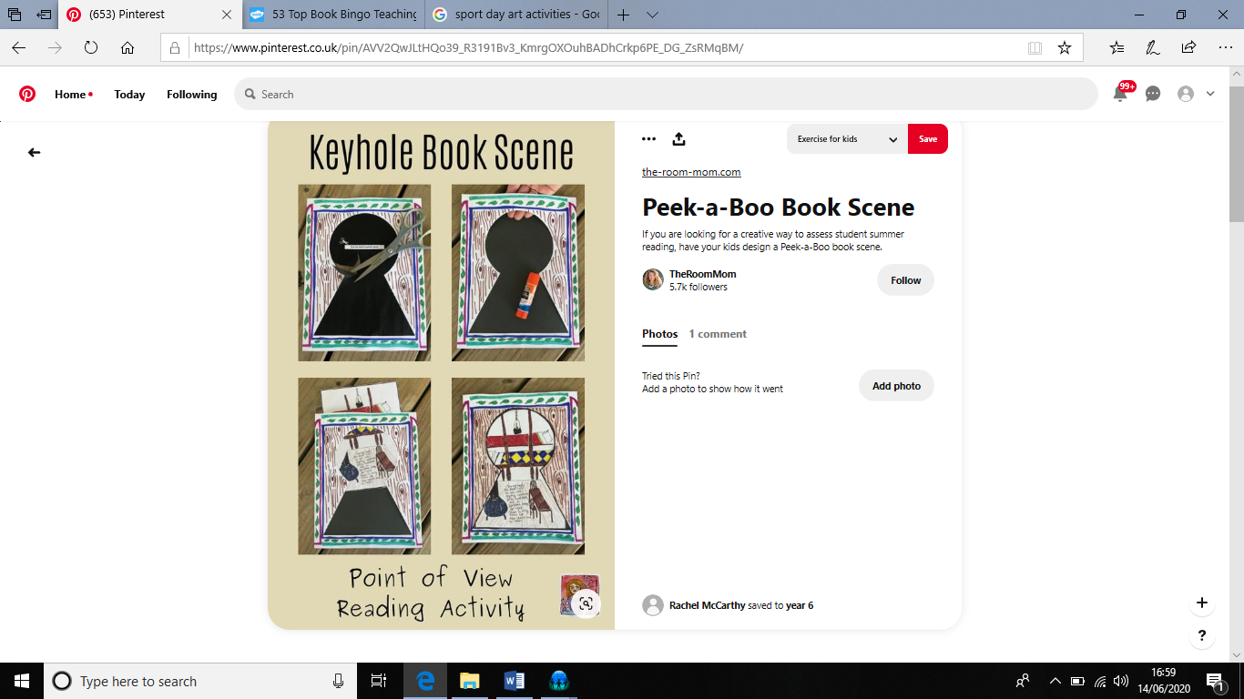

Can you create a keyhole poster about a book you have read this week? The poster should show:

* An important part in your story.
* A few sentences in your own words about the story?