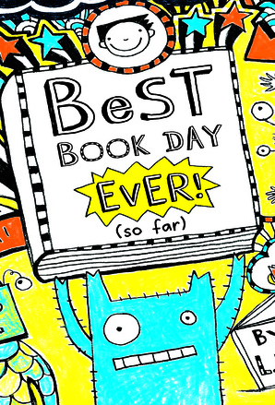
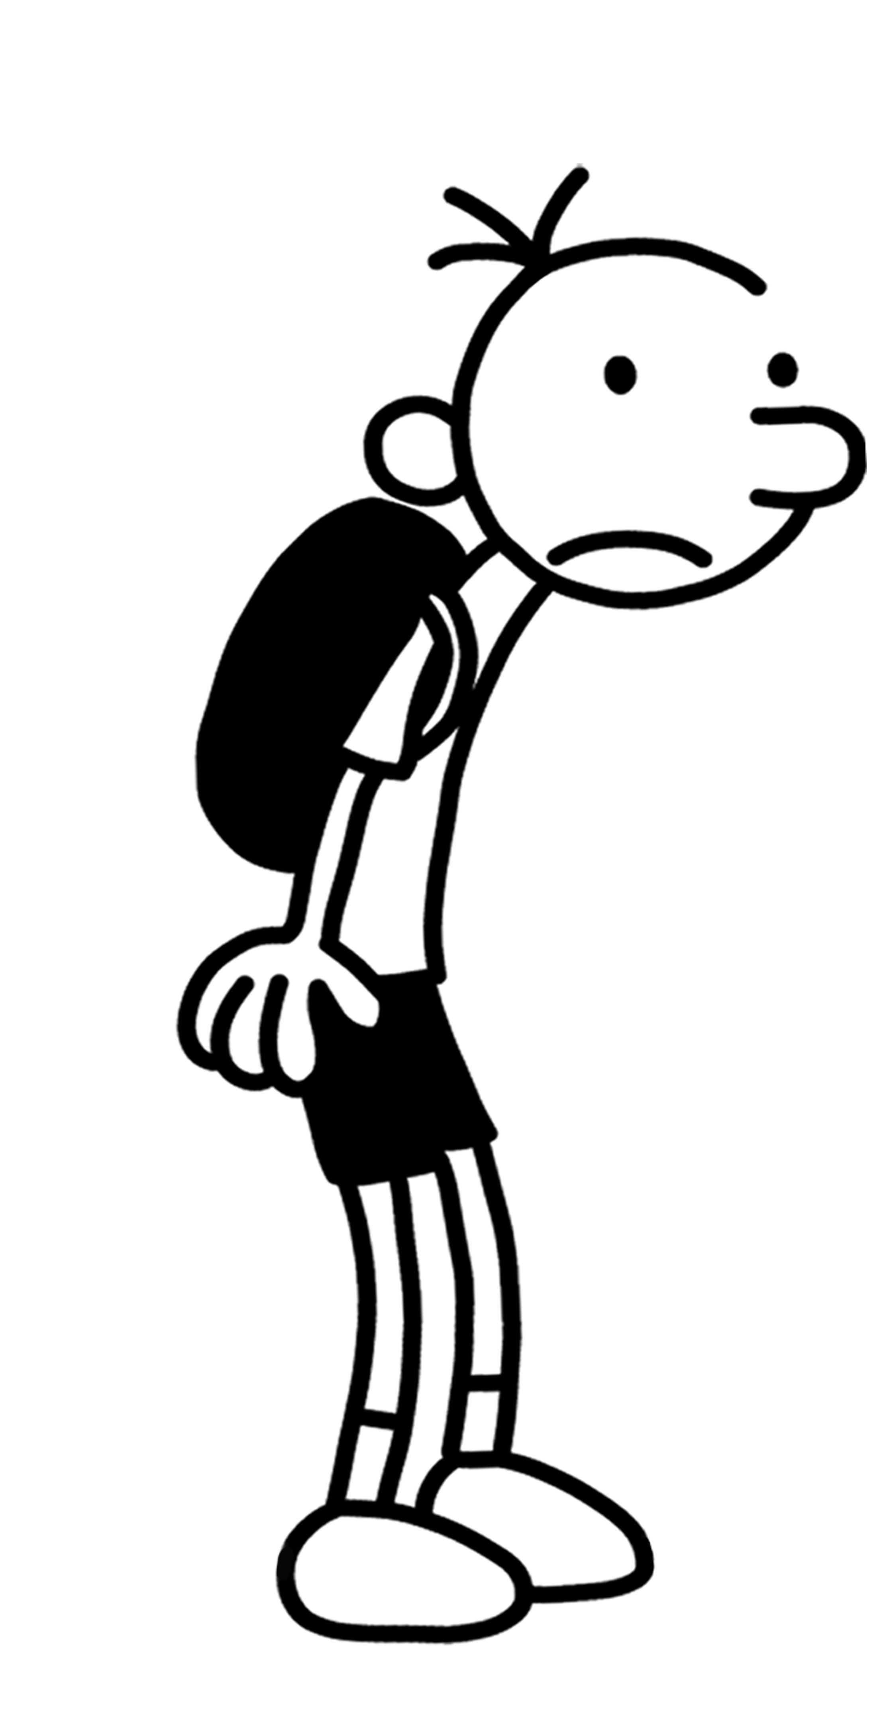
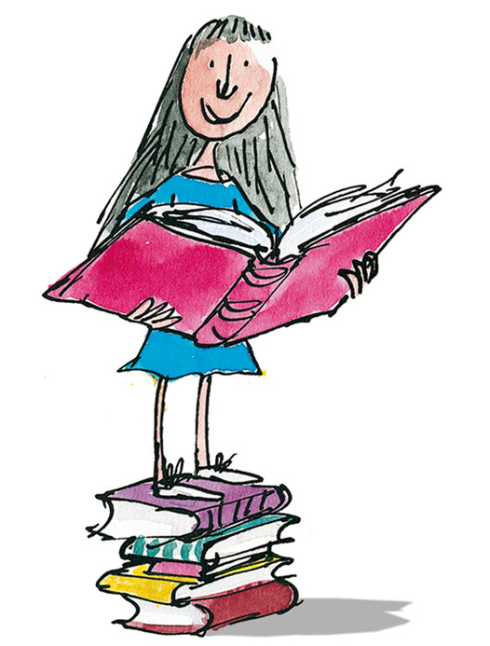
What words has the author used to make their writing interesting? For example: gloppy, gigantic.
_______________________________________________________________________________________________________________________________________________________________________________________

Rating:
Would you/would you not recommend the book? Why?
_________________________________________________________________________________________________________________________________________________________________________________________________________________________________________________________________________________________________________________

Rating:
Who would this book be suitable for and why? Age/interests
____________________________________________________________________________________________________________________________________________________________________________________________________________________________________________________

What is the book about?
_________________________________________________________________________________________________________________________________________________________________________________________________________________________________________________________________________________________________________________
Book Review
Book Illustration
Book review by: ___________________________________________
Title: __________________________________________________
Author: ________________________________________________
Non fiction Fiction

