Spelling Tasks:  Green, Yellow, Red spelling list:  dress, mess, less, grass  Blue Spelling list:  fan, lap, got, bin, of. | Green ,Yellow and Red Groups:  The phoneme of the week is ss  Link below allows you to hear the sound:  https://www.youtube.com/watch?v=6G0G-CEVXis  Can you use you use your spelling list to:  - Look, say, cover, write and check each word?  Your common words are:  - four, miss, never, these  - Can you put your words into sentence?  Further spelling activity ideas for both you common words and spelling list:  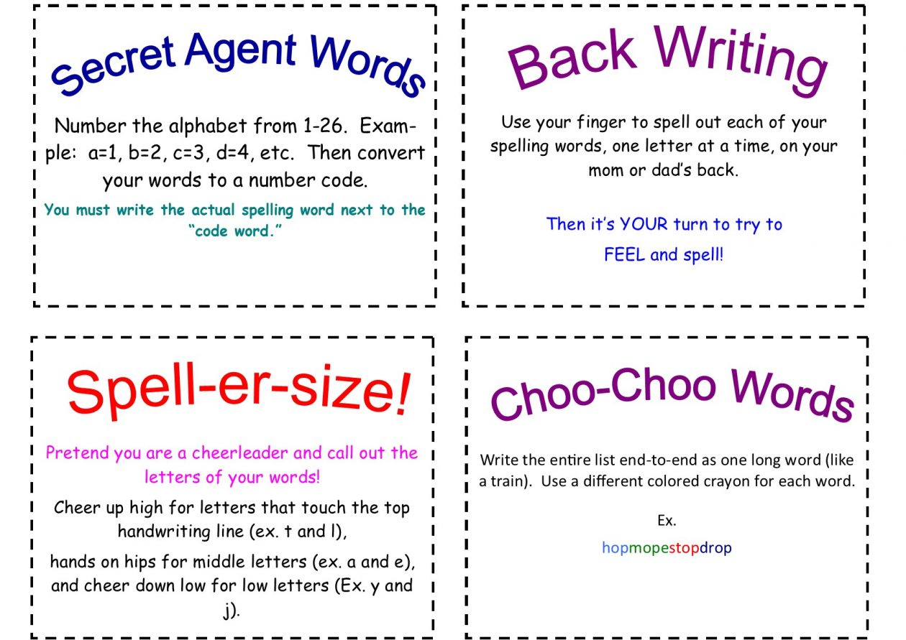  Use your finger to draw your spelling words out on someone else’s back.  Blue Group:  You are revising sounds this week.  - Some examples of sounds to practise, but you can also use your homework  jotter to choose.  - g, l, j, z, b, u,v,f,o  - Practise look, say, cover, write, check with you spelling words.  - Write your spelling words with different coloured pencils or pens.  - Use the following link to listen to all the different sounds on Alphablocks:  https://www.bbc.co.uk/cbeebies/shows/alphablocks  Your common words are:  your, be, have, was  Can you think of a sentence with these words  and say the sentence to an adult?
Maths and Numeracy | This week we will continue to look at time.  Circles and Squares:  Look over minutes, seconds and hours.  Can you use previous work to work out:  How many minutes in an hour?  How many hours in a day?  Use the link below to help with your understanding:  https://www.youtube.com/watch?v=1RwE9z2PAtA  Remember practising will help you get better and better when telling time.  - If you feel confident with time you can move onto our new concept of angle,  symmetry and transformation. ( I know we have looked at some symmetry before, but we  will be looking at different learning).  - We are going to look at using the correct words to describe , follow and record  directions.  - Such as full turn, half turn, quarter turn, clockwise, anticlockwise, right turn and  left turn.  - Using your previous knowledge when looking at a clock talk to an adult about  what you think these words mean.  - Have a discussion and show each other by turning your body in the direction  you think each word means.  - When you have a better understanding of each word, direct each other around a  room using the correct words. You could even try direct them to a specific thing in the room.  - You could draw a treasure map? Then you would have to direct them to the treasure?  Triangles:  Continue to look at time on the analogue clock:  https://www.youtube.com/watch?v=5TA5z_DE204  Can you make your own clock using pencils/pens and paper.  For your clock hands you can use pencils of cut up some paper.  - Practise making different o’clock times.  - Play a time game using the link below: http://www.snappymaths.com/other/measuring/time/interactive/halfhours/oclockhpimm/oclockhpimm.htm  - Can you think of anything else that helps tell time? For example a calendar  to tell time of year  - If you feel confident with time you can move onto our new concept of angle,  symmetry and transformation.  - We are going to look at using the correct words to describe , follow and record  directions.  - Such as front, behind, above, below, left, right, forwards and backwards.  - Have a discussion and show each other by turning your body in the direction  you think each word means.  - When you have a better understanding of each word, direct each other around a  room using the correct words. You could even try direct them to a specific thing in the room.  - You could draw a treasure map? Then you would have to direct them to the treasure?
Reading Tasks | Green, Yellow and Red Group:  Choose a book from Oxford Owls to complete any of the following tasks:  - Phoneme detective- Write down 4 different phonemes you have looked at  recently, making sure to use this weeks ss. Write them along the top of some paper and then  using any book you have been reading, see if you can find any words with the  sounds you have picked and write them underneath. Example below:  ss y  grass cry  Tess fly  Blue Group:  - Continue to read Oxford Owl books.  - Use Youtube to access Jollyphonics.  - Can you write the alphabet using Jollyphonics and say each sound aloud.
Health and Wellbeing | Staying positive:  - Remember there are lots of ways to stay in contact with friends and family during  this time.  - I have attached a little video about staying positive:  https://www.youtube.com/watch?v=2PnnFrPaRgY  - I have also attached separately a worksheet where you can write  short paragraphs about why you should be proud of yourself.  Stay active!  - Continue to work through the variety of indoor Disney activity ideas in the link below:  https://www.nhs.uk/change4life/activities/indoor-activities
Topic | Endangered species.  Endangered species means an animal or plant that is at risk of not being around much longer.  This could be because they have lost where they live.  - Use the following link to learn more about different endangered animals. It  has may different links to games, information and videos.  https://sciencetrek.org/sciencetrek/topics/endangered_species/games.cfm

