Spelling Tasks: | Green ,Yellow and Red Groups:  This week is a revision week. You can revise any phoneme you are unsure of, using your  homework jotter to help. I have also listed below some you may want to revise.  igh for night, light.  ou for round, found.  y for fly, cry.  i-e for five, fire.  Using which ever phoneme you want to revise (remember it can be more  than one or any one from your homework jotter) to complete some of the following tasks.  - Can you write at least 6 words that have that phoneme in it?  - Can you find objects in your home that have that phoneme, then  draw the objects and label your drawing?  f ou n d  - Can you split your words into sounds using an Elkonin box. I have given an example  below as it will have been some time since you have used these:  n igh t  sh ow  Revision common words this week are:  bring, Mr. , two, school  Remember you can also choose any from your homework jotter.  Can you put your common words into a sentence? You could use different colours for each  sentence and create a rainbow. As shown below:  bring my teddy with  to me  like two eyes and on  have one my  I I mouth. walk.  Blue Group:  You are revising j and v this week.  Remember j for jug and v for van.  - Practise look, say, cover, write, check with you spelling words.  - Write your spelling words with different coloured pencils or pens.  - I have also attached separately some CVC sound worksheets to revise other sounds.  If you do not have a printer. Remember you can always write on a blank piece of paper.  Your common words are:  have, just, to  Can you think of a sentence with these words  and say the sentence to an adult?
Maths and Numeracy | This week we will continue to look at time.  Circles and Squares:  We are going to look at time on a digital clock. With some revision of analogue time to help  - https://www.youtube.com/watch?v=sAYiUZSRmk0  - Use the following game to help your understanding of digital time in 12 hours  not 24 hours.  https://mathsframe.co.uk/en/resources/resource/116/telling-the-time  Understanding AM and PM on a clock:  - https://www.youtube.com/watch?v=wv3mtG_wGWw  - I have attached separately a worksheet for a.m and p.m.  I know these are new concepts and it can be hard doing them at home so remember  these are only suggestions. If you think you need to revise some of the work from last week  such as reading time in 5 minutes to help your understanding you can always go back to  last week’s videos and tasks. I have kept last week’s links below if needed.  Use your clock from last week to revise o’clock and half past and practise quarter past  and quarter to.  - Play a time game using the link below:  - https://mathsframe.co.uk/en/resources/resource/117/telling_the_time_in_words#  If you challenged yourself with talking about minutes past you can also try the following game  https://mathsframe.co.uk/en/resources/resource/116/telling_the_time#  Triangles:  Let us look at time :  - We are going to continue to sequence events in the right time order.  - Let us look at the months of the year:  https://www.youtube.com/watch?v=5enDRrWyXaw  - Using the video above to practise saying the months in the correct order.  - I have attached separately a worksheet for ordering the months.
Reading Tasks | Green, Yellow and Red Group:  - Continue to use Oxford Owl to read a variety of books.  - Choose a phoneme and read through a book of your choice  to find as many words with that phoneme and put them into a phoneme flower.  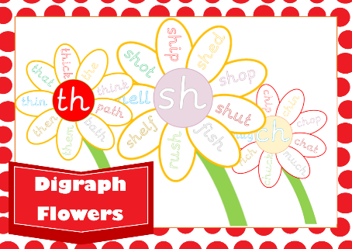  Example given below:  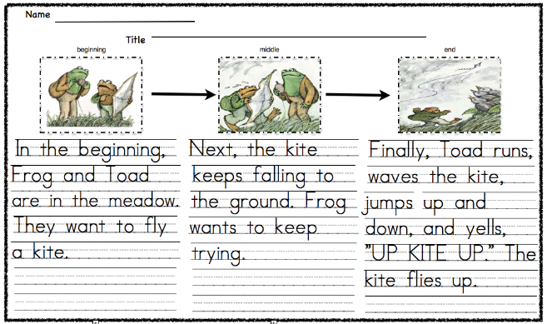  - Can you complete a beginning, middle and and end from a book from Oxford Owl. Owl. I have given an example to remind you how to do this:  Blue Group:  - Continue to read Oxford Owl books.  - Can you find and j or v words in your book and write them down?  - Can you create your own colouring sheet for each sound? I have given  an example below:
Health and Wellbeing | Let us stay healthy and happy.  - Take some time to relax with some mindfulness yoga or meditation:  https://www.youtube.com/watch?v=mV9BBR1RoGg  https://www.youtube.com/watch?v=ZvJH8Kbzj54
Topic | Endangered species.  Endangered species means an animal or plant that is at risk of not being around much longer.  This could be because they have lost where they live.  Continue to use the following websites to research:  - dkfindout.com have an endangered species section.  - Discover kids.com have a spotlight on endangered species section.  - Youtubekids has lots of education kids videos.  - https://www.youtube.com/watch?v=7k8CcAU2Lt0  - Can you create a poster using any animal you have researched? Can you  add detail such as where they lived? What they ate? What they looked like? How could we help endangered animals? Use the link above to help with the last question

