Spelling Tasks:  Green, Yellow and Red Groups spelling List:  tune, cute, cube, June  Blue Group Spelling words:  hat, hug, we, win | Green ,Yellow and Red Groups:  Your new phoneme this week is a-e. Remember this means u with magic e.  For example tube and cube  The link below lets you hear the sound:  https://www.youtube.com/watch?v=BdfBg1SMFzM  Can you use you use your spelling list to:  - Look, say, cover, write and check each word?  - Dot spell each word?(This means use dots to create each letter in the word)  - Can you fine any u-e objects at home?  Common words this week are:  every, find, want, girl  Can you put your common words into a short story?  Blue Group:  You are revising h and w this week.  Remember h for hat and w for win.  - Can you draw 5 things starting with h and 3 things starting with w?  - Practise look, say, cover, write, check with you spelling words.  - Write your spelling words with different coloured pencils or pens. Can you curve  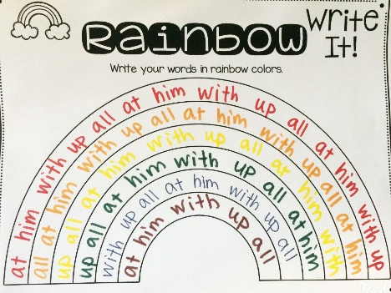  them to create a spelling rainbow?  Your common words are:  was, went, his  Can you think of a sentence with these words  and say the sentence to an adult?
Maths and Numeracy | This week we will continue to look at time.  Circles and Squares:  We are going to look at quarter past and quarter to.  This video also goes onto minutes. You can challenge yourself with this if you feel  confident, but we are focussing on quarter past and quarter to.  https://www.youtube.com/watch?v=8RJzoyIVzV8  Use your clock from last week to revise o’clock and half past and practise quarter past  and quarter to.  - Play a time game using the link below:  - https://mathsframe.co.uk/en/resources/resource/117/telling_the_time_in_words#  If you challenged yourself with talking about minutes past you can also try the following game  https://mathsframe.co.uk/en/resources/resource/116/telling_the_time#  Triangles:  Let us look at time in regards to our daily routine.  - I have attached a worksheet on the Glow blog for you to create your daily routine  in the correct order.
Reading Tasks | Green, Yellow and Red Group:  Continue to use Oxford Owl to read a variety of books.  - Can you find your u-e phoneme in any of the books you read this week?  I have attached a few reading task worksheets on Glow blogs for u-e. If you do not  have a printer you can use the worksheets as ideas.  For example:  - Word search worksheet you could create your own word search  - For the cut and stick worksheet you could write some u-e words, cut them up  then try to unjumble them and then draw a picture of what the word means.  - For the phoneme spotter worksheet you could look through the story and write  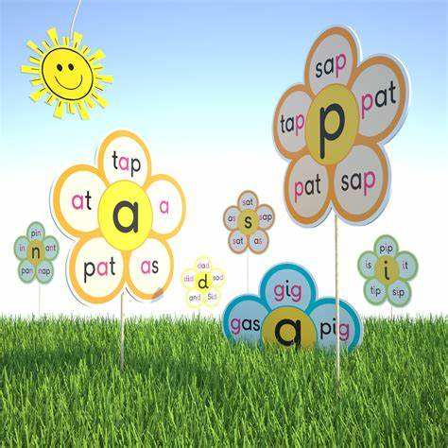  the u-e words on a piece of paper.  Blue Group:  - Continue to read Oxford Owl books.  - Can you find and h or w words in your book and write them them down?  - Create a phoneme flower by drawing a flower and filling in the the petals with words that have your sounds in them. Do a h a a h flower then w flower.
Health and Wellbeing | Let us stay healthy.  Can you draw a healthy meal and label it? Can you tell me why your meal healthy?  Stay active!  Hopefully the weather stays sunny and you can go for a walk or jog. Can you spot any Rainbows  on your walk or jog?  Remember there are lots of home workout videos online too!
Topic | Endangered species.  Endangered species means an animal or plant that is at risk of not being around much longer.  This could be because they have lost where they live.  Use the following websites to research:  - dkfindout.com have an endangered species section.  - Discover kids.com have a spotlight on endangered species section.  - Youtubekids has lots of education kids videos.  Continue your research of all the different endangered species.  - Can you find out the answer to the following questions using the dkfindout.com  webpage? Remember answer in full sentences.  - How high can a male tiger leap?  - Why do tigers have stripes?  - What do orang-utans eat?  - What does the word orang-utan mean?

