Maths | Art | Healthy Food
- Write a list of as many objects in your house as you can. Draw a picture of those objects. Can you draw a line down the middle to check if they are symmetrical? Remember if they are symmetrical they will be the same on each side of your line. | - Draw a t shirt shape and design it by answering the questions from the picture below. 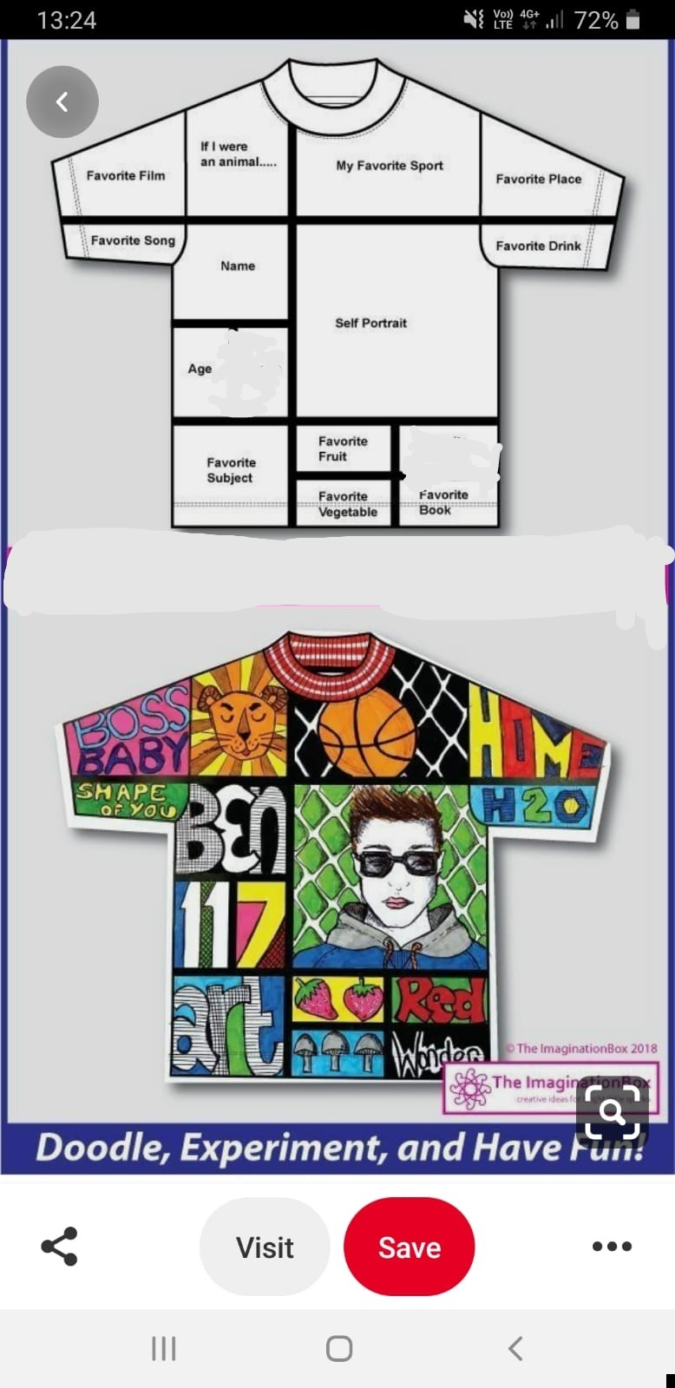 | - With the help of an adult, make a healthy snack.
Literacy |  | Health
- Green, Yellow and Red group use the following spelling words for this task or any others from your homework jotters. Grow, snow, glow, always, when, because.  - Blue group use the following words or create all the sounds of the alphabet. Get, the, go, be, bin, sat.  - Choose from as many of the following tasks as you like and use the words above to complete.  - Use lego bricks to create your words.  - Use magazines or newspapers to cut out letters to stick on paper to make your words.  - Use buttons to spell out your words.  - Challenge! Can you use these words and create an imaginative story using as many of these words as you can? | 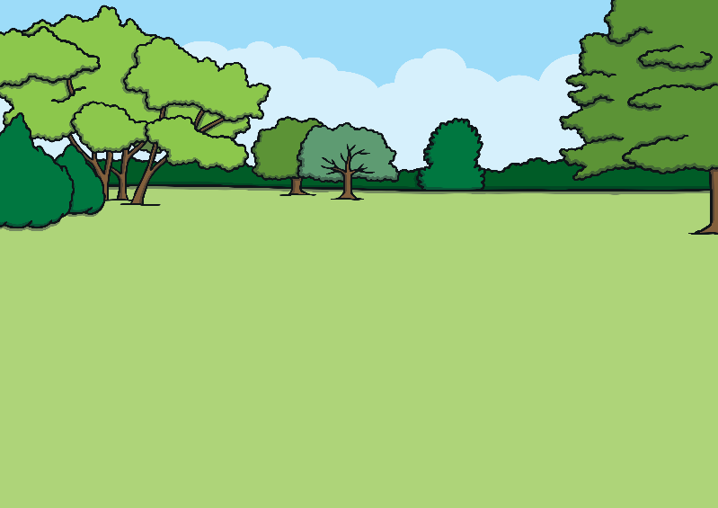  Homework Choice Grid  Back to School | - Can you make your own workout routine. You can do it with an adult and sibling too!
Look outside | Having fun!
- Have a look out your window. Pick an object. Can you think of any other objects that rhyme with that object?  - For example: I see a tree so I think of bee. | - Create a special handshake with a sibling of family member. | - Miss McLaughlin hopes you all have had a good Easter holiday and are staying safe. Remember you can show me all your lovely work through glow or our Microsoft teams chat.

