Literacy Home Activities
Write pairs of rhyming words in your jotter. | Read/Listen to a story and discuss with someone the heading, title, author and pictures. | Read a story and retell the main actions/events in a logical sequence. Use the picture clues. | Using puppets put on a puppet show for your family.  You could think of some traditional tales/ fairy tales.  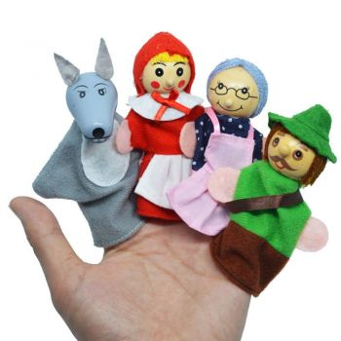
Choose a story & discuss what you enjoyed. Write about what you liked and disliked. | Log on to Sumdog Reading & Spelling. How many questions can you answer correctly? | Practise your letter formation. Write your common words and try to use them in a sentence. | Make letters and words using a variety of materials. Paint, pipe cleaners, playdough etc.  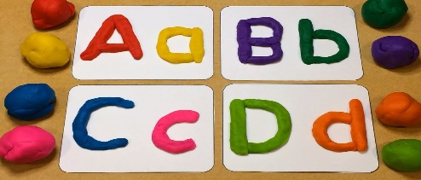
Make/Write a card for someone.  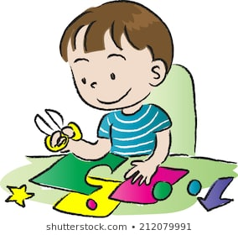 | Select your favourite cartoon or T.V. character and create a book for this character.  - Create a title for the book  - Illustrate the front cover  - Write a ‘blurb’ for the back cover | Talk to a family member and describe tasks/activities which you have been doing during the day. Ask questions about what other people have been doing. | Choose an item in your home and talk/describe this to someone.  