Hello P1a,

Hope you are all safe and enjoyed the Teddy Bear Themed week last week!
I can’t believe this is our last full week of you being a P1!

This week we are going to have lots more fun as it is Ladywell Primary Sports Week as this would have been our Sports Day week.

North Lanarkshire Council are having a virtual Sports Day on 22nd of June so Ladywell Primary are going to have a week of Sports leading up to that.

Please find a grid below with the weeks schedule and information on how it is all going to work. Any questions, please just ask.
Ladywell Sports Week Timetable of Events

This will be a house competition. Each day you have to email Mrs Carton your times. Please include your name and stage in the email.

Mrs Carton will award points to the winning house each day! (announcement of this will probably run a couple of days behind to allow for all the results to be emailed in.)

Information can be found on Twitter and through our Teams page also.
Good luck and enjoy!

Along with our Sports week we have a few home learning activities. Please find ideas for these below -

Maths

- This week activities on Studyladder are based on revising Addition and Subtraction.
- Another Sumdog Challenge is set for you of answering 50 questions correctly (please contact me if you require your sumdog login details).

Phonics & Spelling
- This week I would like you to revise the chilli challenge phonemes of
sh, ch and ng – activity grid attached through our Microsoft Teams page or click below –
ch, sh, ng consolidation

Reading
- This week I would like you to read the book ‘Tiger’s Fish’ from the Oxford Owl eBook library. There are some ch, sh and ng words in this book so look out for them. How many can you find?
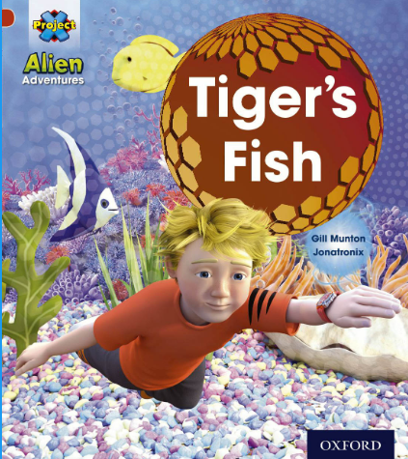

- You can complete the online activity at the end of the book by clicking the pencil icon at the bottom of the ‘Retell the story’ page. I have also included a cut and stick story sequence task as a little challenge this week which is attached below.
Tiger's Fish Follow Up Activity

Health & Wellbeing

- Design a flag or banner to cheer yourself on for your virtual races!

Miss McGhee

