Story Sequencing
Cut out the parts of the story and sequence them in the correct order. Use your book to help you. When you have finished retell the story to someone in your house using your completed task as a prompt.

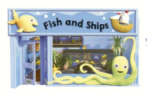  Mum, Tiger and Nok went to the Fish and Ships shop. | 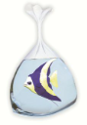  Tiger got a pet Fish. | Nok jumps into the fish tank to swim with the fish.
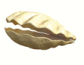  Nok’s leg gets stuck in the shell. | 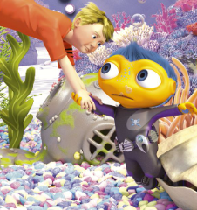  Tiger pulls Nok from the shell.

