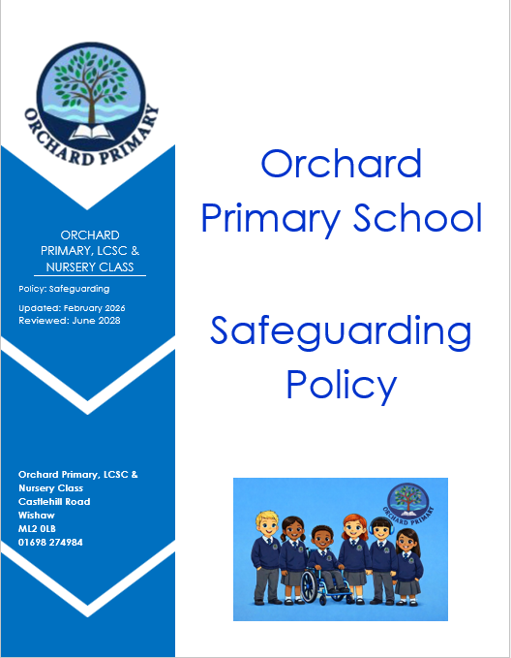

This policy applies to all staff, including volunteers, supply staff, students or anyone working on behalf of North Lanarkshire Council.

Safeguarding children means:
- Protecting children from all forms of violence, neglect, abuse and bad treatment by their parents or anyone else who looks after them (UNCRC Article 19).
- Protecting children from becoming unhealthy (UNCRC Article 24).
- Respecting the rights of children to a standard of living that is good enough to meet their physical, social and mental needs (UNCRC Article 27).
At Orchard Primary School, we respect our children and want to keep them safe and help to protect their rights. We do our best to help children make good educational progress (UNCRC Article 29). We teach children how to recognise risks in different situations and how to protect themselves and stay safe (UNCRC Article 6).

The purpose of this policy is:

- To protect children and young people in our school.

- To provide staff and volunteers with the overarching principles that guides our approach to safeguarding and child protection.

Newmains Primary School believes that a child or young person should never experience abuse of any kind. We have a responsibility to promote the welfare of all children and young people and to keep them safe. We are committed to protect them. All adults working with children have a responsibility to safeguard and promote the welfare of children. This includes a responsibility to be alert to possible abuse and to record and report concerns to the Child Protection Officer within the school.

Framework:

This policy has been written on the basis of law and guidance that seeks to protect the children:
- Un Convention on the Rights of the Child (1989) – ratified by UK in 1991
- North Lanarkshire Child and Adult Protection Policy
- The Children and Young People (Scotland) Act 2014

This policy should be read alongside our school and North Lanarkshire Council’s policies and procedures on:
- Promoting Positive Behaviour
- Child Protection
- Health and Safety
- ICT Acceptable Use
- Physical Restraint
- Equality and Diversity
- School Safety and Security
- Respect for All- Anti-bullying
- Weapons policy

We recognise that the welfare of the child is paramount. All children, regardless of age, disability, gender, racial heritage, religious belief, sexual orientation or identity, have a right to equal protection from all types of harm or abuse. some children are additionally vulnerable because of the impact of previous experiences, their level of dependency, communication needs or other issues. Working in partnership with children, young people, their parents, carers and other agencies is essential in promoting young people’s welfare.
We will seek to keep children and young people safe by:
- Valuing them, listening to and respecting them.
- Having an appointed Child Protection and Named Person (Head Teacher or Principa
- Adopting child protection and safeguarding through procedures and a safeguarding policy for staff and volunteers.
- Implementing the NLC internet safety policy
- Providing effective management for staff and volunteers through supervision, support, training and quality assurance measures
- Ensuring all necessary checks are made when recruiting staff and volunteers (PVG scheme).
- Recording and storing information on pastoral notes.
- Ensuring procedures for safeguarding and promoting good practice is shared children, staff and volunteers during assemblies.
- Using our safeguarding procedures to share concerns and relevant information with agencies who need to know; and involving children, young people, parents/carers and families appropriately.
- Creating and maintaining an anti-bullying environment and ensuring that we have a policy and procedures to help us deal appropriately with any bullying that does arise.
- Ensuring we have complaints and whistle blowing measures in place.
- Ensuring that we provide a safe physical environment for our children, young people, staff and volunteers; by applying health and safety measures in accordance with the law and regulatory guidance.

Safeguarding in the Curriculum
The following areas are addressed in health and wellbeing (in the curriculum and during assemblies):

- Anti-Bullying/cyberbullying awareness
- Drugs, alcohol and substance misuse
- Internet/e-safety
- Fire and water safety
- Sun safety
- Road safety
- Self esteem
- Sexual health and relationships
- Diversity
- Health and wellbeing

Monitoring
All staff have the responsible for implementing this policy. The policy will be reviewed with staff on an annual basis. (See appendix 1 How Good is Our School? 4 – 2.1, Safeguarding and Child Protection).

Child Protection Co-ordinator Mr Scott Smith HT
(*in the absence of the HT please contact another member of SLT Lorna Riquelme, Elaine Dyer or Laura Hume immediately)

