Orchard

Primary School & Language and Communication Support Centre Handbook
2022-2023

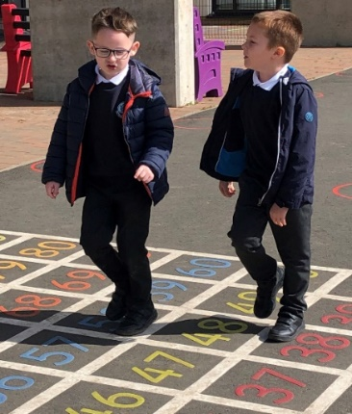
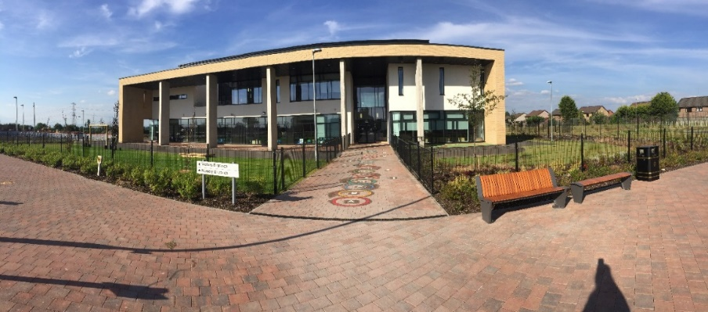

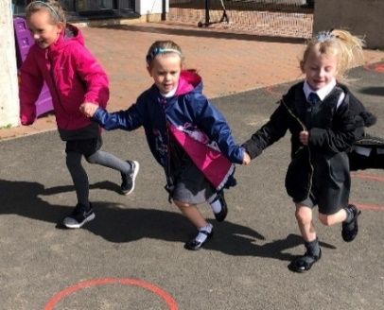

Updated January 2023

Dear Parents*

Welcome to Orchard Primary School. This handbook is written for
all parents of children at Orchard Primary School our Language and Communication Support Centre and for those who are about to start. It contains information about the school itself and the varied aspects of primary education. We hope you will find it useful and informative. We also have an additional handbook for our nursery.

We look forward to welcoming our new pupils and parents to our school community and can assure you that we will all do our best to make sure that you and your child will enjoy being part of our school in the years to come.

Our aim is to work in partnership with you as parents and we actively encourage you to take a positive role in the education of your child. With your support we can work together to make sure your child experiences the best learning possible. It is our aim to ensure that all children in our school achieve excellence and have ambition.

Covid-19 Pandemic
NLC will continue to align supports, from across the service, in response to the Covid-19 pandemic, to support children and families and maintain educational provision. Further information is available directly from the school or from North Lanarkshire Council’s website www.northlan.gov.uk

Enquiries are dealt with speedily and courteously. Should you wish to speak with any member of staff please call into the school office, where every effort will be made to allow you to speak to the appropriate person. Alternatively, telephone 01698 274984 to make an appointment for a mutually suitable time.

Yours sincerely,

Helen Mackenzie (Acting Head)
Head Teacher

* The term ‘parent’ is used throughout to refer to parents, carers, guardians and/or the person(s) who have responsibility for care of the child.

**Any information that is specifically for our Language and Communication Support Centre will be written in blue.**

Contents

1. Introduction
2. Welcome
3. School Information
4. Staff
5. School Administration and Arrangements
6. School holiday arrangements 2023/2024
7. Transfer/ Enrolment Arrangements
8. Equal Opportunities and Social Inclusion
9. Curriculum for Excellence
10. Additional Support Needs
11. Improvement Agenda
12. Homework
13. School Ethos
14. Extra- Curricular Activities
15. Freedom of Information
16. Data Protection Act 1998
17. Child Protection
18. Adult Protection
19. School Discipline Procedures
20. Home and School Links
21. Attendance at School
22. Clothing and Uniform
23. Meals
24. Placing Requests
25 Transport
26. Medical and Health Care
27. Information in Emergencies
28. The Parent Forum & The Parent Council
29. Important Addresses
30. Specialist Terms
31. Qualifying Statement

1. Welcome
Here at Orchard Primary School and Language and Communication Support Centre, our vision is that:

- Orchard Primary School and nursery class will be a place where children thrive and can see even wider possibilities for their own learning now and in the future.
- Orchard Primary will be a safe and fun learning environment for all to thrive in.
- All children will benefit from inclusion which supports development and removes barriers.
- All our partners and learners are treated with respect.
- All will learn and develop in a nurturing environment which promotes and celebrates success and achievement.

In Orchard Primary Language and Communication Support Centre we seek to:
- Enable each child to achieve his/her true potential
- Enable each child to grow in independence while developing self-confidence and self-esteem
- Ensure the acquisition of skills, attitudes and understanding necessary for effective learning
- Provide a secure, calm, happy, sensory environment wherein each child will encounter a variety of learning experiences
- Ensure an ethos of mutual respect where the child is encouraged to show care and consideration for other people in the world in which they live
- Provide a Girfme Plan which will aim to remove barriers to each child’s learning
- Foster a genuine partnership with parents and establish close community links

School Aims
In Orchard Primary we aim to ensure that all children, staff and parents are treated equally, fairly and with dignity and respect.

In each area here are our aims:

- Curriculum: To provide a broad and balanced curriculum that matches the individual needs and experiences of each young person.

- Attainment: To give all pupils the opportunity to realise their full potential by recognising there are lots of ways to learn and we all learn at a different pace.

- Learning and Teaching: To provide the highest quality of learning and teaching experiences, which enable children to become active participants in their learning.

- Support for Pupils: To provide effective and meaningful support for all children, ensuring all feel important, valued and listened to.

- Ethos: To provide a welcoming, safe and nurturing environment where all have clear routines and adults to keep learners feeling safe.

- Resource Management: To enhance learning experiences through the use of stimulating and purposeful resources.

In Orchard Primary we develop the four capacities of a Curriculum for Excellence: - that all children have the opportunity to be

- Successful learners
- Effective contributors

- Responsible citizens
- Confident individuals

The Ten Dimensions of Excellence for this journey are: -

- Promoting equity by ensuring every child has the same opportunity to succeed.

- Focusing on outcomes and maximising success for all learners

- Promoting well-being and respect

- Developing a culture of ambition and achievement

- Developing a common vision among young people, parents and staff

- Fostering high quality leadership at all levels

- Working in partnership with other agencies and the community

- Working together with parents to improve learning

- Reflecting on our work in school and thriving on challenge

- Valuing and empowering staff and young people.

2. School Information
Orchard Primary school and Language and Communication Support Centre is situated on the outskirts of Wishaw, supporting the Overtown and Gowkthrapple areas. We are co-located in the new Clyde Valley Campus and share the building and campus facilities with Clyde Valley High School. We are the first 3-18 campus in North Lanarkshire. Orchard Primary has a nursery class, a Language and Communication Support Centre and Mainstream Primary.

The campus has been designed and built to meet the needs of the curriculum in the 21stcentury and to cater for the needs of every individual child who attends all sectors of the school. The shared campus is providing endless opportunities for staff and children from both schools to work in partnership together.

To ensure the safety of children walking to school, a crossing patrol has been provided on Castlehill Road. Children who live more than a mile from the school, but within the school’s catchment area, are entitled to free bus transport provided by North Lanarkshire Council.

To ensure the safety of children coming to school the first two rows of the car park are clearly labelled as pick up and drop off for LCSC pupils. Pupils are escorted directly to the LCSC playground where they will be met by their teachers at their classroom doors at 8.50am. Likewise at the end of the school day they will be transferred directly from their classrooms to their escorts at 2.50pm. Children who have additional support needs and who are allocated a place in LCSC are entitled to free transport provided by North Lanarkshire Council. Parental expenses will be paid if a parent would rather transport their child themselves.

We foster a sense of community at Orchard Primary, which means we strive to work in partnership with the school, home and community. We are developing all our learner involvement in the campus and in the wider work done by the school.

We have achieved our first Eco Schools Scotland green flag and have been awarded our Gold level Rights Respecting School Status. We are also a digital school.

Orchard Primary School does not provide Gaelic Language Education.

School Name: Orchard Primary School

Address: Clyde Valley Campus
Castlehill Road
Wishaw
ML2 0LB

Telephone Number: 01698 274984-

 | E-mail: |  | enquiries-at-orchard@northlan.org.uk
 | Website: |  | https://blogs.glowscotland.org.uk/nl/orchard
 | Twitter: |  | @PrimaryOrchard
 | Denominational Status: |  | Non-denominational
 | Co-educational Status: |  | The school is co-educational
 | Associated Secondary School: |  | Clyde Valley High School
Clyde Valley Campus
Castlehill Road
 |  |  | Wishaw  ML2 0LB | 01698 274950
Associated Secondary Schools: |  | Pupils in LCSC transfer to a range of High  Schools within the Authority.

Planning Capacity: 214
Parents should note that the working capacity of the school will vary dependent upon the number of pupils at each stage and the way in which the classes are organised. The maximum number of children in P1 is 25, P2 and P3 is 30 and all others 33. The maximum number for any composite class is 25.

Stages Covered: Primary 1 – 7

Present Roll: 171 Mainstream
65 LCSC

Present Class Structure:
Mainstream Primary 1 LCSC L1/2

Primary 2 L1
Primary 3 L2/3a

Primary 4 L2/3b
Primary 5 L3

Primary 6 L4/5/6
Primary 7 L4/5
L5
L5/6/7a
L5/6/7b
L5/6/7c

Composite Classes

Composite classes are made up of children from more than one stage, e.g. P3/4 class will consist of children from both P3 and P4. From time to time it may be necessary to form composite classes as described in the definition above.

The school will consult with the Parent Council and parents annually to agree school policy for the criteria to be used when forming composite classes and it was agreed that ‘working groups’, based on literacy assessment would be the determining factor. When forming a composite P.1/2, we would take into account social observations made at pre-school visits and nursery information.

Community Facilities:
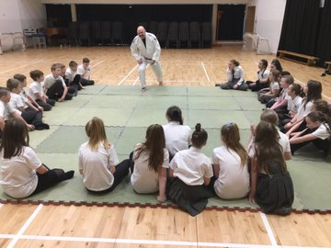
The school is currently used in the evenings for school- based lets, community lets and the pitches will be part of our sports hub so will be used regularly in evenings. All applications for the use of the school should be directed to the Community Education Officer in Community Education, 9 Old Monkland Road, Coatbridge, who will advise on availability and charges. The school will be advised in writing of the proposed lets and will be invited to approve the lets having regard to the direction of the authority in terms of policy and charges

3. Teaching Staff
Total number of Teaching Staff – 8 FTE (Mainstream)

Acting Head Teacher:
Mrs. Helen Mackenzie
(Overall responsibility for the administration, running and management of the school. To lead and manage learning and teaching, to lead and develop people, to lead change and improvement, to build community and to shape policy making)

Acting Depute Head Teacher:
Mrs. Lorna Sneddon
(Day to day management of the Language and Communication Support Centre. Lead the teaching staff in LCSC in the development and review of GIRFME plans and to link with external agencies to coordinate support. To manage the support staff with responsibility in LCSC to ensure effective learner support, Numeracy development from P1-7 and Pastoral care P1-7)

Principal Teachers:
Mrs Elaine Dyer (0.8FTE)
(Remit may vary from year to year. Teaching commitment if required, curricular responsibility for Primary 1-3, Literacy development P1-7, pastoral care P1-7)

Mrs Linzi Bowden (1.0FTE)
(Remit may vary from year to year. Teaching commitment if required, Nursery planning and management, curricular responsibility for Primary 4-7, Probationer Mentor, Assessment and Moderation Pedagogy Practitioner, pastoral care P1-7)

Mainstream Staff

Primary 1 | Miss Ruth Wilson
Primary 2 | Mrs Lorna Hill
Primary 3 | Miss Amber Quammie
Primary 4 | Miss Lorna McDonagh
Primary 5 | Mrs Rosie Nisbet/Mrs Linzi Bowden
Primary 6 | Miss Lauren Craig
Primary 7 | Miss Meghan Karran
NCC | Mrs Laura Hume

LCSC Staff

L1 | Mrs Louise Brownlie
L1/2 | Mr Ross MacLeod
L2/3a | Mrs Erika Kydd
L2/3b | Mrs Emma Garvie
L3 | Mrs Lesley Kent/Mrs Kirsty Harris
L4/5 | Mr David Dornan
L5 | Mrs Beverley Monaghan
L4/5/6 | Mrs Claire Young
L5/6/7 | Mrs Audrey Clemenson
L5/6/7a | Miss Kayleigh Cassells
L5/6/7b | MS Samatha Edwards (temp)

Nursery staff

Lead Practitioner | Mrs Amanda Letarte
Early Learning & Childcare Keyworker | Mrs Elaine Hall
Early Learning & Childcare Keyworker | Miss Lucy Smith
Early Learning & Childcare Support Worker | Mrs Helen McPherson
Early Learning & Childcare Support Worker | Mrs Heather McKendrick

Ancillary Staff

Clerical Staff | Janitor | Classroom Assistants | ASN Assistants
Mrs Lesley Histead  Mrs Natalie Agnew  Mrs Janette Ramage | Mrs Martha Wilson | Mrs Amy Chisholm | Mrs Mary Cullen  Mrs Lynda Ferris  Mrs Sharon Kenmuir  Mrs Kel Stevenson  Mrs Caroline Conroy  Mrs Loraine Rielly  Mrs Margaret McAteer  Mrs Kate Reid  Mrs Gail Jeffrey  Mrs Delane Thomson  Mrs Jaqueline Barclay  Mrs Theresa McDermott  Miss Lesley Jackson

In addition, we have a team of cleaners (including a cleaning supervisor Mrs Amy Clark), catering staff (including a catering manager Mr Danny Muir) and various students and volunteers throughout the school year

4. School Administration and Arrangements

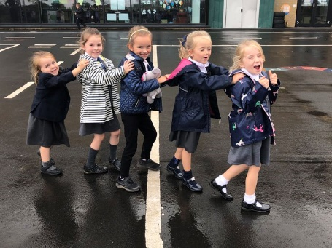
The School Day:

The school opens each day at 8.50am and closes at 2.50pm

Morning interval is at 10.20am until 10.35am

Lunch starts at 11.45am and finishes at 12.30pm

Children who start Primary 1 for the first time in August 2018 attend school whole days from the first day of term. More details will be given nearer starting school.

Breakfast Club:

Opens at 8.00am every day and serves breakfast until 8.20am. There are supervised games, activities and crafts in the hall after breakfast and children are then taken to class in time for the start of the school day.
Most children who come to LCSC are taxied so are unable to access this service. However, if you
would like your child to be included please speak to Mrs Mackenzie.

Nursery timings:

The nursery opens each day at 8.50am and closes at 2.50pm.

Out of School Care:

For further information parents should contact:

Lanarkshire Childcare Services 01698 862584

Children are picked up from the school at 2.50pm then escorted to after care facilities off campus.

5. The School Year

School holiday arrangements 2023/24

August 2023
Teachers return and in-service day: Monday 14 August 2023
In-service day: Tuesday 15 August 2023
Pupils return: Wednesday 16 August 2023

September 2023
September weekend: Friday 22 September to Monday 25 September 2023 (inclusive)

October 2023
October week: Monday 16 to Friday 20 October 2023 (inclusive)

November 2023
In-service day: Monday 13 November 2023

December 2032 - January 2024
Schools close: Friday 22 December 2023 at 2.30pm
Christmas and New Year holidays: Friday 23 December 2022 to Friday 6 January 2023 (inclusive)
Schools return: Monday 8 January 2024

February 2024
Mid-term break: Monday 12 February 2024 and Tuesday 13 February 2024
In-service day: Wednesday 14 February 2024

April 2024
Schools close: Thursday 28 March 2024 at 2.30pm
Spring holiday (Easter): Friday 29 March to Friday 12 April (inclusive)
Good Friday: 29th March 2024
Easter Monday: 1 April 2024
Schools return: Monday 16 April 2024

May 2024
In-service day: Thursday 2 May 2024
May Holiday: Monday 6 May 2024
May weekend: Friday 24 May 2024 to Monday 27 May 2024 (inclusive)

June 2024
Schools close: Wednesday 26 June 2024 at 1pm

6. Transfer/ Enrolment Arrangements

Enrolment:

Children who are starting school for the first time in August 2022 are normally enrolled or registered in January 2022. Advance notice of the actual dates will be placed in the local press and information will be available from local nurseries and playgroups. Notice is also given through school newsletters and our website. It is normally around the third week in January.

Parents wishing to visit the school prior to enrolment should contact the Head Teacher.

Parents who need a place for a child at any other time of the school year should contact the Head Teacher to discuss availability and to make arrangements to visit the school.

All Language and Communication places are allocated centrally. There is an allocation panel, which meets several times a year to decide on individual applications. The panel consists of range of Head Teachers, Depute Head Teachers and Principal Teachers from schools within ASN provision, representatives from divisional offices and representatives from other agencies involved in supporting children e.g. Psychological Services and Speech and Language Therapists.

Placing Requests:
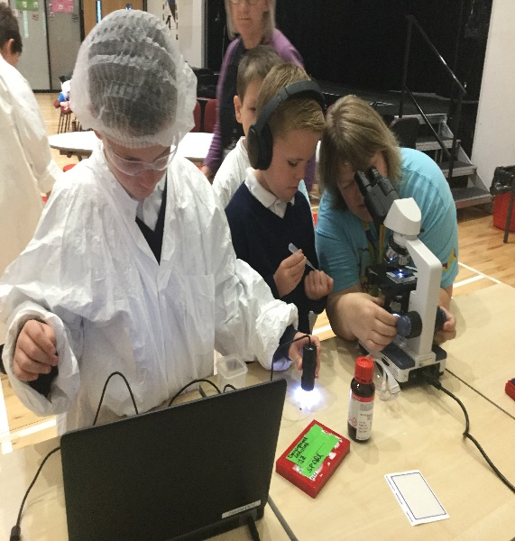
You have the right to make a placing request for your child to be educated in a school other than the local school. In December each year, the authority will advertise its arrangements for placing requests. There are sound educational reasons for trying to ensure that the transfer or admission of children to a school takes place at the start of a school session. Other than those who are moving home, to a new area, parents are advised to time any placing requests so that they take effect from the beginning of the new school session. Every effort will be made to try to meet the parental wishes, but you should note that it is not always possible to grant every placing request to a particular school.

Placing requests to a primary school does not necessarily ensure that your child will have a direct entry into the associated secondary. Advice on this must be sought from the primary school Head Teacher. All placing requests details and procedures are available from the school or the council’s website.

Parents and young people have the right under the Additional Support for Learning Act 2009 to make a placing request for their child or young person to attend nursery (including partnership nursery) within a special school or special class managed by the home authority. In the event of a successful placing request the authority are not required to provide transport. The Act also enables parents and young people to make a placing request to attend a school/establishment belonging to another authority.

Photographs /Video Footage:

On occasion events in school may receive coverage from the local or national press resulting in photographs/video footage of children appearing in newspapers, leaflets and/or school/authority documents. At enrolment parents will be asked for permission to allow their child’s photos to be used.

If circumstances change in any way during your child’s school life with us, parents should write to the Head Teacher to make this known.

Transfer from Primary to Secondary

Pupils normally transfer between the ages of 11 ½ and 12 ½, so that they will have the opportunity to complete at least 4 years of secondary education. Parents will be informed of the arrangements no later than December of the year preceding the date of transfer at the start of the new session.

Pupils from Orchard normally transfer to: -

Clyde Valley High School
Clyde Valley Campus,
Castlehill Road
Wishaw
ML2 0LB

Tel. 01698 274950

We have excellent partnership links with Clyde Valley High school including a varied programme of transition events starting in Primary 6 for all cluster primaries. At Orchard we are in the unique position that we share the campus with Clyde Valley High and this naturally develops our links even further.

We have a very good relationship with Clyde Valley High and its staff and pupils, and with our other partnership primary schools within the Clyde Valley cluster. Links are strong in curricular continuity and transition procedures and these are reviewed annually to ensure the highest quality of service and smooth transition for pupils and parents.

Language and Communication Support Centre Transfer from Primary to Secondary

Pupils normally transfer between the ages of 11 ½ and 12 ½, so that they will have the opportunity to complete at least 4 years of secondary education. The transition process for pupils in LCSC will begin in their P6 year. Pupils from Orchard typically transfer to a range of schools including their local High School, Brannock High(LCSC), Caldervale(LCSC) Glencryan High, Firpark High, Bothwell Park High and Redburn High.
We have excellent partnership links with our associated Secondary schools including a varied programme of transition events starting in Primary 7. Links are strong in curricular continuity and transition procedures and these are reviewed annually to ensure the highest quality of service and smooth transition for pupils and parents.

7. Equal Opportunities and Social Inclusion
Orchard Primary School is committed to eliminating unlawful discrimination and promoting equality of opportunity for and between different groups of people in line with the Equality Act 2010, the Service’s Promoting Equality and Diversity Circular Gen 155-10 and the Council’s Equality and Diversity Policy and Equality Strategy 2019 -2024.
The school is committed to ensuring its policies and practices do not impact adversely on any particular group(s) of people and opportunities to promote equality are actively pursued.
The Equality and Human Rights Commission’s Technical Guidance for Schools in Scotland details the essential requirements of the Equality Act 2010 for schools. This can be accessed at;
https://www.equalityhumanrights.com/en/publication-download/technical-guidance- schools-scotland
The Senior Leadership Team meet termly for Inclusion meetings which are held to ensure there are robust plans to support individuals/groups/classes. These meetings plan for all pupils across both sectors. Pupils then benefit from learning experiences appropriate to their individual needs and pupils are supported with staff and resources. Teaching Staff and the Leadership team discuss in advance of each term whole school activities and identify and remove barriers to LCSC pupil taking part.
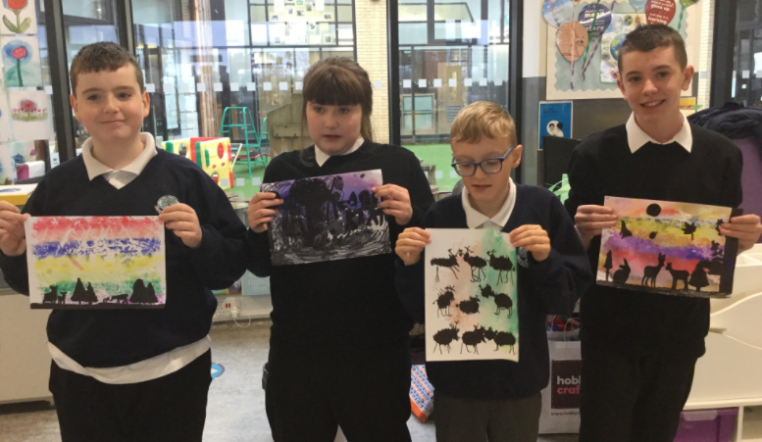

8. Curriculum for Excellence
What is Curriculum for Excellence?

Curriculum for Excellence is Scotland’s national curriculum. It provides a coherent and inclusive curriculum from 3-18 years wherever learning is taking place, including early learning childhood centres, schools, colleges and community learning. It places children and young people at the heart of Scottish Education.

The purpose of Curriculum for Excellence is encapsulated in the four capacities – to enable each child or young person to be

•a successful learner,
•a confident individual,
•a responsible citizen and
•an effective contributor.

These four capacities govern the entire curriculum from age 3 to 18 and aim to raise the standards of achievement for all learners.

Curriculum for Excellence is underpinned by the values inscribed on the mace of the Scottish Parliament – wisdom, justice, compassion and integrity.

Throughout Curriculum for Excellence there is a strong focus on Literacy, Numeracy and Health and Wellbeing across all aspects of learning and every teacher will support learners with the development of these, including digital literacy skills.

Curriculum for Excellence is defined as:
The totality of all that is planned for children and young people throughout their education’.
The opportunities for learning and teaching are governed by the Four Contexts for Learning, which ensure that the education your child receives is informative, interesting, relevant and fun.

These contexts are:
•Ethos and life of the school as a community
•Curriculum areas and subjects
•Interdisciplinary learning
•Opportunities for personal achievement.

What are the Curriculum for Excellence levels?
There are five levels and these are flexible depending on pupils’ needs and abilities (some children and young people may achieve these levels earlier or later dependent on ability):
•Early level pre-school to P1
•First level to the end of P4
•Second level to the end of P7
•Third and fourth levels S1 to S3
•Senior phase S4 to S6 and other forms of study.

N.B. All children in LCSC will be taught according to the appropriate Level for their individual needs.

Curriculum Areas and subjects
The BGE is delivered via 8 curricular areas which, in secondary school cover years S1 to S3, and may be subdivided further into individual subjects.

The 8 curricular areas are:
•Expressive Arts
•Languages and Literacy
•Health and Well Being
•Mathematics and Numeracy
•Religious and Moral Education
•Sciences
•Social Studies
•Technologies.

At Orchard Primary Curriculum for Excellence is at the heart of all that we do. Lessons are planned and implemented using the Curriculum for Excellence Framework and assessed timeously against the Benchmark Levels. Weekly certificates are awarded to children and these are issued against the 4 capacities.

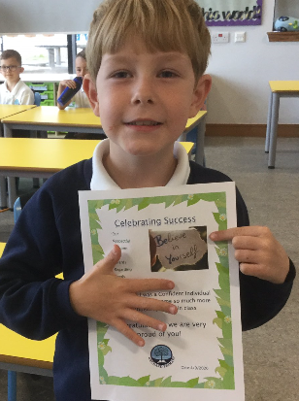
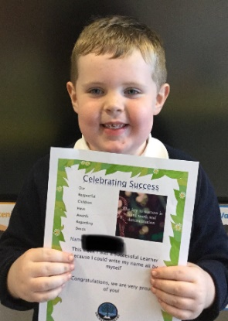

In Orchard pupil groups are established where every child from Primary 2 to Primary 7 is involved in leading an area of school involvement. Our work on Rights Respecting Schools is central to our whole ethos and curriculum. Children are supported and encouraged to develop and discuss their understanding of rights on a regular basis.

We also have a Pupil Voice Improvement Group made up of representatives from P3-7, who also represent younger classes and who take forward the children’s agenda for change with Mrs Mackenzie, Acting Head Teacher.

Our Pupil Groups are currently functioning differently due to Covid-19 restrictions.

Curriculum for Excellence developments in Orchard Primary School are being taken forward through the priorities identified in the School Improvement Plan. (See section 10)

Importantly literacy and numeracy are given added importance because these skills are so vital in everyday life. All teachers will have responsibility to teach Literacy and Numeracy with Health and Wellbeing, as an integral part of every day.

What is the Broad General Education?
The Broad General Education (BGE) is the first phase of two closely connected phases of education. The BGE phase stretches from age 3 until the end of S3 after which learners move into the Senior Phase which starts in S4.
Learning is divided into levels. The levels are as follows :-

Level Stage
Early the pre-school years and P1 or later for some

First to the end of P4, but earlier or later for some
Second to the end of P7, but earlier or later for some

Third and Fourth S1-S3, but earlier for some
Senior Phase S4-6 and college or other means of study

Literacy and Language (including Modern Languages)

In Orchard Primary and Language and Communication Support Centre we follow North Lanarkshire Council’s Active Literacy Approach. This Literacy programme uses a variety of strategies that are designed to incorporate visual, auditory and kinaesthetic (active) learning. ‘Phonics’, the sound of the letters, is taught alongside early reading skills such as using pictorial clues. Work is carried out within the contexts of the class or group reading lessons and throughout many other curricular areas.

From First Level onwards the focus for teaching and learning moves to more complex skills of comprehension with children again using a variety of materials to consolidate and extend their skills. We use a range of novels and commercially produced resources to develop reading and comprehension skills.

Talking and listening and knowledge about language skills are linked to work in reading.

The development of writing and handwriting skills are directly taught as part of North Lanarkshire

Council’s Active Literacy Programme. Children are taught the skills they need in groups and targets are set and worked towards. -Talking and listening skills are developed across all other areas of the curriculum.

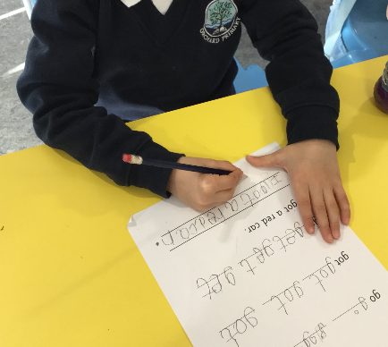
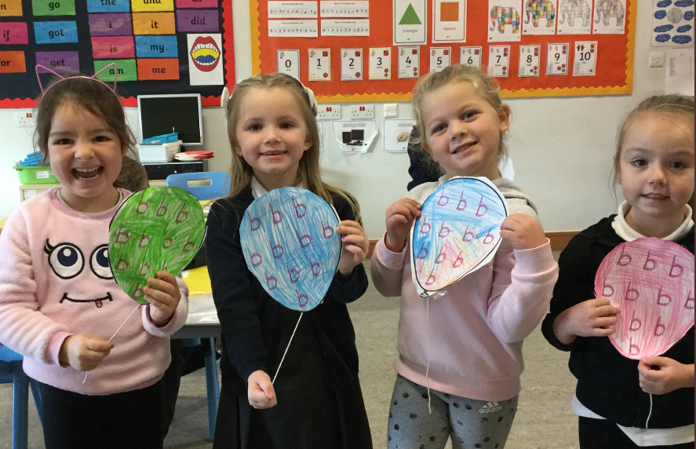

As part of the school’s development of Scottish Governments 1+2 programme for Modern Languages, French is taught in Orchard Primary from P1-7. The development of vocabulary and skills is planned progressively across the stages. This language is continued in Third level of the curriculum at Clyde Valley High School.

Pupils in LCSC will be given opportunities to learn languages if appropriate.

We are continually updating expanding our provision of library books in order to encourage an interest in reading for information and for enjoyment. Every class in the school visits our school library weekly. Children choose a personal interest book. Children are given the opportunity to read these in school and to take home. This increases our children’s opportunities to read.

We use a range of interventions such as Rapid and Rainbow reading to support children who may face barriers to reading. We also use ICT as a support strategy with programmes such as IDL and Clicker 8 to support and develop children’s writing and spelling.

Numeracy and Mathematics

Children learn basic number skills, i.e. addition, subtraction, multiplication and division, as well as developing problem-solving and practical skills and knowledge. Oral and mental maths has a significant role to play in developing mental agility and time is spent on this area of maths in each class on a daily basis. An active approach is employed in the teaching of Numeracy and Mathematics.

To assist our teaching and learning a variety of resources are used including Heinemann Active Maths, TeeJay Maths and Scottish Heinemann. Other materials available in the school include Active Learn and various computer programmes/apps.

In order to offer personal support and challenge we use approaches such as Maths Recovery, Maths Comprehension, Sumdog and Maths 5 Minute Box.

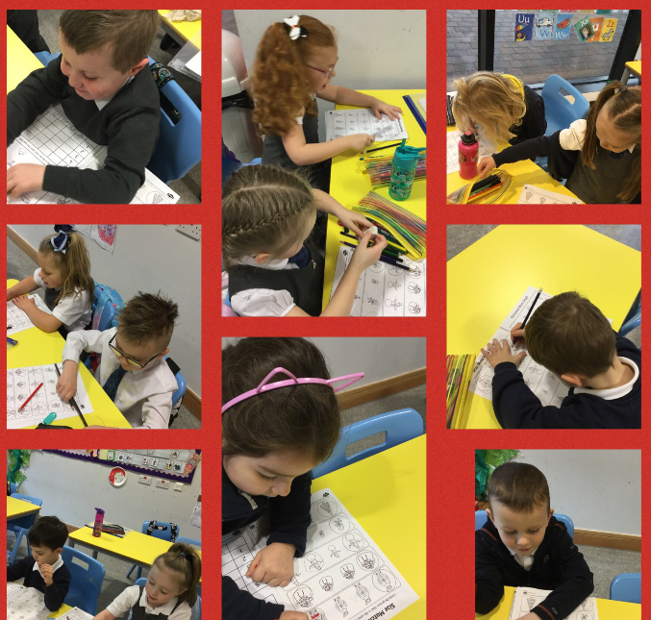

Health and Wellbeing

Learning in Health and Wellbeing ensures that children and young people develop the knowledge and understanding, skills, capabilities and attributes which they need for mental, emotional, social and physical wellbeing now and in the future. Learning through Health and Wellbeing enables children and young people to:
- make informed decisions in order to improve their mental, emotional, social and physical wellbeing

- experience challenge and enjoyment
- experience positive aspects of healthy living and activity for themselves
- apply their mental, emotional, social and physical skills to pursue a healthy lifestyle

- make a successful move to the next stage of education or work

- establish a pattern of health and wellbeing which will be sustained into adult life, and which will help to promote the health and wellbeing of the next generation of Scottish children

It also enables some to perform at high levels in sport or prepare for careers within health and leisure industries.

As part of the Health and Wellbeing programme staff and pupils will also explore subjects such as Personal Safety, Relationship, Sexual Health and Parenthood, Drug and Alcohol Abuse, Road Safety, Bully Proofing, Keeping Healthy, etc. The focus for this is linked to the indicators of wellbeing from GIRFEC. This is delivered by class teachers in the main and when available specialist practitioners. All programmes are delivered in line with NLC guidance. Parents are informed when sensitive issues may be discussed in class and have the opportunity to discuss concerns with then class teacher, Principal teacher or the Head Teacher as appropriate.

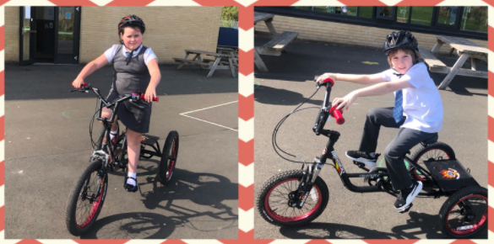
In LCSC the focus of Health and Wellbeing will be on developing Emotional Health and Social Skills. LCSC has, in addition, a sensory programme of work. We also deliver programmes called Relax Kids, Primary Movement and Story Massage. These programmes help reduce stress and anxiety in our children and are delivered in line with NLC guidance. Parents are informed when sensitive issues are All pupils have two hours of P.E. each week in addition to any physical activity that is planned and delivered. This provides them with opportunities to develop physical skills, encourage confidence and co-operation with others and to foster a positive attitude to health and fitness. We aim to engage as many coaches as possible to help deliver a variety of coaching sports such as rugby, street dance, Fun Fitness, hockey, badminton and netball to name a few (Covid regulations permitting). Whilst we share the gym space with Clyde Valley High on a timetabled basis, we also have use of the outdoor all weather pitch on a daily basis. The LCSC also have access to bikes/trikes and scooters.

As part of our health promotion work our pupils receive high quality health education and take part in a range of activities throughout the year including sport taster sessions, visits from our dental hygienist, a variety of after school clubs and opportunities to prepare healthy food. We are also committed to the Daily Mile initiative, with every class aiming to walk a mile a day.

Physical Education

All pupils have two hours of P.E. each week in addition to any physical activity that is planned and delivered. This provides them with opportunities to develop physical skills, encourage confidence and co-operation with others and to foster a positive attitude to health and fitness. We aim to engage as many coaches as possible to help deliver a variety of coaching sports such as rugby, street dance, Fun Fitness, hockey, badminton and netball to name a few. Whilst we share the Gym Space with Clyde Valley High on a timetabled basis-we will also have shared use of the outdoor all-weather pitch facilities. All classes have 1hr of indoor PE and 1hr of outdoor PE weekly.

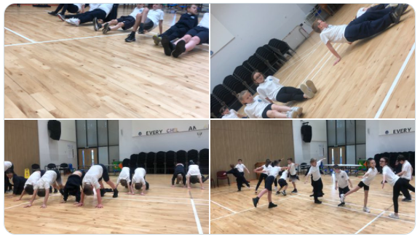

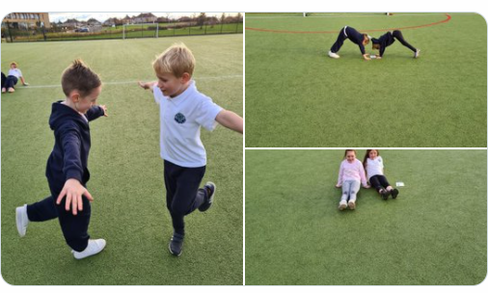

Social Studies
In Social Studies children learn about the world around them (locally and globally) and develop the understanding, skills and attitudes necessary to interpret it. Children are encouraged to make informed decisions about their own behaviour. Positive and caring attitudes are fostered using problem solving, decision making and practical action.

These areas may be studied through interdisciplinary work. When an interdisciplinary theme is planned any areas that are not part of the study are then taught as a subject discreetly.

Children are encouraged to learn in a variety of ways; through explanation, enquiry, activity and discussion. They also learn in a variety of settings within and beyond the classroom. Social Studies also provides a context for and brings relevance to learning across the curriculum. Children are taught how to develop enquiry skills in researching, recording, planning and evaluating.

Our programmes of study are devised to ensure balance and progression throughout the school and to ensure an appropriate balance of knowledge and understanding and enquiry skills.

Educational visits are arranged, where appropriate to support learning and teaching in Social Studies. Likewise members of the community and visiting specialists add practical and personal contributions to our many programmes of study.

Sciences
Through learning in the Sciences, children and young people develop their interest in, and understanding of, the living, material and physical world. They engage in a wide range of collaborative investigative tasks, which allows them to develop important skills to become creative, inventive and enterprising adults in a world where the skills and knowledge of the sciences are needed across all sectors of the economy.

The experiences and outcomes in science provide opportunities for children and young people to develop and practise a range of inquiry and investigative skills, scientific analytical thinking skills, and develop attitudes and attributes of a scientifically literate citizen; they also support the development of a range of skills for life and skills for work, including literacy, Numeracy and skills in information and communication.

Technologies
The Technologies curriculum area relates particularly to contexts that provide scope for developing technological skills, knowledge, understanding and attributes through creative, practical and work- related activities. In the wider world these skills can be applied in business, computing science, food, textiles, craft, design, engineering, graphics and applied technologies. Children and young people will develop their creativity and entrepreneurial skills and be encouraged to become innovative and critical designers of the future.

ICT to Enhance Learning
Orchard Primary School has a fully balanced programme of I.C.T. implemented throughout the school which includes use of the Internet and the Scottish Intranet site Glow. Children can access Glow both in school and at home, it gives access to the children’s e-portfolios and class blogs and the Office 365 tools.

At Orchard Primary School we are committed to promoting quality in learning and teaching for all through the effective use of I.C.T. across the curriculum. Children have access to ICT in class which personalises, supports and challenges their individual learning. Through development of skills we teach digital literacy and children’s understanding of online tools and safety.

As well as providing our young people with the skills they will need in later life, we provide all members of staff opportunities for personal development in ICT in order to enrich and enhance the learning process. To develop broad skills, we make use of a broad range of ICT hardware; pc laptops, iPads, digital cameras, mac books and VR headsets.

The school website is an integral part of our learning. Home Learning can be accessed there as well as displays of the children’s work and whole school events. School events are also on Twitter.

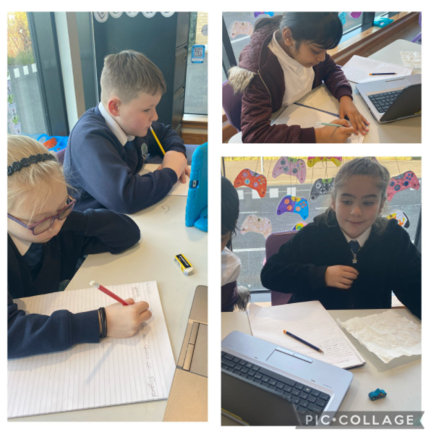

Expressive Arts
Art and Design
Through Art and Design, children are encouraged to express themselves visually and to appreciate and enjoy their own and the work of other artists. Their imaginations are stimulated through various mediums, e.g. music, poetry, the work of famous artists, etc. All children are encouraged to develop their creative talents through participating in activities, which include the use of different materials, e.g. paint, and collage work, plasticine and clay.

Drama

Children from their earliest years use imaginative play to explore, order and make sense of themselves and the world about them. Drama extends and builds on this natural process and helps to build confidence and self-esteem. To help develop a range of dramatic techniques and skills, children have the opportunity to role play, improvise, and use movement and mime, use sound to express their own and others’ ideas. The opportunity to develop these skills often arises through other curricular areas and in Orchard these may often be linked to topic and language work.

Music

Our aim in music is to foster a lasting interest in and enjoyment of musical skills. In Orchard, all children have the chance to realise their full potential, whatever their musical talents and abilities. All classes began using ABC music in session 2016-17 to develop and progress musical skills and abilities. Activities to encourage this may include listening and responding to music, making and inventing their own music by using instruments which are available in the school, and singing modern and traditional songs. P.5 pupils receive voice instruction from a specialist tutor trained in Kodaly techniques.

Dance

Through dance, learners have rich opportunities to be creative and to experience inspiration and enjoyment. Creating and performing will be the core activities for all learners and taking part in dance contributes to their physical education and physical activity. Learners develop their technical skills and the quality of their movement and use their imagination and skills to create and choreograph dance sequences. They further develop their knowledge and understanding and their capacity to enjoy dance through evaluating performances and commenting on their work of others.

How will my child’s learning be assessed?
There will be several ways of assessing each child’s progress to make sure that potential is achieved.
In playrooms and classrooms staff will use improved ways of assessing children’s learning taking into account national and local advice and guidance. Your child’s progress will be reported to you so that you know how well your child is doing.

Each year your school/nursery will let you know what is being done to implement Curriculum for Excellence so that you can be confident that your child is receiving a high-quality education.

In Orchard Primary School assessment is an integral part of teaching and learning, and pupils are continuously assessed in an informal way as part of the daily class routine Children are continuously assessed in order to monitor progress and identify barriers to learning. The class teacher carries out this assessment through observation, discussion, on-going class work etc.

At other times, standardised assessments may be used to help teachers assess pupil progress and to identify any strengths and diagnose any barriers to learning.

Today we don’t compare children against each other but rather treat each as an individual who is always gaining new achievements and attainments for themselves. Their own personal best is what we are aiming for.

We assess to find out:

- Strengths
- Areas of challenge

- If our teaching is effective
- To give out accurate information to all about progress

- To track progress to make sure each pupil is progressing at the right pace.
- To ensure excellence through equity

Lesson success criteria is communicated to pupils and they are involved in the assessment of their own work through indicating whether or not they have met this criteria. Next steps are then identified by the pupil and teacher. Pupils are also involved in self and peer assessment.

The Senior Phase
The senior phase curriculum, from S4 to S6, follows a young person's broad general education, building firmly on the experiences and outcomes they will have experienced and achieved by the end of S3. It enables them to extend and deepen their learning and continue to develop skills for learning, life and work, through qualifications and also through a range of opportunities for personal development such as awards and wider achievements. It is designed to support young people in moving on to positive sustained destinations, whether that is college, university, training or employment. In the Senior Phase, schools and their partners (such as colleges, employers or community learning and development providers) now have flexibility to offer a range of pathways that meet the needs and raise the attainment levels of all learners – including pupils who might previously have become disengaged from education.

Schools are taking a range of approaches to the senior phase and are able to offer greater personalisation and choice for young people in a variety of ways, for example by:
•designing the senior phase as a three-year experience rather than planning each year separately
•delivering qualifications over different timescales in response to young people's needs and prior
achievements
•developing pathways for able learners, which bypass qualifications at lower levels to allow more time
to be spent on more challenging learning at higher levels
•providing specific and appropriate programmes that maximise achievement and attainment for young
people planning to leave after S4.

Across North Lanarkshire improvements to date have been:
- National 4 and 5 qualifications were introduced in 2013/2014
- Access, Highers and Advanced Highers are being updated to reflect Curriculum for Excellence
- New Highers in most subjects were introduced in almost all North Lanarkshire schools in August 2014

Personal Support/Career Planning
From 3-18 years, learners are supported to achieve their full potential and, as they progress through broad general education into senior phase, to plan and prepare for further learning, training or employment. All schools and nurseries in North Lanarkshire are working hard to raise standards so that children and young people will develop all of the skills necessary to continue to be successful when leaving school and entering the world of higher education, training or work. As part of developing skills for learning, life and work, young people will be offered careers information advice and guidance to ensure they leave school and enter a positive post-school destination of higher education, further education, pre-employment training, employment (including modern apprenticeships), activity agreement or volunteering.

Assessment and Reporting
Assessment is an important part of the Curriculum for Excellence and, at all levels, pupils’ progress is closely monitored by teachers and staff.
In turn, teachers and staff work with pupils to reflect on their results, looking at their strengths and learning needs, agreeing next steps and action based on these. As they progress, pupils become more involved in this process, as they develop the skills to make effective judgments on their own learning, developing personal expertise that will be important to them throughout life. Assessment also helps teachers plan learning experiences which are motivating and challenging. Children who may have additional support needs will be assessed using methods best suited to their individual requirements.

Parents are involved in their child’s learning through attending Stay and Learn afternoons, workshops focussing on curricular areas and new initiatives. Parents are given their say through, ‘We asked, you said…’questionnaires.
Parents of children who will be involved in the sensitive Parenthood, Relationships and Sexual Health lessons will be informed of these of these lessons in advance by letter. A formal written report is sent out to parents once a year. This will indicate pupil’s progress in all areas of the curriculum. Verbal reports are given twice a year. We follow an online appointment system for our consultation meetings; however, if the allocation of time is insufficient to discuss your child’s progress, arrangements can be made for another interview at a later date.

9. Additional Support Needs
Orchard Primary and Nursery Class complies with the Additional Support for Learning (Scotland) Act 2004 as amended by the Additional Support for Learning (Scotland) Act 2009 and the Additional Support for Learning: Statutory Guidance 2017.

North Lanarkshire’s policy is contained within “Support for Learning Policy into Practice 2”, a copy of which is available in the school. The school has a Support for Learning policy, available from the school on request which is consistent with North Lanarkshire Council guidelines.

In Orchard Primary and Language and Communication Support Centre we ensure that all children are provided with a curricular experience which is appropriate to their age, stage and development. This may be achieved through class, group and individual teaching approaches enabling children to reach their full potential. However, some children may, at times in their school life, experience a learning difficulty or a barrier in accessing the curriculum fully. Through ongoing formal and informal assessment class teachers will identify where a pupil requires additional support. At this point strategies and possibly targets in the form of a GIRFME Plan are developed, in consultation with pupils and parents. These plans are formally reviewed on a termly basis with annual reviews with parents.

Class teachers are responsible for meeting the needs of all the children in their class. Additional support may be provided by staff with additional responsibility for supporting learning and/or the senior Leadership Team. This support may include additional teaching in smaller groups or 1:1, advice to the class teacher, provision of appropriate materials and practical help within the classroom.

The school follows North Lanarkshire Council’s Support for Learning Policy through the implementation of a staged intervention process, where universal, additional and intensive support can be applied in line with robust planning and review.

Orchard Primary is able to cater for a wide range of additional support needs in the mainstream and specific needs within the Language and Communication Support Centre. The school works closely with Psychological Services and regular meetings are held with the school Educational Psychologist to discuss progress and support for pupils. Other services include N.H.S. Lanarkshire, Hearing and Visual Impairment, Bilingual Services, Speech and Language Therapy, Occupational Therapy and Social Services (including Transport and Housing).

Where a child has English as an additional language they will be supported within school and, where appropriate, by North Lanarkshire’s Bilingual Services.

Care experienced children i.e. children who are cared for directly or whose care is supervised by the local authority are deemed to have Additional Support Needs, unless assessment determines otherwise. We have procedures in place which ensure that all care experienced children are closely monitored and supported. Within Orchard the Head teacher takes overall responsibility for individual care experienced, monitoring their educational progress and overall wellbeing.

Parents and young people can request an assessment to establish whether a child or young person has additional support needs or requires a Co-ordinated Support Plan. This request should be formally made in writing to the Head teacher although the Head teacher welcomes parents with concerns to discuss these concerns with her in the first instance.

Parent and pupils are an essential part of the assessment, planning and review process and your views will be actively sought. Parents and young people can request of the authority to establish whether a child has additional support needs. They can also request an assessment at any time.

Planning

GIRFMe plans enable staff to plan effectively for children and young people when interventions are required to support their learning and improve outcomes. Parents/carers and pupils are an essential part of the assessment; planning and review processes and their views will be actively sought.

Some children and young people may require significant support from education and at least one other agency, such as health, social work and/or voluntary agency to help them meet their learning targets. Where this support requires a high level or co-ordination the opening of a Co-ordinated Support Plan (CSP) may be considered. A CSP may be initiated by the school or another agency.

Parents/carers and young people can, if they wish, request that a CSP be considered and would be involved in the process.

Parents/carers will receive letters from the Education Authority throughout the CSP process.

Parents/carers and young people will be invited to take part in multiagency meetings and their views will be recorded in the plan.

Where more intensive support for a child or young person needs to be planned for, usually when a number of agencies are involved in supporting their wellbeing then a Child’s Plan may be developed. The plan will tell you what actions need to be taken and who will help with each action. It will usually be someone called a ‘Lead Professional’ who will have the job of making sure that the actions outlined in the plan take place and things get better for the child or young person.

Dispute Resolution

North Lanarkshire Council is committed to resolving any differences of views through discussion, dialogue and building on common ground.

If the matter cannot be resolved with the Education Authority you have the right to request mediation. An independent mediation service is available to parents/carers and young people through Resolve (see contact details at the back of this handbook). Mediation is free through Resolve and independent of the Education Authority.

In the event that a disagreement cannot be resolved through mediation, then an application for Independent Adjudication (see contact details at the back of this handbook) can be made by parents/carers free of charge. The Independent Adjudicator will make recommendations to the Education Authority about how the dispute should be resolved.

The Additional Support Needs Tribunal has been set up to hear appeals made by parents/carers or young people on the decisions made by the Education Authority relating to Co- ordinated Support Plans, placing requests and post school transition. If you disagree with any decision relating to your child’s Co-ordinated Support Plan, either the creation of a CSP, or the content of it, you may be entitled to refer to the Tribunal.

10. Improvement Agenda
School Improvement

All schools in Scotland are required to devise an improvement plan as a means of managing change and planning for major development initiatives. Following audit, including consultation with parents, pupils, staff and the wider school community, and taking into consideration national and authority targets, priorities are then identified.

We are committed to improvement in the following areas: School Leadership, Teacher Professionalism, Parental Engagement, and Assessment of children’s progress and School Improvement.

Priorities are decided on an annual basis through a series of self-evaluation and monitoring.

Copies of the School Improvement Plan and School Improvement Report are available on request at the school office. We issue a summary to parents on an annual basis. Our School Improvement Pupil Group are involved in writing a learner version of the improvement plan.

New priorities for session 2023-24 will be set in May 2023 to take forward from August 2023. These will be set against the success of the 2022/23 priorities and will relate to where the school is in its three year cycle of improvement.

Cluster  Priority | To provide increased equity for all learners by ensuring wellbeing needs are met and by closing the attainment gap in Numeracy and Mathematics.
Priority 1 | To provide all pupils with a nurturing environment within the school. Whole school and individual supports will ensure we are GIRFEC
Priority 2 | To improve Literacy attainment throughout the school and increase parental engagement and pupil voice
Nursery Priority | To develop family learning opportunities within the Nursery to promote parental engagement and parental involvement in order to improve literacy skills. To develop work with stakeholders within the community to support children to become responsible citizens.

HMIE
Orchard Primary was opened in August 2016 and was inspected by H.M.I.E. in April 2018. The inspection team found the following strengths in the work of the School, Nursery and Language and Communication Support Centre.

- The Head Teacher is providing strong strategic leadership. She actively seeks the views of children, parents, staff and partners in bringing about school improvement.

- Children are friendly, polite, confident and well-behaved. They are proud of their school, supportive of each other and keen to learn.

- Staff work well as a team to create a nurturing and caring ethos across the school community. This impacts positively on children’s wellbeing and improving equity for all.

- Partners make a very effective contribution to school improvement. They engage well with the school to support staff, children and families.

The following areas for improvement were identified and discussed with the Head Teacher and a representative from North Lanarkshire Council.

- Continue to build consistency in high quality learning and teaching. Staff should provide more opportunities for children to lead their own learning whilst ensuring appropriate pace and challenge.

- Continue to ensure the effective use and understanding of assessment, and monitoring and tracking of children’s progress across all curriculum areas. Staff should continue to raise their expectations and aspirations to improve further children’s attainment and achievement.

H.M.I.E. evaluated Orchard Primary under the following categories:
Leadership of change - very good
Learning, teaching and assessment - good
Raising attainment and achievement - good
Ensuring wellbeing, equality and inclusion - very good

Descriptions of the evaluations are available from How Good is our school? (4th edition), Appendix 3: The six-point scale. A more detailed document called Summarised Inspection Findings will be available on the Education Scotland website at https://education.gov.scot/inspection-reports/northlanarkshire/1003488.

11. Homework
Homework is issued termly and children are provided with a jotter. It can be handed in/submitted online for feedback from class teachers. Any homework tasks that are issued should not require specific resources which would not readily be available at home. We welcome parental involvement in Homework and comments are encouraged via the Home-School Diaries.

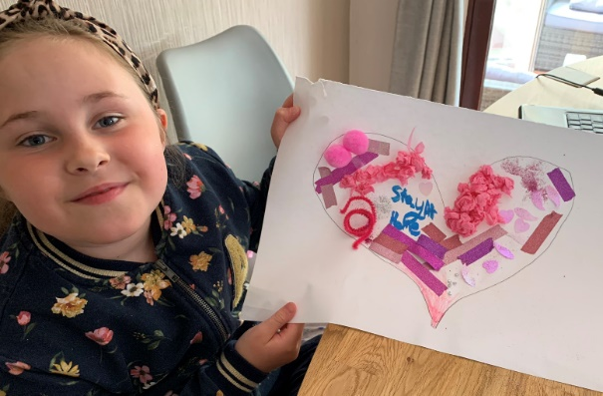

Parents who wish additional activities to support or challenge learning at home should arrange to meet with the Depute Head Teacher to discuss this further. The school also encourages use of ICT programmes such as Active Learn, IDL and Sumdog to enhance home learning.

12. School Ethos
All Behaviour is Communication

Orchard Primary has an inclusive ethos to behaviour and learning. We seek to include all in the life of the school and its community. All staff in the school strive to work with all partners to ensure that children and families are welcomed into the school and included in the learning environment. Staff are supported by the school’s leadership team to view behaviours as communication and where appropriate use a range of personal strategies to support further engagement with the learning environment. Communication and the views of all stakeholders are central to the school’s ethos and development.

School Improving Pupils Group

Our Pupil Voice Group/ Pupil Council was established in August 2017 with representatives from P3-7 who also represent the younger classes. The group meets with the Acting Head Teacher; Mrs Helen Mackenzie regularly. This forum offers pupils the chance to raise issues of concern and for the whole pupil population to have a voice in the running and improvement of the school.

Other Pupil Committees

Our pupils are involved in many aspects of school life and their ideas and opinions are often sought. We run a variety of committees (listed below) which promote citizenship and give pupils from Primary 2-7 responsibilities in a range of areas. The children lead these under the supervision of a nominated staff member. These are mixed stage groups. Primary 1 are also involved in groups with play-based approach to the issues being developed in groups.

School Community Links

The school fosters close links with the community. The school has regular visitors from the local Community Police, Fire Service and Health Service Staff. Members of the community are often invited to the school to support work in Social Studies and programmes are further enhanced through visits through visits to community facilities e.g. Wishaw Library. The school actively seeks opportunities to participate in community events. We also participate in partnership activities with Garrion People’s Housing Co-operative. We link in with Clyde Valley High School as often as we can to promote links within and across our learning campus.

Out of School Experiences
We aim to enrich the children’s learning experiences through a variety of additional experiences out with the school building. We make very good use of local facilities and all they have to offer, as well as other places of interest in the local and surrounding areas. We also encourage and request support of external agencies who can come into school to deliver curriculum based workshops.

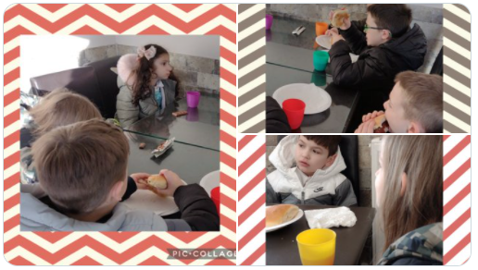

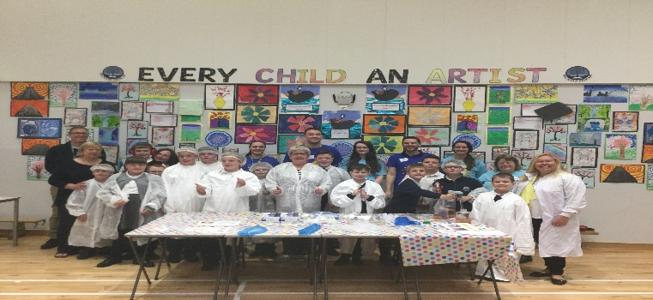

13. Spiritual, Social, Moral and Cultural Values
Religious Education makes a distinctive contribution to the curriculum in helping pupils towards a consistent set of beliefs, attitudes and practices within our own community and beyond. Religious and Moral Education is taught in Orchard Primary with these broad aims in mind and reflects council and national policies as set out by the Education (Scotland) Act 1980.

We have a structured programme, which is taught by class teachers and includes input from the school chaplain. Included in our R.E. programme is the study of Christianity and other world religions. We place particular focus on other world religions of Islam and Buddhism. This encourages harmony, appreciation and consideration for the beliefs of others. While studying R.E., classes may make visits to local churches and other sacred buildings.

It is recognised that the Education (Scotland) Act 1980 allows parents to withdraw their children from any religious instruction and observance, and parents wishing to do so should contact the Head Teacher, in writing, to allow any arrangements to be made.

Parents from ethnic minority religious communities may request that their children be permitted to be absent from school in order to celebrate recognised religious events. Only written requests will be considered. Appropriate requests will be granted on not more than three occasions in any one school session and the pupil noted as an authorised absentee in the register.

Through our curriculum children are given opportunities to become responsible citizens who have respect for others and a commitment to participate responsibly in political, economic, social and cultural life within their community. They are able to develop knowledge and understanding of the world and

Scotland’s place in it, understand different beliefs and cultures and make informed choices and decisions.

14. Extra Curricular Activities
After School Clubs are provided by staff and by trained coaches. We annually review the clubs we offer after school and during lunchtimes to ensure we are meeting the needs and interests of children and families. Where possible we also offer family learning opportunities in activities and ICT.

Orchard Primary are proud of the After School activities which are, at present, available to the children. These include, at various times of the year, and may vary from year to year:

Badminton Netball
Tennis Sportshall
Gymnastics Dance
Jewellery Making Basketball
ICT

15. Freedom of Information
Freedom of Information (Scotland) Act 2002 came into force in 2005. The Act allows anyone to ask for information held by the Council and imposes a time-scale of 20 working days for the Council to respond. To deal with Freedom of Information requests, the Council has appointed a Corporate Freedom of Information Officer with the support of an officer in each Service. The Freedom of Information and Records Management Officer can be contacted by telephone on 01698 302484.

16. General Data Protection Regulations (GDPR) Statement
What is this statement?
This statement explains when and why we collect personal information about you, your child or young person and how this information is used, the conditions under which it may be disclosed to others and how it is kept secure.

Who are we?
North Lanarkshire Council is a Local Authority established under the Local Government etc. (Scotland) Act 1994. Education, and Families is located in Civic Centre, Motherwell ML1 1AB

Why do we need your personal information and that of your child or young person?
The Council has a legal obligation to deliver an effective education service to all children and young people in North Lanarkshire. In order to do this we need to collect personal information about children, young people and their families so that we can help them to learn and keep them safe.

Legal basis for using your information
We provide this service as part of our statutory function as your Local Authority. Processing your personal information is necessary for the performance of a task carried out in the public interest by the Council. If the information we have asked for is not provided, then we will not be able to provide this service to your child or young person.

Your personal information
Education uses the national IT system, SEEMiS, to store personal information electronically. We ask parents/carers during registration and enrolment to provide us with their child’s name, date of birth, gender, address, family contact details (phone/email). We will also ask you to update this information annually. We may also ask you for information about medical conditions, additional support needs, religion, and ethnicity. We may also record information you might wish to provide about your family circumstances. We require this information to ensure children and young people are educated appropriately, supported, and that we take account of their health and wellbeing. During a child’s journey through education a pupil’s record is kept, this core record is mainly paper based and is stored securely in the child or young person’s establishment. If the establishment has requested assistance from educational staff out with the nursery or school, key staff from these services may also store information securely about your child or young person.

How will we use this information?
Your personal information will be used:
- to enrol your child or young person in nursery or school
- to provide your child or young person with an appropriate education
- for teaching, assessment and planning purposes and to monitor educational progress of children and young people
- to support pupil learning, improve outcomes and identify where additional support is needed to help children and young people
- to provide appropriate pastoral care to support health and wellbeing of children and young people
- to keep children and young people safe
- to maintain records e.g. of attendance, absence, attainment and behaviour of children and young people (including exclusions)
- to support children and young people during transitions when moving on each year from nursery to primary, primary to secondary and when they move or leave school
- to enable schools and establishments to process personal data in support of SQA and Further Education
- to monitor and report on pupil attainment and achievement in relation to the national improvement framework issued by the Scottish Government
- to assure the quality of our education services in line with national expectations from Education Scotland
- when we require to contact you by post, email, telephone or text.

Who do we share information with?
To support your child or young person’s access to appropriate education and meet our legal obligations, personal information may be shared internally between Services of the Council. From time to time, education staff may also need to share information about you, your child or young person with another person from another agency or service, e.g. Social Work, Health.

We also share information with Scottish Government and bodies such as Education Scotland, Scottish Qualifications Authority, Skills Development Scotland and other organisations that support children and young people’s learning.

When a child or young person moves or transfers to another school the Council has an obligation to pass on information with regards to pupil records to the new school.

Only identified staff and those who require to have the information to enable them to carry out their job, will have access to you, your child or young person’s information. We care about the information we hold in respect to the education of children and young people. We will keep this information safe and secure.

How long do we keep your information for?
We only keep personal information for the minimum period of time necessary. Sometimes this is set out in law, but in most cases it is based on what we need to fulfil our function. We maintain a ‘records retention and disposal schedule’ which sets out how long we hold different types of information for. You can view this on our website at

http://www.northlanarkshire.gov.uk/index.aspx?articleid=15003

Your rights under GDPR
You can:
- Request access to your information – you have the right to request a copy of the personal information that we hold about you, your child or young person. You can ask us to confirm what personal information is being used and with whom it has been shared with.
- Request a correction to your information – we want to make sure that all personal information is accurate, complete and up to date. Therefore you may ask us to correct any personal information that you believe does not meet these standards.
- Request the restriction of processing – this enables you to ask us to suspend the processing of personal information about you, your child or young person, for example if you want us to establish its accuracy or clarify the reason for processing it.
- Request the transfer – you can request the transfer of your information to another party.
- Deletion of your information – you have the right to ask us to delete personal information about you, your child or young person where:
- you think that we no longer need to hold the information for the purposes for which it was originally obtained
- you have a genuine objection to our use of personal information
- or, use of personal information is contrary to law or our legal obligations.
If you wish to update any personal information, retrieve it, or have it removed from records please contact your child or young person’s head teacher or head of establishment in the first instance.

The Council’s Data Protection Officer
If you have any questions or are unhappy about the way that we use the personal information of your child, young person or yourself you can contact the Data Protection Officer.
Data Protection Officer (DPO)
Civic Centre,
Windmillhill Street,
Motherwell ML1 1AB
or by email to AITeam@northlan.gov.uk

The Information Commissioner
You also have the right to complain to the Information Commissioner about the way the Council has handled your rights, to enquire about any exercise of these rights or to complain about the way the Council has dealt with your rights (or any other aspect of data protection law).
Information Commissioner's Office,
45 Melville Street,
Edinburgh, EH3 7HL
or by e-mail to
casework@ico.org.uk

Transferring Educational Data about Pupils
Education authorities and the Scottish Government
Education Portfolio (SGEP) exchange data about pupils either on paper or electronically through the ScotXed programme.

The data collected and transferred covers areas such as date of birth, postcode, registration for free-school meals, whether a pupil is looked after by his/her local authority, additional support needs including disability, attendance, absence and exclusions from school. Pupil names and addresses are collected by the school and the council but they are not passed to SGEP. The postcode is the only part of the address that is transferred. Data is held securely and no information on individual pupils can be published by SGEP

Providing national identity and ethnic background data is entirely voluntary. You can choose the ‘not disclosed’ option if you do not want to provide this data. However, we hope that the explanations contained in this message and on our website will help you understand the importance of providing the data.

Why do we need your data?
In order to make the best decisions about how to improve our education service, SGEP and education authorities need accurate, up-to-date data about our pupils. We are keen to help all our pupils do well in all aspects of school life and achieve better educational outcomes. Accurate and up-to-date data allows SGEP, education authorities and schools to:
- plan and deliver better policies for the benefit of all pupils,
- plan and deliver better policies for the benefit of specific groups of pupils,
- better understand some of the factors that influence pupil attainment and achievement,
- target resources better.

Your GDPR rights
The collection, transfer, processing and sharing of ScotXed data is done in accordance with the GDPR. We also comply with the National Statistics Code of Practice requirements and other legislation related to safeguarding the confidentiality of data. GDPR gives you the right to know how we will use your data. This message can give only a brief description of how we use data. Fuller details of the uses of pupil data can be found on the ScotXed website (www.scotxed.net).

SGEP works with a range of partners including Education Scotland and the Scottish Qualifications Authority. On occasion, we will make individual data available to partners and also academic institutions to carry out research and statistical analysis. In addition, we will provide our partners with information they need in order to fulfil their official responsibilities. Any sharing of data will be done under the strict control and prior agreement of the Data Access Panel in SGEP, which will ensure that no subject specific data will be made public as a result of the data sharing and that such data will not be used to take any actions in respect of an individual.

Further details are available on:
https://www2.gov.scot/Topics/Statistics/ScotXed/PrivacyInformation

Any Concerns
If you have any concerns about the ScotXed data collections you can email school.stats@scotland.gsi.gov.uk or write to:
The ScotXed Support Office, SEGP, Area 1B, Victoria Quay, Leith, EH6 6QQ.

Alternative versions of the ScotXed data exchanges and privacy information are available, on request from the ScotXed Support Office, in other languages, audio tape, braille and large print.

Want more information?
Further details about ScotXed data exchanges are also available on the ScotXed website, http://www.scotxed.net.

17. Child Protection
Every adult in Scotland has a role in ensuring all our children and young people are safe and protected from harm at all times and in all situations.

The Head Teacher is responsible for the school’s actions in response to Child Protection concerns.

If there are any Child Protection concerns the Head Teacher or the Child Protection Co-ordinator will follow North Lanarkshire Child Protection Procedures and Guidelines.

Child Protection Co-ordinator is: Mrs. Helen Mackenzie
Telephone Number: 01698 274984

18. Adult Protection
The Council has responsibility under the Adult Support and Protection (Scotland) Act 2007 for the protection and support of adults at risk of harm within North Lanarkshire. Its employees therefore have the responsibility to ensure the welfare of all adults at risk of harm with whom they come into contact, as well as providing the highest possible standard of care for some of the most vulnerable members of our society.

The Head Teacher is responsible for the school’s actions in response to Adult Protection concerns.

If there are any Adult Protection concerns the Head Teacher or the Adult Protection Co-ordinator will follow North Lanarkshire Adult Protection Procedures and Guidelines.

The Adult Protection Co-ordinator is Mrs Helen Mackenzie

Telephone number: 01698 274984

19. School Discipline Procedures
Anti-bullying
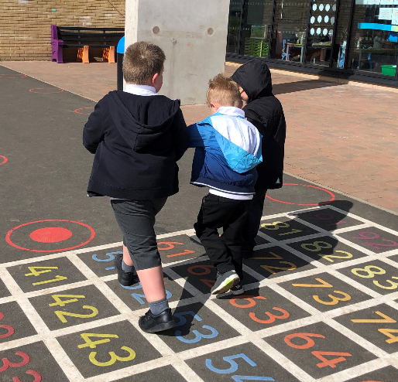

Orchard Primary School is committed to the belief that every child has the right to grow up free from bullying. We want children to live, learn, socialise and work in an inclusive environment, where differences between people are valued, people support each other, treat each other with respect and understanding.

All those who play a daily role in the lives of our learners should be enabled to prevent bullying and respond effectively to incidents of bullying behaviour when they occur.

The school recognises that the impact of bullying behaviours will differ for each child. It is often the signs of bullying behaviour and the impact on the child that will give rise to concern, intervention and support.

In many instances this behaviour will be seen at home before in school, therefore parents/carers should contact the school as soon as possible. These concerns will be treated in a confidential and sensitive manner.

Bullying incidents are very rare in the school and we believe that is due to our proactive approach. Parents, children and the school will be kept informed and the children supported to accept appropriate behavior. If you would like further information on our anti-bullying measures at Orchard Primary, please do not hesitate to contact the Head teacher.

Promoting Positive Behaviour/ Celebrating Achievement

The relationship between pupils and teacher is similar to that between a child and their parents and is built on trust and mutual consideration, understanding and tolerance on both sides. The ethos of Orchard promotes positive behaviour and relationships, rather than punishment for misbehaviour. However, pupils and parents should realise that rules and structures are necessary to ensure the safety and well-being of all.

Parents are partners in supporting children’s behaviour and their understanding of what this looks like in school. We work hard for all to be involved in supporting the children and resolving issues.
Where the challenges with behaviour continue parents would be invited to the school to discuss the situation and agree the support or approach required to support the child.

Our children are very successful in the wider school community in a range of sporting and recreation activities out with School. We encourage the children to celebrate their own and others’ achievements through assemblies, class discussion and circle time. We record and celebrate achievements so that all children feel part of that wider celebration and the whole school community.

Supervision at Non-class times

During non-class times (including times when weather is inclement) children are supervised in their classrooms by additional support needs assistants, janitors and when possible members of the Leadership Team.

All ASNAs are in the playground at break times in terms of the Schools (Safety and Supervision of Pupils) (Scotland) Regulations 1990. The Principal Teachers, Depute Head Teacher and the Head Teacher also provide a presence in the playground areas when possible.

During inclement weather the school doors will open at 8.40 a.m. and children may go to class. However, due to staffing availability before 8.50am, there is limited supervision during this time, and parents are requested to arrange children’s arrival as close to the bell as possible. This provision is at the discretion of the Head Teacher.

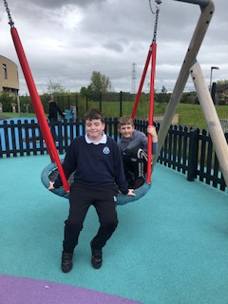
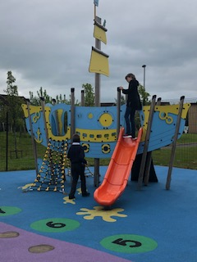

20. Home and School Links
In Orchard Primary we take pride in the level of parental involvement throughout the school and are constantly looking for ways in which many parents can become involved in school life. We have helpers who, from time to time, help out with a range of events and activities throughout the school year e.g. supporting learning experiences in class, assisting on educational visits, and special events. Any parents/carers wishing to become helpers, should contact the Head Teacher or one of the Principal Teachers.

Regular newsletters are sent home to inform parents of coming events, to report on activities that have taken place and to celebrate the achievements of our pupils. Newsletters and updated school information is on our website https://blogs.glowscotland.org.uk/nl/orchard and on Twitter @PrimaryOrchard.

Open days are organised to allow parents to see round our school and to meet with staff in an informal setting. Pupil achievements are displayed around the school and in the local press. Curricular workshops are organised for parents as well as both formal and informal parent/teacher sessions.

During the year there are two parents evenings where parents have the opportunity to meet with their child’s teacher and children are also issued with a written report once a year.

If parents have any worries or concerns they can phone the school to speak to a member of the management team or email the Head Teacher directly at enquiries-at-orchard@northlan.org.uk

Orchard Primary has an active Parent Council who raise funds and organise events across the school year. The Parent Council have previously provided funding for trips, resources and equipment.

We also have the LCSC Parent Support Group who meet once a month to provide support for parents with children with ASD.
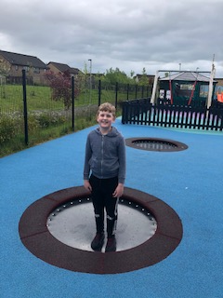
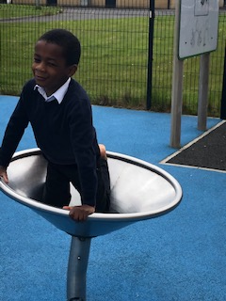

21. Attendance at School
Section 30 of the 1980 Education Act places a duty on every parent of a child of ‘school age’ to ensure that their child attends school regularly. Attendance must be recorded twice a day, morning and afternoon.

Regulation 7 of the Education (School and Placing Information) (Scotland) Amendment, Etc. Regulations

1993 requires each child’s absence from school to be recorded in the school register as authorised or unauthorised: As defined by the Scottish Government.

At the start of each school session parents will be asked to provide contact details including at least one emergency contact number and one mobile number (for the text messaging service). Parents are required to inform the school if these contact details change during the course of the year.

Parents and carers are asked to inform the school if a pupil is unable to attend from the start of the school day on the morning of the first day of absence. Where a child has not registered and the school has not been informed of the absence the school will try to contact the main carer, and any other contacts that we hold on file. In terms of child safety, police will be contacted if all attempts to locate the child have been exhausted.

Parents should inform the school by letter or telephone if their child is likely to be absent for some time, and to give the child a note on his or her return to school confirming the reason for absence.

Every effort should be made to avoid family holidays during term time as this both disrupts the child’s education and reduces learning time. Parents should inform the school by letter of the dates before going on holiday.
These absences are recorded as unauthorised.

A family holiday judged to be important to the wellbeing and cohesion of the family, following serious or terminal illness, bereavement or other traumatic events would be considered an authorised absence where there has been prior agreement with the Head Teacher.

A family holiday classified under the ‘authorised absence’ category will not include such reasons as:

- The availability of cheap holidays

- The availability of desired accommodation

- Poor weather experience during school holidays

- Holidays which overlap the beginning or end of term

- Parental difficulty obtaining leave (except in cases where evidence is provided by the employer that it cannot accommodate leave during school holidays without serious consequences)

Family holidays with the above similar characteristics will be classified as unauthorised absence. Where the Head Teacher’s prior agreement has not been sought the absence will automatically be classed as unauthorised.

Where most family holidays will be recorded as unauthorised absence (see above) extended leave with parental consent will not be considered the same as a family holiday. Leave in such circumstances will be authorised under circumstances such as:
- Extended overseas educational trips not organised by the school

- Short-term parental placement abroad

- Family returning to its country of origin (to care for a relative, or for cultural reasons)

- Leave in relation to the children of travelling families

Parents may request permission for such leave in writing and the school may authorise such requests under the following circumstances:

- The period immediately after an accident or illness
- A period of serious or critical illness of a close relative

- A domestic crisis which causes serious disruption to the family home, causing temporary relocation.

Parents may request permission for a child to be absent from school to make an extended visit to relatives. For a request to be granted and the absence recorded as authorised it must be in writing and detail the destination and duration of the absence, and the provision to be made for the education of the child during the period of absence.

If there is no explanation from the parents, the absence will be recorded as unauthorised.

It should be emphasised that the school investigates unexplained absences and low attendance, and that the Authority has the power to write to, interview, or prosecute parents, or to refer pupils to the Reporter of the Children’s Panel, if necessary.

In Orchard we put a great deal of emphasis on attendance at school. The school rewards excellence in attendance in various ways, monitors closely the attendance of all pupils and informs parents (by letter) when concerns emerge. We monitor attendance monthly and will follow NLC guidance in improving attendance at school where necessary. If attendance rate is below 90% and there is no reasonable reason known to the school, we will contact parents to ask for explanation and to ensure improvement in attendance. If no improvement is made referral will be made to Reporter to the Children’s Panel. In some cases Social Work department will be contacted in line with Child Protection Guidelines.

22. Clothing and Uniform
All North Lanarkshire schools must have a dress code, which encourages children to dress in a way which is appropriate to attendance at school. This dress code must not lead to direct or indirect discrimination on the grounds of race, religion, gender or disability. Prior to drawing up the dress code the parents, pupils and staff were fully consulted. It is the expectation of the education skills and youth employment services that parents will be keen to support the dress code and written agreement may be sought.

If there are any sensory issues around your child not being able to wear certain clothing, please contact the school and we will seek a solution. All North Lanarkshire schools must have a dress code, which encourages children to dress in a way which is appropriate to attendance at school.

Clothing which is unacceptable in school under any circumstances includes items which:

- could potentially encourage factions (e.g. football colours);

- could cause offence (e.g. anti-religious symbolism or political slogans);

- could cause health and safety difficulties such as loose-fitting clothing, dangling earrings, and other potentially dangerous jewellery;

- are of flammable materials which may be a danger in certain classes (e.g. shell suits);
- could cause damage to flooring
- carry advertising in particular for alcohol or tobacco, and

- could be used to inflict damage on other pupils or to be used by others to do so.

Orchard’s uniform consists of a navy sweatshirt/cardigan, white polo shirt or white school shirt and school tie, charcoal grey trousers/skirt/pinafore. Navy school blazers are optional. All items of clothing are available to purchase from Be Schoolwear located on Main Street Wishaw or Miyo Apparel online or 10 Clamp Road, Wishaw/77 Manse Road, Motherwell. We prefer the children to wear black shoes rather than trainers to school. Parents are asked to ensure that their child(ren) do not wear valuable jewellery or clothing to school. All children should have a pair of soft shoes, which are kept in school for indoor wear and to wear for PE

Parents/carers in receipt of a clothing grant from the Council will be encouraged to purchase items which are in accordance with the school dress code. Approval of any requests for such grants in other circumstances are at the discretion of the Executive Director of Education and Families. Information and application forms may be obtained from any school or First Stop Shop. Parents/carers are entitled to receive a clothing grant if they are in receipt of any of the following benefits: Income Support, Job Seekers Allowance (income based). Employment & Support Allowance (income related), Universal Credit (with an income below £625 per month), housing benefit, council tax reduction.

Whilst in general terms it would not normally be the policy of the authority to exclude a pupil from school solely on the basis of his/her dress, persistent refusal to respond to a reasonable dress code may be deemed to be a serious challenge to the Head Teacher’s authority and be detrimental to the wellbeing of the whole school community. In such circumstances a Head Teacher could justify the use of the school discipline procedure.

The council wishes to minimise claims arising from the loss of pupils’ clothing and/or personal belongings. Parents are asked to assist in this area by ensuring that valuable items and unnecessarily expensive items of clothing, jewellery etc. are not brought to school. Parents should note that any claims submitted to cover the loss of such items is likely to be met only where the authority can be shown to have been negligent.

**Please make sure that all articles brought to school are clearly marked with your child’s name.**

23. Meals
Our school operates a breakfast service which starts at 8.00am each morning. Children have the choice of cereal, toast and milk or fruit juice. There is a tuck shop at Interval where children can purchase toast, drinks and snack items. For lunch, the kitchen provides a choice of snack and main meals, and either a starter or dessert. All foods are freshly prepared on the premises each day and the menu varies from day to day. Primary 1-3 children are entitled to a free school meal. For information, a vegetarian option is available on a daily basis.

We operate a cash cafeteria system where children pay for meals daily using a cashless system. The children preload their cards with money then use this at break and lunch times to pay for their meals. Children who choose to bring a packed lunch to school also eat their lunch in the dining hall. The children all eat lunch in the dining hall and choose where to sit- there are no separate areas for school meals or packed lunches. The children sit in their friendship groups. The Head teacher, Depute Head Teacher and Principal Teachers supervise the lunch arrangements. Our support staff are also in the social area at lunch to offer additional support to children at the point of service and when eating meals.

All Primary 1-5 children are entitled to a free meal and free milk. Pupils in P6 and P7 who qualify for a free school meal are entitled to free school milk. Milk is available for purchase in school during the lunch period. A vegetarian meal option is offered on a daily basis.

Information and application forms for free school meals can be downloaded from the council website www.northlan.gov.uk and are available in first stop shops.

We operate a pre order system in the Dinner hall where the children receive a coloured band relating to their order. Children sometimes forget or lose their money. No child will ever not be able to get a meal due to shortage or lack of appropriate payment. A child who has not paid will be issued with a slip to let you know what the cost of the meal was so it can be paid the next day.

Availability of special diets

Diets required as a result of a medical condition (a medically prescribed diet e.g. coeliac disease, diabetes, food allergy or intolerance) can be provided in school. A medically prescribed diet form must be completed by the child’s Registered Dietician or General Practitioner. Procedures and forms can be assessed from North Lanarkshire‘s website www.northlan.gov.uk or dietician, or from North Lanarkshire’s catering service. Occasionally, parents may be asked to supply prescription foods or attend a meeting to discuss the child’s dietary requirements. Some children with additional support needs may require food to be adapted to an appropriate texture and consistency. In this instance the child’s Registered Dietician or Speech and Language Therapist will liaise with the Head Teacher and school catering service to ensure appropriate food provision. Special diets required for ethical, religious or cultural reasons should be requested in writing to the Head Teacher, who will liaise with the school catering service.

We seek to support our children with dietary issues in LCSC. In the first instance please discuss with Mrs Mackenzie/Mrs Sneddon any worries or concerns you have regarding lunches/snacks and we will do our best to help. Some children with additional support needs may require food to be adapted to an appropriate texture and consistency. In this instance the child’s Registered Dietician or Speech and Language Therapist will liaise with the Head Teacher and school catering service to ensure appropriate food provision. Special diets required for ethical, religious or cultural reasons should be requested in writing to the Head Teacher, who will liaise with the school catering service. It is important that the Head Teacher is aware of any medically prescribed diets within the school and on occasion may be asked to attend a meeting. Forms that have not been signed by a medical professional will be rejected. The form will be returned to the parent along with a letter stating the reason for the refusal and also they will be issued with a new form. Any change in the child’s dietary requirements must be advised through a Registered Dietitian or Medical Practitioner to the Facilities Support Services (FSS) Nutritionist. When children move to a High School or change schools FSS will need to be informed as soon as possible.

Other
Parents/carers are entitled to receive a clothing grant if they are in receipt of any of the following benefits: Income Support, Job Seekers Allowance (income based). Employment & Support Allowance (income related), Universal Credit (income below £625 per month), housing benefit and council tax rebate. Information and application forms for clothing grants may be obtained from schools, first stop shops and Council offices, Kildonan Street, Coatbridge. Application forms can also be downloaded from the council website www.northlan.gov.uk and are available in first stop shops.

From August 2021, all eligible two year olds and all children aged from 3 to those not yet attending
primary school, that attend a North Lanarkshire Council Nursery or a Funded Provider (childminder voluntary/private nursery), will be entitled to 1140 hours Early Learning and Childcare provision. Those children attending for four hours per day, or more, will receive a free meal as part of the Early Learning and Childcare entitlement.

24. Placing Requests
You have the right to make a placing request for your child to be educated in a school other than the local school.

In December each year, the authority will advertise its arrangements for placing requests.

There are sound educational reasons for trying to ensure that the transfer or admission of children to a school takes place at the start of a school session. Other than those who are moving home to a new area, parents/carers are advised to time any placing requests so that they take effect from the beginning of the new school session.

Every effort will be made to try to meet the parental wishes, but you should note that it is not always possible to grant every placing request to a particular school.

Placing requests to Primary School does not necessarily ensure that your child will have a direct entry to the associated secondary. Advice on this must be sought from the Primary School Head Teacher.

Further information on placing requests and procedures is available from the school or the council’s website.

Parents/carers and Young People have a right under the Additional Support for Learning Act 2009 to make a placing request for their child or young person to attend a nursery (including partnership nursery), special school or special class managed by the home authority. In the event of a successful placing request the authority are not required to provide transport. The Act also enables parents/carers and young people to make a placing request to attend a school/establishment belonging to another authority.

25. Transport
General

The Council has a policy of providing free transport to primary pupils who live more than one mile from their catchment school by the shortest suitable walking route. This policy is more generous than the law requires. This provision may be reviewed at any time.

Parents/carers who consider they are eligible should obtain an application form from the school or from Education and Families. These forms should be completed and returned before the end of February for those pupils beginning school in August to enable the appropriate arrangements to be made.

Applications may be submitted at any time throughout the year but may be subject to delay whilst arrangements are made.

There is discretion in certain circumstances to grant privilege transport for pupils to travel in transport provided by the authority, where spare places are available and no additional costs are incurred.

Pick-up points
Where free transport is provided it may be necessary for pupils to walk a certain distance to the vehicle pick-up point.

Walking distance in total, including the distance from home to the pick-up point and from the drop-off point to the school in any one direction, will not exceed the authority’s limits (see above paragraph).
It is the parent’s/carers responsibility to ensure their child arrives at the pick-up point in time. It is also the parent’s/carers responsibility to ensure the child behaves in a safe and acceptable manner while boarding, travelling in and alighting from the vehicle. Misbehaviour could result in a loss of the right to free transport.

Placing Requests
The council does not provide transport for those pupils in receipt of a placing request other than in exceptional circumstances.
In the case of early entry requests if a child is offered a place in the catchment area school, transport will be provided in accordance with the Council’s policy as stated above.

26. Medical and Health Care
Children are examined medically during their school life, normally in the first year of primary schooling and then at 10 – 11 years and 13 – 14 years, by staff of Lanarkshire Health Board. Parents are notified in advance and will be informed if any issues arise from the medical. Occasionally the school nurse may visit to examine whole classes for general fitness and hygiene. Dental inspections are carried out on a routine basis in primary schools and parents are offered any necessary treatment for their children although they may choose instead to attend the family dentist. Children who are thought to have sight, speech or hearing problems may be referred to the appropriate service by the Head Teacher, where any necessary tests may be carried out by qualified staff – naturally, parents are informed before any referral. Parents should always inform the school of any medical problems, which may affect their child’s schooling or if their child needs regular medical treatment.

On occasions it may be necessary for a child to be taken home due to ill health, etc. In all cases the school makes every effort to contact a parent in the first instance. Parents/Carers should inform the school of any particular medical requirements. If a parent is not available the school will make contact with the child’s emergency contact for the necessary arrangements to be made. It is essential, therefore, for the school to have an emergency contact that can be reached by telephone should any child have to be taken home unexpectedly. Under no circumstances will a child be sent home/allowed to leave the school unaccompanied.

If a young person is unable to attend a suitable educational establishment as a result of prolonged ill-health, North Lanarkshire Council must make special arrangements for the pupil to receive education elsewhere, other than that at an educational establishment.

In North Lanarkshire children and young people are treated in the paediatric in-patient unit within Wishaw General Hospital. It is not common for children and young people to have extended stays in Wishaw General and therefore North Lanarkshire Council does not require a dedicated hospital education service.

Children and young people resident in North Lanarkshire and in hospital in Glasgow, may access education through the Hospital Education Service (HES). The Service is provided by Glasgow City Education Department and Social Work Services. For further information please contact the school.

27. Information in Emergencies
We make every effort to maintain a full educational service, but on some occasions, circumstances arise which lead to disruption. For example, schools may be affected by severe weather, temporary interruption of transport, power failures or difficulties of fuel supply. In such cases we shall do all we can to let you know about the details of closure or re-opening. We shall keep you informed by using letters, notices in local shops and community centres, announcements in local churches and announcements in the press on local radio, on the NLC website and twitter.

28. The Parent Forum
As a parent of a child at this school you are automatically a member of the Parent Forum. The Parent Forum is composed of all the parents and carers of children at the school.

As a member of the Parent Forum you can expect to:

- get information about what your child is learning
- get information about events and activities at the school

- get advice/help on how you can support your child’s learning
- be told about opportunities to be involved in the school
- have a say in selecting a Parent Council to work on behalf of all parents at the school

- be invited to identify issues for the Parent Council to work on with the school.

The Parent Council
Parent Councils came into force from 1st August 2007. The Head Teacher is the professional adviser to the Parent Council. A Parent Council has been established within Orchard. All correspondence should be addressed to the school office.

The Parent Council’s rights and duties include:
- supporting the work of the school;
- representing the views of parents;

- consulting with parents and reporting back to the Parent Forum on matters of interest;

- promoting contact between the school, parents, pupils, providers of nursery education and the wider community;
- fundraising;

- taking part in the selection of senior promoted staff;

- receiving reports from the Head Teacher and education authority; and

- receiving an annual budget for administration, training and other expenses.

Members of Parent Councils, on a voluntary basis, may also have an advisory role in decisions on placing requests by parents in respect of those situations where the number of placing requests for a particular school or for a particular stage in a particular school exceeds the number of places available.

The current Parent Council office bearers are:
Chairperson Ms Jillian Ford
Vice-Chair Mrs Sharon Grant
Treasurer Mrs Christine Durie

The Head Teacher has a right and duty to attend all meetings of the Parent Council. Meetings of the Parent Council are open to members of the public.

The Parent Council hold their A.G.M. annually. All parents are invited to attend. Officer bearers will be reselected on an annual basis at the A.G.M. The parental membership of the Parent Council, will be a minimum of three parents of children attending the school. The maximum number of parents is twenty. Newsletters to inform parents of coming events and the success of past events are sent home with pupils. Meetings are held monthly in the school.

Any parents of a child at the school can volunteer to be a member of the Parent Council, the preferred make up being at least one parental representative from each year group. In the event that the number of volunteers exceeds the number of places set out in the constitution, members will be selected by formal election. Anyone not selected to be a member of the Parent Council may be offered the opportunity to be part of any sub groups set up by the council.

The Parent Council works hard organising fund raising and social events for both children and parents. They will donate funds to the school allowing us to purchase resources/materials and provide experiences. To encourage their invaluable work and contributions to the quality of school life, we urge all parents/carers and pupils to actively support the events organised. Newsletters to inform parents of coming events and the success of past events are sent home with pupils.

Parent Support Group
Orchard Primary has a very active Support group for parents and families of children with ASD in LCSC and Mainstream. Please consider coming along to their meetings of which we will give you advance notice. They are an invaluable support. Meetings are very informal, usually coffee and a chat.

29. Important Addresses
Education, Skills & Youth Employment
Civic Centre
Windmillhill Street Education and Families Manager – Jaqueline Burton
MOTHERWELL
ML1 1AB

Chief Executive
Civic Centre
Windmillhill Street Chief Executive – Mr Des Murray
Motherwell
ML1 1AB

Senior Education Officer
Judy Pollock

Councillors for the School
Councillor Jim Hume Councillor Sam Love
Councillor Frank McKay Councillor Rosa Zambonini

Contact via: Member Services
Civic Centre
Windmill Hill Street
MOTHERWELL
ML1 1AB Tel. - 01698 302697

Area Community Learning and Development
Wishaw/Shotts CLD Locality Office
Calderhead High School
Dyfrig Street
Shotts
ML7 4DH Tel: 01698 274343
E: CLD-Wishaw@northlan.gov.uk

Contacts in relation to Support for Learning
CILL – Carol Anne McGinty
McGintyCar@northlan.gov.uk

You can also get more help and advice from:

Enquire
The Scottish advice service for additional support for learning operated by Children in Scotland, Enquire offers independent confidential advice and information on additional support for learning. Enquire also provide a range of factsheets,
Tel No: 0345 123 2303
Enquire
Children in Scotland
Rosebery House
9 Haymarket Terrace
Edinburgh
EH12 5EZ

Email: info@enquire.org.uk
Website: www.enquire.org.uk for parents/carers and practitioners
Website: www.enquire.org.uk for children and young people

Children in Scotland - Resolve Mediation
0131 313 8844
Email: resolve@childreninscotland.org.uk

Independent Adjudication
Scottish Government
Directorate for Learning
Support and Wellbeing Unit
Area 2C North
Victoria Quay
Edinburgh
EH6 6QQ

Reference to Additional Support Needs Tribunal (Scotland)
ASNTS
Health and Educational Chamber
First Tier Tribunal for Scotland
Glasgow Tribunals Centre
20 York Street
Glasgow
G2 8GT
0141 302 5860
www.asntscotland.gov.uk

NHS Lanarkshire Social Work
Wishaw Health Centre Wishaw/Shotts
Tel. – 01698 355511 Tel 01698 348200

30. Specialist Terms
Curriculum The range of subjects taught in every class and school, e.g. Numeracy, Literacy, Social Studies, etc.

Curriculum Continuity This term relates to the need for schools to make sure that the courses children follow show progression and do not overlap unnecessarily.

Emergency Contact The person(s) nominated by a child’s parents/guardians to be the first to be contacted if a parent/guardian is not available.

Ethos This term related to the specific characteristics of the school; the spirit or principles of the school.

Out of School Hours Subjects which are not taught in the formal curriculum, e.g. Learning after school clubs.

Group Teaching Children are normally taught and work in groups with other children – for Literacy and Numeracy these groups are normally ability groups where children of a similar ability progress at a similar rate; for most other curricular areas children are taught in mixed ability and social groups.

Transition This term usually relates to the movement of children from nursery to primary, or primary to secondary.

31. Qualifying Statements
Although this information is accurate at time of printing, there could be changes affecting any of the matters dealt within the document
a) before the commencement or during the course of the school year in question.
b) in relation to subsequent school years.

Education Authorities are required by law to issue a copy of the school handbook to certain parents/carers in December each year.
It details the current policies and practices of both the council and the school.

We look forward to working in partnership with you and your children as you become part of the Orchard Learning Community.

Orchard Primary School Clyde Valley Campus, Castlehill Road Wishaw. ML2 0LB

Acting Head Teacher: Mrs Helen Mackenzie
01698 274984

Safe | Responsible | Included | Achieve | Healthy
Nurture | Active |  | Respect

