ORCHARD PRIMARY
NURSERY CLASS HANDBOOK

2023/24

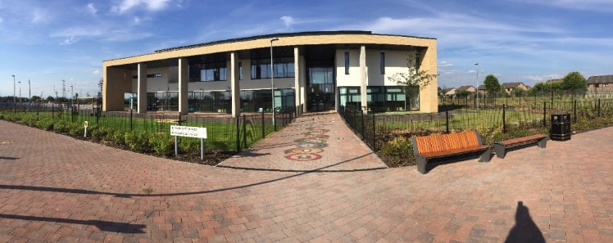

Introduction

Dear Parent/Guardian

Welcome to Orchard Nursery Class. This handbook is written for all parents of children at or about to enrol as a pupil at Orchard Nursery. It contains information about the school itself and the varied aspects of the nursery curriculum. We hope you will find it useful and informative.

We look forward to welcoming our new children and parents and can assure you that we will do our best to make sure that you and your children will enjoy being part of our nursery.

Our aim is to work in partnership with parents and we actively encourage you to take a positive role in the education of your child. With your support, we can work together, to make sure your child experiences the best learning possible.

You are free to visit the nursery at any time and we aim to make sure that any enquiries are dealt with speedily and courteously. Should you wish to speak to any member of staff please call at the school office, where every effort will be made to allow you to speak to the appropriate staff member. Alternatively you could telephone 01698 274984 to make an appointment for a mutually suitable time.

Covid-19 Pandemic:
NLC will continue to align supports, from across the service, in response to the Covid-19 pandemic, to support children and families and maintain educational provision. Further information is available directly from the school or from North Lanarkshire Council’s website www.northlan.gov.uk

Yours sincerely

Helen Mackenzie

Helen Mackenzie
Acting Head Teacher

Dear Parent/Guardian

I am delighted to be working with Orchard Nursery class this year. It’s a wonderful environment for our young people to flourish and learn. I would like to extend a warm welcome to all our parents. Our staff strive to provide a caring, nurturing learning environment and endeavour to Get it Right For Every Child. We promote learning through play in a wide range of opportunities and experiences both indoors and outdoors and encourage our children to explore, experiment, work together and most importantly have fun. I am very much looking forward to working in partnership with you whilst I am in post as Principal Teacher of the Nursery.

Linzi Bowden
Principal Teacher
* The term ‘parent’ is used throughout to refer to parents, carers, guardians and/or the person(s) who have responsibility for care of the child.

Introduction

Following consultation with our children, staff and parents our Vision was decided as:

To provide a nurturing, inspirational and challenging learning environment in the present. Allowing learners to understand opportunities, develop creativity and overcome barriers to achieve all goals in the future

The four values we chose to represent our school, its ethos and learning are:

- Partnership
- Ambition
- Inclusion
- Respect

School Aims

- In Orchard Primary we aim to ensure that all children, staff and parents are treated equally, fairly and with dignity and respect. Through our ethos, partnership, learning and teaching we aim to:

- Recognise that all behaviour is communication and that all stakeholders have the right to be heard.
- Ensure a safe and engaging learning environment where the rights of all are understood and respected.
- Provide learners with opportunities to personalise their learning and to develop their school and their community.
- Ensure all children benefit from a range of learning experiences and opportunities, including digital technologies, which develop their skills for learning, life and work.
- Promote achievement, recognise and celebrate the success of all both within their learning and in their wider life
- Work with families and partners to ensure inclusion is embedded in everyday experiences, which supports development, challenges learning and skills and overcomes barriers

In Orchard Primary we develop the four capacities of a Curriculum for Excellence: - that all children have the opportunity to be
- Successful learners
- Effective contributors
- Responsible citizens
- Confident individuals

The Ten Dimensions of Excellence for this journey are: -

- Promoting equity by ensuring every child has the same opportunity to succeed.

- Focusing on outcomes and maximising success for all learners

- Promoting well-being and respect

- Developing a culture of ambition and achievement

- Developing a common vision among young people, parents and staff

- Fostering high quality leadership at all levels

- Working in partnership with other agencies and the community

- Working together with parents to improve learning

- Reflecting on our work in school and thriving on challenge

- Valuing and empowering staff and young people.

Nursery Information

Orchard Nursery is situated on the outskirts of Wishaw, supporting the Overtown and Gowkthrapple areas. We are co-located in the new Clyde Valley Campus and share the building and campus facilities with Clyde Valley High School. We were the first 3-18 campus in North Lanarkshire. Orchard Primary has a nursery class, a Language and Communication Support Centre and Mainstream Primary. The campus has been designed and built to meet the needs of the curriculum in the 21stcentury and to cater for the needs of every individual child who attends all sectors of the school. The shared campus is providing endless opportunities for staff and children from both schools to work in partnership together.

We foster a sense of community at Orchard Primary and Nursery, which means we strive to work in partnership with the school, home and community. As we are a relatively new school, we are developing all our learner involvement in the campus and in the wider work done by the school. We are currently a Gold Rights Respecting School, have achieved our first Eco Flag and recently received the Digital Schools Award.

School Name: Orchard Primary School

Address: Clyde Valley Campus
Castlehill Road
Wishaw . ML2 0LB

Telephone Number: 01698 274984

E-mail: | enquiries-at-orchard.northlan.org.uk
Website: | https://blogs.glowscotland.org.uk/nl/orchard
Twitter: | @PrimaryOrchard and @nursery_orchard
Denominational Status: | Non-denominational
Co-educational Status: | The school is co-educational
Associated Secondary School: | Clyde Valley High School
Clyde Valley Campus
Castlehill Road
 | Wishaw ML2 0LB | 01698 274950
orchardpc16@gmail.com  Parent Council:  Gaelic Language: | Not applicable

Nursery Hours

We implement 1140 hours provision at Orchard Primary Nursery. Following enrolment, all pupils are offered a 5 day placement from 8.50am- 2.50pm. These hours are aligned with our Primary School in order to offer parents a more streamlined approach for dropping off and collecting children.
There is no requirement for children to attend for the full-time hours as outlined above, parental discretion is advised when thinking about the individual needs of their child. This is something you can discuss with your child’s keyworker at enrolment and decisions made are open to change as the session progresses.

The Nursery/ School Year

School holiday arrangements 2023/24

August 2023
Teachers return and in-service day: Monday 14 August 2023
In-service day: Tuesday 15 August 2023
Pupils return: Wednesday 16 August 2023

September 2023
September weekend: Friday 22 September and Monday 25 September 2023 (inclusive)

October 2023
October week: Monday 16 to Friday 20 October 2023 (inclusive)

November 2023
In-service day: Monday 13 November

December 2023 - January 2024
Schools close: Friday 22 December 2023 at 2.30pm
Christmas and New Year holidays: Monday 25 December 2023 - Friday 5 January 2024 (inclusive)

February 2024
Mid-term break: Monday 12 February and Tuesday 13 February 2024
In-service day: Wednesday 14 February 2024

April 2024
Schools close: Thursday 28 March 2024 at 2.30pm
Spring holiday (Easter): Friday 29 March - Friday 12 April 2024 (Inclusive)

May 2024
In-service day: Thursday 2 May 2024 (to coincide with UK Parliamentary elections, but may be subject to change)
May holiday: Monday 6 May 2024
May weekend: Friday 24 May 2024 and Monday 27 May 2024 (inclusive)

June 2024
Schools Close: Wednesday 26 June 2024 at 1pm

Enrolment Procedures

Parents are invited to come along and put their child’s name on the waiting list around the time of their child’s second birthday. Should you have particular difficulties surrounding the child or as a parent, these can be discussed at this time and the best course for all those concerned decided. Around the time of your child’s third birthday you will be notified by telephone or letter to come with the child to fill in the enrolment form and you will be given a starting date. Priority is normally given to children using the Council’s admissions policy. Please talk to the Head Teacher who will explain this policy in full.

Staff
Helen Mackenzie Acting Head Teacher
Linzi Bowden Principal Teacher

Amanda Letarte Lead Practitioner
Elaine Hall Early Learning and Childcare Keyworker
Lucy Smith Early Learning and Childcare Keyworker
Helen MacPherson Early Learning and Childcare Support Worker
Heather McKendrick Early Learning and Childcare Support Worker

Lesley Histead Senior Clerical Assistant
Janette Ramage Clerical Assistant (Wed & Thur.)
Natalie Agnew Clerical Assistant (Mon, Tues & Fri)

We will also be involved in the training of students from various colleges and schools. The pattern of attendance and duration of placement may vary from course to course.
All staff and students will have name badges to identify who they are.
Open Access

The Head Teacher and all staff of the nursery school are here to help both parents and children. If you have any concerns or wish to simply talk to a member of staff for advice please do not hesitate. The nursery is a busy place so if there is a time we are unable to speak to you immediately, we can make time later on to listen, just ask.

Equal Opportunities Policy

The nursery is committed to equality of opportunity for all its pupils, regardless of sex, religion, physical ability or social background. The nursery is committed to ensuring its policies and practices do not impact adversely on any particular group(s) of people and opportunities to promote equality are actively pursued

Implementation of the Education and Families Equality Policy including The Equality and Human Rights Commission’s Technical Guidance for Schools in Scotland details the essential requirements of the Equality Act 2010. This can be accessed at https://www.equalityhumanrights.com/en/publication-download/technical-guidance-schools-scotland

In addition, staff ensure that all children have access to every aspect of the curriculum and that teaching programmes are planned regardless of sex, social background, religion or race.

Race Relations Act

Subject to the Race Relations (Amendment) Act 2000, this school has a Race Equality Policy. A copy of this is available in the schools policy folder for anyone to
read.

Admission Guidelines
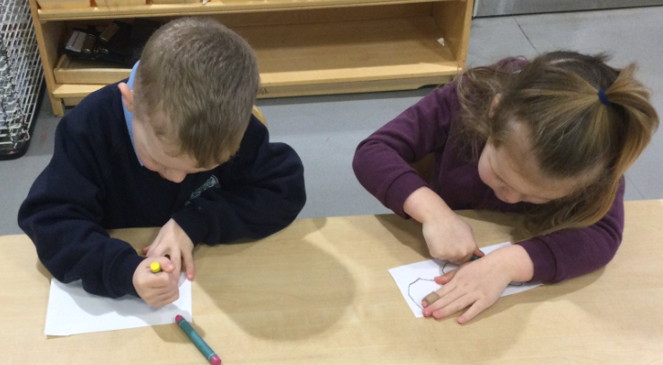

All nursery places are allocated in line with the Council’s Admission
Procedures and Guidelines and the nursery staff will be happy to
advise you as to how this policy operates when you apply for a place.

There is an admission panel, which meets annually to decide on how
nursery places will be allocated. The panel consists of all heads of
pre five establishments in the area, a representative from divisional offices and representatives of other agencies involved in supporting children and their families eg Social Work, NHS.

Under Scottish Executive guidance North Lanarkshire Council has a statutory duty to offer a place to all eligible children. As far as possible and in line with the Council’s admissions policy parental wishes, will be accommodated however, parents should be made aware that this might not always be possible.

Register of Applications

The Head Teacher and Principal Teacher (PT) will keep a register of all applications and the information contained in the applications will be considered by the admissions panel to assist in the allocation of places.

Please note that the length of time a child’s name has been on the register will not affect the child’s priority for admission.

Parents can ask to see their child’s application form at any time. If the circumstances change which affect the application you should speak to either the Head Teacher or PT.

Age Range of Children

Orchard Nursery class takes children from 3 to 5.5 years of age.

Numbers of children

We have the capacity for 24 children within our Nursery and each child is allocated a keyworker and group. Current groups are the Butterflies, Ladybirds and Dragonflies. Our staff have a nurturing and inclusive approach and work with all children throughout the course of a session, but focused activities are completed within groups to allow for targeted support and assessment.

Nursery Lunches

From September 2020, all eligible two year olds and all children aged from 3 to those not yet attending primary school, that attend a North Lanarkshire Council Nursery or a Funded Provider (childminder or voluntary/private nursery), will be entitled to 1140 hours Early Learning and Childcare provision . Those children attending for four hours per day, or more, will receive a free meal as part of the Early Learning and Childcare entitlement
The menu with meal choices will be given to you at enrolment and are also available online if you search for ‘North Lanarkshire Council Nursery Menu’.
We eat lunch in the Primary School canteen and all children are provided a hot meal each day.
Please note, you can send in a packed lunch for your child if you would prefer, staff will leave uneaten food inside the lunchbox so you can see how much they have eaten.

Photographs /Video Footage

On occasion events in school may receive coverage from the local or national press resulting in photographs/video footage of children appearing in newspapers, leaflets and/or school/authority documents. At enrolment parents will be asked for permission to allow their child’s photos to be used.

Nursery Fund

We ask parents to give a small donation each week, which allows us to provide healthy snack and extra special learning opportunities for the children. Donations are greatly appreciated and are used to benefit all of our children.

A money box is available at the Nursery Class Signing In Area for donations. (Nursery Class only).

Suitable Clothing

Your child will be working with glue, paints and dough to name but a few of the activities. We will always try to make sure that they wear aprons but accidents happen, so please dress your child in easy to wash clothes.

Try to have a spare pair of pants and jogging trousers in your child’s bag in case he/she does not make it to the toilet on time. If they are busy playing they can sometimes forget to go. We do have spare clothes in the nursery for such emergencies. Please launder and return any items your child borrows.

Make life easy for your child by putting on clothes and shoes they can manage by themselves. Velcro or slip-on shoes are best to start with.

A nursery uniform can be purchased from local suppliers. The uniform consists of a pale blue polo shirt and navy sweatshirt both with nursery badge. Ask at the school office for further supplier details.

We provide the children with waterproofs and wellington boots for outdoor play.

Settling in

Since children are all individuals and react differently to strange situations, we treat them as such. This is often the first major separation of children and parents and our aim is to make it as natural as possible. As your child gets to know staff, other children and which activities they like the best, so their dependence on their parents wanes and their confidence in themselves grows enough to let you go for increasingly larger periods of time. As we only admit a few children per week, staff have time to devote to this settling in period and we ask parents to play their part by returning at the stipulated time. Since children are catered for individually, this gradual intake system takes varying lengths of time and parents should be prepared to be patient for as long as it takes.

Attendance at Nursery

While attendance at Nursery is not compulsory, we are concerned if your child is unable to attend regularly and you do not notify us with a reason for the absence. As per our Attendance Policy/Practice we text you and ask you to respond to let us know that your child is safe in your care and to offer explanation of why he/she has been unable to attend on the specific day.

Parents should inform us if their child is likely to be absent from nursery at any time. If a child is absent for more than 5 sessions in a row nursery staff/office staff will contact the parents/carers to ensure that they are still seeking to retain the placement. Attendance information is recorded and passed on to the primary school as part of the transition record.

If your child is having problems in attending regularly we shall be happy to discuss any difficulty with you and seek to assist you in easing the situation. If you move from the area, please find the time to let us know that your child will no longer require their place.

Arrival and Collection of Children

It is expected that a responsible adult (aged at least 16) will bring a child to and from the nursery.

A child will not be handed over to someone the nursery does not know of or have not been informed about. It is vital that you keep staff informed of any changes to your details.

If a child is not collected within 30 minutes and no-one has informed the nursery of a reason why, the Head Teacher will contact the Social Work Department on their emergency telephone number to arrange care for the uncollected child.

Nursery Routines

- Children are settled in each day with a whole-group welcome time led by one of our practitioners.
- They are then offered breakfast and a chance to explore the playroom without the direction of an adult.
- Some mornings, staff gather their own groups for a Health and Wellbeing time to provide children with a safe space to share their ideas and stories.
- Following group time, our children are split into groups: some will explore our outdoor area, whilst the others have a focused learning experience with their keyworker.
- Lunch is served at 11.45am (this is in line with the lunch time of our Primary lunch times).
- Following lunch, the children then have another whole-group experience before separating again into groups again to explore and play.
- Toward the end of a session, children enjoy a whole-group goodbye time.

All of our children will be outside for a significant portion of their day regardless of the weather. We provide wellingtons, waterproof trousers and outdoor jackets, but would ask you to support us with their outdoor experiences by ensuring your child is dressed in appropriate undergarments.

Valuables

Parents should ensure that valuable items are not left in the nursery, as the nursery cannot replace the loss of personal items.

We try to discourage children from bringing their own toys to nursery. The child often forgets about them at the end of the day. Children often have the same toys and do not realise that the item belongs to someone else.

Excursions and consent forms

When outings or trips for children are planned, the staff will advise you in advance. You will be asked to complete an annual consent form, which gives your permission for your child’s participation and also medical details of your child. You will also be informed by letter when outings are taking place so that you can update any information, medical or personal, as required. Children cannot take part in outings unless a consent form has been completed.

Transport

Transport is not normally provided for children who attend pre five establishments. The Council may, however, provide transport to and from the nursery for children with special needs who may require to travel some distance to take up their placement. Parents are normally expected to make their own arrangements for their child travelling to and from the nursery.

Emergency Closure Arrangements

The nursery will be opened on the times already outlined, but on some occasional circumstances the nursery will go through an emergency closure.

We make every effort to maintain a full educational service, but in emergencies some circumstances arise which lead to disruption. For example, schools may be affected by severe weather, temporary interruption of transport, power failures or difficulties of fuel supply. In such cases we shall do all we can to let you know about the details of closure or re-opening. We shall keep you informed by using letters, notices in local shops and community centres, announcements in local churches and announcements in the press, on local radio and the North Lanarkshire Council’s website and Twitter.

Accommodation for Parents

We do not have a specific area for parents. Please speak to a member of staff who will direct you to an area where you can wait for your child. There is a visitor’s toilet located at the entrance of the building. We do have rooms we use for special events and meetings.

Breastfeeding Friendly Establishment

We are a breastfeeding friendly establishment.

Aims of our Breastfeeding Friendly Nursery:
To contribute to social and cultural change by promoting an environment where breastfeeding is promoted as a natural, healthy way to feed a child.

Objectives:
- To provide education and training for staff to enable them to support breastfeeding appropriately.
- To support informed choices in relation to infant feeding.
- To increase breastfeeding awareness with appropriate sources of support and information.
- To use resources which promote breastfeeding within our establishment.
- To provide a welcoming environment for breastfeeding mothers and to promote our allocated breastfeeding area within our story corner.
- To support all breastfeeding mothers who visit our establishment.
- To promote a positive social attitude to breastfeeding.
- To ensure our early years establishment meets the criteria for the Breastfeeding Friendly Award.

No Smoking Policy

All buildings and school grounds owned by North Lanarkshire Council operate a strictly no smoking policy.

Child Safety/Child Protection Policy
Every adult in Scotland has a role in ensuring all our children and young people are safe and protected from harm at all times and in all situations.

The Head Teacher is responsible for the schools actions in response to Child Protection concerns.

If there are any Child Protection concerns the Head Teacher or the Child Protection Co-ordinator will follow North Lanarkshire Child Protection Procedures and Guidelines.

Child Protection Co-ordinator is: Mrs. Helen Mackenzie, Acting Head Teacher
Telephone Number: 01698 274984

Adult Protection

The Council has responsibility under the Adult Support and Protection (Scotland) Act 2007 for the protection and support of adults at risk of harm within North Lanarkshire. Its employees therefore have the responsibility to ensure the welfare of all adults at risk of harm with whom they come into contact, as well as providing the highest possible standard of care for some of the most vulnerable members of our society. If there are any Adult Protection concerns the Head Teacher or the Adult Protection Co-ordinator will follow North Lanarkshire Adult Protection Procedures and Guidelines.

Adult Protection Co-ordinator is: Mrs. Helen Mackenzie, Acting Head Teacher

Telephone number: 01698 274984

Security

The building is fitted with a secured entry system (bell). It is only as safe as the people who use it.

To enter - press the appropriate button, state your name and the name of the child you are here to collect, do not let any unknown person in with you, make sure that the door is closed firmly behind you.

Do not allow your child to play around the front door area. Your child is your responsibility once collected from the nursery playroom.

All our visitors and visits to the nursery should go via the school/campus main entrance, where you will be asked to sign in and take an identity badge.

Medical Information

The nursery staff will not administer prescribed medicines unless a parent has completed the appropriate medical pro-forma, which states the medicine, dosage, time etc. These forms can be obtained from the main school office.

If your child suffers from asthma you must tell the head teacher and nursery staff if there are any activities or specific circumstances, which are likely to bring on an attack. Your child should also have their inhaler with them at nursery.

If Your Child Becomes Ill

The nursery would welcome a telephone call if your child was unable to attend nursery on a particular day.

If your child becomes ill at nursery you will be contacted and asked to come and take them home. If the nursery cannot contact you, named emergency contacts will be phoned. It is therefore your responsibility to ensure that all emergency contact information is up to date. Let staff know of any changes to your mobile or home telephone number.

Minor Accidents and Upsets

These will be dealt with on the spot and entered in the incident book. Parents will be informed when they pick their child up of the circumstances or treatment the child received. At this point you will be asked to sign a form to indicate you are satisfied with the report and action taken by staff.

Visits by Health Care Professionals

Please sign the form that allows your child to be seen by visiting health care professionals. These are mainly a dentist and a dental hygienist. You will always be informed of any other specialist involved in your child’s health and welfare.
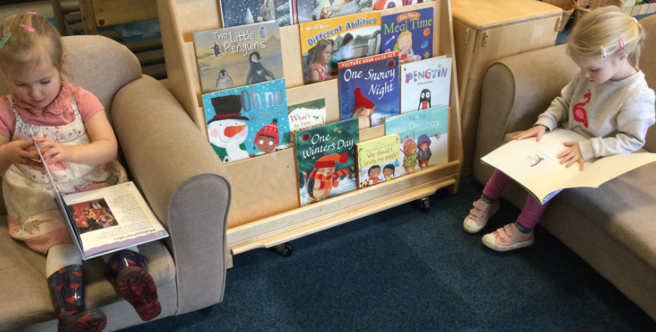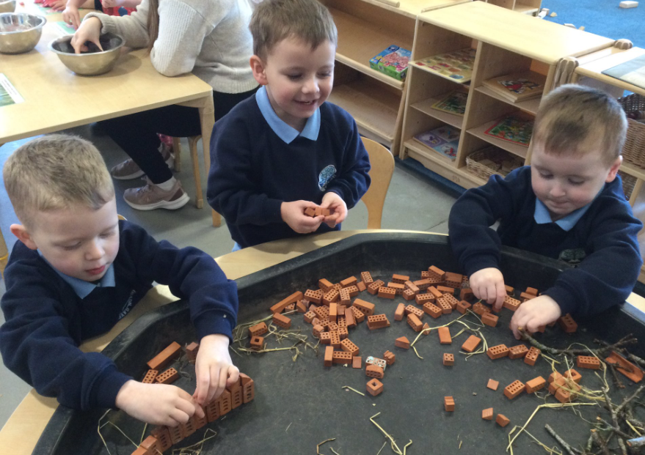

Learning and Teaching

The Scottish Executive’s documents ‘Curriculum for Excellence’,
How Good is Our Early Years and Childcare document and
Education Scotland’s Building and Realising the Ambition
documents are used as the basis for your child’s learning
experiences in the nursery.
What is Curriculum for Excellence?

Curriculum for Excellence is Scotland’s national curriculum. It
provides a coherent and inclusive curriculum from 3-18 years
wherever learning is taking place, including early learning childhood centres, schools, colleges and community learning. It places children and young people at the heart of Scottish Education.
The purpose of Curriculum for Excellence is encapsulated in the four capacities – to enable each child or young person to be
• a successful learner,
• a confident individual,
• a responsible citizen and
• an effective contributor.
These four capacities govern the entire curriculum from age 3 to 18 and aim to raise the standards of achievement for all learners.
Curriculum for Excellence is underpinned by the values inscribed on the mace of the Scottish Parliament – wisdom, justice, compassion and integrity.
Throughout Curriculum for Excellence there is a strong focus on Literacy, Numeracy and Health and Wellbeing across all aspects of learning and every teacher will support learners with the development of these, including digital literacy skills.
Curriculum for Excellence is defined as:
The totality of all that is planned for children and young people throughout their education’.
The opportunities for learning and teaching are governed by the Four Contexts for Learning, which ensure that the education your child receives is informative, interesting, relevant and fun.
These contexts are:
• Ethos and life of the school as a community
• Curriculum areas and subjects
• Interdisciplinary learning
• Opportunities for personal achievement.

What are the Curriculum for Excellence levels?
There are five levels and these are flexible depending on pupils’ needs and abilities (some children and young people may achieve these levels earlier or later dependent on ability):
• Early level pre-school to P1
• First level to the end of P4
• Second level to the end of P7
• Third and fourth levels S1 to S3
• Senior phase S4 to S6 and other forms of study.

What is the Broad General Education?
The Broad General Education (BGE) is the first phase of two closely connected phases of education. The BGE phase stretches from age 3 until the end of S3 after which learners move into the Senior Phase which starts in S4.

Curriculum Areas and subjects
The BGE is delivered via 8 curricular areas which, in secondary school cover years S1 to S3, and may be subdivided further into individual subjects.
The 8 curricular areas are:

• Expressive Arts
• Languages and Literacy
• Health and Well Being
• Mathematics and Numeracy
• Religious and Moral Education
• Sciences
• Social Studies
• Technologies.

Literacy, Numeracy and Health and Wellbeing make up the substantive curricular areas in our nursery as these skills are vital in everyday life. All teachers and nursery practitioners have responsibility to teach these key areas as an integral part of every day. However, activities for our children are planned across all areas of the curriculum to ensure children experience an engaging, motivating, well-rounded and comprehensive education
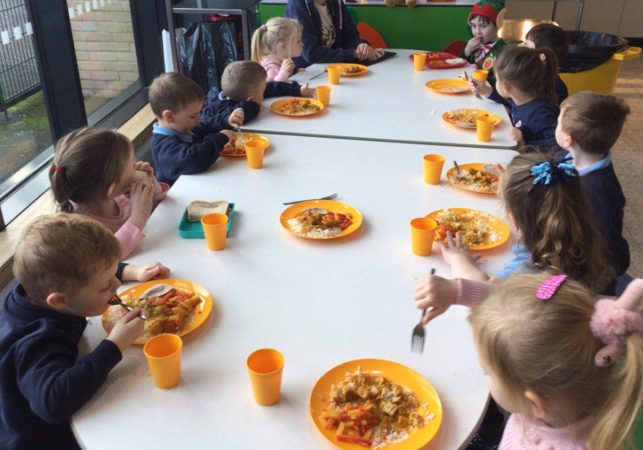
Through robust but responsive planning, we ensure that:

- The learning environment is stimulating & challenging and
provides appropriate opportunities for learning through
outside play in each of the key aspects of children’s
development and learning.
- We establish clear practices and guidelines for learning and
teaching.
- We build upon parent partnerships with the introduction of
home link packages.
- We bring school policies and practices in line with national and local advice.

How we promote learning
Our nursery programme is based on learning through play. When planning experiences for the children our staff ensure variety and challenge and an element of responsive planning to meet the interests of the children. Staff also support and encourage language development and resource the environment so that the children have an element of personalisation and choice within their daily routine.
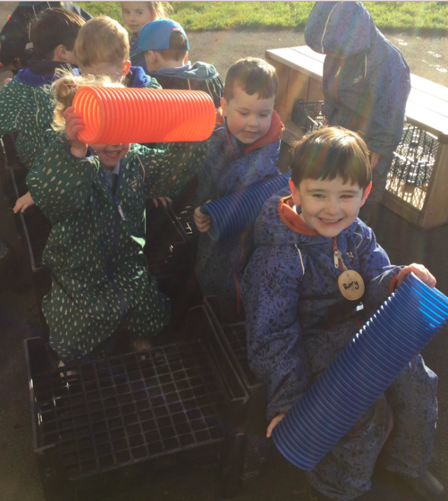

It is important to encourage the development of a positive self-image so that a child may realise their full potential in later life. Children gain confidence by succeeding at tasks which are all carefully graded. Children are then encouraged by success to try new and more difficult activities. Staff are nurturing, supportive and encouraging in their approaches thus ensuring our children experience a fun, safe and motivating learning environment.

Assessment

In the playroom staff will be using different ways of assessing children’s learning, taking account of national and local advice and guidance. Your child’s progress will be reported to you so that you know how well your child is doing through online Learning Journals, parent’s evenings and yearly report cards. We also use Twitter to share photos and information about our experiences.

Each year your nursery will let you know what is being done to continue to implement Curriculum for Excellence so that you can be confident that your child is receiving a high quality of education.
Since we are fortunate enough to see our parents on a daily basis, our discussions about your child’s progress can be continuous and informal. Staff also complete more formal assessments for both the parent and the primary school at the end of your child’s time in nursery. This allows the parent, nursery and primary school to give each child the best start possible to his/her formal school life.

Please speak to a member of staff if you have any concerns about your child’s development.

Parental Involvement

We regularly send out newsletters, which will let you know what has been happening in the Nursery and also what we are planning for future weeks. It is a place for us to share organisational information and give you an insight into the life of our nursery.
We may also ask you to fill in surveys or questionnaires about progress and improvements and value your input with these.
We look forward to welcoming you along for special events at our Nursery too.

Very successful initiatives that we offer:
- ‘stay & play sessions’ where you will be given the opportunity to spend the session with your child in the playroom and see what they are learning.
- ‘Biscuits and Blethers’ sessions which allow parents to meet staff and other parents for an informal chat and to learn more about what is happening in the Nursery.

Adult Helpers

We are always looking for adult helpers for trips etc. Please let staff know if you can be called upon to help out with any aspect of nursery life. All helpers require to undertake a PVG (Protection of Vulnerable Groups) check but in general this is only a formality. It does ensure however that all children remain safe while in the care of staff, helpers, students, etc.

Promoting Positive Behaviour

The nursery staff actively promotes positive behaviour and work with the children using different strategies to encourage independence, self-control, fairness, honesty, respect and positive attitudes towards each other. The Promoting Positive Behaviour Policy is issued to parents during enrolment. Parental co-operation is much appreciated.

Spiritual, Social, Moral and Cultural Values
Parents/carers from ethnic minority religious communities may request that their children be permitted to be absent from school in order to celebrate recognised religious events. Only written requests will be considered. Appropriate requests will be granted on not more than three occasions in any one school session and the pupil noted as an authorised absentee in the register.

Additional Support Needs

Orchard Nursery complies with Learning (Scotland) Act 2004 as amended by the Education (Additional Support for Learning (Scotland) Act 2009 and the Additional Support for Learning: Statutory Guidance 2017
North Lanarkshire Council’s policy is contained within “Support for Learning Policy into Practice 2”, a copy of which is available in the School. The school has a Support for Learning Policy, available from the school on request which is consistent with North Lanarkshire Council guidelines.
Children with additional support needs will be identified in the nursery using the staged intervention process (see below). Parents and pupils are an essential part of the process and views will be actively sought. Getting it Right for Me paperwork will then be used to help identify effective teaching and learning strategies and resources that will help the child access the curriculum.

Level 1 - nursery staff identify that a child needs support or planning which can be met within the nursery using school resources.

Level 2 – Requesting support from within Education Youth and Communities (services/resources out with school) e.g Educational Psychologist, Community Learning and Development.

Level 3 – Requesting support from another agency (Joint working with partner agency/agencies including 3rd Sector). When further planning is required to further develop the wellbeing of children the Named Person may request assistance from colleagues in partner agencies.

Level 4 – Integrated and Compulsory working with other agency/agencies. Targeted intervention(s) required to promote the wellbeing of the child would be identified by relevant agencies (child’s Network of Support) and included in the Child’s Plan. A Lead Professional would be identified. At level 4 there would an expectation that a statutory Child’s Plan with integrated assessment, integrated chronology and Lead Professional is in place.

Where a child has English as an additional language they will be supported within the nursery.

Looked After Children i.e. children who are cared for directly or whose care is supervised by the local authority are deemed to have Additional Support Needs unless assessment determines otherwise.

Parents and young people can request an assessment to establish whether a child or young person has additional support needs or requires a Co-ordinated Support Plan. This request should be formally made in writing to the Head teacher although the Head teacher welcomes parents with concerns to discuss these with her in the first instance.

Parent and pupils are an essential part of the assessment, planning and review process and your views will be actively sought. Parents can request an assessment at any time.

Getting it Right for Me plans

(GIRFMe) enable staff to plan effectively for children and young people when interventions are requires to support their learning a improve outcomes. Parents/carers and pupils are an essential part of the assessment; planning and review processes and their views will be actively sought.
Some children and young people may require significant support from education and at least one other agency, such as health, social work and/or voluntary agency to help them meet their learning targets. Where this support requires a high level or co-ordination the opening of a Co-ordinated Support Plan (CSP) may be considered. A CSP may be initiated by the school or another agency.
Parents/carers and young people can, if they wish, request that a CSP be considered and would be involved in the process.
Parents/carers will receive letters from the Education Authority throughout the CSP process.
Parents/carers and young people will be invited to take part in multiagency meetings and their views will be recorded in the plan.
Where more intensive support for a child or young person needs to be planned for, usually when a number of agencies are involved in supporting their wellbeing then a Child’s Plan may be developed. The plan will tell you what actions need to be taken and who will help with each action. It will usually be someone called a ‘Lead Professional’ who will have the job of making sure that the actions outlined in the plan take place and things get better for the child or young person.
Dispute Resolution
North Lanarkshire Council is committed to resolving any differences of views through discussion, dialogue and building on common ground.
If the matter cannot be resolved with the Education Authority you have the right to request mediation. An independent mediation service is available to parents/carers and young people through Resolve (see contact details at the back of this handbook). Mediation is free through Resolve and independent of the Education Authority.
In the event that a disagreement cannot be resolved through mediation, then an application for Independent Adjudication (see contact details at the back of this handbook) can be made by parents/carers free of charge. The Independent Adjudicator will make recommendations to the Education Authority about how the dispute should be resolved.
The Additional Support Needs Tribunal has been set up to hear appeals made by parents/carers or young people on the decisions made by the Education Authority relating to Co- ordinated Support Plans, ASN placing requests and post school transition. If you disagree with any decision relating to your child’s Co-ordinated Support Plan, either the creation of a CSP, or the content of it, you may be entitled to refer to the Tribunal

Improvement Agenda

All schools in Scotland are required to devise an improvement plan as a means of managing change and planning for major development initiatives. Following audit, including consultation with parents, pupils, staff and the wider school community, and taking into consideration national and authority targets, priorities are then identified.

We are committed to improvement in the following areas: School Leadership, Teacher Professionalism, Parental Engagement, and Assessment of children’s progress and School Improvement.

Priorities are decided on an annual basis through a series of self-evaluation and monitoring.

Copies of the School Improvement Plan and School Improvement Report are available on request at the school office. We issue a summary to parents on an annual basis.

Our Nursery priorities for session 2022/23 centres around Parental Involvement and Engagement, and improving Literacy for our children.

Transfer to Primary School

Pupils normally transfer to primary school between the ages of four and a half and five and a half years. Information on registration and enrolment procedures for primary schools will be given in the local press early in the calendar year and can also be found in libraries.

In the summer term our children go for several visits to their future primary school so that the changeover may be made easily. Parents are also invited to Pre-entrant programmes.

Our local primary schools are:-

Orchard Primary School St Thomas’ Primary School
Castlehill Rd Caledonian Rd
01698 274984 01698 274960

Thornlie Primary School
Lomond Dr
01698 352539

The Parent Forum

As a parent of a child at this school you are automatically a member of the Parent Forum. The Parent Forum is composed of all the parents and carers of children at the school.

As a member of the Parent Forum you can expect to:

- get information about what your child is learning
- get information about events and activities at the school

- get advice/help on how you can support your child’s learning
- be told about opportunities to be involved in the school
- have a say in selecting a Parent Council to work on behalf of all parents at the school

- be invited to identify issues for the Parent Council to work on with the school.

The Parent Council

Parent Councils came into force from 1st August 2007. The Head Teacher is the professional adviser to the Parent Council. A Parent Council has been established within Orchard. All correspondence should be addressed to the school office.

The Parent Council’s rights and duties include:
- supporting the work of the school;
- representing the views of parents;

- consulting with parents and reporting back to the Parent Forum on matters of interest;

- promoting contact between the school, parents, pupils, providers of nursery education and the wider community;
- fundraising;

- taking part in the selection of senior promoted staff;

- receiving reports from the Head Teacher and education authority; and

- receiving an annual budget for administration, training and other expenses.

- Improving home school partnership and facilitating parental involvement

Members of Parent Councils, on a voluntary basis, may also have an advisory role in decisions on placing requests by parents in respect of those situations where the number of placing requests for a particular school or for a particular stage in a particular school exceeds the number of places available.

The current Parent Council office bearers are:
Jillian Price Chairperson Sharon Grant Vice Chair
Christine Durie Treasurer

The Head Teacher has a right and duty to attend all meetings of the Parent Council. Meetings of the Parent Council are open to members of the public.

The Parent Council hold their A.G.M. annually in June. All parents are invited to attend. Officer bearers will be reselected on an annual basis at the A.G.M. The parental membership of the Parent Council, will be a minimum of three parents of children attending the school. The maximum number of parents is twenty. Newsletters to inform parents of coming events and the success of past events are sent home with pupils. Meetings are held monthly in the school.

Any parents of a child at the school can volunteer to be a member of the Parent Council, the preferred make up being at least one parental representative from each year group. In the event that the number of volunteers exceeds the number of places set out in the constitution, members will be selected by formal election. Anyone not selected to be a member of the Parent Council may be offered the opportunity to be part of any sub groups set up by the council.

The Parent Council work hard organising fund raising and social events for both children and parents. They will donate funds to the school allowing us to purchase resources and materials. To encourage their invaluable work and contributions to the quality of school life, we urge all parents/carers and pupils to actively support the events organised. Newsletters to inform parents of coming events and the success of past events are sent home with pupils.

Freedom of Information

Freedom of Information (Scotland) Act 2002 came into force in 2005. The Act allows anyone to ask for information held by the Council and imposes a time-scale of 20 working days for the Council to respond. To deal with Freedom of Information requests, the Council has appointed a Corporate Freedom of Information Officer with the support of an officer in each Service. The Freedom of Information Co-ordinator can be contacted by telephone on 01698 302484.

Data Protection

Privacy statement for enrolment of pupils in a North Lanarkshire school
What is this statement?
This statement explains when and why we collect personal information about you, your child or young person and how this information is used, the conditions under which it may be disclosed to others and how it is kept secure.
Who are we?
North Lanarkshire Council is a Local Authority established under the Local Government etc. (Scotland) Act 1994. Education and Families is located in Civic Centre, Motherwell, ML1 1AB.
Why do we need your personal information and that of your child or young person?
The Council has a legal obligation to deliver an effective education service to all children and young people in North Lanarkshire. In order to do this we need to collect personal information about children, young people and their families so that we can help them to learn and keep them safe.
Legal basis for using your information
We provide this service as part of our statutory function as your Local Authority. Processing your personal information is necessary for the performance of a task carried out in the public interest by the Council. If the information we have asked for is not provided, then we will not be able to provide this service to your child or young person.
Your personal information
Education and Families uses the national IT system, SEEMiS, to store personal information electronically. We ask parents/carers during registration and enrolment to provide us with their child’s name, date of birth, gender, address, family contact details (phone/email). We will also ask you to update this information annually.

We may also ask you for information about medical conditions, additional support needs, religion, and ethnicity. We may also record information you might wish to provide about your family circumstances.
We require this information to ensure children and young people are educated appropriately, supported, and that we take account of their health and wellbeing.

During a child’s journey through education a pupil’s record is kept, this core record is mainly paper based and is stored securely in the child or young person’s establishment. If the establishment has requested assistance from educational staff out with the nursery or school, key staff from these services may also store information securely about your child or young person.

How will we use this information?
Your personal information will be used:
- to enrol your child or young person in nursery or school
- to provide your child or young person with an appropriate education
- for teaching, assessment and planning purposes and to monitor educational progress of children and young people
- to support pupil learning, improve outcomes and identify where additional support is needed to help children and young people
- to provide appropriate pastoral care to support health and wellbeing of children and young people
- to keep children and young people safe
- to maintain records e.g. of attendance, absence, attainment and behaviour of children and young people (including exclusions)
- to support children and young people during transitions when moving on each year from nursery to primary, primary to secondary and when they move or leave school
- to enable schools and establishments to process personal data in support of SQA and Further Education
- to monitor and report on pupil attainment and achievement in relation to the national improvement framework issued by the Scottish Government
- to assure the quality of our education services in line with national expectations from Education Scotland
- when we require to contact you by post, email, telephone or text.

Who do we share information with?
- To support your child or young person’s access to appropriate education and meet our legal obligation, personal information may be shared internally between departments of the Council. From time to time, education staff may also need to share information about you, your child or young person with another person from another agency or service, e.g. Social Work, Health.
- We also share information with Scottish Government and bodies such as Education Scotland, Scottish Qualifications Authority, Skills Development Scotland and other organisations that support children and young people’s learning.
- When a child or young person moves or transfers to another school the Council has an obligation to pass on information with regards to pupil records to the new school.
- Only identified staff and those who require to have the information to enable them to carry out their job, will have access to you, your child or young person’s information. We care about the information we hold in respect to the education of children and young people. We will keep this information safe and secure.

How long do we keep your information for?
We only keep personal information for the minimum period of time necessary. Sometimes this is set out in law, but in most cases it is based on what we need to fulfil our function. We maintain a ‘records retention and disposal schedule’ which sets out how long we hold different types of information for. You can view this on our website at http://www.northlanarkshire.gov.uk/index.aspx?articleid=15003

Your rights under GDPR
You can:
- Request access to your information – you have the right to request a copy of the personal information that we hold about you, your child or young person. You can ask us to confirm what personal information is being used and with whom it has been shared with.
- Request a correction to your information – we want to make sure that all personal information is accurate, complete and up to date. Therefore you may ask us to correct any personal information that you believe does not meet these standards.
- Request the restriction of processing – this enables you to ask us to suspend the processing of personal information about you, your child or young person, for example if you want us to establish its accuracy or clarify the reason for processing it.
- Request the transfer – you can request the transfer of your information to another party.
- Deletion of your information – you have the right to ask us to delete personal information about you, your child or young person where:
- you think that we no longer need to hold the information for the purposes for which it was originally obtained
- you have a genuine objection to our use of personal information
- or, use of personal information is contrary to law or our legal obligations.
If you wish to update any personal information, retrieve it, or have it removed from records please contact your child or young person’s head teacher or head of establishment in the first instance.

The Council’s Data Protection Officer
If you have any questions or are unhappy about the way that we use the personal information of your child, young person or yourself you can contact the Data Protection Officer.

Data Protection Officer (DPO)
Civic Centre,
Windmillhill Street,
Motherwell ML1 1AB
or by email to AITeam@northlan.gov.uk

The Information Commissioner

You also have the right to complain to the Information Commissioner about the way the Council has handled your rights, to enquire about any exercise of these rights or to complain about the way the Council has dealt with your rights (or any other aspect of data protection law).
Information Commissioner's Office,
45 Melville Street,
Edinburgh, EH3 7HL
or by e-mail to casework@ico.org.uk

Transferring Educational Data About Pupils

Education authorities and the Scottish Government Education Portfolio (SGEP) exchange data about pupils either on paper or electronically through the ScotXed programme.

The data collected and transferred covers areas such as date of birth, postcode, registration for free-school meals, whether a pupil is looked after by his/her local authority, additional support needs including disability, attendance, absence and exclusions from school. Pupil names and addresses are collected by the school and the council but they are not passed to SGEP. The postcode is the only part of the address that is transferred. Data is held securely and no information on individual pupils can be published by SGEP.

Providing national identity and ethnic background data is entirely voluntary. You can choose the ‘not disclosed’ option if you do not want to provide this data. However, we hope that the explanations contained in this message and on our website will help you understand the importance of providing the data.

Why do we need your data?

In order to make the best decisions about how to improve our education service, SGEP and education authorities need accurate, up-to-date data about our pupils. We are keen to help all our pupils do well in all aspects of school life and achieve better exam results. Accurate and up-to-date data allows SGEP, education authorities and schools to:

- plan and deliver better policies for the benefits of all pupils.

- plan and deliver better policies for the benefit of specific groups of pupils,

- better understand some of the factors that influence pupil attainment and achievement,

- target resources better.

Your GDPR rights

The collection, transfer, processing and sharing of ScotXed data is done in accordance with the GDPR). We also comply with the National Statistics Code of Practice requirements and other legislation related to safeguarding the confidentiality of data. GDPR gives you the right to know how we use data. This message can give only a brief description of how we use data. Fuller details of the uses of pupil data can be found on the ScotXed website (www.scotxed.net).

SGEP works with a range of partners including Education Scotland and the Scottish Qualifications Authority. On occasion, we will make individual data available to partners and also academic institutions to carry out research and statistical analysis. In addition, we will provide our partners with information they need in order to fulfil their official responsibilities. Any sharing of data will be done under the strict control and prior agreement of the Data Access Panel in SGEP, which will ensure that no subject specific data will be made public as a result of the data sharing and that such data will not be used to take any actions in respect of an individual.

Further details are available on:
https://www2.gov.scot/Topics/Statistics/ScotXed/PrivacyInformation

Concerns

If you have any concerns about the ScotXed data collections you can e-mail school.stats@scotland.gsi.gov.uk or write to The ScotXed Support Office, SGEP, Area 1B, Victoria Quay, Leith, EH6 6QQ.
Alternative versions of this page are available, on request from the ScotXed Support Office, in other languages, audio tape, Braille and large print.

Want more information?

Further details about ScotXed data exchanges are available on the ScotXed website, www.scotxed.net.

Suggestions and Complaints

We are always anxious to improve our service. If you have any suggestions to make about the service, please contact our Nursery team. Similarly your suggestion can be made in writing or verbally to the head teacher.

If you have a complaint about any aspect of the service, you should contact the Head Teacher. If you feel your complaint has not been satisfactorily resolved with the Head, please contact the education officer for your area.

Concerns may also be raised with the Care Inspectorate
Care Inspectorate Care Inspectorate
60 Princes Gate Compass House
Castle Street 11 Riverside Drive
Hamilton Dundee
Tel 01698 897800 Tel 0345 600 9527
Tel 01382 207100

Useful Addresses
North Lanarkshire Council
Education, Skills & Youth Employment
Kildonan Street
Coatbridge
Tel 01236 812222

Contacts in relation to Support for Learning

Clyde Valley HS cluster Carol-Anne McGinty McGintyCar@northlan.gov.uk

You can also get more help and advice from:
Enquire

The Scottish advice service for additional support for learning. Operated by Children in Scotland, Enquire offers independent confidential advice and information on additional support for learning, Enquire also provide a range of factsheets.

Tel. – 0345 123 2303

Email - info@enquire.org.uk

Website for parents and practitioners - www.enquire.org.uk
Website for children and young people - www.enquire.org.uk
Children in Scotland
Rosebery House
9 Haymarket Terrace
Edinburgh
EH12 5EZ

Children in Scotland – Resolve Mediation
Tel. – 0131 313 8844
Email: resolve@childreninscotland.org.uk

Independent Adjudication |  |  | Reference to ASN Tribunal (Scotland)
Scottish Government  Directorate for Learning  Support and Wellbeing Unit  Area 2C North  Victoria Quay  Edinburgh  EH6 6QQ |  | ASNTS  Health and Educational Chamber  First Tier Tribunal for Scotland  Glasgow Tribunals Centre  20 York Street  Glasgow  G2 8GT
NHS Lanarkshire |  |  | Social Work
Wishaw Health Centre |  |  | Kings House
Tel. – 01698 355511 |  |  | King Street
 |  |  | Wishaw. ML2 8BS
 | Tel. – 01698 348200
Wishaw/Shotts CLD Locality Office
Coltness High School
Mossland Drive
Wishaw
ML2 8LY
Tel: 01698 274343
E: CLD-Wishaw@northlan.gov.uk

Qualifying Statement

Although this information is accurate at time of printing, there could be changes affecting any of the matters dealt within the document
a) before the commencement or during the course of the school year in question.
b) in relation to subsequent school years.
Education Authorities are required by law to issue a copy of the school handbook to certain parents/carers in December each year.
It details the current policies and practices of both the council and the school.

We look forward to working in partnership with you and your children as you become part of the Orchard Learning Community.

Orchard Primary School, LCSC & Nursery,
Clyde Valley Campus, Castlehill Road, Wishaw, ML2 0LB

Acting Head Teacher: Mrs Helen Mackenzie, 01698 274984

Safe | Responsible | Included | Achieve | Healthy
Nurture | Active |  | Respect

