books online but also to read from the book or novel.

Non-fiction
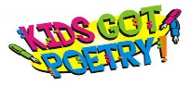
Each term the children will have the opportunity to study non-fiction texts. The non-fiction books are available online via Wordsmith. They are designed to allow the children to explore information on a variety of subjects in an exciting way. Each book has a different curricular focus, examples being science, history, etc.

Poetry
Each term the children will work on poetry, written by some well-known children’s poets such as Michael Rosen and Roger McGough.

Live
Each term the children will experience a Live Unit. A Live Unit focuses on modern, real world applications of literacy skills. Features include raps, debates and radio plays. These focus on speaking, listening as well as reading and writing.

Wordsmith also contains Word Detectives and Grammar Blasts units at each stage. Word Detectives allows children to investigate spelling patterns while Grammar Blasts focuses on both grammar and
Punctuation.
Accessing Wordsmith at home
Accessing Wordsmith at home should be straightforward as Wordsmith is part of Heinemann Active which all children at Orchard already have a login for.

The process for accessing Wordsmith at home is as follows;

- Login to Active Learn
- Click on the Wordsmith Icon
- Click on the book and activities allocated to your child

If you have any questions around Wordsmith, please don’t hesitate to contact the school

Contact with Orchard Primary

Website – https://blogs.glowscotland.org.uk/nl/orchard
Twitter - @primaryorchard
Email – enquiries@orchard.n-lanark.sch.uk

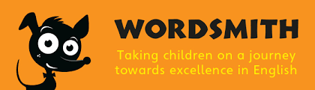

                - Logo

Orchard Primary
School

Wordsmith
Parent Guide

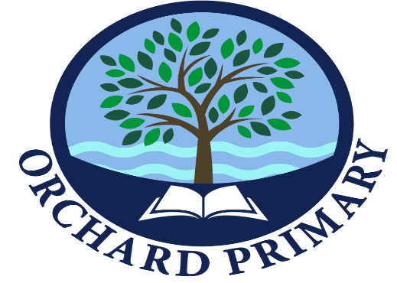

Wordsmith at Orchard
At Orchard Primary School, Wordsmith will be used in conjunction with the already established NLC Active Literacy Programme. This collaborative working will enhance your child’s learning in Literacy, providing them with more opportunities to engage with reading through a wider variety and style of texts.
This means children will continue to work on spelling and phonics as part of Active Literacy. They will also continue to read books banded at their level.
Children and parents will be able to access Wordsmith books allocated to children by their teacher at home.
Your child will also continue to experience the three main outcomes in Literacy and English to ensure they become successful learners, effective contributors, confident individuals and responsible citizens.

Literacy and English Outcomes
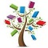
The three main outcomes which form the areas for learning on our Literacy and English curriculum are:
- Listening and Talking
- Reading
- Writing

What is Wordsmith?

Wordsmith is a whole-school approach to Literacy and English. It is a resource that helps deliver creative, dynamic and effective lessons.

The programme has been developed using research that was done into how children learn best. This research was based on the four principles on which Wordsmith is based.

What are the four principles?
- Varied, whole texts
- Purpose and audience
- Talk for writing
- Contextualised grammar

Varied, whole texts
Wordsmith’s use of varied whole texts allows the children to become engaged in a range of texts. These texts have been carefully chosen to develop children’s reading skills and their knowledge.

Purpose and audience
Wordsmith contains Live units of work. When working on these units the children’s writing takes on a whole new meaning and excitement as they know that it is being composed for a real purpose and a specific audience.
Talk for writing
Wordsmith promotes oral rehearsal which helps children to develop an understanding of what a sentence is. It also allows them to see a difference between how we speak and how we write.

Contextualised grammar
Wordsmith allows children to explore the grammar choices of authors, how grammar is used in real texts and in return provides children with the tools to use language confidently and effectively in their own writing.

Each term Wordsmith provides units that cover the following four text types;
- Fiction
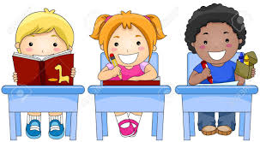
- Non-fiction
- Poetry
- Live

Fiction
Each term the children will read text written by well-known authors such as Michael Morpurgo and Chris Riddel. They will the opportunity to study the whole text and to become fully immersed in the book. The children will be able to access the fiction

