Orchard Primary School
Home Learning Ideas
Class P.2 Term 4, 2016-17
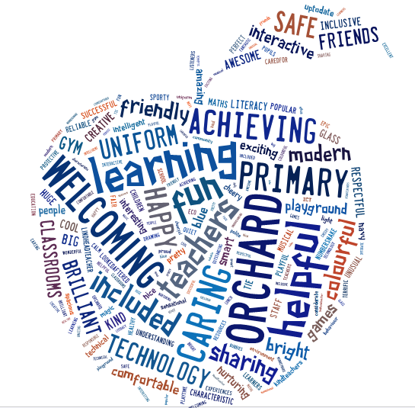

The purpose of our home learning sheet is to give you an overview of what learning your child’s class will be developing this term. It will also give suggested activities that you and your child can complete at home if you wish.

You will get your child’s snapshot jotter home once a month which will have examples of their work across the curriculum and have teacher comments and next steps to show you their progression.
Our PE Days
Monday and Wednesday. Please ensure all clothes are labelled with your child’s name as we have changing facilities in the School, and items are getting mixed up.
Monday –outdoor kit
Wednesday – indoor kit
My Class Teacher
Mrs. McGuire

Other adults who work in my class:
Mr Tollan Mrs. Sneddon

Remember all children have reading to do at home every night. Weekly they have spelling/common words and numeracy facts to practice. These will be assessed in class as part of their learning tasks.
Discreet Subject Areas
We will looking at percussion instruments.
Ideas for home
Using a tin, the children could make a simple drum http://www.redtedart.com/story-art-great-start-drum-roll-please/

/

PE & Sports planned Learning
Summer outdoor games
Ideas for home If you can, try to get to the park to play a game of rounders, football and rugby. Here are some more ideas:
https://www.parentmap.com/article/outdoor-and-indoor-party-games-for-kids

Literacy
Planned learning focus for daily writing activities. This term we are looking at simple paragraphs and learning to write recounts (writing about what happened in the past using a sequence and discussion of events) and explanations (writing to explain how something works or why something happens)
Further learning ideas for home When the children are cuddled up in bed, you could ask them to recount and describe their day (who, what, when, where) and ask them if anything happened they would change. For explanations, look at their routines and ask “explain why you brush your teeth, why you tidy your room, why you need to wash daily………”
Topic/Interdisciplinary Learning Theme
This term we are learning about ‘Native Americans’. We are reseaching what they ate and wore, their myths, customs and traditions, their housing and their inventions. We will compare their life to ours.
- Could you visit the Kelvingrove Museum as they have an Native American section and tweet your pictures to the Orchard Twitter page?
- For the adventurous, could you build a wigwam with your child and tweet a picture to our website? http://porch.com/advice/15-diy-teepees-and-play-tents-your-kids-will-spend-all-summer-in/
- Your child could create an imaginary creature based on everything they have learnt, name and describe it and tweet a picture of it to the Orchard Twitter Page.
- Watch the Disney movie Pocahontos.
- Could you go to Wishaw Library to get some books to read on Native Americans?

Numeracy & Maths
Planned learning focus for numeracy/Maths activities We are learning about measurement (length, weight, capacity and volume) this term and revising our number bonds to 20 so we get really quick at them!
Further learning ideas for home I will allocate games in Hinemann Active Maths related to our work. Here are two other games http://resources.hwb.wales.gov.uk/VTC/the_zoo/eng/Introduction/mainsession1.htm
http://www.topmarks.co.uk/PlayPop.aspx?id=4743. Get the children to
- estimate and measure (in metres) their bedroom, their bed and living room. Talk about who is the tallest/shortest in the family.
- How many water bottles it would take to fill their sink for the dishes or the bath.

