Orchard Primary School
Home Learning Ideas
Class P5/6/7 LCSC Term 3, 2016-17
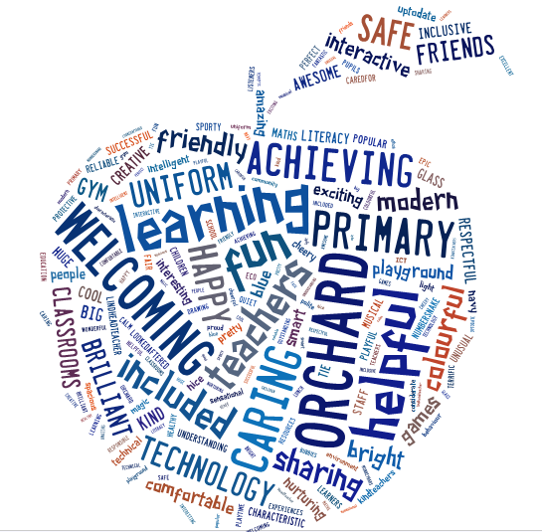

The purpose of our home learning sheet is to give you an overview of what learning your child’s class will be developing this term. It will also give suggested activities that you and your child can complete at home if you wish.

You will get your child’s snapshot jotter home once a month which will have examples of their work across the curriculum and have teacher comments and next steps to show you their progression.
Our PE Days are Tuesday and Friday. Please ensure all clothes are labelled with your child’s name as we have changing facilities in the School, and this will stop items from getting mixed up.

My Class Teacher
Mrs. Black
Other adults who work in my class:
Mrs McDermott, Mrs. Jeffrey, Mrs. Ramage
Mrs. Thomson, Mrs. McMullan,
Mrs Monaghan

Remember all children have reading to do at home every night. Weekly they have spelling/common words and numeracy facts to practice. These will be assessed in class as part of their learning tasks.
Topic/Interdisciplinary Learning Theme
Scotland and Scottish Food
Further learning ideas for home
- Locate towns, cities, regions, landmarks on map
- Research famous Scots
- Visit new Scottish towns, cities and landmarks
- Taste a variety of Scottish foods

PE & Sports planned Learning
Fitness
Ideas for home
- Take part in regular physical exercise
- Go for a walk
- Wii sports, wii fit, just dance
- Go for a bike ride

Literacy
Planned learning focus for daily writing activities
- Punctuation
- Instructional and persuasive writing
- Identify main points of text
- Handwriting
Further learning ideas for home
- Take notes from texts ubder given headings
- Look for different forms of instructional (recipes, cooking instructions, building lego, etc) and persuasive (posters, leaflets, etc) writing at home.
Numeracy & Maths
Planned learning focus for numeracy/Maths activities
- Fractions
- Measurement
- Money
- Symmetry
Further learning ideas for home
- Trips to shop – count out coins to pay for items, calculate change, make shopping lists
- Look for symmetry in your everyday surroundings
- Help measure ingredients when cooking

Discreet Subject Areas
Planned learning
- Food and Nutrition
- French – family, classroom objects
- Spanish – Pets/animals
- Lent/Easter
- Living things - animals
Ideas for home
- Practice using learned vocabulary
- Look at the nutritional values of food on packaging
- Visit an animal park/zoo/farm (or look online) and identify a variety of animals and their traits

