Orchard Primary School
Home Learning Ideas
Class P.2 Term 3, 2016-17
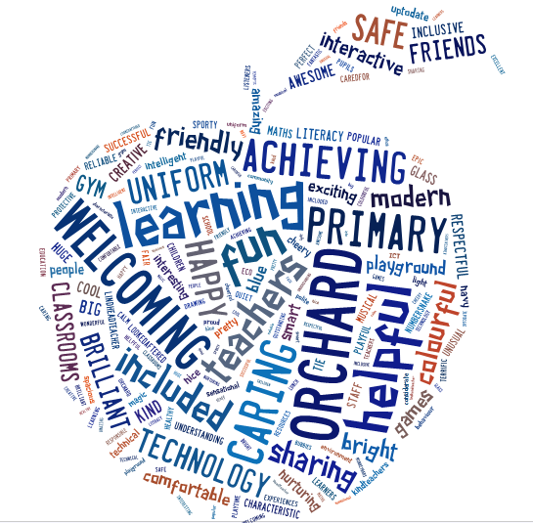

The purpose of our home learning sheet is to give you an overview of what learning your child’s class will be developing this term. It will also give suggested activities that you and your child can complete at home if you wish.

You will get your child’s snapshot jotter home once a month which will have examples of their work across the curriculum and have teacher comments and next steps to show you their progression.
Our PE Days
Monday and Wednesday. Please ensure all clothes are labelled with your child’s name as we have changing facilities in the School, and items are getting mixed up.
We are getting better at getting dressed more quickly. Let’s keep practising at home too!
My Class Teacher
Mrs. McGuire

Other adults who work in my class:
Mrs. Cullen, Mr Tollan Mrs. Davidson

Remember all children have reading to do at home every night. Weekly they have spelling/common words and numeracy facts to practice. These will be assessed in class as part of their learning tasks.
Discreet Subject Areas
We are learning about the traditions of world religions.
Ideas for home
Could you go to Wishaw Library to get some books to read on this?
/

PE & Sports planned Learning
We are going to be working on dance and movement.
Ideas for home It is great fun to put the radio up loud and dance around the living room with your child. If you are feeling adventurous here is a great wee Justin Timberlake routine for you to learn with your child! https://youtu.be/seg8bLgxV1g.

Literacy
Planned learning focus for daily writing activities. This term we are looking at describing words and learning to write reports with a title, headings and a labelled diagram. We are also learning to write imaginative/ narrative stories that has a setting, a few main events and interesting characters.
Further learning ideas for home As your children watch their favourite TV program you could ask them to name and describe the characters. You can find some great stories online here too http://www.storylineonline.net. Can they make a word picture (like the apple in the front of this sheet) with describing words for one of the stories? Can they make up a story for “The day I found a talking pufferfish in my bath” How did they feel? What happened? How did it end?
Topic/Interdisciplinary Learning Theme
This term we are learning about ‘Under the Sea’. We are reseaching interesting sea creatures and their habitats. We are also looking at food chains and Life Cycles.
Let’s tweet......!
- Could you visit a Scottish seaside town, take some sealife photos and tweet them to the Orchard Twitter page?
- You could help your child find the most interesting sea creature fact you can and tweet it to the Orchard Twitter page. Mrs McGuire will give a prize to the child who finds the most fascinating or shocking fact!
- Your child could create an imaginary creature based on everything they have learnt, name and describe it and tweet a picture of it to the Orchard Twitter Page.

Numeracy & Maths
Planned learning focus for numeracy/Maths activities We are learning about a half and a quarter of a shape and finding a half of a number. We are also learning about symmetry (when a shape has one side the mirror image of the other) and finding different lines of symmetry.
Further learning ideas for home Here are some games for home http://www.topmarks.co.uk/maths-games/5-7-years/shapes. I have also allocated a game in Hinemann Active Maths.
You can fold a piece of paper in half and draw a shape on one side and get your child to draw the mirror image.
Please reinforce the language when you see opportunities eg. Shall we share this pizza – would you like half? Can I please have a quarter of your apple? Play a game – I have a number ( eg 12, 14 or 16) if you are half, what number are you? Give them a small prize/treat when they get 10 correct in 1 minute.

