Orchard Primary School
Home Learning Ideas
Class: Primary 3 Term: 2
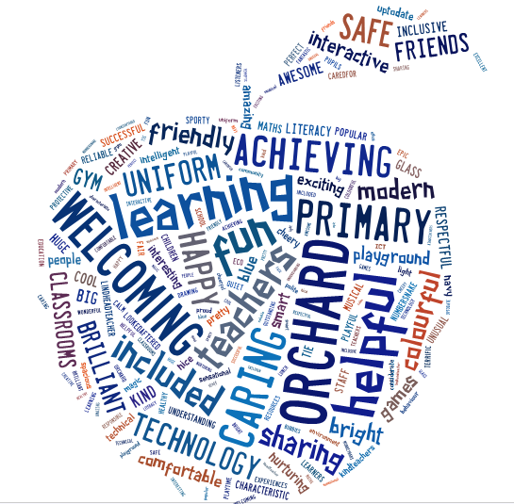

The purpose of our home learning sheet is to give you an overview of what learning your child’s class will be developing this term. It will also give suggested activities that you and your child can complete at home if you wish.

You will get your child’s snapshot jotter home once a month which will have examples of their work across the curriculum and have teacher comments and next steps to show you their progression.
Our PE Days
Tuesday and Thursday
Please ensure all items of clothing are labelled with your child’s name as we have changing facilities for the children to use.

My Class Teacher:
Mrs Johnstone
Other adults who work in my class:
Miss Davidson (NCC Cover)
Mr Tollan (Classroom Assistant)

Remember all children have reading to do at home every night. Weekly they have spelling/common words and numeracy facts to practice. These will be assessed in class as part of their learning tasks.
Discreet Subject Areas
Planned learning:
RME – Christmas around the world. Music - Kodaly
Ideas for home:
Design a Christmas card for someone special. Practise keeping the beat to various songs.

PE & Sports planned Learning:
Ball Handling
Ideas for home:
Practise ball tricks, throwing and catching or dribbling a ball.
Numeracy & Maths
Planned learning focus for numeracy/Maths activities:
Time – 12 hour clock, timetables and calendar work, 2D shape, symmetry and data handling.
Further learning ideas for home:
Take every opportunity to look for different times around your home. Use the TV planner to find what time your favourite programme starts and finishes. Make a timetable of what you do at particular times each week. Draw a picture using only 2D shapes. Do a survey of cars passing your house and make a bar chart with the results.
Literacy
Planned learning focus for daily writing activities:
Spelling - Word attack strategies for tricky words. Sequencing a story.
Further learning ideas for home:
Look for tricky words in various texts around your home. Use your strategies to help you spell the word. Find the meaning of the words by using a dictionary. Write a story with a beginning, middle and end.

Topic/Interdisciplinary Learning Theme:
Bagpipes and Bhangra.
Further learning ideas for home:
Use books / internet to research information about Scotland and India/. Can you find some interesting facts about each country? If possible, sample some traditional Scottish and Indian foods. Try to visit somewhere in Scotland you’ve never been before.

