Orchard Nursery Class
NEWSLETTER
October 2016
CHILDREN’S LEARNING
We have been very busy in the Nursery learning all about ourselves and our families. In Maths we have been counting and ordering numbers in lots of different ways, inside and outside. In Literacy we have been taking turns when talking and listening. In Health we have been learning about our cleanliness, hygiene and the importance of being active. In Science we have been exploring our senses and using them in the world around us. In RME we have learned all about Christenings and we even had our toys Christened!!! This week and next week our learning and activities are related to Hallowe’en. Our next contexts will be Dinosaurs and Light and Dark. Keep your eyes peeled for your opportunity to add your ideas to the planning board outside the Nursery.
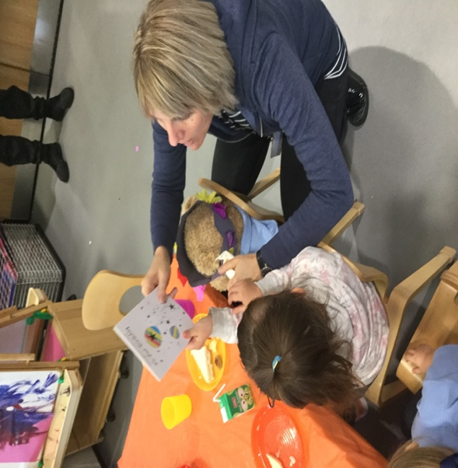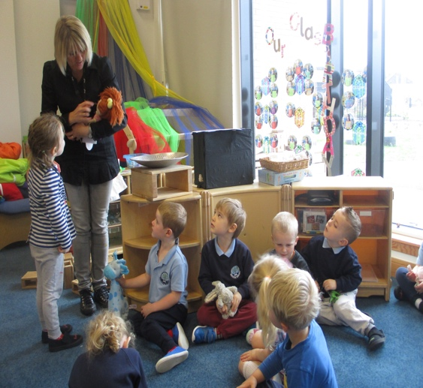
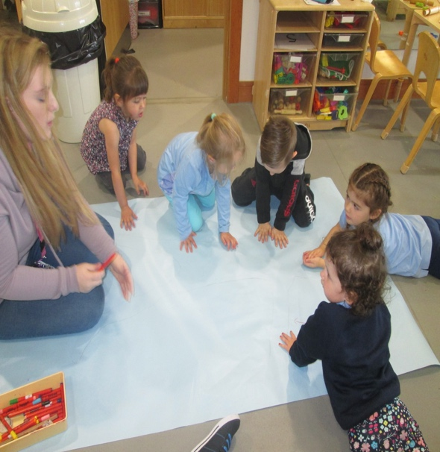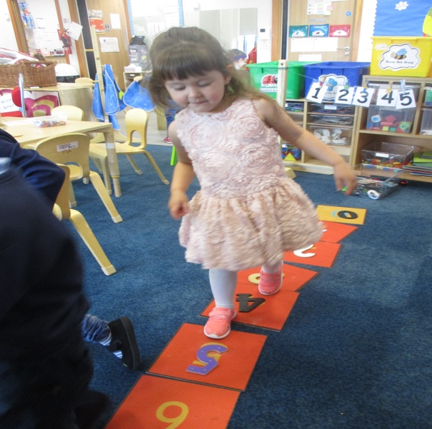

HALLOWEEN
Our Halloween party will be on Tuesday 31st October. Children should come along to their session in fancy dress but we would appreciate no scary masks as this might upset some of our children. We will have lots of fun activities and scary snacks! The children will walk through the school to show off their costumes.

FUND RAISING
Thank you for all your support with our sponsored number hunt and a wee reminder that any outstanding money is due in for Friday 27th October.

FOREST KINDERGARTEN
Our first Forest Kindergarten trip was a huge success with children and carers enjoying getting outdoors and participating in fun games and activities. On Friday 27th October we again plan to meet at the Snack Bar at the bottom of Castlehill Road at 9.30am and 1.30pm. Again we would ask that on this day parents stay with their children in order to provide them with the best possible experience. This week the staff have some Halloween activities planned so beware!!! If you have any questions please speak to any of the staff.
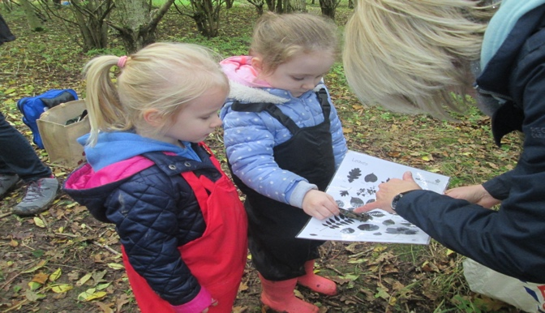

PARENTS NIGHT
Thank you for your feedback about parents night and your preferences for how you would like it to run. The views were pretty evenly split between during the Nursery session and parents evening timings. As a result of this we have decided that our Early Years Practitioners, Fiona, Elaine and Jillian will offer appointments in the week beginning the 6th November and our teachers, Claire and Louise will be available on the evening of Thursday 2nd November from 3.00pm - 5.30pm and 6.30pm – 9.00pm. Sign up sheets are available outside the Nursery for you to choose your slot.

HOW TO FIND OUT WHAT’S HAPPENING IN OUR NURSERY CLASS
Please visit our nursery class blog as it will be regularly updated with information and photographs about our nursery learning activities. The blog can be accessed at
https://blogs.glowscotland.org.uk/nl/Orchard
Or by simply typing Orchard Primary and Nursery Class into your search engine.

ANY QUESTIONS OR ENQUIRIES
If you have any questions, concerns, worries or would like to give us any feedback please feel free to speak to any member of staff, myself, Lorna Sneddon, Principal Teacher, or alternatively contact our Head Teacher, Mrs Jill Woodward by email at
ht@orchard.n-lanark.sch.uk

DATES FOR YOUR DIARY
FRIDAY 27th OCTOBER – Forest Kindergarten Walk
MONDAY 31st OCTOBER – Halloween party
MONDAY 20th NOVEMBER – closed, In-Service training day
FRIDAY 8th DECEMBER – Christmas Jumper Day
WEDNESDAY 13th DECEMBER – Christmas Concert
FRIDAY 22nd DECEMBER – Nursery closes.
MONDAY 8th JANUARY 2018 – Nursery reopens.

