“Supertato” by Sue Hendra

Clink on the link below to listen to the story:  https://www.youtube.com/watch?v=QlaMeNmTG6c | Who is your favourite character?  Can you make a picture or model of them?  You can use pens, pencils, crayons, collage, junk or playdough. | We eat vegetables to keep our bodies healthy.  What else could you do today to keep yourself fit and healthy?  How about giving this a try?  https://www.youtube.com/watch?v=Zo5fCFgGPpg
Let’s Talk  What part of the story was your favourite?  Where did the story take place?  Did you think the story was funny?  How did the story end? | 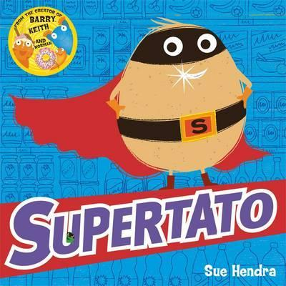 | Let’s Get Messy!  If you have some shaving foam handy you could squirt some onto a table. I wonder if you could write the letter ‘S’ for Supertato in it with your finger. Maybe you could draw some of the vegetables too.
Let’s Discover  Can you remember all the different vegetables in the story?  Which ones do you like to eat?  Ask your family members what their favourite vegetable is. | Let’s Pretend  If you were a superhero, what do you think would be your superpower?  Can you pretend to be a Superhero, doing lots of good deeds to help people? | Let’s Create  Can you make your own vegetable superhero? I wonder what vegetable you will choose? What will be their superpower?

