Primary 2 – 4 Learning Activities
LET’S GO FLY A KITE!

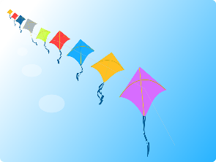

- Use the internet to research how to make a kite.
- Decide the best shape to allow your kite to both look good and fly well.
- Decide which materials would be best to make your kite (are your materials light enough to fly?).
- Draw a plan of your design and record important measurements such as the length and breadth of the kite, the length of supports and the length of string/thread.
- Decorate your kite. Remember that bold colours and patterns will be easily seen from a distance.
- You may wish to add a tail to your kite.
- Work with another member of your family to attach your kite securely to the flying line.
- Go fly your kite!

MY SPECIAL SOMETHING

- Do you have a favourite game or toy? Or maybe you have something special that someone gave you like a photo or a present? Decide on something special which you can share your feelings about once back in school.
- Look closely at your special something. Draw an accurate picture of it.
- Write a detailed description of your special something. Don’t forget to use lots of adjectives.
- Practise your special something presentation in front of someone in your family.
- Write a list of questions you might like to ask a classmate about their special something.
- Take your special something into school and share it with your class.

PLANNING AND SERVING AFTERNOON TEA

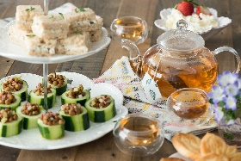

- Work out how many people are coming to afternoon tea.
- Design an invitation for each of your guests.
- How many sandwiches and cakes will each person get? Work out the total number you’ll need.
- Set out the table in an attractive way. You may wish to design and make a decoration for the middle.
- Ask an adult or older brother or sister to help you prepare food for the afternoon tea.
- Once everyone’s at the table, can you halve the cake? Can you cut it into quarters? What about eighths?
- Share out the sandwiches and cakes equally, so everyone has the same.
- At the end of afternoon tea, be a responsible citizen by helping tidy the table and doing the dishes.
TREASURE ISLAND

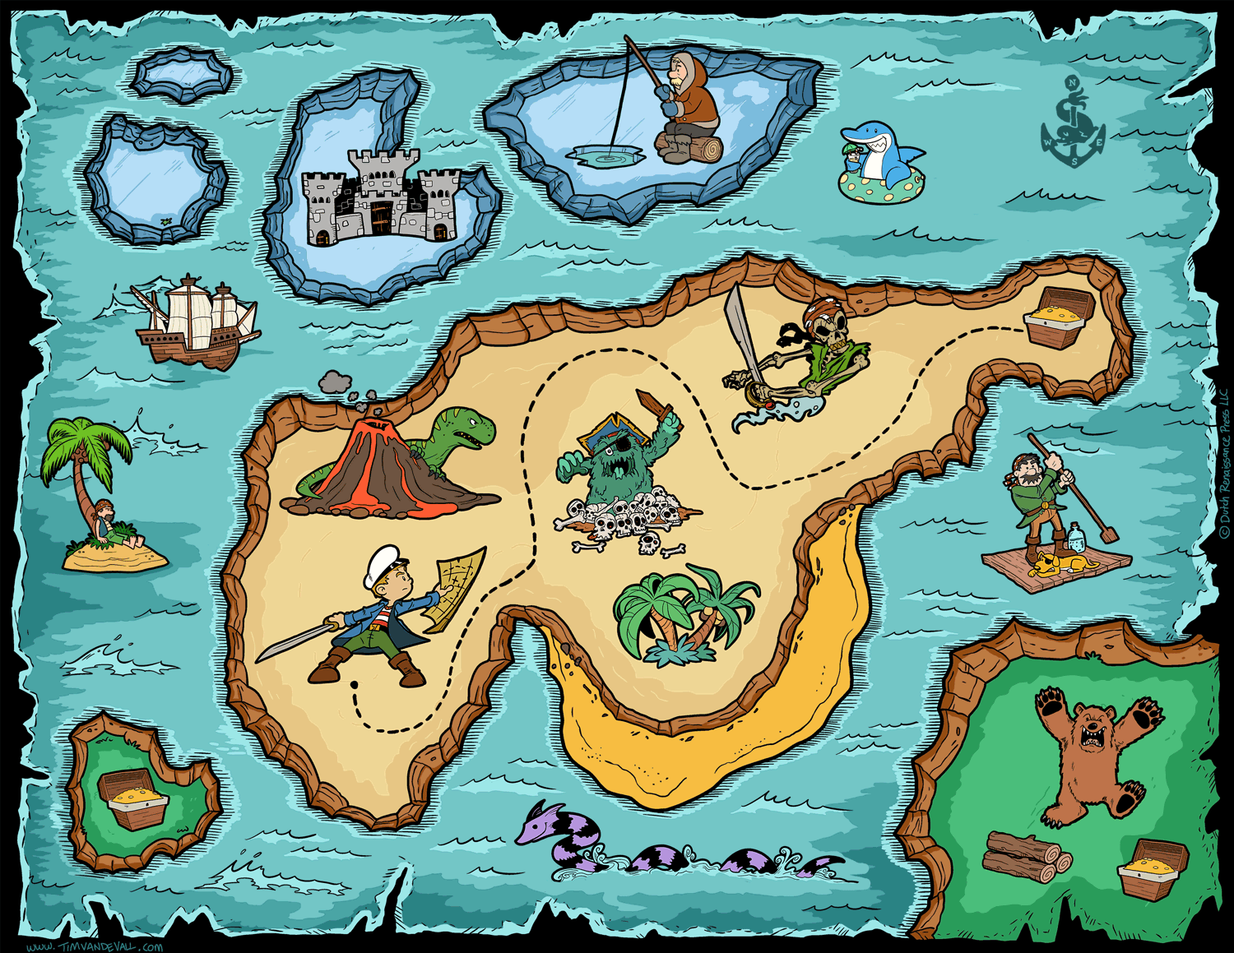

The map for a secret treasure island has been lost at sea. Create a new map so that Captain Josie can find the hidden treasure.

- Draw the shape of your island on a piece of paper.
- Add a compass in the corner of the page showing North, South, East and West.
- Add different features such as rivers, mountains, beaches, swamps, secret caves, etc.
- Decide where the treasure is hidden, but don’t mark this on the map!
- Write clear, step by step instructions on how to find the treasure. Use compass directions and the features you have draw to help Captain Josie get to the treasure.
- Invite a family member to pretend they are Captain Josie and use the instructions to discover where the hidden treasure is. Did they manage to find it?

CREATING A BOARD GAME

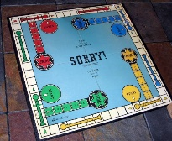

You and your friends are BORED, BORED, BORED playing the same old BOARD games, so you decide to design a brand new one. You can be as imaginative and creative as you like!

- Think about board games you have played in the past. Brainstorm ideas for your own.
- Think of a theme for your board game. This could be almost anything: dinosaurs, school, the jungle, outer space!
- Make a rough sketch of your game. Opportunities for players to jump forward or go back spaces will make your game all the more exciting!
- Ask a member of your family for feedback. Is there anything they think would improve your game?
- Make your final board game (the reverse side of a cereal box would be a good thing to use). Make sure you use a ruler to measure out everything carefully. You may even wish to make your own spinner or dice.
- Write clear instructions on how to play your board game.
- Once finished, sit down with members of your family and enjoy playing your game!

