Primary 5 – 7 Learning Activities

IMPROVING YOUR LOCAL COMMUNITY

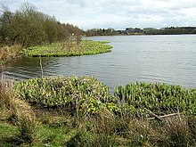

- Use a map to identify the various facilities within your local area and record this information in a suitable format.
- Think about facilities which could be added to improve your local area.
- Choose one facility to be developed and create a plan showing key features.
- Create a 3D model from your plan.
- Think about how you will present your model to your class once you are back in school.

CREATING A BOOK FOR YOUNGER READERS

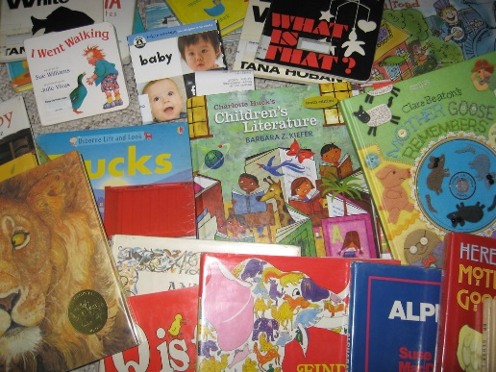

- Brainstorm ideas of possible stories. Remember that this book is for younger readers (Primary 1 and 2 children).
- Choose one of your ideas and plan out the story, thinking about the setting and characters.
- Write the first draft of your story. Share this with someone in your family to get feedback.
- Edit your story, ensuring spelling and punctuation are correct.
- Think about the title, layout, front cover and illustrations of your book. Once you are ready, create your book.
- Once back in school, read your story to a younger audience.

DECORATING YOUR HOUSE

- You have decided to redecorate the living room, kitchen, bathroom and one of the bedrooms in your house. You have a budget of £1500.
- Carefully measure each room. You will need to workout the total area of each wall and floor using the length X breadth formula.
- Using an online DIY site, ‘buy’ sufficient paint to paint the walls, skirting boards and doors.
- Using an online DIY site, ‘buy’ sufficient wallpaper for the bedroom.
- Select and ‘buy’ new carpet for the living room and bedroom.
- Design a bathroom tile with at least one line of symmetry and use this to create a repeated pattern.
- Using an online DIY site, ‘buy’ sufficient tiles to replace the existing tiles in your bathroom.
- You are fortunate that your family has a friend who is a carpet fitter – he has agreed to fit the carpets for £40. However, you will need to take into account additional materials such as paint brushes, wallpaper paste and grout.

PLANNING A HOLIDAY

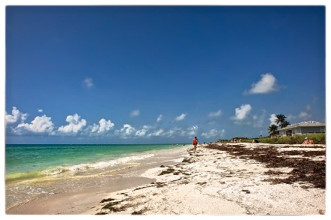

- Your family would like to go on holiday in July for one week. You have a budget of £2500.
- Use the internet to research transport options (ferry, train, plane, etc.)
- Find the best value transport cost for your family and calculate the actual travel price (remember to deduct this from your budget)
- In the same way, calculate the best accommodation costs for your family.
- Apply any child/other discounts to the cost.
- After subtracting transport and hotel costs, work out what your daily budget will be for food, drink and excursions
- Research available activities/excursions at your holiday destination. Work within your budget to choose which to go on
- Discuss food requirements for the day and work out how much these will cost over the week.
- Design and write a postcard for your chosen destination.
- Imagine you have returned from holiday. Write a review using persuasive language for Trip Advisor.
MARKETING A NEW PRODUCT

- You are a local company which specialises in manufacturing homemade biscuits and snacks. You have decided to produce a new energy bar.
- Research and source online the cheapest price for the raw ingredients
- Work out the cost of producing a batch of energy bars
- Agree on a selling price which ensures your company makes a profit
- Decide on your target market
- Decide on a name for your product
- Write a catchphrase/jingle to use in your advertising campaign
- Design the packaging
- Produce a poster to advertise your product
- Write and record a radio advertisement to promote your product.

