CfE Higher Biology

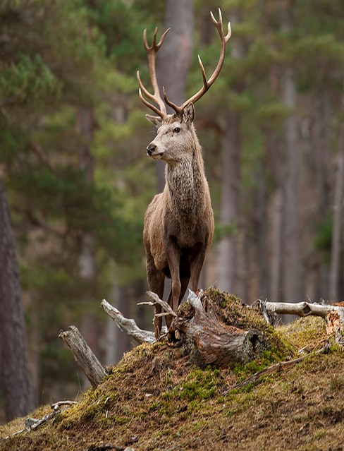

Unit 3
Sustainability and Interdependence
Pupil Notes

Name _________________________

Section 3.1 – Food Supply, Plant growth and Productivity
3.1(a) Food Supply
Food security is the ability of a population to access food in sufficient quality and quantity to maintain a healthy population.
The human population is increasing rapidly and there are concerns about food security. These two facts combined have led to a demand for increased food production.
Food must be produced in a way that is sustainable. This means that the production methods should not degrade natural resources which would make it harder to grow food in the future.
Agricultural production depends on factors that control photosynthesis and plant growth. The physical area that we have to grow crops is limited. This means that to increase food production we must look at ways that we can increase plant growth.
Example of this are:
- Breeding higher yielding cultivars (plant varieties)
- Using fertilisers
- Protecting crops from pests
- Protecting crops from disease
- Protecting crops from competition
Plant breeders produce food crops such as cereals, potato, toots and legumes that have higher nutritional values. Other favourable characteristics include resistance to pest and disease, ease of growth and harvesting and ability to thrive in particular conditions.
Farming can also involve the rearing of livestock. This has advantages and disadvantages;
Disadvantages – This produces less food per unit area than crop plants due to loss of energy between trophic levels in a food chain.
Advantages – Livestock production is often possible in habitats unsuitable for growing crops.
REMEMBER N5
Food chains and webs

3.1(b) Photosynthesis
REMEMBER N5
Photosynthesis
Photosynthesis is the process in which light energy is absorbed by photosynthetic pigments to generate ATP and for photolysis.
Reflected
There are 3 fates of light, when it hits the leaf
- Absorbed – used for photosynthesis
- Reflected – bounces back out
Absorbed
- Transmitted – passes straight through
Transmitted

Photosynthetic Pigments
There are various pigments involved in absorbing light energy for photosynthesis.
- Chlorophyll a
- Chlorophyll b
- Carotenoids (including carotene and xanthophyll)
These pigments are found in chloroplasts. They all absorb a different range of wavelengths of light. Chlorophyll is the main pigment. The Carotenoids extend the range of wavelengths that are absorbed and pass the energy on to chlorophyll.
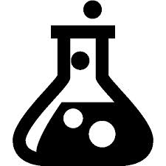
ACTIVITY 1
You are going to do an experiment to extract and separate leaf pigments
Collect the protocol card and your teacher will guide you through the practical activity.

ACTIVITY 2
400 500 600 700
Wavelength of light (nm)
Colour in the diagram to show the colours produced when white light is split into its various components of different wavelengths.

Absorption Spectrum
400 500 600 700
Wavelength of light (nm)

When white light is passed through leaf pigments certain colours are absorbed and disappear from the light spectrum. This gives rise to the absorption spectrum.

Black bands are found where light of that particular wavelength has been absorbed by the leaf pigments, most of the absorbed light is in the blue and red regions of the spectrum. Green light is not absorbed by the leaf pigments, instead it is reflected which is why chlorophyll is green.
Absorption spectrum can be graphed as wavelength in nm (x-axis) against relative absorbance (y-axis). A detailed absorption spectrum for each pigment is shown below.

Absorbance

Accessory Pigments (carotenoids)
400 500 600 700
Wavelength of light (nm)
Wavelength of light (nm)

Chlorophyll a
Absorbance

400 500 600 700
Wavelength of light (nm)
400 500 600 700
Wavelength of light (nm)
Wavelength of light (nm)

Chlorophyll b
Absorbance
Carotenoids *(carotene and xanthophyll) absorb light in other regions e.g. green

Carotenoids extend the range of wavelengths absorbed and pass the energy to chlorophyll for photosynthesis.

Chlorophyll a and b absorb in the blue and red end of the spectrum.

Action Spectrum
The action spectrum shows the amount of photosynthesis you get from each wavelength of light, from all the pigments working together.

Wavelength of light (nm)

400 500 600 700
Wavelength

W

Wavelength of light (nm)
Photosynthetic activity

Absorption Spectrum | Action Spectrum
Light absorbed in blue and red regions of the spectrum by chlorophyll a and b | Light absorbed by chlorophyll a and b is used for photosynthesis
Light absorbed in green regions by carotenoids | Light absorbed by carotenoids is passed to chlorophyll a and b for photosynthesis

Energy Capture (light dependent stage)
When the chlorophyll pigments absorb light, the energy excites electrons in the pigment molecules. The transfer of these electrons through the electron transport chain releases energy to generate ATP by ATP synthase.
Remember Unit 2
Respiration and ATP Synthase
Energy is also used for photolysis, in which water is split into oxygen, which is evolved (given off as a by-product), and hydrogen which is transferred to the co-enzyme NADP (acting as a hydrogen acceptor) to form NADPH.
The ATP and NADPH are passed on to the next stage, the Calvin Cycle.

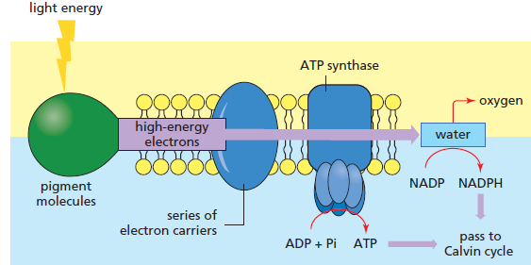

The Calvin Cycle (carbon fixation stage)
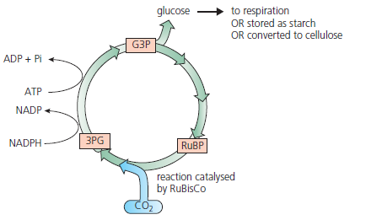
In this stage of photosynthesis carbohydrate is produced by the following metabolic pathway.

- The enzyme RuBisCo fixes carbon dioxide by attaching it to ribulose biphosphate (RuBP). This produces 3-phosphoglycerate. (3PG)
- The 3-phosphoglycerate (3PG) produced is phosphorylated by ATP and combined with hydrogen from NADPH to form glyceraldehyde-3-phosphate (G3P).
- G3P is used to regenerate RuBP (to continue the cycle) and for the synthesis of glucose.

Fate of Glucose
Glucose may be used a respiratory substrate, synthesised into starch or cellulose or passed to other biosynthetic pathways.
Glucose

Cellulose
(Structural carbohydrate e.g. cell wall)
Starch
Storage Carbohydrate)
Passed to other biosynthetic pathways which can lead to the formation of a variety of metabolites such as DNA, protein and fat.
Respiration
(Respiratory substrate)

ACTIVITY 3 – ESSAY HIGHER 2019 16A
Write notes on photosynthesis under the following headings.
- Use of energy absorbed by photosynthetic pigments (3)
- Carbon fixation (4)

ACTIVITY 20: Extended Answer
2014 Section C - Q2B (Revised Higher)
Give an account of genomics and its importance in phylogenetics and personalised medicine. (8)
ACTIVITY 20: Extended Answer
2014 Section C - Q2B (Revised Higher)
Give an account of genomics and its importance in phylogenetics and personalised medicine. (8)

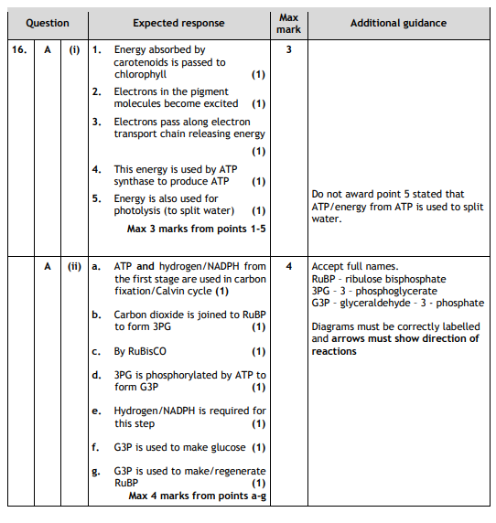

Section 3.2 – Plant and Animal Breeding
3.2(a) Plant and Animal Breeding
Plant and animals can be bred to improve characteristics to help support sustainable food production.
Breeders develop crops and animals with:
- Higher food yields
- Higher nutritional values
- Pest and disease resistance
- The ability to thrive in particular environmental conditions
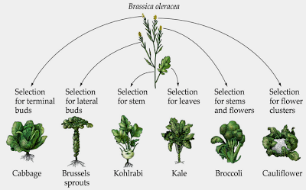

Heritable characteristic | Example
Higher yield | Increase in mass of food produced by wheat crop
Higher nutritional value | Increase in mass of protein produced by soya bean crop
Resistance to pests | Resistance of tomato to eelworm
Resistance to disease | Resistance of potato to late blight
Ability to thrive in a particular environment | Ability of maize to grow in cold, damp climate.

3.2(b) Plant Field Trials
Field Trials
Plant field trials are carried out in a range of environments to compare the performance of different cultivars or treatments and to evaluate GM crops
A plant field trial is an investigation which is set up to
- Compare the performance of two different plant cultivars (e.g. conventional versus GM) under the same set of experimental conditions
- Find out the effect of different environmental conditions on a new cultivar of crop plant.
Designing a field trial.
The area of land being used in a field trial is divided into equal sized portions called plots. Once you have decided what it to be investigated the following factors must be considered:
Selection of treatments to be used – involving one variable factor to ensure that a fair comparison can be made.
Number of replicates to be included – to take account of the variability within the sample
Randomisation of treatments – to eliminate bias existing when measuring treatment effects.

ACTIVITY 4 Field trials
You are going to design a field trial to investigate the effect of concentration of a nitrogenous fertiliser on a new cultivar of cereal plant. Think about
- What the variable will be?
- What variables will you control?
- How many replicates will you make, check the plot diagram below and work this out.

ACTIVITY 4 Field trials

If the plots are treated in an orderly basis then bias can happen – soil moisture may be lower on one side of the field, e.g. plot a treatments having a built in bias of less soil moisture compared with plot d treatments.

Non randomised field test
a | b | c | d
a | b | c | d
a | b | c | d
To overcome this you must randomise the pattern of replicated treatments in your trial to eliminate bias.
Example Treatments
Treatment a – no nitrogen fertiliser used
Treatment b –25% nitrogen fertiliser used
Treatment c – 50% nitrogen fertiliser used
Treatment d – 75% nitrogen fertiliser used.
On the plot diagram and mark in which treatments (a –d) you will use on which areas.
a | b | c | d
d | a | b | c
c | d | a | b
b | c | d | a

ACTIVITY 4 Field trials
Answer these questions
- What is the difference between a plot and a treatment?

- Why did you vary only one factor in the treatments?

- Give sources of experimental error which may affect the outcome.

- What feature of the experimental design takes this uncontrolled variability into account?

- Explain how bias due to different conditions in soil is prevented.

3.2(c) Inbreeding
Inbreeding involves the fusion of two gametes from close relatives.
In inbreeding, selected related plants or animals are bred for several generations until the population breeds true to the desired type. This means that all new plants show the same desirable characteristics. This happens due to the elimination of heterozygotes. All new plants produced are homozygous for the desired trait.
A result of inbreeding can be an increase in the frequency of individuals who are homozygous for recessive deleterious alleles (alleles which result in phenotypes that are harmful to the organism). These individuals do less well at surviving and this results in inbreeding depression, which means that the population as a whole cannot survive and reproduce as well.
Effects of Inbreeding
Inbreeding ensures that the members of each generation of a selectively bred strain receive alleles for the desired characteristic. But can also lead to:
- Loss of heterozygosity and development of homozygosity.
- Inbreeding depression – due to the accumulation of recessive, harmful homozygous alleles. This appears as a decline in vigour, size, fertility and yield of the plant or animal.
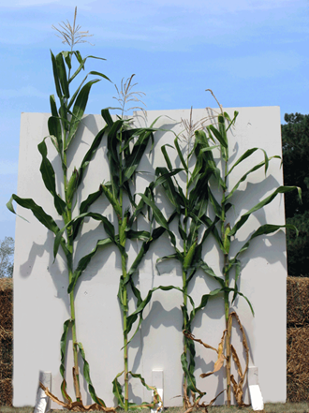
Inbreeding depression in maize.
3.2(d) Cross Breeding and F₁ hybrids
Crossbreeds
In animals, individuals from different breeds (but within the same species) can mate to produce offspring called crossbreeds. This process may produce a new crossbreed population with improved characteristics. The two parent breeds can be maintained to produce more crossbred animals showing the improved characteristic.

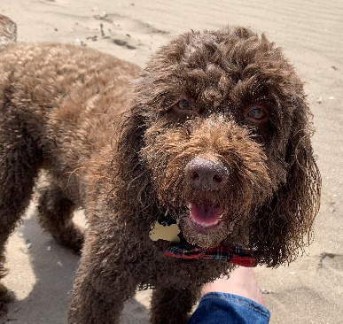
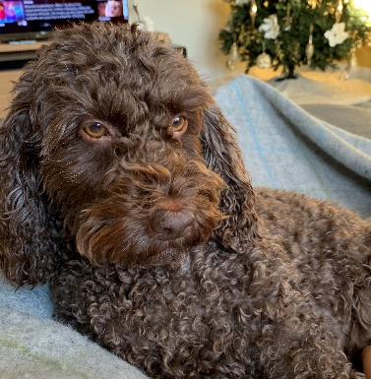
Cocoa the perfect crossbreed
(F₁ offspring from poodle x cocker spaniel)
SHE’S SO FLUFFY!!!

New desirable alleles can be introduced to plant and animal lines by crossing one cultivar (plant variety) or breed with an individual with a different, desired genotype.

F1 hybrids
F₁ hybrids are produced when two different inbred populations (different species) are crossed.
In plants this creates a relatively uniform heterozygous crop. F1 hybrids often have increased vigour and yield. Plants with increased vigour may have increased disease resistance or increased growth rate.
F1 hybrids are not usually bred together as the F2 produced shows too much variation.

ACTIVITY 4
- Research crossbred dogs. Try to find two examples. Identify the parental breeds and describe how the offspring show improved characteristics.
- Find an example of a F1 hybrid plant. What species are crossed to produce it? What are its desirable characteristics?

3.2(e) Genetic Technology
As a result of genome sequencing, organisms with desirable genes can be identified and then used in breeding programmes. Breeding programmes can involve crop plants that have been genetically modified using recombinant DNA technology.
Single genes for desirable characteristics can be inserted into the genomes of crop plants, creating genetically modified plants with improved characteristics. Examples of this include insertion of Bt toxin gene into plants for pest resistance, and insertion of glyphosate resistance gene for herbicide tolerance.
ACTIVITY 5
Pick one of the examples above (Bt toxin gene or glyphosate resistance gene)
Try to find out what species the inserted gene came from and what benefits it gives to the genetically modified plant.

Section 3.3 – Crop Protection
3.3(a) Weeds, pest and disease
Different organisms can damage crop plants and so reduce productivity.
- Weeds compete with crop plants for nutrients, space and light.

There are two different types of weeds:
  - Annual weeds — rapid growth, short life cycle, high seed output and long-term seed viability.
  - Perennial weeds — use storage organs and vegetative reproduction to allow them to reproduce quickly.

- Invertebrate animals such as insects, nematode worms and molluscs can damage plant organs by feeding on them.

- Fungi, bacteria or viruses can cause plant diseases and are often carried by invertebrates.

3.3(b) Control of Weeds
Weeds, other pests and diseases can be controlled without the use of chemicals.
The following methods of pest control are known as cultural methods:
- Ploughing - The soil is turned over and any weeds have their roots disrupted and
are pushed under the soil.
- Weeding - Weeds are pulled out of the soil and are disposed of.
- Crop rotation - Differentiation of crops grown over time on the same field.
Different crops bring about different cultural practices, which act as a factor in disrupting the growing cycle of weeds, as they cannot adapt due to differing pressures.

3.3(c) Pesticides
Pesticides are a group of chemicals that kill pests!
There are different categories of pesticides that are specific to certain pests:
- Herbicides – kill weeds
- Fungicides – kill fungal diseases
- Insecticides – kill invertebrates (insects)
- Molluscicides – kill molluscs (slugs and snails)
- Nematicides – kill nematodes (tiny worms)
Pesticides can be either:
- Selective – Selective herbicides have a greater effect on certain plant species
(eg. With broad leaved weeds).
- Systemic – The chemicals are absorbed by the plant and spread through the
vascular system. Systemic herbicides prevent regrowth. Systemic insecticides, molluscicides and nematicides kill pests feeding on plants as they ingest plant material containing the chemical.

There are disadvantages to using pesticides
- Other species of non pest plant may be damaged
- Many pesticides do not break down and so persist in the environment.
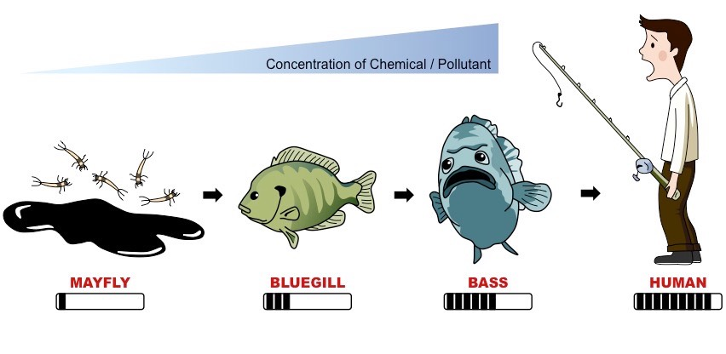
- Bioaccumulation can occur when the chemicals build up in an organism as its unable to be broken down. This can be harmful.
- Biomagnification occurs in food chains when the chemical increases in concentration as organisms move up trophic levels.
- Pest species can develop resistance.

3.3(d) Other Methods of Control
In today’s environmentally conscious society the risks of pesticides are often considered too great and farmers look for other more natural methods of pest control.
These include:
- Biological control - the control agent is a natural predator, parasite or pathogen of the pest. There are risks with this method as the control organism may become an invasive species, parasitise, prey on or be a pathogen of other non-pest species.
- Integrated pest management – a combination of chemical, biological and cultural control.

ACTIVITY 6 – ESSAY HIGHER 2016
Write notes on crop protection under the following headings:
- weeds, pests and diseases (4)
- methods of control (4)

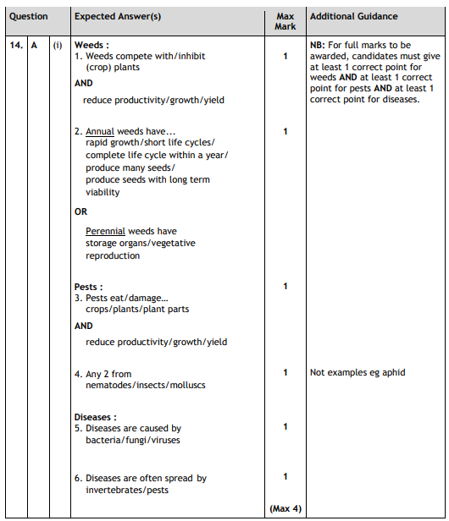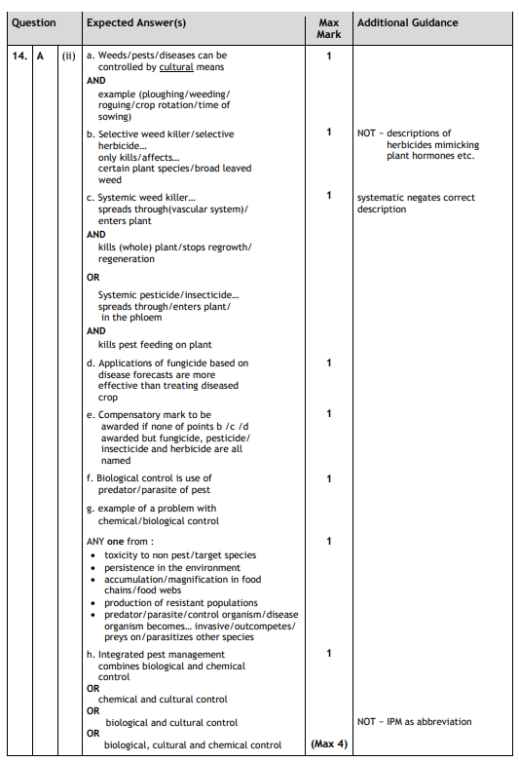Section 3.4 – Animal Welfare
Livestock production is a major industry across the globe. In the UK there are strict laws concerning animal welfare but these are only in terms of basic levels of care. Many animal producers choose to provide higher levels of welfare in demand from more environmentally conscious consumers.
Method | Intensive farming | Free range farming
Advantages | Low cost so higher profit  More cost effective as less land needed | Can be sold at a higher price  Animals have a better quality of life
Disadvantages | Less ethical | More land needed  More labour intensive

When animals have poor welfare they can show various behaviours;

- Stereotypy – performing repetitive movements that have no purpose eg. Pacing and rocking.
- Misdirected behaviour – this is when normal behaviour is performed excessively such as over grooming and gnawing at solid non-food items.
- Failure in sexual behaviour – animals stop demonstrating mating behaviours
- Failure in parental behaviour – animals abandon their offspring, even kill, or eat them.
- altered levels of activity – animal activity becomes very low (apathy) and they sit or lie in the same position for long period of time or very high (hysteria) where they move around excessively and are easily alarmed or panicked.

Section 3.5 – Symbiosis
Symbiosis is defined as a co-evolved intimate relationship between members of two different species.
There are two types of symbiotic relationship; parasitism and mutualism.
3.5(a) Parasitism
A parasite is an organism that needs another organism to carry out all or part of its life cycle.
The parasitic organism benefits in terms of energy or nutrients, whereas its host is harmed by the loss of these resources. Parasites often have limited metabolism and cannot survive out of contact with a host.
Parasite have to be transmitted to new hosts. They can do this by using
- Direct contact – host has physical contact with another potential host.
- Resistant stages – larvae and pupae can survive adverse environmental conditions until they come into contact with another potential host.
- Vectors - some parasites use another species to transfer them from one host to another for example the Plasmodium parasite (commonly known as malaria) is carried by mosquitoes (the vector) from one human to another.
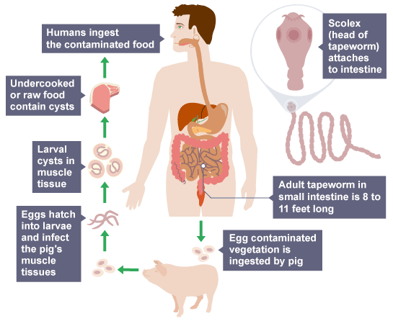
Some parasitic life cycles involve intermediate (secondary) hosts to allow them to complete their life cycle. The diagram shows how tapeworms use pigs as a secondary host.

3.5(b) Mutualism
In mutualism, one species relies on another for survival but unlike parasitism, both mutualistic partner species benefit in an interdependent relationship.
Examples of this include...
- 'Cleaner' fish feed off the dead skin and parasites of larger fish such as sharks. This provides the cleaner fish with food and protection and keeps the larger fish clean and less prone to infections.
- Lichens are formed by algae and fungi living together. Algae can photosynthesise and make food, which is shared by the fungus. The fungus in turn shelters the algae from a harsh climate.
- Leguminous plants (such as peas, beans and clover) have colonies of nitrogen-fixing bacteria in nodules attached to their roots. The plants gain nitrates from the bacteria, and the bacteria gain sugars from the plants. This is another example of mutualism.
ACTIVITY 7 – ESSAY HIGHER 2018
Write notes on parasitic relationships and transmission of parasites.

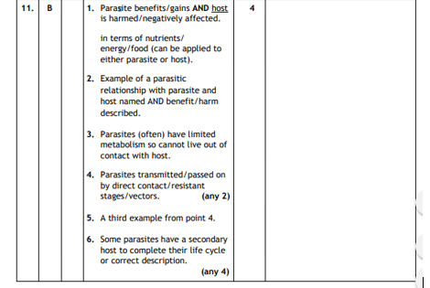

Section 3.6 – Social Behaviour
3.6(a) Social Groups
Many animals live in social groups. These animals have behaviours that are adapted to group living such as…
- Social hierarchy is a rank order within a group of animals consisting of a dominant and subordinate members. In a social hierarchy, dominant individuals carry out ritualistic (threat) displays whilst subordinate animals carry out appeasement behaviour to reduce conflict. Social hierarchies increase the chances of the dominant animal’s favourable genes being passed on to offspring. Animals often form alliances in social hierarchies to increase their social status within the group.

- Co-operative hunting is when animals hunt together in groups. This may benefit subordinate animals as well as dominant ones, as they may gain more food than by foraging alone. The main benefit is that less energy is used per individual. Co-operative hunting enables larger prey to be caught and increases the chance of success.
- Social defence is when groups work together to avoid predation. These strategies increase the chance of survival as some individuals can watch for predators whilst others can forage for food. Groups adopt specialised formations when under attack protecting their young, such as forming a huddle with the young on the inside.

3.6(b) Altruism and Kin Selection
An altruistic behaviour harms the donor individual but benefits the recipient. Behaviour that appears to be altruistic can be common between a donor and a recipient if they are related (kin). When organisms are related, they share genes and so the donor will benefit in kin selection because there are shared genes in the recipient’s offspring or future offspring. By helping the recipients offspring survive then they are also ensuring that their own genes are passed on. This is shown in bees when worker bees feed and care for eggs laid by the queen bee.
Reciprocal altruism is where the roles of donor and recipient later reverse (tit for tat). This often occurs in social animals. This is shown in higher order animals as there is an element of learning and memory. This is shown when birds sound warning calls to warn the group so making themselves a target for predators.

3.6(c) Social Insects
In social insects (such as bees, wasps, ants and termites) only some individuals reproduce. The queen mates with the males (drones) to reproduce. Only the queen lays eggs. Most members of the colony are sterile workers who co-operate with close relatives to carry out other roles such as
- raise relatives
- defending the hive
- collecting pollen
- carrying out waggle dances to show the direction of food.
All of the members of the colony are closely related and so share many genes. Social insects show altruistic behaviour and kin selection to increase the survival of shared genes.
ACTIVITY 8 – ESSAY HIGHER 2016
Write notes on social behaviour in animals under the following headings:
- social hierarchy and cooperative hunting;
- social insects.

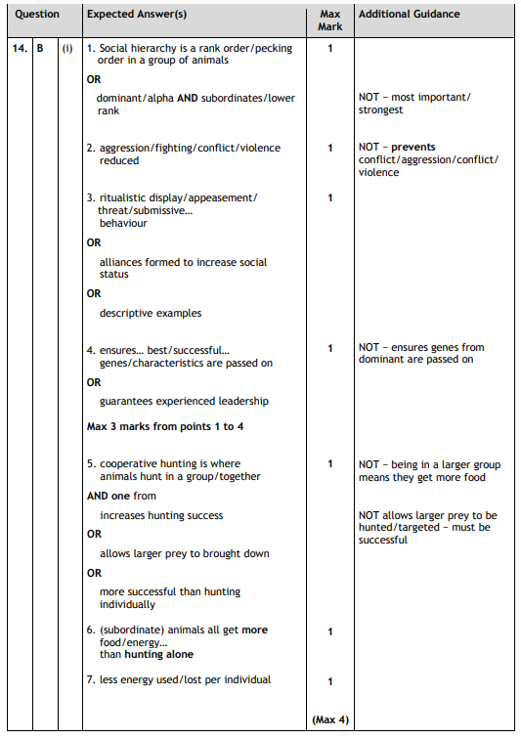

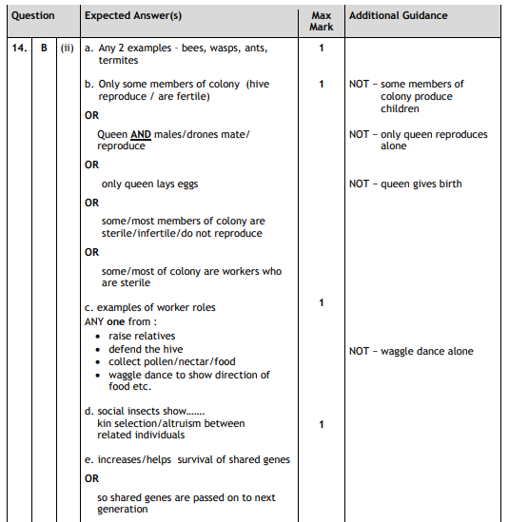

3.6(d) Primate Behaviour
Primates have a long period of parental care. They look after their offspring for years. Chimpanzee babies nurse for 4-5 years and stay with their mothers for 7 to 8 years. This allows the learning of complex social behaviour.
These complex social behaviours support the social hierarchy and include ritualistic display and appeasement behaviour. A social hierarchy means that there are dominant and subordinate individuals. These behaviours reduce conflict and aggression. They do not prevent it.
Alliances form between individuals, which are often used to increase social status within the group. Grooming is a method used to form alliances. Primates also use facial expression, body posture and sexual presentation to form alliances.
ACTIVITY 9 – ESSAY HIGHER 2017
Write notes on primate behaviour. (4)

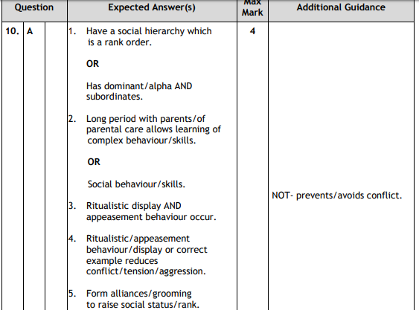

Section 3.7 – Components of Biodiversity
Biodiversity include three components;
- Genetic diversity - the number and frequency of all the alleles within a population. If one population of a species dies out then the species may have lost some of its genetic diversity, and this may limit its ability to adapt to changing conditions

- Species diversity - the number of different species in an ecosystem (the species richness) and the proportion of each species in the ecosystem (the relative abundance). A community with a dominant species has a lower species diversity than one with the same species richness but no particularly dominant species.

- Ecosystem diversity - refers to the number of distinct ecosystems within a defined area.
ACTIVITY 9 – ESSAY HIGHER 2016
Write notes on components of biodiversity and how these are measured. (4)

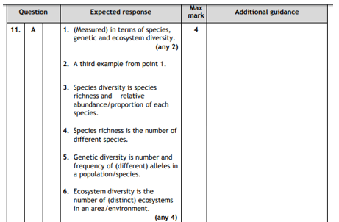
Section 3.8 – Threats to biodiversity
3.8(a) Exploitation
Exploitation and recovery of populations and the impact on their genetic diversity. With overexploitation, populations can be reduced to a low level but may still recover. Some species have a naturally low genetic diversity in their population and yet remain viable.
The bottleneck effect — small populations may lose the genetic variation necessary to enable evolutionary responses to environmental change.
In small populations, this loss of genetic diversity can be critical for many species, as inbreeding can result in poor reproductive rates.

3.8(b) Habitat Loss
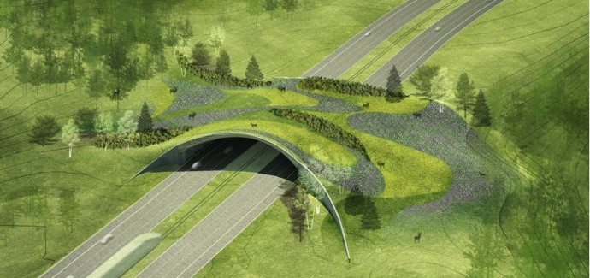
The clearing of habitats has led to habitat fragmentation. Degradation of the edges of habitat fragments results in increased competition between species as the fragment becomes smaller. This may result in a decrease in biodiversity. To remedy widespread habitat fragmentation, isolated fragments can be linked with habitat corridors.
More isolated fragments and smaller fragments exhibit a lower species diversity. The corridors allow movement of animals between fragments, increasing access to food and choice of mate. This may lead to re-colonisation of small fragments after local extinctions.

3.8(c) Invasive Species
Introduced (non-native) species are those that humans have moved either intentionally or accidentally to new geographic locations. Those that become established within wild communities are termed naturalised species. Invasive species are naturalised species that spread rapidly and eliminate native species therefore reducing species diversity. Invasive species may well be free of the predators, parasites, pathogens and competitors that limit their population in their native habitat. Invasive species may prey on native species, out-compete them for resources or hybridise with them.
ACTIVITY 11 – ESSAY Higher 2017
Write notes on invasive species. (4)

