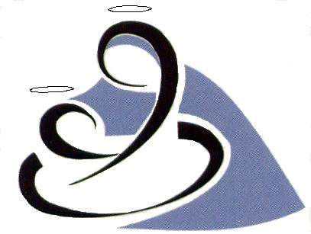

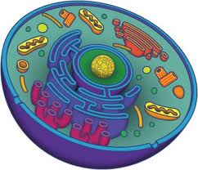
Our Lady’s High
Biology

Unit 1
Cell Biology

Pupil Notes

Unit 2 Cells
BGE Outcomes
Experiences and Outcome | Benchmarks
I have taken part in practical activities which involve the use of enzymes and microorganisms to develop my understanding of their properties and their use in industries. SCN 4-13b | Describes the properties and industrial uses of at least one microorganism, for example, the use of yeast in brewing and bacteria in yogurt production.  Describes the properties of at least one enzyme used in industry, for example, enzymes within biological detergents and stain removers or pectinase in the breakdown of plant material to release juice
I can contribute to the design of an investigation to show the effects of different factors on the rate of aerobic respiration and explain my findings. SCN 4-02b | Explains, using experimental findings, the effect of different factors on the rate of aerobic respiration.  Uses the word equation to describe the process of aerobic respiration.
I can debate the moral and ethical issues associated with some controversial biological procedures. SCN 4-13c | Formulates a reasoned argument, based on evidence and using correct scientific vocabulary, to debate moral and ethical issues of the chosen controversial biological procedure, for example, the collection and use of stem cells and DNA profiling.
I have researched new developments in science and can explain how their current or future applications might impact on modern life. SCN 4-20a | Researches and communicates developments in science, explaining how current and future applications might impact on life.  Demonstrates increasing understanding of how the transferrable skills developed through the sciences are used in a wide variety of jobs including science, technology, engineering and mathematics (STEM) careers.

Unit 1 Topic 1 – Cell Structure
- Cell Structure
Cells are the basic units of life. All living things are made of cells.
Cells contain different structures that do different jobs.
Cell wall

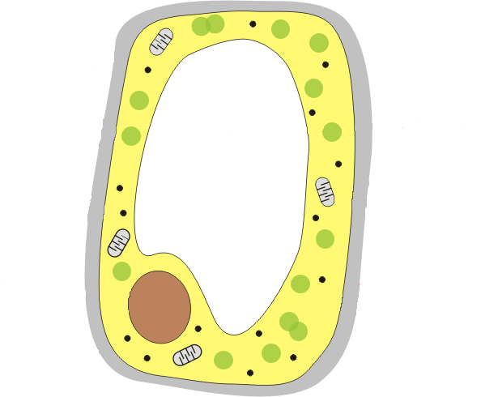
Animal cell
Plant cell
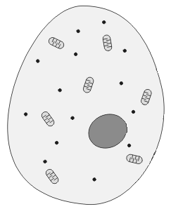
Cytoplasm
Mitochondriao
ribosomes
Nucleus
Cell membrane

Vacuole

Chloroplast

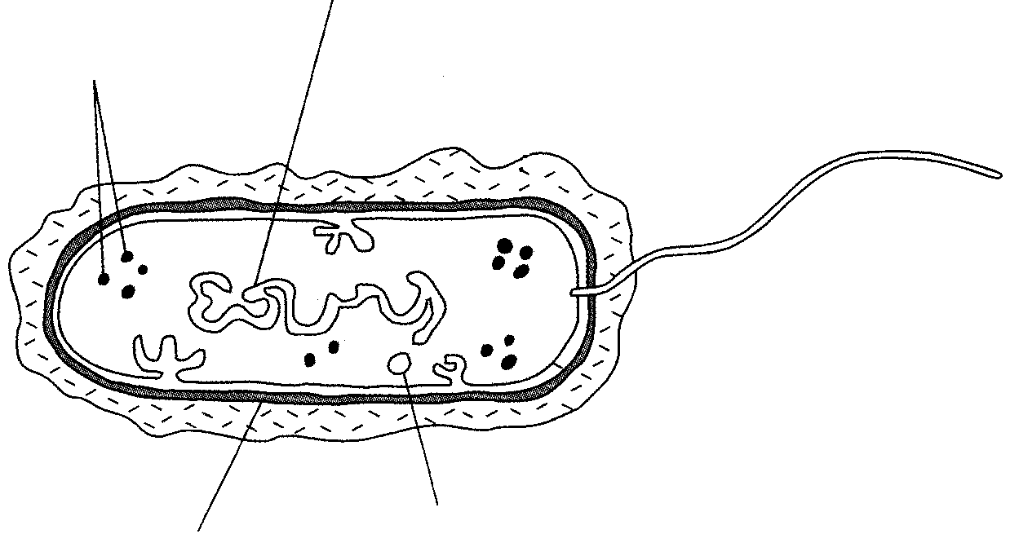
Ribosomes
Circular DNA
Plasmid
Cell wall
Bacterial cell

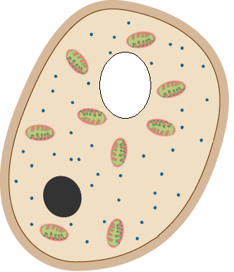
Cell wall
Mitochondria
vacuole
nucleus
cytoplasm
Cell membrane
ribosomesm
Fungal cell

Part | Function
Cell wall | Provides support and gives structure.  Made of cellulose in plant cells and other materials in bacteria and fungal cells
Mitochondria | Site of aerobic respiration
Chloroplasts | Site of photosynthesis
Cell membrane | Controls the entry and exit of materials
Vacuole | Contains sap and is involved in water balance
Nucleus | Contains DNA and controls cells activities
ribosomes | Site of protein synthesis
plasmid | Extra pieces of bacterial DNA

Bacteria
- Bacteria are single celled micro-organisms.
- They are like plant cells as they have a cell wall and ribosomes, but no other parts.
- The cell wall has a different structure to plant cell walls as it is not made of cellulose.
- They have one large circular piece of DNA and extra little pieces called plasmids.
- Plasmids give bacteria extra properties such as the ability to resist antibiotics.
- Bacteria can be used in biotechnology to make yoghurt and cheese.
- They can also be used to produce biofuels.

Fungi
- Fungi are organisms which are not quite plants or animals.
- Their cells are similar to other plant and animal cells but have a different cell wall which is not made of cellulose.
- Some fungi such as yeast are simple, unicellular organisms.
- Yeasts are important in biotechnology, where they are used in baking and brewing.
- They use sugar to make alcohol and carbon dioxide.
- Other complex fungi are used in biotechnology to produce a variety of enzymes and for production of antibiotics such as penicillin.


Focus on Problem Solving
How many times greater/smaller

How to do:
Divide the bigger number by the smaller number.

Example:
How many times greater is the concentration of DDT in the osprey compared to the trout?
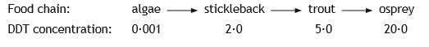

Working: 20.0/5.0 = 4

Answer: 4 times greater

Now you try one…
Lugworms live on the seashore in dark moist burrows under the sand. As the distance from the sea water at low tide increases the average number of lugworms increases from 9 per m² at 7 metres to 27 per m² at 11 metres.

Calculate how many times greater the average number of lugworms at 11 metres is compared to 7 metres from the seawater at low tide.
(adapted from N5 2014 Q10)

Space for working
11m = 27 per m² 7 m = 9 per m² at

27 / 9 = 3

Answer ________________

Unit 1 Topic 2 – Transport across cell membranes

a) Function and Structure of the Cell Membrane
The cell membrane allows the transport of materials in and out the cell.
It is composed of phospholipids and protein molecules.
Phospholipid
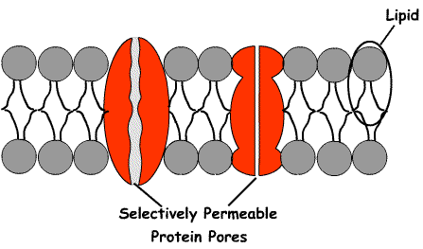
Selectively permeable protein pores
protein

The cell membrane is said to be selectively permeable because it lets small molecules through but not big ones.

b) Diffusion
Molecules move from an area of high concentration to an area of low concentration.
Area of High
Concentration
Area of Low
Concentration

A concentration gradient is the difference in concentration between two areas. In diffusion molecules move down a concentration gradient from high to low.
This process does not need energy and so it is said to be passive transport.

- Importance of Diffusion

Diffusion is a vital process in the survival of living organisms. In multicellular organisms it allows the movement of oxygen from the lungs into the blood, down a concentration gradient. It also moves oxygen and glucose into cells for respiration and allow waste products such as carbon dioxide to be removed from cells and excreted from the body. In a unicellular organism diffusion is the means by which it obtains food and oxygen from its surrounding environment.

- Osmosis
Osmosis is the movement of water molecules from a region of high water concentration to a region of low water concentration through a selectively permeable membrane. It is also passive transport as it does not require energy.

When water enters and leaves cells by osmosis it changes their appearance.

- Animal Cells

- Animals cells placed in a solution with a low water concentration will lose water and shrink.
- Animals cells placed in a solution with a high water concentration will gain water and burst.
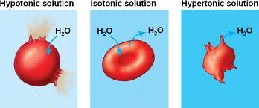

In high water concentration → Cell Bursts
In low water concentration → Cell shrinks

Plant Cells

- Plant cells placed in a solution with a low water concentration will lose water and become plasmolysed.
- Plant cells placed in a solution with a high water concentration will gain water and become turgid.
- The cell wall prevents the cell from bursting.
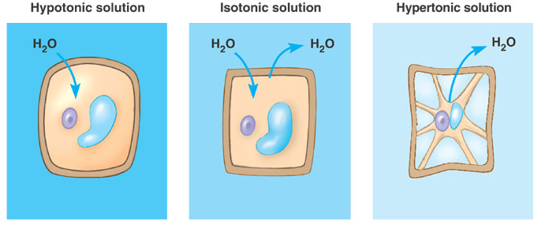

In high water concentration
→ Cell gains water and swells becoming turgid.
In low water concentration
→ Cell loses water, vacuole shrinks and membrane pulls away from wall becoming plasmolysed.

- Active Transport

Active transport is movement of molecules from a region of low concentration to a region of high concentration against the concentration gradient. In this process membrane proteins move molecules and ions against the concentration gradient and so it requires energy in the form ATP (see topic 1.8).
Area of High
Concentration
Area of Low
Concentration

Focus on Problem Solving

Percentages – Percentage Change

How to do: difference
X 100

original
Example:
Complete the table by calculating the percentage change in mass for beaker A.

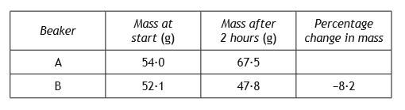

Working: difference
X 100
Don’t forget to add a + to show a percentage increase and a – to show a percentage decrease!
Original

= 67.5 – 54.0
X 100
54.0

= +25%

Answer: +25%

Now you try one…

Two gardeners compared their tomato crops. Both grew 10 plants of the same variety in a greenhouse. One gardener altered the environmental conditions in his greenhouse to increase the rate of photosynthesis. His plants yielded 720 tomatoes. The other gardener only produced 480 tomatoes.

What was the percentage increase in the yield of tomatoes when the rate of photosynthesis was increased?

Space for calculation
720-480 = 240
240 / 480 = 0.5
0.5 x 100 = 50%

Answer __________%

(from SGC 2013 Q5(a)i)
Unit 1 Topic 3 – DNA and the Production of Proteins

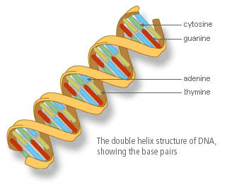
- Structure of DNA

Genetic information is found in the nucleus of cells in the form of a molecule called DNA. DNA is organised into genes and these are found on chromosomes. Genes are sections of DNA that code for a protein. DNA contains all the information needed for normal cell function. Each individuals DNA is unique.

DNA is a molecule that is made of two strands held together by complementary base pairs. The double stranded DNA molecule is then twisted to form a coiled shape described as a double helix.

There are four different bases that make up DNA; the bases are called Adenine (A), Cytosine (C), Guanine (G), and Thymine (T). These bases make up the genetic code and determine the sequence of amino acids in a protein.
A always bonds with T and G always bonds with C.

T A C T G T G G

A T G A C A C C T G T A T A G G A T G A C G C C A G

- DNA and Proteins
DNA carries the genetic information for making proteins. Genes code for proteins. Proteins are made of molecules called amino acids.
The base sequence in a gene determines the amino acid sequence in a protein.
To make a protein the code from the DNA in the nucleus has to be carried to a ribosome where proteins are made.
A molecule called messenger RNA (mRNA) carries a copy of the code from the DNA in the nucleus to a ribosome in the cytoplasm.
The protein is assembled on a ribosome using amino acids.
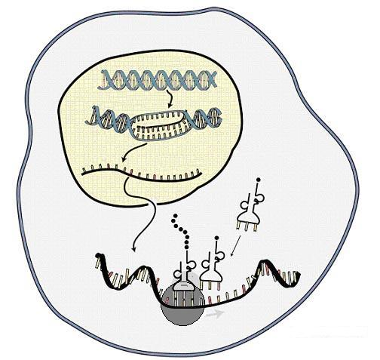
DNA
Amino acid
Protein
mRNA
Ribosome
membrane
nucleus
cytoplasm

- In the nucleus a section of DNA opens up and a molecule of mRNA is made against the DNA bases. The mRNA carries a complementary copy of the genetic code from the DNA.
- The mRNA molecule leaves the nucleus and travels through the cytoplasm to a ribosome.
- Amino acids are brought to the mRNA on the ribosome. The base sequence of the mRNA determines the amino acid sequence.
- The amino acids bind together to make a protein.
The sequence of the amino acids determines the structure and function of the protein.

Focus on Problem Solving
Calculating rate (speed)

How to do:

Rate is a measurement of the speed of a reaction. It is a measurement that shows change with time.
It is related to distance and time;
rate = distance / time
time = distance / rate
distance = rate x time

To work out rate you have to know what the change is and the time taken for the change to happen.

Example:
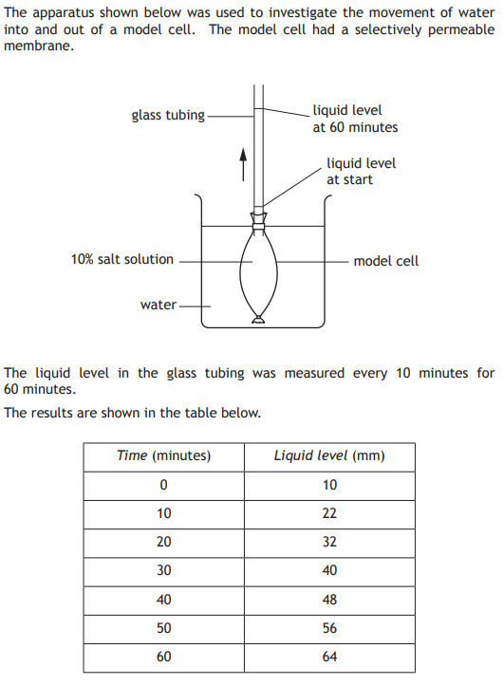

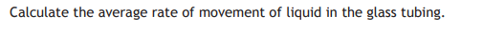

Remember rate = distance / time

So work out the change in distance
64mm - 10mm = 54mm

Then what time it takes place over
60 minutes - 0 minutes = 60 minutes

Then divide the change by the number of minutes
54mm / 60 minutes = 0.9 mm per minute

There are other types of question that use rate calculations.

Example
During mitosis a pair of chromatids was pulled apart, each moving away from the equator, towards opposite poles, at a rate of 1 micrometre per second. Calculate the distance between them after 20 seconds.

How to do
Here you are given the rate and time and have to work out the distance.

Remember Distance = rate x time
So 1 micrometre per second x 20 seconds
= 20 micrometres.

Now try this one…
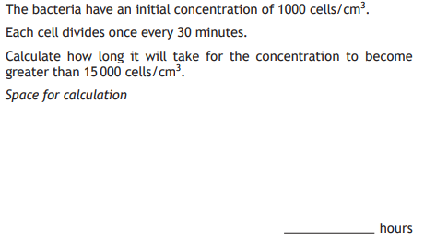
1000
2000
4000
8000
16000 = 4 divisions
4 x 30mins = 120 mins = 2 hrs

Unit 1 Topic 4 – Proteins and Enzymes

a) Proteins and their Functions
This sequence of amino acids determines the protein’s shape and function.
Proteins have a variety of functions including:
Structural Make up the cell membrane and forms supporting frameworks inside cells e.g. tubulin forms spindle fibres during mitosis.
Enzymes Speed up chemical reactions inside cells.
Hormones Act as chemical messengers. They are produced by endocrine glands and travel through the blood to carry messages to certain cells and organs.
Antibodies Produced by white blood cells to defend the body against infection by combining with foreign particles like bacteria and viruses to destroy them.
Receptors Are found on the surface of a cell. Hormones attach to them to send signals into the cell to start cellular processes.

b) Enzymes

Enzymes function as biological catalysts and are made by all living cells. They have three main features:

  - They speed up the rate of cellular reactions.
  - They are unchanged in the process.
  - They have an active site with a specific shape that fits the substance they act on (substrate).

Each enzyme is able to act on only one type of substance (its substrate) since this is the only substance whose molecules exactly fit the enzyme's active site.

The enzyme is said to be specific to its substrate and the substrate's molecular shape is said to be complementary to the enzyme's active site. The enzyme acts on the substrate to produce products.
Enzymes can be involved in two types of reaction:
- Synthesis reactions build up small molecules to make big molecules
phosphorylase
glucose-1-phosphate starch

- Degradation reactions break down large molecules into small molecules e.g.
amylase
starch maltose

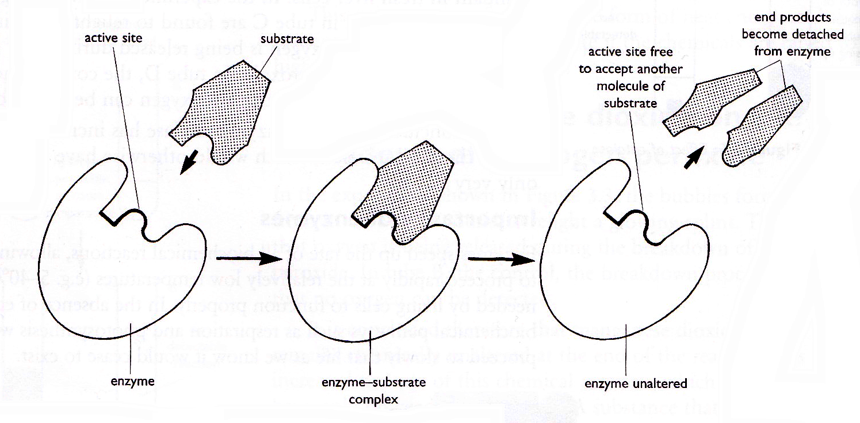

The substrate fits into the active site of the enzyme.
An enzyme-substrate complex forms to facilitate the reaction.
The substrate reacts to form product(s) which then leave the active site

Name of enzyme | Substrate | Products
Catalase | Hydrogen peroxide | Oxygen and Water
Amylase | Starch | Maltose
Pepsin | Protein | Polypeptides
Invertase | Sucrose | Glucose and Fructose
Phosphorylase | Glucose -1- Phosphate | Starch

- Factors Affecting Enzyme Activity

Each enzyme is most active in its optimum conditions. Enzymes and other proteins can be affected by temperature and pH.

Temperature
Enzymes are proteins and the structure of proteins is easily changed by heating to high temperatures, as seen when boiling an egg. This results in a change in their shape. This effect is permanent and the protein is said to be denatured. This is irreversible. When an enzyme is denatured its rate of reaction is reduced.

pH
The term pH is used to describe whether a solution is acid, alkaline or neutral.

Enzymes work within a range of pH values. Each enzyme works best at its optimum pH.

The shape of an enzyme, or protein, can be changed by changes in the pH of the solution it is in. This will affect the rate of reaction between the enzyme and substrate and may result in the enzyme becoming denatured.

- Enzymes and Industry
Biotechnological industries also use enzymes to produce useful products:

- Biological Washing Powders:
Digestive enzymes are added to detergents. These enzymes break up the stains on clothes, allowing them to be washed at lower temperatures. These temperatures cause less damage to fabrics and save energy, making them better for the environment.

- Cheese
Cheese is produced from milk by adding the digestive enzyme rennet. This is the same enzyme that is found in a calf’s stomach while it is still feeding from its mother.
Focus on Problem Solving
Line Graphs

How to do: SLUP!

S – Scale = Draw numbers along the x-axis. Always have a number at the bottom line (usually zero) and make sure the scale is even eg. going up in 5’s, 10’s etc. Repeat for the y-axis.

L – Labels = write a label to explain what your scales show. If you are plotting a graph from a table, use the headings in the table.

U – Units = write units next to your labels eg. temperature will be ºC, volume could be ml.

P – Plots = draw your plots as little x’s. Join them up using a ruler. Don’t connect the first point to 0,0 unless you have a plot there. Check that they are accurate.
Example:

Plot a line graph to show the effect of temperature on the dry mass of tomatoes.
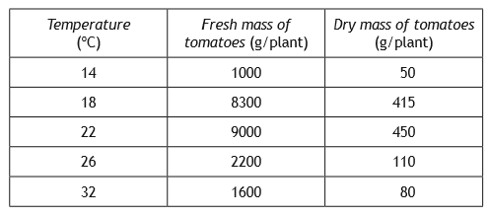

Answer:
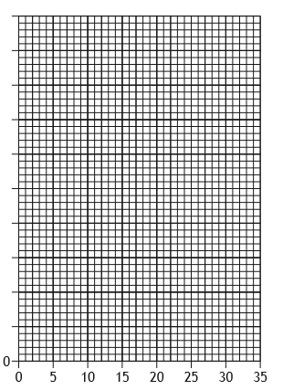
500

400

300
Dry mass of tomatoes (g/plant)

200

100

Temperature (ºC)
Now you try one…
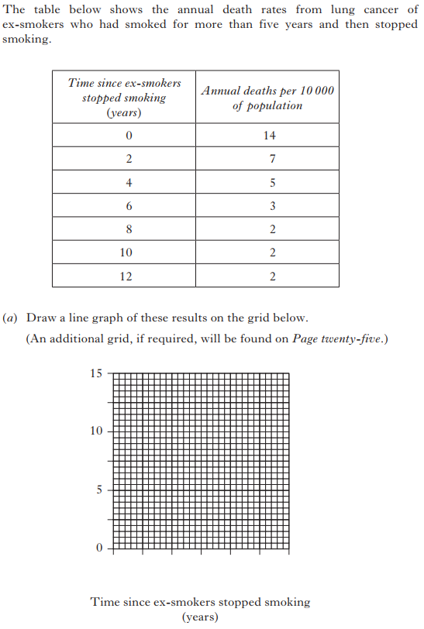

x

Annual deaths per 10000 of population

x
x
x
x
x
x
0 2 4 6 8 10 12

(SG 2013 Q11)
Unit 1 Topic 5 – Genetic Engineering

Genetic information can be transferred from one cell to another by genetic engineering.

In genetic engineering, a piece of chromosome containing the required gene from the cell of one organism (e.g. a human) can be transferred into a bacterial cell. The bacterial cell may then produce a substance normally made by the other organism.

Genetic engineering is of medical value because useful substances which can be produced include: human insulin used by people suffering from diabetes to control their blood sugar levels, and human growth hormone.

The stages in genetic engineering are shown below:

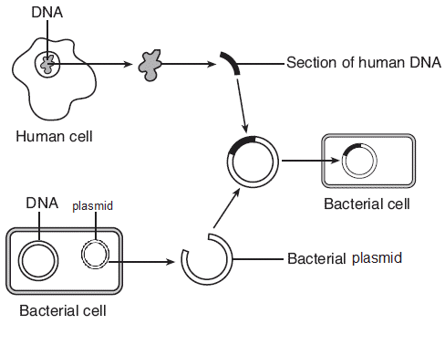

1A

3

2

1B

1A - The gene of interest is located on the human chromosome and it is extracted using an enzyme.
1B - A plasmid is extracted from a bacterial cell and cut open using enzymes.
2 - The human gene of interest is inserted into the bacterial plasmid and sealed in using an enzyme.
3 - The altered plasmid is inserted into the host bacterial cell to produce a genetically modified organism. The bacterial cell replicates and produces the human protein from the gene of interest e.g. insulin or growth hormone.

Therapeutic Use of Cells
Genetic engineering is a relatively easy, cheap and fast method to produce crucial proteins for therapeutic medical use, such as insulin, human growth hormone or Factor VIII – a blood clotting protein used to treat haemophilia. The technique can also be used on agricultural crops to produce greater yield, resistance to disease or a longer shelf life.

Controversy
Genetic Engineering can be seen as controversial. Some people disagree with it for a number of reasons:
- There is a risk of harmful side effects.
- It involves interfering with nature.
- There is a risk to contamination of the environment if genetically engineered crops could contaminate natural crops.
- There is a risk to biodiversity if genetic engineered crops out complete natural crops.

Focus on Problem Solving
Averages

How to do:

Add up all the numbers and then divide by how ever many numbers you’ve added together.

Example:

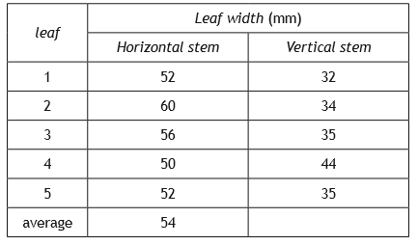
Complete the table by calculating the average width of the leaves from the vertical stem.

Working:
32 + 34 + 35 + 44 + 35 =180
180/5 = 36

Answer: 36

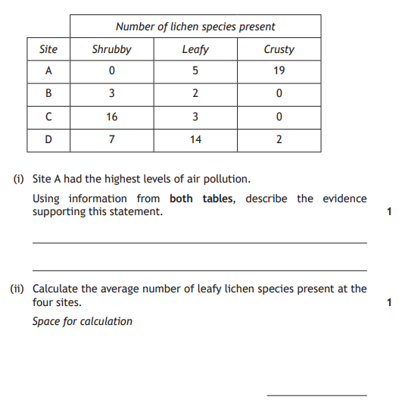
Now you try one…

A – 0+5+19 = 24 24/3 = 8
B – 3+2+0 = 5 5/3 = 2
C – 16+3+0 = 19 19/3 = 6
D – 7+14+2 = 23 23/3 = 8
always round your answers if the results are in whole numbers!

(adapted from N5 2015 Q17)
Ratio

How to do:

Write down each number with a : between them. Simplify each number until they can’t be simplified anymore. If there is a decimal place, multiply each number by 10, 100 etc. to get a whole number, then simplify as normal.

Example:

In a survey of 90 students it was found that 25 of them had hitchhiker’s thumb. Calculate the number of students with straight thumb to hitchhiker’s thumb as a simple, whole number ratio.

Working: 90 in total. 25 = hitchhiker’s thumb. Therefore, 90 – 25 = 65 have straight thumb.

straight : hitchhiker’s

Both numbers can be divided by 5

65 : 25

= 13 : 5

Answer: 13:5

Now you try one…
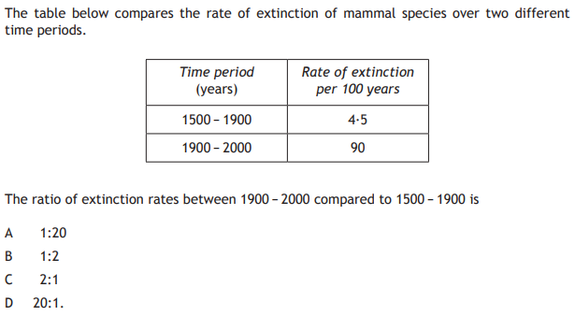
Answer – D N5 2014 QA20)
Unit 1 Topic 6 – Respiration

- Respiration
In all cells the chemical energy stored in glucose is released by a process called respiration. Respiration involves a series of enzyme controlled reactions. As it involves enzymes, respiration is affected by temperature. If the temperature is too high or too low then respiration will not take place effectively.

- ATP Generation & Energy Storage
The energy released from the breakdown of glucose is used to generate a molecule called ATP which stores chemical energy. ATP transfers energy to many cellular activities.

The energy released by ATP can be used for cellular activities including:
  - Muscle cell contraction
  - Cell division
  - Protein synthesis
  - Transmission of nerve impulses

c)d) Respiration
There are two types of respiration
- Aerobic – requires oxygen
- Fermentation – does not require oxygen

Aerobic respiration involves the breakdown of glucose via pyruvate to form carbon dioxide and water.
2 molecules of Pyruvate
Glucose
Carbon Dioxide
+
water
2 ATP
Many ATP

This requires oxygen and gives many molecules of ATP.
2 molecules are generated when glucose breaks down to pyruvate.

When oxygen is present and pyruvate breaks down to carbon dioxide and water a large number of ATP molecules are generated.
Aerobic respiration starts in the cytoplasm and is completed in the mitochondria. Cells such as muscle and sperm have many mitochondria as they require a lot of energy. The higher the energy requirement of a cell the greater the number of mitochondria present in that cell

Fermentation
Fermentation is the release of energy from glucose in the absence of oxygen.
This happens differently in plant and animal cells.

Animal cells
Lactate

Glucose
pyruvate

Plant and yeast cells
Ethanol and
Carbon dioxide
2 ATP

This does not require oxygen and gives 2 molecules of ATP.
This occurs in the cytoplasm.

Comparison of Aerobic Respiration and Fermentation

Type of Respiration | Aerobic Respiration | Fermentation  in Animals | Fermentation  in Plants
Location(s) | Cytoplasm and Mitochondria | Cytoplasm | Cytoplasm
Final Products | Carbon Dioxide and Water | Lactate | Ethanol and Carbon Dioxide
ATP Yield | Many | 2 molecules (few) | 2 molecules (few)

Aerobic Respiration
ATP (many) + Carbon Dioxide + water
Glucose + Oxygen

Fermentation
In Plant cells Glucose Alcohol + Carbon dioxide + ATP (2)

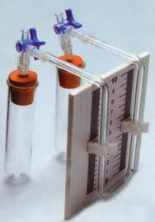
In Animal cells Glucose Lactate + ATP (2)

Respirometer

A respirometer is a piece of apparatus that can be used to investigate
respiration.
As the organism respires it takes in oxygen and gives out carbon dioxide.
The chemical in the test tube absorbs the carbon dioxide so this does not affect the volume of gas in the apparatus.
The absorption of oxygen results in a decrease in the volume of gas in the test tube and the coloured liquid is pulled up the glass tube at the same rate as oxygen is absorbed by the organism.
This allows the rate of respiration to be measured
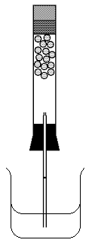
Glass tube with scale
Stopper to seal tube
Living organism
Chemical to absorb carbon dioxide
Coloured Liquid

