S5 Lesson 1: May 2020 Participation in Christian Witness
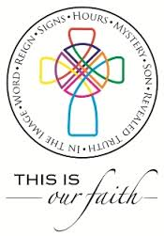
Pope Francis said in his letter for the Month of May, dedicated to Our Lady in the Church:

‘Beloved Mother, help us realise that we are all members of one great family and to recognise the bond that unites us, so that, in a spirit of fraternity and solidarity, we can help to alleviate countless situations of poverty and need. Make us strong in faith, persevering in service, constant in prayer.’

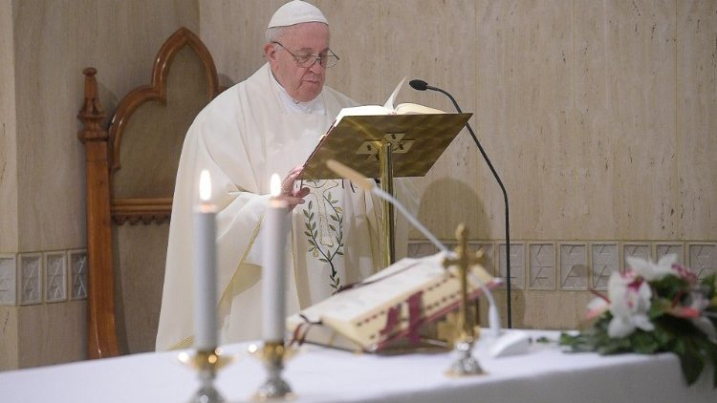

Task:

- Christian witness means putting faith into action. Participate in at least one Christian witness activity per week throughout this holy month of May. Make a note of what you have done or take photographs to illustrate how you have helped those at home, neighbours, parish or charities.

- Find rosary beads or create your own. Pray the rosary and document what you thought during it or how it made you feel. Perhaps it was the first time you have said this prayer in a while, note why you think Christians take great comfort and strength from this prayer.

