S1 Unit 5: Life of Jesus
Son of Man
Son of God
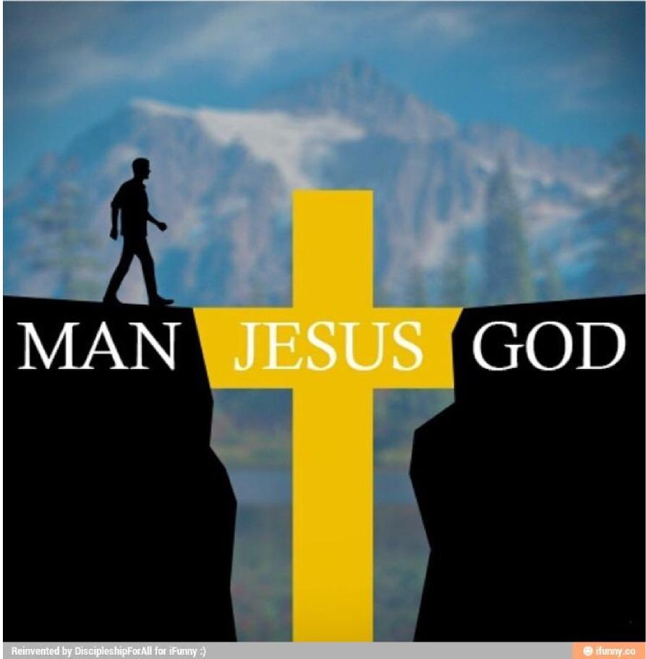

© Learning and Teaching Scotland 2003 1

S1 Unit 5: Life of Jesus
© Learning and Teaching Scotland 2003 2
Son of Man Son of God
Overview
This unit is about how Jesus is presented in the Gospels as both Man and God
During this unit we will:
❖ explore how Mark wanted to tell people that Jesus was both divine and human.

S1 Unit 5: Life of Jesus
Explore and Reflect: Jesus, Son of Man (1)
In his Gospel, Mark tells his friends that Jesus is a real person, with real feelings, just like them. He tells them that Jesus is the Son of Man, a human being. Mark wants his friends to remember that Jesus will help them because he understands their pain and suffering, and their hopes and dreams. Mark speaks about Jesus experiencing human emotions again and again in his Gospel. | 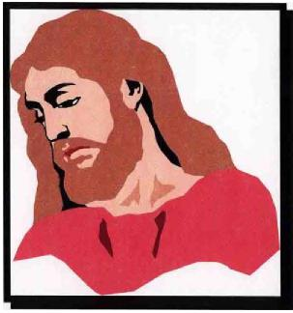

Task A
Look up the following passages, and write the words that tell you what Jesus was feeling at the time, for example ‘happy’, ‘sad’, ‘lonely’, and so on.
1. Mark 1:41 2. Mark 3:5 3. Mark 6:6
4. Mark 8:2 5. Mark 10:21 6. Mark 11:12
7. Mark 14:34

Mark shows his readers that Jesus understands life. He uses Jesus’ own stories (or parables) to show this. In these parables, Jesus gives us a message about how we should treat one another, God and ourselves. However, Jesus uses images in his stories that everyone listening to them would understand. Many people were farmers, so Jesus often used shepherds, lamps or seeds in his stories.
© Learning and Teaching Scotland 2003 3

S1 Unit 5: Life of Jesus
Explore and Reflect: Jesus, Son of Man (2)
During the three years that Jesus travelled around Palestine, teaching and working miracles, he gained many friends and followers. These people believed that Jesus was special, and may even be the Messiah, the Chosen One of God. They believed that everything Jesus said and did was possible through the power of God.
However, groups like the Pharisees and the Sadducees did not agree with this. In Jesus’ time, the Pharisees and the Sadducees were very powerful because they were among the leaders of the Jewish people. They believed that Jesus threatened their religion and their power. Some of them even believed that everything Jesus said and did was only possible through the power of the devil.

Mark’s Gospel speaks of the suffering and pain Jesus had to go through, especially in the last days of his life on earth. Indeed, one third of Mark’s Gospel is about the trial and death of Jesus.
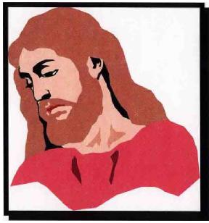
In this part of the Gospel, Jesus suffers at the hands of his enemies. These people want to see Jesus dead because they do not like his Good News. This is exactly what is happening to the Roman Christians as Mark writes his Gospel for them. Mark tells the Roman Christians to have the faith to follow the example of Jesus.

Complete at least two of the following tasks (A–D).
Task A
+ Jesus’ friends and followers believed he was special, and may even be the ... + The friends and followers of Jesus believed everything Jesus said and did was possible through the ...
+ In the time of Jesus, the Jews who were very powerful were the ...
+ They believed that Jesus threatened their ...
+ Some of the leaders of the Jews believed that everything Jesus said and did was only possible through the power of ...
© Learning and Teaching Scotland 2003 4

S1 Unit 5: Life of Jesus

Task B
© Learning and Teaching Scotland 2003 5
Read Mark 2:1–12 and the information below. Then answer the questions.
‘Teachers of the Law’ is another way of talking about the Pharisees and the Sadducees.
‘Blasphemy’ means to speak against God or say you are God – to speak about God without respect.
- What was the first thing Jesus said to the paralysed man?
- What did the teachers of the Law think when they heard this?
- What did Jesus say and do in reply?
- Imagine you were a Sadducee and witnessed this event. Write an account of what happened and how it affected you.
Task C
Read Mark 2:15–17 and the information below. Then perform the task.
‘Tax collectors’ were hated by the Jewish people because they collected taxes for Rome. Jews thought tax collectors were traitors.
Imagine you are Matthew, sometimes referred to as Levi. Record your memories of your meeting with Jesus, e.g. how you felt ...

S1 Unit 5: Life of Jesus

Task D
Read Mark 3:1–6 and the information below. Then answer the questions/perform the tasks.
The Law (or the Torah) says that no Jewish person should work at all during the Sabbath day.
- In your own words, retell this story.
- Imagine you are a friend of Jesus. What do you think of Jesus now?
- Imagine you are a teacher of the Law. What do you think of Jesus now?
From what we have learned so far, we know that Jesus had enemies. Most, although not all, of Jesus’ enemies were teachers of the Law: the Pharisees and the Sadducees.
Jesus spent three years travelling around Palestine preaching, teaching and healing. During these three years, Jesus gained many friends and followers. However, he also gained many enemies, who were waiting for a chance to catch Jesus out, so they could get rid of him. The enemies of Jesus would eventually get their chance to kill Jesus in the holy city of Jerusalem.

The Gospels tell us again and again that Jesus knew that he was going to be killed in Jerusalem. For example, Mark 10:32–34 tells us:
© Learning and Teaching Scotland 2003 6
Jesus and his disciples were now on the road going up to Jerusalem. Once again Jesus took the twelve disciples aside and spoke of the things that were going to happen to him. ‘Listen,’ he told them, ‘we are going up to Jerusalem where the Son of Man will be handed over to the chief priests and the teachers of the Law. They will condemn him to death and then hand him over to the Gentiles, who will mock him, spit on him, whip him, and kill him; but three days later he will rise to life.’

S1 Unit 5: Life of Jesus
© Learning and Teaching Scotland 2003 7
People can be confused about this. Why would Jesus willingly go to Jerusalem if he knew he would be mocked, spat on, whipped and killed?
There is no easy answer to this question. However, Christians think that Jesus had to die, so that he could rise to life three days later. Once Jesus had done this, everyone else could follow Jesus and rise to life after they died.
Task E
Complete the following.
- Imagine you are one of the twelve disciples listening to Jesus saying he is going to be killed very soon. What do you say to Jesus?
- Read Mark 10:35–45. What did James and John say to Jesus?
- What does Jesus mean when he talks about ‘drinking the cup of suffering’?
- What did the other disciples think of this?
- In your own words, explain what Jesus says about why the Son of Man came to Earth (Mk 10:45).
- Write about a time when there was something you didn’t want to do but felt that you had to. Were there reasons for doing it and not doing it?

S1 Unit 5: Life of Jesus
© Learning and Teaching Scotland 2003 8
Explore and Reflect: Jesus, Son of Man (3)
Mark’s Gospel spends a great deal of time explaining how Jesus was put to death. Jesus’ death should have been the end of the story, but it was really only the beginning.
It is early on Friday morning. It is still dark. The leading Sadducees of the Sanhedrin Council meet together. They try Jesus and find him guilty. Since they can’t kill him without the Romans’ permission, they send Jesus to Pontius Pilate, the Roman Governor of the area. Pilate is uneasy about sentencing Jesus to death, but feels forced into it. Jesus is put to death with thieves on his left and right.
Crucifixion is a horrible form of death. Romans never crucified Roman citizens, because it was too terrible. Only foreigners, such as Jesus, were crucified.
Crucifixion was a humiliating way to die. It was possible to be on the cross for days before you died. People would come up and scream, shout, laugh and torment you. Sometimes you were tied to the cross with ropes, but on other occasions, nails were used. Nails were placed through your wrists (not your hands) and through your feet. The pain was excruciating. If you were on the cross for too long for any reason (such as when a religious festival was beginning), then Roman soldiers would come and break your legs. This would cause your lungs to fill with blood, and you would suffocate to death.
Burial would take place quickly. In Jesus’ case, this had to be done immediately because the Sabbath day was about to begin (at dusk on Friday). Jesus’ disciples took him from the cross and buried him.

S1 Unit 5: Life of Jesus

Task A
Read Mark 15:1–47 and then complete the following task.
Imagine you are one of the male or female disciples of Jesus completing your diary at the end of Good Friday. Write a few sentences explaining what you have heard and seen. Explain how you feel. You should illustrate this with a drawing.
Task B – Extension task
© Learning and Teaching Scotland 2003 9
Read Isaiah 52:13 to 53:12, ‘The Suffering Servant’.
Christians believe that this part of the Old Testament is about Jesus, the Messiah, who would suffer and die for the sins of the world.
- In your own words, explain what this passage tells us about the Messiah who is the ‘Suffering Servant’.
- What do you think of the passage? Does it help you to understand why Catholics believe Jesus died for the sins of the world? Explain your answer.

S1 Unit 5: Life of Jesus
Explore and Reflect: Jesus, Son of God (1)
In his Gospel, Mark also tells his friends in Rome that Jesus is the Son of God. He tells his friends this so that they too will know that Jesus is the only one who has the power to help them. Jesus will give them strength to live, and perhaps die, for their faith in him.
Mark tells the Roman Christians that he believes Jesus is the Son of God. He illustrates his faith by telling them about the many miracles Jesus performed.
Mark shows Jesus as having power over sickness, nature, evil and even death. Mark’s message to the Christians in Rome is that the presence among them of Jesus, the Risen Christ, gives them the strength to endure the persecution of Nero.

Task – Group/paired discussion

Consult the following texts:
© Learning and Teaching Scotland 2003 10
• | Mk 4:35–41
• | Mk 5:35–43
• | Mk 9:14–29

and discuss the following points.
- How do these accounts illustrate Jesus’ power over sickness, nature, evil and death?
- How would these accounts encourage the early Christians to endure the persecutions of Nero?
- How do these accounts encourage Christians today?

S1 Unit 5: Life of Jesus
© Learning and Teaching Scotland 2003 11
Explore and Reflect: Jesus, Son of God (2)
Of course, the story of Jesus does not end with His death. Many of us will have heard the story of Jesus’ resurrection many times – how He came to life in a new and different way. To the disciples, this event was the most amazing event of all.
Jesus had told them He would rise from the dead after three days, but somehow they did not understand. When the women found the tomb empty on Sunday morning, they were amazed and scared. How could He rise from the dead like this?
It is only later that they understand how important this event is. Jesus has killed death. Life will no longer end when we die. Jesus is with us now, and like Jesus, His followers will live forever in company with Him! This is Good News indeed! Near the end of his Gospel, Mark describes what happened.
After the Sabbath was over, Mary Magdalene, Mary the mother of James, and Salome bought spices to go and anoint the body of Jesus. Very early on the Sunday morning, at sunrise, they went to the tomb. On the way they said to one another, ‘Who will roll away the stone for us from the entrance to the tomb?’ (It was a very large stone.) Then they looked up and saw that the stone had already been rolled back. So they entered the tomb, where they saw a young man sitting on the right, wearing a white robe – and they were alarmed.
‘Don’t be alarmed,’ he said. ‘I know you are looking for Jesus of Nazareth, who was crucified. He is not here – he has been raised! Look, here is the place where you put him. Now go and give this message to his disciples, including Peter: He is going to Galilee ahead of you; there you will see him, just as he told you.’
Mk 16:1–7

S1 Unit 5: Life of Jesus
© Learning and Teaching Scotland 2003 12
Task A
Answer the following questions.
- ‘The Early Christians of Rome would have liked to hear about the resurrection, because it was very important to them.’ What are the main elements in the story that they would have shared over and over again?
- Do you believe that Jesus rose from the dead? Give reasons for your answer
Task B – Extension task
- Design a banner for your church showing the happiness that Christians feel about Jesus rising to life.
- Find out the meaning of some of the customs celebrating Easter in our country.
Christians believe that after the resurrection Jesus returned to the Father (on the occasion of the Ascension); and Father and Son sent the gift of their love, the Holy Spirit on Jesus’ followers (at Pentecost). Jesus’ followers today share belief in three persons in one God, The Father, the Son and the Holy Spirit. This belief is referred to as belief in The Trinity.

S1 Unit 5: Life of Jesus
Response: Who Do You Say I Am?
In his Gospel, Mark wanted people to change their lives and be good followers of Jesus, no matter the cost. In his Gospel, Jesus asks his disciples, ‘Who do you say I am?’ He is asking his followers whether or not they believe he really is both the Son of Man and the Son of God, or in other words, the Messiah.
Read the passage in Mark’s own words.
Jesus and his disciples went away to the villages near Caesarea Philippi. On the way he asked them, ‘Tell me, who do people say I am?’ ‘Some say that you are John the Baptist,’ they answered. ‘Others say that you are Elijah, while others say that you are one of the prophets.’ ‘What about you?’ he asked them. ‘Who do you say I am?’
Peter answered, ‘You are the Messiah’.
Mk 8:27–29

According to Jewish tradition, Elijah, a great prophet who performed miracles, was supposed to return to Earth just before the Messiah. Some people thought that because Jesus also performed miracles, he must be Elijah. Other people thought that Jesus must be another great prophet. Palestine had not had a great prophet for hundreds of years, and many people hoped that Jesus was one of these. However, it is Peter’s answer that is important. Peter tells Jesus that he is the Messiah or Christ. Messiah or Christ means ‘the anointed one’, appointed by God to lead the people and free them from their suffering.
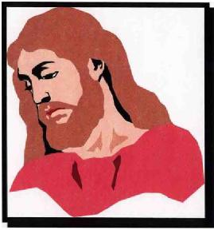
© Learning and Teaching Scotland 2003 13
This is a very important story since Jesus is asking everyone who hears this question to answer it for themselves.

S1 Unit 5: Life of Jesus

Task A – Individual exercise

Jesus asks you the same question,
© Learning and Teaching Scotland 2003 14
What is your answer to Jesus’ question: ‘Who do you say I am?’?
Give reasons for what you write.
Task B – Group discussion
Although Jesus rose from the dead and returned to The Father, Christians still believe he is with them in the power of the Holy Spirit. There are many people who suffer and are persecuted in today’s society, for example refugees, homeless people, drug or alcohol abusers.
How can all Christians cooperate with the power of the Holy Spirit in the task of bringing help and comfort to these people?
Task C – Individual reflection
Mark is telling Christians today in Scotland that:
+ Jesus’ message is still Good News
+ Jesus is always with them
+ Jesus is the Son of God, with great power to help them
+ Jesus is the Son of Man, who understands their thoughts and feelings
+ Jesus knows about human suffering and pain
+ Jesus is an example of how to live their lives for God and other people – to
bring about God’s Kingdom (or Reign) on earth.
Nearly 2000 years after John Mark wrote his Gospel, people all over the world are still reading it. These people still think that Mark has something to say to them today.
What does the Gospel of Mark tell you today?

S1 Unit 5: Life of Jesus
© Learning and Teaching Scotland 2003 15
Glossary
Acts of the Apostles – the fifth book of the New Testament, written by Luke.
Blasphemy – to use God’s name or speak of God in a disrespectful
way.
Catacombs – burial sites common in Rome (usually underground)
that Christians used. According to some reports, Christians even hid in them.
Crucifixion – execution on a wooden cross, a very brutal form of
death.
Gospel – means ‘Good News’. There are four expressions of
the Good News in the New Testament, written by Matthew, Mark, Luke, John.
Kingdom/Reign of – the image used by Jesus to proclaim the closeness of
God God. It means that God is reigning over all creation,
and that future salvation is already present in Jesus.
Nero – the Emperor of Rome at the time Mark wrote his
Gospel.
Persecution – when a person or a group of people is treated badly
by others for a period of time. Often there is no good reason for this bad treatment.
Teachers of the Law – the Pharisees and the Sadducees: religious leaders in the time of Jesus.
Trinity – the three persons in the one God: Father, Son and
Spirit.

