Mental Health Awareness Week 2020

In celebration of Mental Health Awareness Week 2020 and the theme of kindness, we are encouraging pupils in Our Lady’s High School to get mentally healthy by spreading a little kindness. Kindness is important because;

- It makes you feel good
- It improves relationships
- It makes us all happy
- It bonds our community, class or family

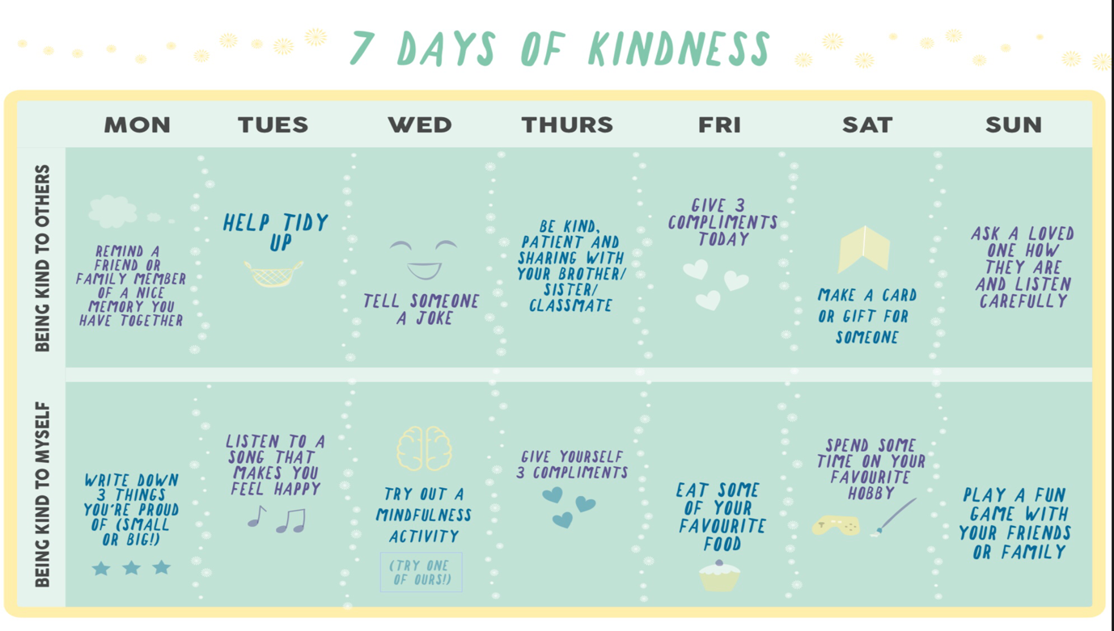
This calendar, designed to be used throughout Mental Health Awareness Week, encourages you to do two acts of kindness each day – one for someone else and one for yourself. There is an example below, however there is a blank calendar for you to create your own.
