S
C
O
T
T
I
SH
A
SSOCI
AT
I
ON OF TE
A
CHER
S
OF
P
H
Y
S
I
C
A
L EDU
C
AT
I
O
N
Broad General Education
Physical Education
Cover work
This resource has been created for those unfortunate times when there is no Physical Education teacher available to take a practical class and pupils are sent to a classroom. It is hoped the worksheets will allow for meaningful work to take place when these incidents occur.

Each worksheet is based around the Broad General Education Significant Aspects of Learning/Benchmarks, and has been designed to take at least one period to complete and requires little input from the cover teacher and no digital technology.
Please note SATPE does not support using these worksheets in a practical lesson or as a homework task.
40
coloured laminated A4 sets at a cost of
£266
+
VAT
of enclosed Cover Work can be ordered
via email to
iain@wigwam.marketing
SATPE would like to acknowledge and thank the following teachers for their time and effort to complete and share this resource.
Russell Imrie | Kerri Marshall | John Millar
Lawrence Brown | Aaron Anderson | Paddy Cuthbertson
Kirsty Shearer | Lewis Clelland | Ryan Gilmour
Christopher Love | Cameron Love | Sean Thomson
Daniel Turner | Catherine Dorans | Jodie Stewart
Harry Prescott | Tom Murray

These worksheets are available to download free from the resources section of the SATPE website. www.satpe.co.uk

CREATIVITY
Creativity – is the ability to move in a unique and imaginative way. You can have creative movements independently and with others. In sport, a player is labeled as being creative if they do something that is not expected and can add flair to a skill. Athletes are able to be creative in what they do to solve problems during a performance. A skill or movement, like passing in basketball, can obviously be performed through a basic bounce pass or chest pass. However, players often have to be much more creative to create scoring opportunities.

(Answer the following questions on the A4 paper provided)
- Describe a situation where you were creative in a sport of your choosing. What did you do and why was it successful?
- Write down your own definition of creativity.
- In some sports, creativity gains extra points. Put the following sports into the category they belong in. The first 2 have been done for you. You will need to copy out the table.
> Football > Dance
> Gymnastics > Hockey
> Badminton > Freestyle skiing
> Diving > Squash
> Golf > Curling
NO EXTRA MARKS FOR CREATIVITY | EXTRA MARKS FOR CREATIVITY
Netball | Synchronised swimming
- Can you think of an example of a famous sports person being creative during a game or activity? Explain what they did differently and what would have been a simpler action. 5) List as many words as you can that you associate with creativity.
6) Compare how creative sportsmen and women are viewed by fans/the media/coaches to other non creative athletes.

CUE RECOGNITION

MY THINKING SKILLS
Cue Recognition – Is a thing said or done that serves as a signal to a performer to begin or continue their performance. Cue recognition can be verbal or physical and the performer has to respond to it.

(Answer the following questions on the A4 paper provided)
- For each of the activities listed in the boxes below, give an example of how a performer would need to react quickly to get a positive outcome. Try to write a different example for each sport/activity.
100m Sprint | Basketball | Swimming | Football | Dance
Gymnastics | Hockey | 1500m run | Rugby | Badminton

- What are some of the important skills/movements you require to be able to respond effectively to a cue in sport?
- What could happen if you miss the cue in sports? List some of the consequences.
- Describe a time during a PE lesson where you had to react to a cue. Try to relate it to a particular activity.
- Describe a time during a PE lesson where you missed a specific cue which resulted in a negative outcome.

DECISION MAKING
Decision Making – refers to the choices you make during a performance. The decision you take and perform will affect what others decide to do in the game. During performances, lots of decisions have to be made quickly under pressure and making a correct decision can lead to improved performance. There are many factors during a game that will influence all decisions that are made.
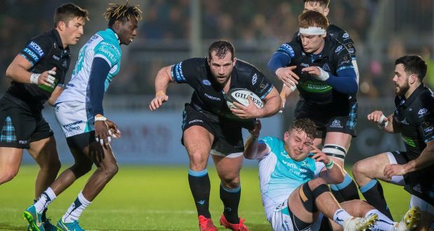

(Answer the following questions on the paper provided)
- Write down 5 decisions you have had to make during a performance in PE.
- You are playing a team invasion game and your teammate passes you the ball, what decision do you now have to make?
- A professional player, playing in the world cup final, drives forward towards 2 defenders rather than pass the ball to his teammate who is in space. Do you think they made the right decision and why?
- Pick a sport of your choice and list as many things that influence the decisions players make during the match.
- Think of a time where you were taking part in sport. Explain a decision that you made during that game and why you made it. Was it a good or bad decision?
- Choose a sport of your choice, imagine there are 5 minutes left to play and you are losing.
How will this pressure affect what decisions you make?

FOCUS AND CONCENTRATION
Focus and Concentration – is being able to keep your attention on tasks you have to perform, blocking out any other distractions in the environment. During performance, there can be many distractions happening all at once. Remaining focused on what you need to do is a crucial skill outside of sport as well. Sports/physical activities are usually fast paced, you need to switch from one task to another quickly to be successful.
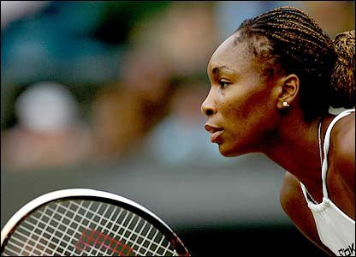

(Answer the following questions on the paper provided)
- Write about 3 times you were distracted during sport. What happened?
- One of your teammates is finding it hard to focus on the game. What could you say to them to fix this?
- Imagine you are in the final of a major golf tournament. You have to make a putt that could win you the tournament. What kind of distractions do you think you would face?
- Goal setting can be a good way to maintain your focus and concentration. Think of 3 different goals you could have for a sport of your choice.
- During a game you will need to focus on what your opponents are doing so you can work out how to respond. What kind of things should you focus on?
- If you are performing a complex skill, you need to have high levels of concentration, so you can perform it well. Think of an example of a complex skill in a sport of your choice and explain what you need to concentrate on.

PRIORITISING

My Thinking Skills
Prioritising - You decide which tasks are most important and when to deal with them in order. You recognise and act upon the importance of ‘what next?’ as a key element within a sequence of decisions and actions.
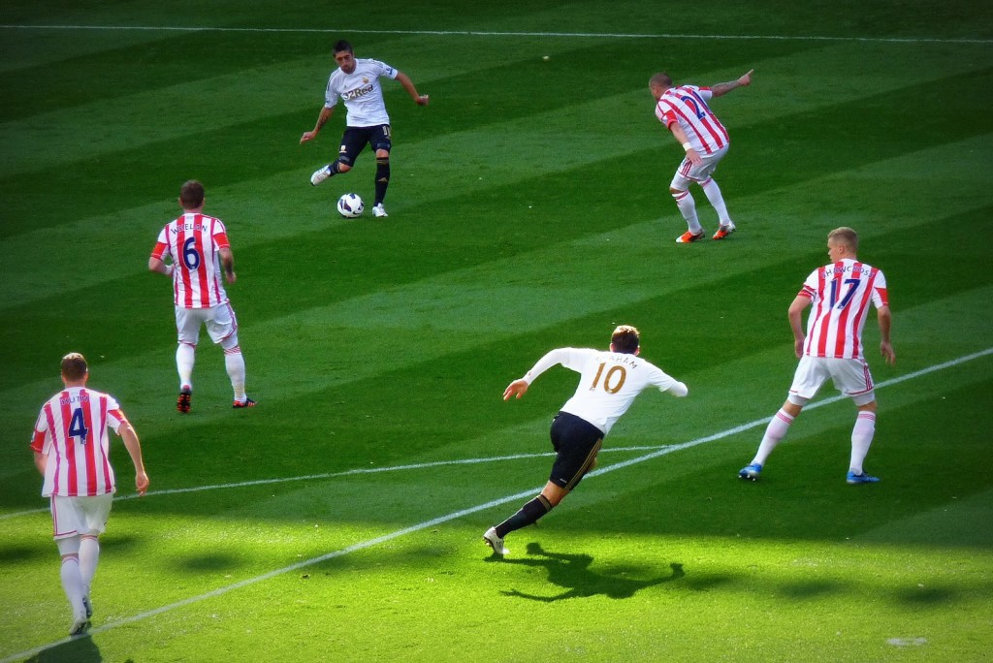

(Answer the following questions on the paper provided)
- List as many things in your day-to-day life that you need to prioritise (eg. homework, hobbies etc).
- Now list them in order of most important to least important.
- You can also prioritise decisions when participating in sport. Write a few sentences to describe a time during your PE lessons where you prioritised effectively to get a positive outcome (scoring a goal, performing a sequence, executing a smash shot etc.).
- Now describe a time where you prioritised in the wrong way resulting in a negative outcome.
- What do you think might help you to become better at prioritising when participating in sport?
- Pick an activity of your choice. Draw a diagram or list the steps you would take when making a decision during a game. When completing this task think of how you would prioritise the decisions you make to ensure you get a positive outcome.

PROBLEM SOLVING
Problem solving - being able to overcome a problem by selecting and applying a strategy or movement during a performance. A problem in sport can be anything from having to beat a defender, where to aim your shot depending on where the goalkeeper is or how to return the shuttle if your opponent plays a drop shot. During a game, many things are happening all at once and each one affects another. As a player, you have to react to what is happening and adapt what you are doing to solve problems. These situations can be both familiar to a player or completely new.

(Answer the following questions on the paper provided)
- There are often many different ways to solve a problem during a game, this is why it is exciting to watch and play. Imagine you are dribbling forwards in basketball and a defender is blocking your path to the basket. What different ways could you deal with this problem?
- Creativity is often associated with problem solving. Players are able to be creative to get out of situations that seem impossible. Give an example of when you have seen this.
- If you are defending against a player who has lots of speed, this could be a problem for you in the game. What actions could you do to try and ‘solve’ this? You can choose any sport you like.
- Describe a time in sport where you managed to solve a problem, how did you decide what to do in this situation.
- Pick any professional athlete. Come up with a list of problems they might face in training and during performance.
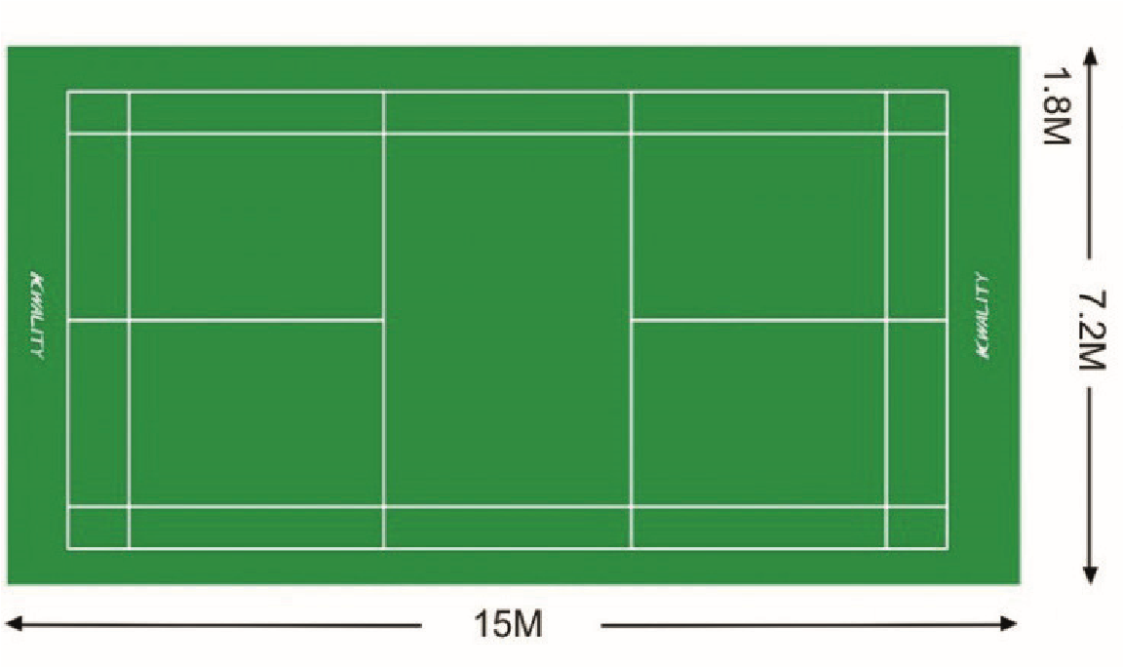
O
- You can often solve problems quicker when you work with others. Pair up with someone in the class who is also on this question and draw all the possible shots this badminton player (O) could take. Write down why each shot could help them in the game.

SEQUENTIAL THINKING

MY THINKING SKILLS
Sequential Thinking - Refers to a person’s ability to process and organise information. A person with high sequential thinking skills is able to automatically shuffle and organise large amounts of information.

(Answer the following questions on the paper provided)
- For four of the skills listed in the boxes below, list in order how a performer would complete the skill using sequential thinking. Describe step by step how you would perform this skill.
i.e. Hockey push pass – ball at back foot, sink the hips and place weight on back foot, stick at 45 degrees, push ball from back to front, transfer body weight from back to front foot, follow through with stick towards target area.
Softball Batting | Basketball Lay up shot | Swimming  Dive | Football Free kick | Volleyball Serve
Gymnastics  Dive forward roll | Hockey Tackle | 100m  Sprint | Rugby Try | Badminton Smash
- Pick a different activity AND a skill. Describe step by step how you would perform this skill using sequential thinking.
- Draw a picture to show the different steps you would take to perform your skill.
- If you were a performer and you had POOR sequential thinking skills, what impact do you think this could have on your performance?
- If you were a performer and you have VERY GOOD sequential thinking skills, what impact do you think this could have on your performance?

BALANCE & CONTROL
Balance & Control - the ability to keep the centre of mass above the base of support when stationary (static balance) or moving (dynamic balance). This helps gymnasts maintain their position and prevents moving players from falling over at speed.
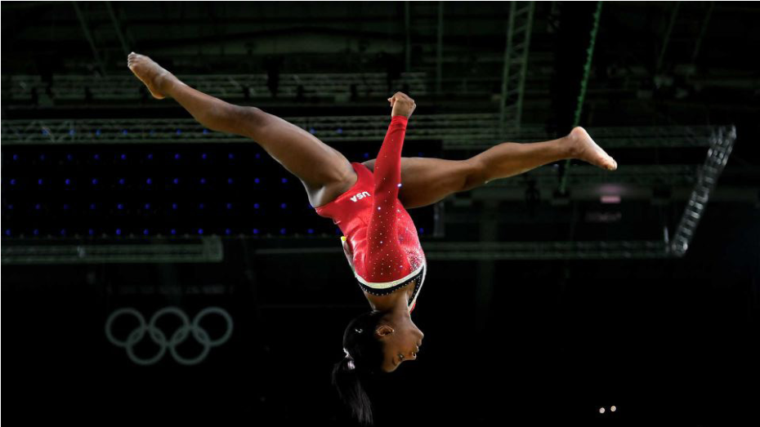

(Answer the following questions on the A4 paper provided)
- Identify 5 Sports/physical activities that require a high level of balance and control.
- Choose any 3 of the 5 sports/ physical activities you identified in question 1 and provide an example of balance and control being used within the sports.
- Can you think of a PE lesson or a time when you were doing physical activity/sport and you had to use balance and control to be successful?
· What activity were you participating in?
· What part required balance and control? Provide an example
- You and your partner are working together to practice different balances in gymnastics. Your partner is practicing a balance on one leg.
Can you think of 3 things you could tell them to do with their body to help them with their balance? Pick one of these suggestions and justify why they should do this.
- Design a poster of what you think balance and control looks like.
You can be as creative as you like.

COORDINATION AND FLUENCY
Coordination and Fluency – This is having the ability to use different parts of the body together efficiently. Movement of different body parts that are seen to be graceful as well as achieving an intended outcome would be seen to be coordinated and fluent. It can be important in Physical Education as many activities require movement of different body parts in a controlled way.
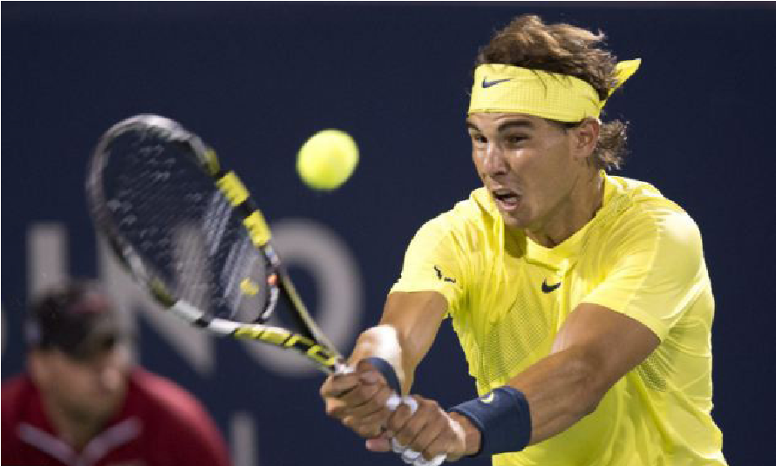

(Answer the following questions on the A4 paper provided)
- Create a mind-map and do the following:
  - Place co-ordination and fluency at the centre.
  - Branch off 3 different activities.
  - For each activity, branch off a skill/movement that requires good co-ordination.
  - For each skill/movement, branch off what body parts you would use together.
- For one of the skills/movements above explain why certain body parts need to be used together to produce a good performance.
- Name a famous sports person that you think demonstrates good coordination and fluency. Justify why you chose that person and provide one example of it helping their performance.
- Imagine you could only use one body part at a time. Choose a team activity and explain how this would have an impact on your performance. Things to think about:
  - How would this affect your passing?
  - How could your shooting be inaccurate?
  - How would this affect your performance in your team?
- Think of an activity/sport where you could be scored on your coordination or fluency. If you were a judge give some examples of when you would deduct or award marks.

GROSS & FINE MOTOR SKILLS

Gross and Fine Motor Skills
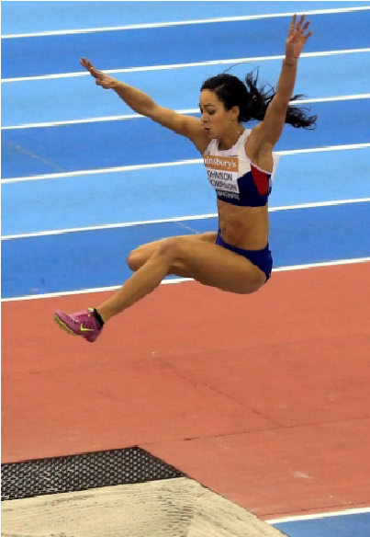
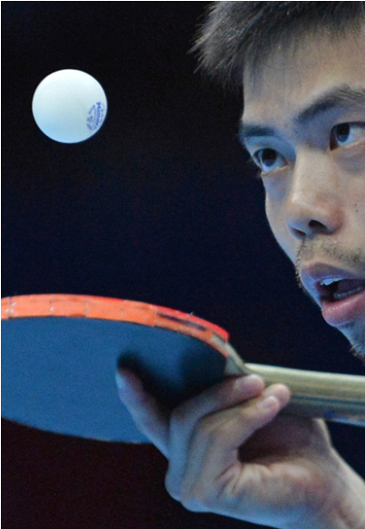
Gross Motor Skills – Large muscle movements which are not very precise and include many fundamental movement patterns such as walking, running and jumping.
Fine Motor Skills - Precise movements using small muscle groups and generally involve high levels of hand-eye coordination. E.g Table tennis serve, dance motif.
(Answer the following questions on the A4 paper provided)
- What is the main difference between gross and fine motor skills?
  - Identify a gross motor skill you performed in any PE activity.
  - Identify a fine motor skill you performed in any PE activity.
  - For each skill, evaluate how well you performed them out of 10 and justify each of your scores.
- Imagine you are the head coach of a sports team, your job is to design a drill or game which will develop gross motor skills.
  - Describe how the drill or game works, include as much detail as possible.
  - List what equipment you will need.
  - Include a diagram of the drill or game.
- In the drill above, you have noticed a player is struggling to perform this skill. How could you break this skill down to make it easier for the player to perform it?
- Draw a picture of a performer performing a gross motor skill in any activity and a picture of them performing a fine motor skill from a different activity.
Please hand your completed work to the class teacher.

KINAESTHETIC AWARENESS

Kinaesthetic Awareness
Kinaesthetic awareness is body awareness; having the ability to be in full control of your body when moving in different ways. This can be in the form of spatial awareness, control of body/ equipment and using different speeds, pathways and levels. For example a tumbling gymnastic knowing when, where and how to land to remain within floor boundaries.
(Answer the following questions on the A4 paper provided)
- Pick two different activities. Think of an example in each where kinaesthetic awareness is required. Compare any similarities or differences between the examples.
- Why do you think kinaesthetic awareness is particularly important in team sports?
- Describe a time when you were able to show good kinaesthetic awareness in sport (this can be in or out with PE). What was the sport? What happened as a result?
- Look at the picture below. Explain how the players have to use their kinaesthetic awareness. Assess this for both teams.
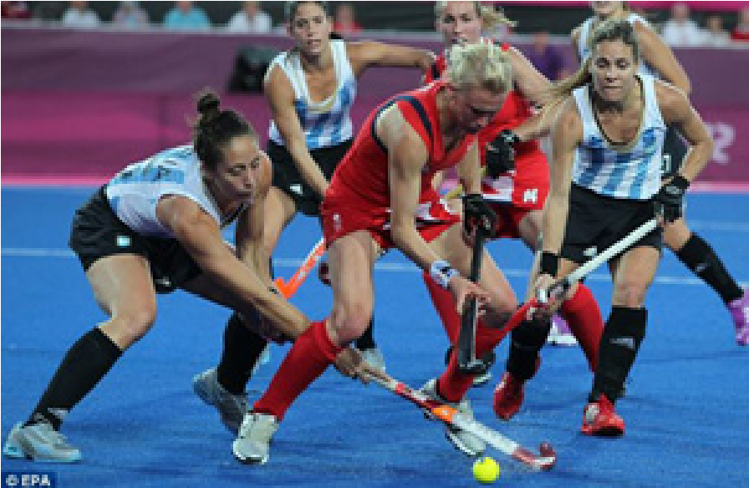
- Imagine you are the head coach of a team in a sport of your choice. Design a drill or game which you think will help to improve players kinaesthetic awareness. You may wish to use diagrams and words to explain.

RHYTHM AND TIMING
Rhythm and Timing - Timing is the ability to execute a skill/movement at exactly the right time and with the right degree of emphasis. Rhythm is the expression of timing during the performance of a skill/movement.

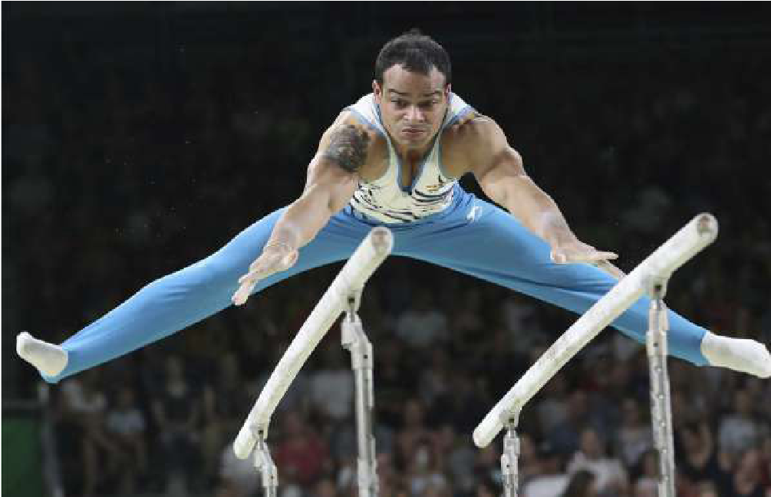

(Answer the following questions on the A4 paper provided)
- Identify 3 activities that requires good rhythm and timing.
- Pick 1 of these activities and identify a skill that requires good rhythm and timing. Explain why it requires good rhythm & timing
- Explain why rhythm and timing is important for a different skill from the activity chosen above.
- Design a drill/practice that can be used to help improve rhythm and timing?
- Design a routine/variety of skills that would link together (using rhythm and timing) to produce a quality performance.
- Consider synchronised swimmers: why must they have good timing? Can you identify a social skill they can use to help their timing and explain how they could use this social skill?

COMMUNICATION
Communicating is any form of sending or receiving information. It is important that you are able to communicate in a host of different ways. Good communicators will be able to communicate with others in lots of different areas and will be an effective member in sports teams, classroom discussions and employment groups. However, it is also just as important that you can listen to others and respect their opinions.

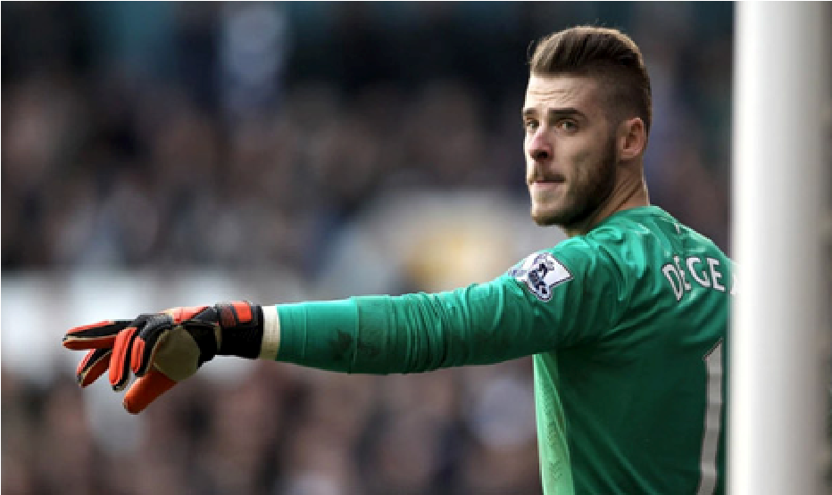
(Answer the following questions on the A4 paper provided)
- Give 2 examples of how you have communicated in P.E.
- Give 2 examples of non verbal communication you have used in P.E.

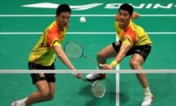
- Look at the picture on the right hand side and consider how poor communication skills may affect the double partners in this rally.
- A pupil is about to give a presentation in English. Can you give them 2 pieces of advice about their communication skills and say why doing these 2 things would help them?
- Identify a learning target for your next PE lesson. The target must relate to your communication skills and mention how you wish to improve them.
- Design a poster, slogan or poem about the importance of communication, both in PE and in other subjects across the school.

CONFIDENCE
Confidence refers to how much belief you have in your own ability and how good you feel about yourself. The way you feel about yourself could refer to how you feel as an athlete, as a pupil in a certain class and as a person in society. In PE, your confidence can be boosted by working hard to learn new skills, being praised by others like your teacher and by feeling like you are part of a team. You also have a responsibility to boost your classmates’ confidence by considering the way you talk and act.
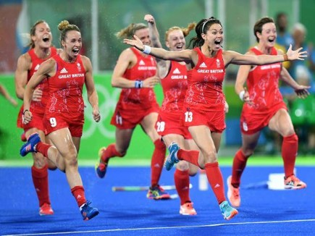
(Answer the following questions on the A4 paper provided)
- List 5 things that can increase your confidence and self-esteem in life.
- Can you think of a time when your confidence went down in any class and explain why this happened.
- Why do you think confidence and self-esteem is important for young adults?
- Think of a time when you felt confident in PE or sport. a) Describe what this situation was.
  - What caused your confidence to be boosted during that lesson/session/match?
  - How did feeling confident help you?
- How might a classmate of yours act if they had low confidence in PE?
- How could you help boost their confidence?
- Design a poster, slogan or poem that could be used to improve the confidence and self- esteem of young people to help them participate in physical activity, physical education and sport.

DETERMINATION & RESILIENCE
Being determined means you will persevere through difficult moments and never give up whilst being resilient means you will bounce back when something does not go to plan. It is important that you are both determined and resilient in sport, education and in life. The way you look at life and what you view as success can really impact on your levels of determination and resilience.
Below are quotes that explain Growth Mindset.
Fixed mindset is the opposite of these quotes.
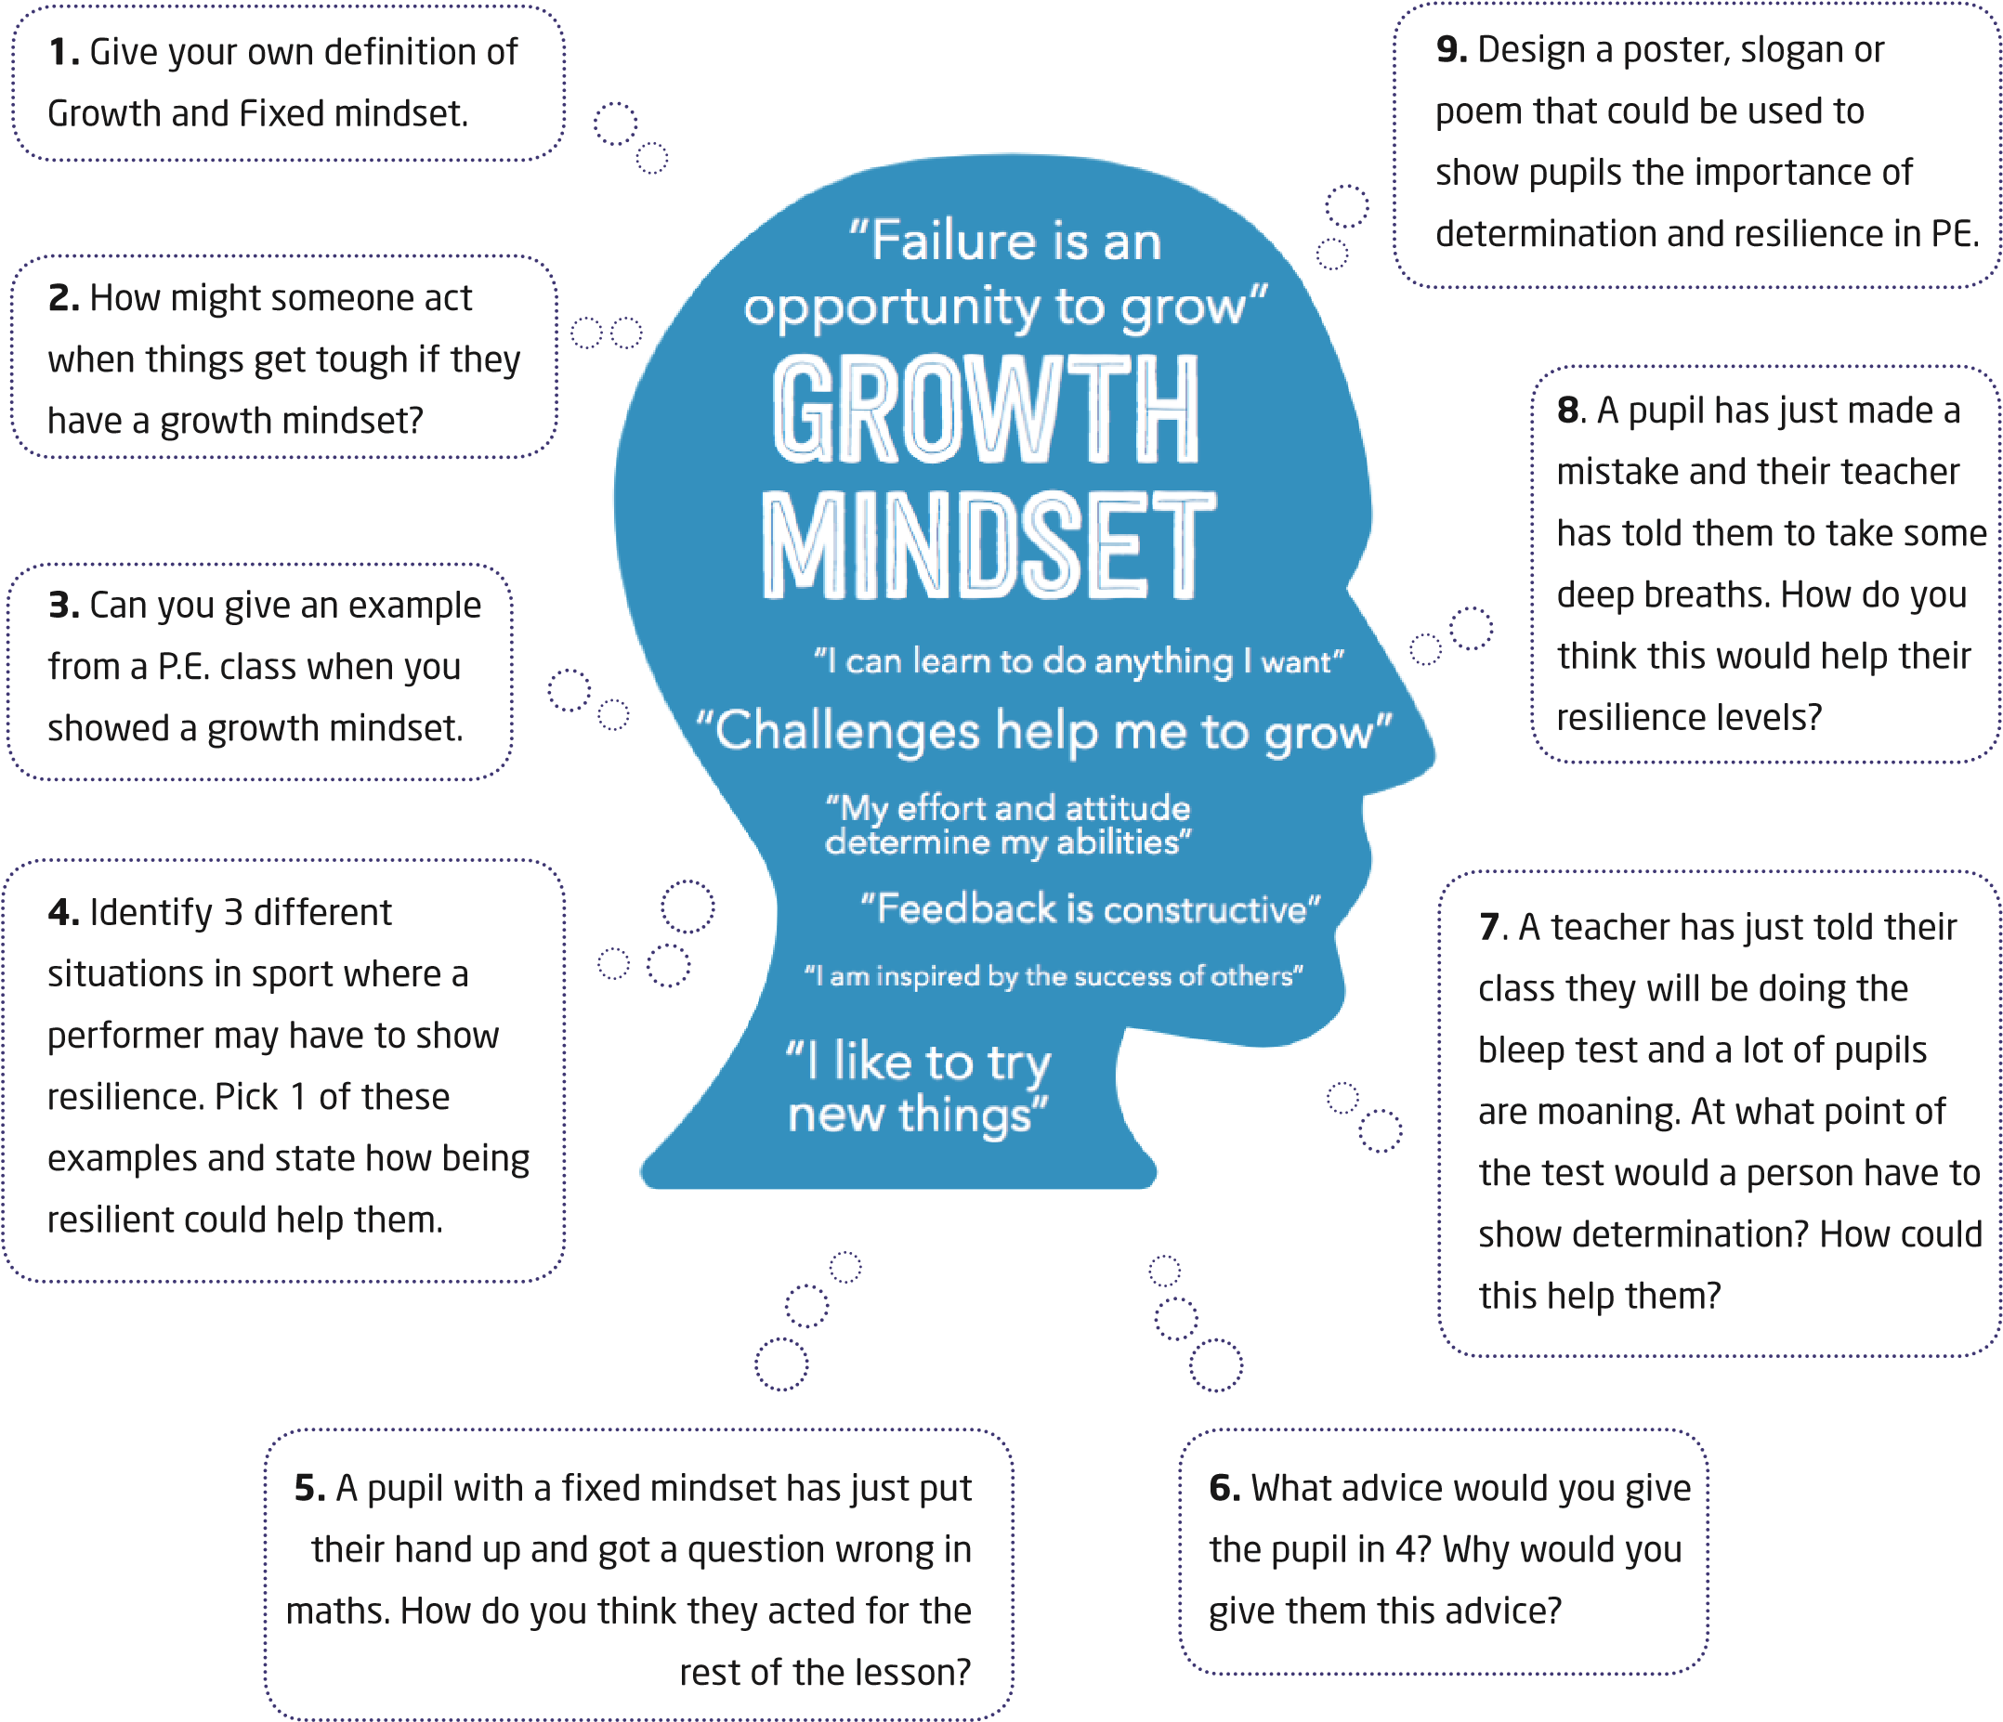

MOTIVATION
How motivated someone is depends on how much they want to accomplish something.
In training, a coach may ask an athlete how much they want to improve. In performance, how much a performer wants to win can determine how hard they try. In education, how much a pupil wants to learn something new can indicate whether they go to extra classes or study harder at home. Being motivated can often lead to people doing extra so they do not cut any corners.
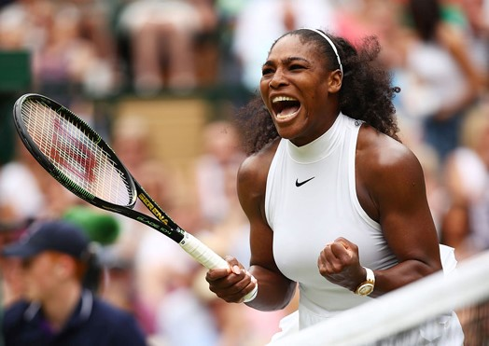
1) Can you identify…
- 3 things that motivates you to participate in sport? Give reasons why this motivates you.
- 3 things that motivates you to work hard at school? Give reasons why this motivates you.
3) Read the extract and answer the questions that follow.
Anthony Joshua is the unbeaten heavyweight champion of the world in boxing. He trains three times a day. Follows a very strict diet. Goes home to recover whilst his friends party. He does this because he wants to be the best in the world. Even when Joshua wins, he tries to find new ways to train and improve. He is obsessed with being the best in history.
- Identify 3 ways Anthony Joshua demonstrates his motivation levels.
- Why does Anthony Joshua make so many sacrifices?
- Create a goal for something you wish to achieve in life or sport.
- Identify 2 things you will do to help you achieve this goal and state how doing these things will help you.
- Some athletes may need to be motivated by others like their coach. Imagine you are the head coach for the Scotland National team (this can be for any sport of your choice) and your team are not motivated. Write an inspiring team talk to help motivate your players.
- Design a poster, slogan or poem that could be used to motivate young people of today to participate in physical activity, physical education and sport.

RESPECT & TOLERANCE
This personal quality relates to how much you consider a person’s feelings and/or opinions. In some cases, these opinions may be similar to you but in other cases, they may be different. Would the world not be boring if we all shared the same opinions and personalities? It is therefore important that you consider others in all aspects of life in order to make them feel comfortable. During discussions, you may need to negotiate and debate in a polite manner for your team to move forward. Moreover, you also need to show respect towards people in certain positions; teachers, coaches and referees. Doing all of the above will help you build relationships and improve key employability skills like working as part of a team.
(Answer the following questions on the A4 paper provided)
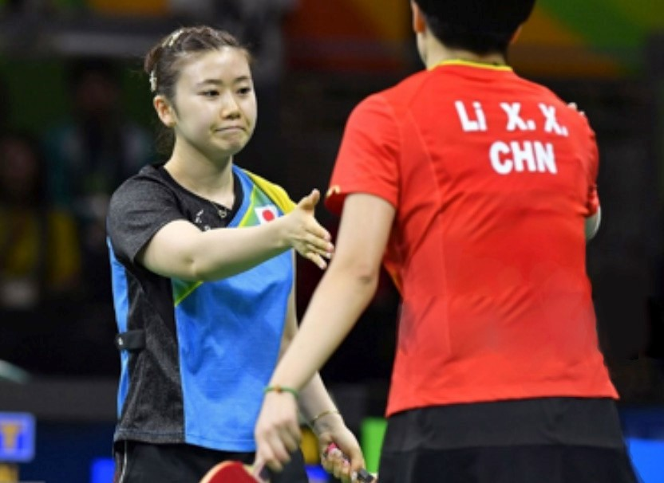
- During a PE lesson, your teacher has told you to provide your partner with feedback. How might you word your feedback in a respectful way and why would you do this?
- Identify 3 different times athletes should show respect in their sport. Pick 1 of these examples and say why this is important.
Pick and complete either question 4 or 5.
- Write a short story on respect and tolerance in sport, school or life. In your story, you must:
  - Define what respect and tolerance is.
  - Create a situation where respect and tolerance has NOT been shown.
  - Identify how the character acted and the impact it had on others.
  - Explain how they should have acted differently and why this would have been better.
- Imagine you are the head coach of a sports team that has displayed a lack of respect. Write an inspirational team talk to help them change their ways that will push them towards displaying respect and tolerance when taking part in their sport.
- Design a poster, slogan or poem to promote respect and tolerance for your school. This can either be specific to PE or designed for use across the school.

RESPONSIBILITY & LEADERSHIP
It is important that you are responsible for your own learning and can take on some leadership roles in class. You may lead your own learning by directing it or you may lead others when working as part of a group. In order to be an effective leader, you must be aware of multiple things including the strengths and weaknesses of others and how other people work best. Not only will this help develop others, but it can also develop your own skill set and boost your self-esteem.
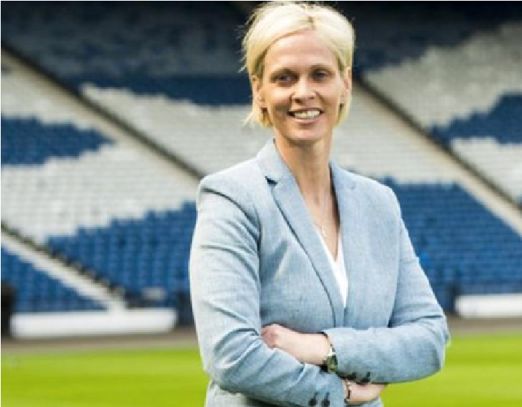
- Identify 3 things that you believe makes a good leader.
- Identify someone who you believe is a good leader. This can be a classmate, a teacher, a politician, a coach, a captain.
  - Provide 3 reasons why you think they are a good leader.
  - For each reason you supply, you must state how you think it affects the people they work with.
- Identify 5 different roles or responsibilities you may carry out in a PE lesson.
- Can you think of a PE lesson or a time when you were doing physical activity/sport and you took on a role or responsibility?
  - What role or responsibility did you have that day?
  - What did you have to do to fulfil that role?
  - How did the role or responsibility help you and your team?
- Read the following extract and answer the questions that follow:
A pupil noticed their teacher was speaking to one of their classmates so they decided to start their own warm up. In doing this, it made others start doing their own warm up also. Later in the lesson, when the pupil was learning a new skill, they saw that their teacher was busy setting up equipment so they decided to try and make the practice harder for themselves because they found it too easy. At the end of the lesson, when the teacher was stating what they would do in the next lesson, the pupil started to set their own goal for that lesson. a) Identify 3 things the pupil did to take responsibility for their own learning.
b) Pick 1 of these things. Why do you think it was good they did this?
6) Design a poster, slogan or poem that could be used to show young people how carrying responsibilities and taking leadership can increase their confidence and self-esteem to help them participate in physical activity, physical education and sport.

STRENGTH
Core strength/Stability - refers to being strong in the midsection of the body. This includes all of the muscles in that region including the front, back and sides. We can demonstrate good core strength through the application of good balance or control, in different activities in Physical Education.
For example, you would require good core strength in order to hold a Y Stand in gymnastics. However, you would also require suitable core strength in order to perform an effectively and prevent injury.
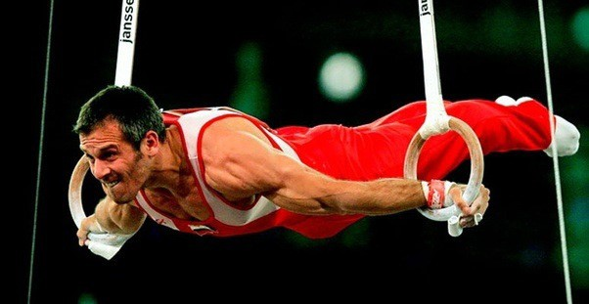
(Please answer the following questions on the A4 paper provided)
- List three activities in physical education that require good core strength. Give an example where good core strength is necessary for each.
e.g. Basketball; performing a lay-up.
- Can you name three exercises you might use in order to improve your core strength?
- Describe what would see if a performer has good core strength in a performance?
- Choose two of the following activities and give two reasons as to why you think good core strength is necessary for these.
> Badminton | > Gymnastics | > Rugby
> Dance | > Football | > Volleyball
- From the following activities, give two reasons why you think core strength is MORE important in one activity than another:
> Bowls > Darts > Swimming
> Circuit Training > Mountain biking

FLEXIBILITY
Flexibility - Flexibility refers to the ability that you have to allow your joints and muscles to move freely. How flexible you are will depend on how comfortable you feel when moving in this way. Good flexibility is necessary for countless activities in physical education. For example, you will require ample flexibility in order to perform a forward roll in gymnastics, to perform an effective overhead clear in badminton or to carry out a successful arabesque in dance.
(Answer the following questions on the A4 paper provided)
- What does good flexibility look like, to you? Describe a sports person who has good flexibility.
- Give five examples of stretches to improve your flexibility?
- Describe a test you can use to check if your flexibility is poor, average, good or excellent?
- Choose your favourite activity in P.E and give two examples where having poor flexibility could impact negatively on your performance?
- Pick 3 of the activities below and give examples where good flexibility could increase your chances of success.
> Waterpolo | > Football | > Dance | > Gymnastics
> Rugby | > Badminton | > Basketball | > Trampolining | > Athletics
- Pick two of the examples below and EXPLAIN two reasons why having good flexibility could improve their performance:
> A goalkeeper in football |  | > A centre in netball
> A gymnast performing on the beam |  | > A hooker in rugby
> A tennis player in a doubles match |  | > A striker in hockey
> A weightlifter |  | > A hurdler in athletics
> A swimmer in 100m front crawl
- Part 1: Pick two of the following famous sportsmen/women and give two reasons why flexibility is important to their sport:
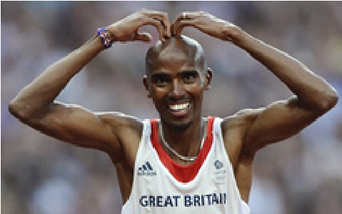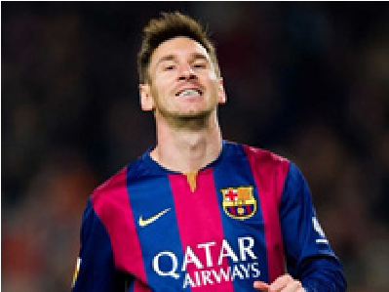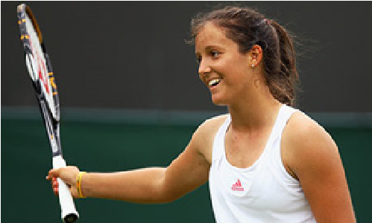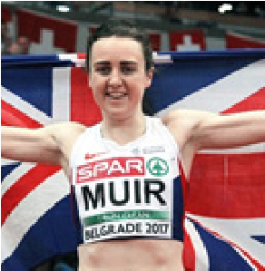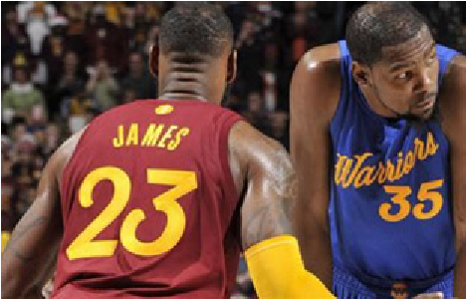

SPEED

PHYSICAL FITNESS
Speed - Speed is one of the main areas of fitness that are important for success in many sports. Speed is the maximum rate at which a person is able to cover a distance or perform a movement in a short period of time.
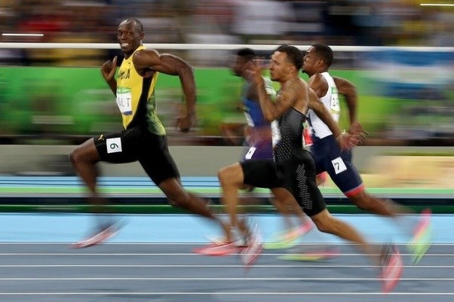

(Answer the following questions on the A4 paper provided)
- List 5 sports where speed is important for success. Give reasons or examples to back up your answer.
- From P.E. explain a scenario where you have had to demonstrate effective speed?
- Describe the running technique in order to run at speed. What does your body do?
- What kind of activities could you do in P.E. to improve your speed?
- Imagine you are the head coach for the Scotland National team (this can be for any sport of your choice). A player in your team has asked you to help them improve their speed in a performance. Create a training exercise for your player to practice, (specific to your sport) that will improve their speed.
- Design a poster, slogan or poem that could be used to show the young people of today the benefits of using speed when taking part in physical activity, physical education and sport.

STAMINA

PHYSICAL FITNESS
Stamina - Stamina in sport is the ability to continue exercising or being active for a long period of time. People who have good levels of stamina can make their body function at a higher capacity, which means their lungs, heart and muscles can work at their best for a longer period of time.
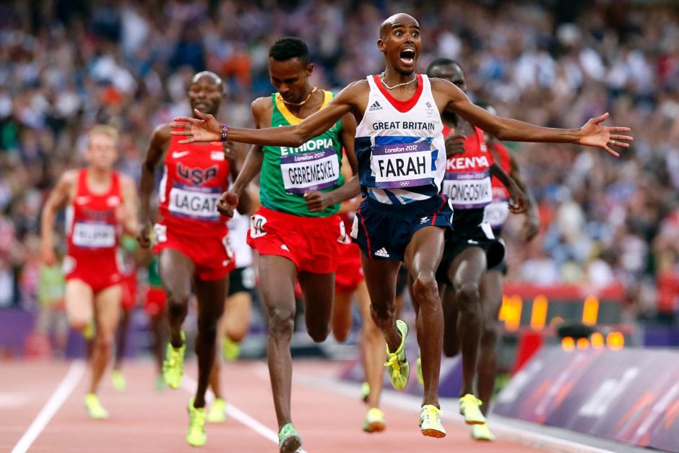
(Answer the following questions on the A4 paper provided)
- List 3 famous athletes that have good levels of stamina in their sport.
- In the sport of your choice, explain why stamina is important.
- Describe how your body feels when you have poor stamina in a performance?
- Give examples of how stamina can impact positively in a team and individual activity of your choice?
- Can you think of a PE lesson that required you to use stamina?

  - What activity where you doing?

  - How would you rate your stamina (poor, average, good, excellent) and give reasons for your answer?
- Imagine you are the head coach for the Scotland National team (this can be for any sport of your choice). Imagine your team’s stamina levels drop in the last 10 minutes of a match, meaning that you lose the game. Create a training exercise/programme for your team to practice, (specific to your sport), that will improve their stamina levels.

