**BGE Drama**

**OLHS CUMBERNAULD**



**Performance Analysis**

**INFORMATION AND ACTIVITIES BOOKLET  
  
In this booklet you will find information and activities related to the study of performance analysis in drama.  
Read the information and engage with study tasks in your jotter, on paper or on a computer.**

**If you are unsure of what to do for a task, just ask your teacher for help!**

**Lesson 1: What is mood and atmosphere?**

**Mood** = feeling

**Atmosphere** = feeling created by the mood

So basically, mood and atmosphere is how your audience is feeling when watching the drama!

For example: The mood and atmosphere of the drama was angry and tense…  
 Mood = angry Atmosphere = tense

**Task 1**

Look at the emoji’s below. State what “mood” each emoji communicates to you.

a) b) c) d) e) f)

**Task 2**

Read the scenes described below. State what you think the mood and atmosphere of each scene would be:

a) Kirsty and Ronnie are having an argument about who does and doesn’t do the most housework around the house. Janet thinks she does more than Ronnie. Ronnie thinks Janet is over-reacting.

b) Adeline and Jonathan are walking their dog when suddenly a man in a balaclava appears and asks for their phone and money. Lucy and Michael stop, doing what he asks them to.

c) Daniel is relaxing in his house when he receives a phone call. It is clear from the conversation that he has been told his mother has been taken into hospital and she isn’t doing very well.

d) Maria and Shaun are having a romantic dinner in the house. Once they have finished their dinner, Shaun gets up, goes down on one knee and proposes. Maria says yes.



**Lesson 2: What is Impact?**

Impact is an important term in drama.

When we watch a performance, we ask ourselves “what impact did that have on me?”

***Impact is to do with…***  
 ***- what the performance makes you think about  
 - what the performance makes you feel  
 - what the performance makes you understand***

[](https://www.youtube.com/watch?v=K9vFWA1rnWc)In order for a performance to have an impact on us, it’s important that we understand what the drama is about. A performance can’t have an impact on us if we can’t follow the storyline and what’s happening to the characters.

**Watch this short video**

This is an advert campaign for Life Insurance.

The advert came out in 2014 and was voted best advert of the year.

Watch the video then answer the questions below.

1. Summarise what you think the message of the advert was.

2. What were you thinking when you were watching the advert?

3. What did you think at the end of the advert? Did your thoughts change after watching the whole advert?

4. How were you feeling when you were watching the advert?

5. How were you feeling by the end of the advert? Did your feelings change after watching the whole advert?

6. What did you learn from watching the advert? Do you think you could take this understanding and put it into practice in your own life? Give an example of how you might do this.

7. What do you think was the mood and atmosphere for the advert?

8. Think about your favourite moment out of the whole video. What were you thinking and feeling whilst watching that moment? What was the mood and atmosphere in this moment?

9. How do you think movement was used in the advert to make you think and feel the way you did? Try and refer to some movement terms in your answer to help explain your point. You can also refer to mood and atmosphere if it helps.

10. How do you think sound was used in the advert to make you think and feel the way you did? Try and describe what the sound was like, how it helped the advert create the mood and atmosphere you mentioned in Q7.

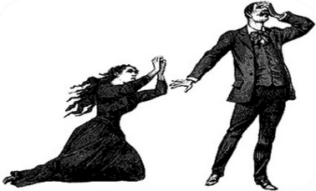**Lesson 3: What is tension?**

Tension helps drive a drama forward.  
It keeps an audience interested in the development of the storyline and what’s happening to the characters.

There are several different types of tension, below are some of the main types of tension that we see in film, theatre, radio and television…

**Element of Surprise**

Character doesn’t know what’s about to happen.

A character surprises another character.

The audience may or may not be in on the surprise.

**A moment of Conflict**

A verbal argument.

A physical fight.

Conflict within a relationship – friends, family or love interests.

**A moment of Suspense**

Builds up to a climax of…  
 - what’s going to happen  
 - what might happen  
 - what’s about to happen

Keeps the audience at edge of their seats wanting to know what’s going to happen next!

**Element of Mystery**

Something is revealed to use we didn’t know about.

There could be a plot twist at any point in the drama.

There is a revelation about a character or a relationship.

**A Dilemma**

Faced with a choice to make, they find difficulty in choosing.

We want to know what they’re going to decide and what’s going to happen as of a result of their choice.

**An issue with a Task**

Character is afraid of or doesn’t want to do something.

Emotions and feelings they experience having to do that task.

**Task 1**

Watch each of the clips below and answer the following questions for each clip…

a) What type of tension did you think is the basis of the drama/advert?

b) Explain how you got an idea of what type of tension it explores. Was it through the acting and/or   
 production skills used? Explain your answer in as much detail as you can.

[](https://www.youtube.com/watch?v=1Ckv_Dz-Sio)[](https://www.youtube.com/watch?v=1O6Qstncpnc&t=17s)

**3.**

**1.**

**4.**

**2.**

[](https://www.youtube.com/watch?v=kIIY1-f_rBg&t=17s)

[](https://www.youtube.com/watch?v=QNUu1d7i26g&t=7s)

**Lesson 4: What is a Target Audience?**

Every drama has a target audience.

A target audience is a group of people that the performance is aimed at.

The drama has been created with that target audience in mind, so that they are the most likely group of people to watch that drama/advert etc.

Most target audiences tend to be aimed towards people who “stereotypically” will be interested in or like the subject matter of the advert/drama/film etc. Target audiences can also be organised by age group, to help narrow the target audience down further.

And so, directors and writers will create that drama with those people in mind, even if other genders, age groups etc. are also interested in that topic.

**For example:**

* The Tweenies (tv program) 🡪 has a **target audience of** **children between the ages of 3 and 5**. This is because of the characters involved, the storylines and explored and the time of day it is broadcast on television. But that doesn’t mean to say children younger than 3 or older than 5 wouldn’t be interested in watching the program, but it is that age group it is aimed at.
* Football Game adverts 🡪 tend to be **targeted towards** **men, interested in football**. This is because stereotypically, it is men who watch football. But that does not mean to say that women are not also interested and wouldn’t be interested in watching the game, after watching the advert.
* Desperate Housewives (tv program) 🡪 **aimed at women in general**. This is because of the characters and the storylines. However, that doesn’t mean to say that men wouldn’t also be interested in watching this program too, but the adverts and program itself is aimed to attract women to watch it.



**Task 1**

Watch each of the clips below.

Answer the following questions for each clip…

a) What do you think is the target audience for this clip?

[](https://www.youtube.com/watch?v=RbMfkRTUzGo) b) Explain why you think that is the target audience

[](https://www.youtube.com/watch?v=Y_iCIISngdI)[](https://www.youtube.com/watch?v=QbrYzezp7e8)

3.

2.

1.

**Lesson 5: Production Skills**

When watching a performance, whether it be a tv advert, tv program, film, play or musical, production skills have been used to **make the performance seem more realistic and also enhance the mood and atmosphere** throughout the performance, or in certain moments.

Production Skills are:

* Lighting
* Sound
* Costume
* Hair and Make-Up
* Props
* Set

The tasks below take you through each production skill, giving you information on it and explaining how it can contribute to a performance.

**Lighting**

Lighting is the use of theatrical lanterns to light the stage.

How does lighting contribute to a performance?  
- allows us to be able to see the actors  
- can contribute towards creating a mood and atmosphere

**Task 1**

Look at the images below.  
a) describe what the lighting looks like  
b) state what you think the mood and atmosphere of it is

1. 2. 3.

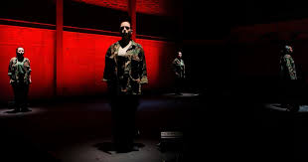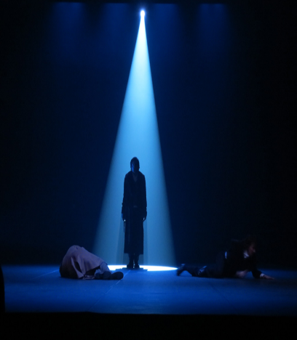

**Sound**

Sound is the use of live or pre-recorded sound in a performance. You can have a sound effect or a piece of music.

Why are they important?  
- can help make actions seem more realistic  
- can contribute towards telling the audience where we are  
- can contribute towards creating a mood and atmosphere

**Task 2**

Read the sound descriptions below.  
a) state what mood and atmosphere you think that sound would create  
b) explain why you think it would create that mood and atmosphere

1. Birds tweeting 2. Gunshot, fired 3. A telephone ringing,  
in the morning in the distance. unexpectedly.

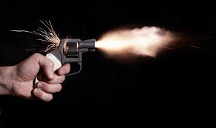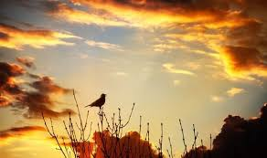

**Costume**

Costume is the clothes worn by the actor for their character.

Why are they important?  
- can help to give the audience more information about a character  
- can help an actor to realistically portray a character (they feel more in character when in costume)  
- can contribute towards creating a mood and atmosphere

**Task 3**

Look at the costume images below.  
a) Describe the impression you get of that character from their costume  
b) What type of mood and atmosphere do you think this character could create, when entering a scene with this costume on.

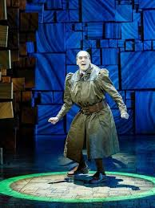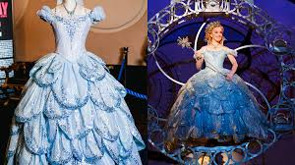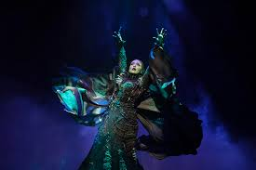1. 2. 3.

**Hair and Make-Up**

Hair – can be the actors own or a wig.  
Make-up – darker then usual so they stand out under the lights.

Why are they important?  
- can help to give the audience more information about a character  
- can help an actor to realistically portray a character (they feel more in character when in hair and make-up)  
- can contribute towards creating a mood and atmosphere

**Task 4**

Look at the hair and make-up designs below.  
a) Describe the impression you get of that character from their costume.  
b) What type of mood and atmosphere do you think this character could create, when entering a scene with this hair and make-up on.

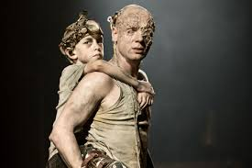1. The blind prophet Tiresias 2. An old homeless man 3. A Panto Dame

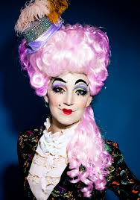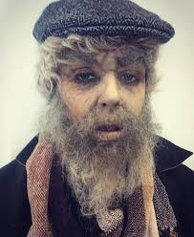

**Props**

Props are everyday items used by the actors.

Why are they important?  
- can help to make an action seem more realistic  
- can give the audience more information on the setting  
- can give the audience more information on a character  
- can contribute towards creating a mood and atmosphere

**Task 5**

Look at the images below.  
State what mood and atmosphere each prop could create if it were to appear/be used in a performance.

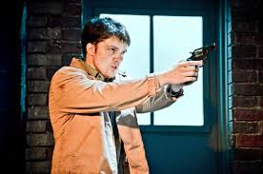1. Someone pulls out a gun 2. Someone receives a bunch of flowers 3. A letter arrives in the post

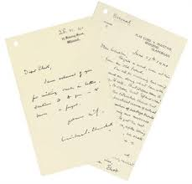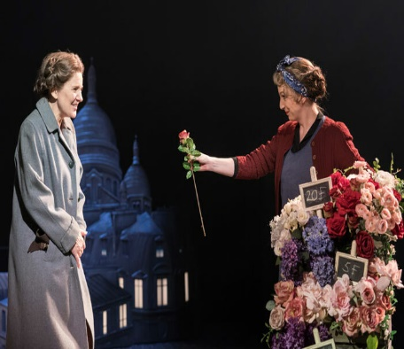

**Set**

Set is the furniture on stage which can change from scene to scene.

Why is set important?  
- can give the audience more information on the setting of the play  
- can contribute towards creating a mood and atmosphere

**Task 6**

Look at the images below.  
State what mood and atmosphere you think the set creates.

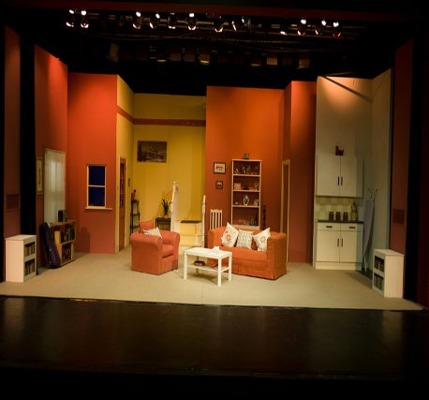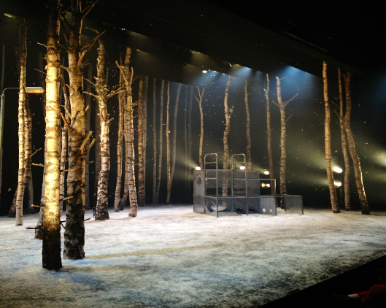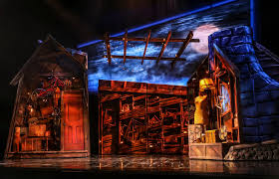1. A haunted mansion 2. A snowy Forrest 3. A Livingroom

**Lesson 6: Voice and Movement**

The voice and movement an actor uses not only helps to portray their character, it helps engage an audience, so they are interested in watching the performance.

If an actor says that they’re angry, but don’t act that way using their voice and movement, then how is an audience supposed to know that’s how they feel?

And so how an actor chooses to use voice and movement can have a big impact on the mood and atmosphere communicated to the audience.

Voice and movement have been split into two sections below.  
Within each section, you will see the terminology which you should be aware of from your study in drama.  
Read the information on each term and engage with the tasks that follow.

**Voice**

Tone

Tone helps to describe the emotion that someone feels. “She spoke in an angry tone”.

**Task 1**

Write down 5 different tones you can think of.  
Top tip: think about emotions you have felt yourself, or emotions you have picked up on from other people, television, film, theatre etc. Or – think of emoji’s! But make sure it’s an emotion!  
  
  
Accent

Accent is the way that someone speaks, depending on where they come from. So if someone is from Ireland, they will speak with an Irish accent.

Pitch

Pitch is how high or low someone’s voice is. This can describe the natural pitch of their voice, so for example, most men have a lower pitch of voice.  
However, a person’s pitch can change depending on how they feel or what they’re experiencing…

**Task 2**

Look at the descriptions below. Decide what pitch you think the person would have based on the description.

a) Someone has been surprised by a friend with a trip away, they are excited about it.

b) Someone has been given a fright by a spider, they are scared of spiders.

c) Someone is feeling upset because they failed their driving test.

Pace

Pace is to do with how fast or slow someone speaks. Lots of people speak naturally faster or slower than others, but a person’s natural pace of speech can change depending on the situation they find themselves in.

**Task 3**

Look at the descriptions below. Decide what pace you think the person would use based on the description.

a) I am so excited this is such a great opportunity!

b) What do you mean you can’t see anything?

c) I just don’t know what to think anymore.

Pause

Pause is used to create dramatic effect. This is usually to help create tension in a drama.

**Task 4**

Look at the sentences below. Decide where you would put a pause for dramatic effect in the sentence.

a) No you need to tell me more than that.

b) Watch out there’s a spider over there.

c) I can’t believe she would do that how does she think that makes me feel.

Clarity

Clarity is all about how clear or unclear someone speaks. A person may choose to speak very clearly on purpose, to ensure their point is made clearly. Someone may also speak unclearly because they are nervous and so they are mumbling when they speak. So clarity, like so many of our other voice terms, is all dependent on the situation the person finds themselves in.

Emphasis

Emphasis is when someone places stress on a word, to make it stand out so that it is the focus of attention. You may have noticed in books or plays, that if a word is in *italics*, it is because the writer wants to emphasise the importance of this word. So when you read it, you say it slightly differently to the rest of the words on the page.

**Task 5**

Look at the sentences below. Decide what word you would put emphasis on, to make it stand out.

a) How dare you speak to me like that, do you now who I am?

b) I am so incredibly happy for you, you’re so lucky.

c) I can’t believe it, I mean did she really do that to you?

**Movement**

Facial Expression

How a person feels is usually expressed through their face. So if someone is feeling sad, happy or angry, we should be able to tell by their facial expression how they feel.

**Task 1**

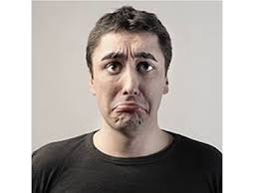Look at the images below. Decide what emotion you think the person is feeling.

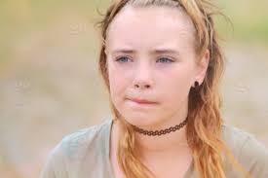1. 2. 3.

Body Language

How a person feels is also expressed through how they hold their body. What they do with their arms and hands. We can describe body language as “open” or “closed” along with the emotion we think the person is feeling. So for example “she had closed and angry body language as she had her arms crossed in front of her body”. By this description, we can get an idea of what the person is feeling because of how their body language is described.

**Task 2**

Look at the images below. Decide what body language you think the person is feeling.

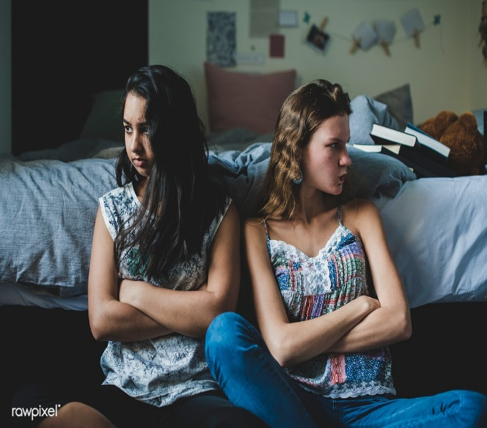1. 2. 3.

Posture

There are two options for posture. These are straight or slouched. Again, a person’s posture can be influenced by what a person is feeling or it can be what they are doing. If a person is relaxing on the couch, they may have a slouched posture, because they’re relaxing. But a slouched posture could also communicate that someone is feeling tired or sad – so it very much depends on the situation!

Gesture

Gesture is communication without words. So we use our hands or our head to communicate a message or a feeling to someone, without speaking. So nodding or shaking our heads, means yes or no – this is a gesture. If someone is moving their hands around meaninglessly when they are talking, this is **NOT** gesture. Gesture has to have a meaning behind it.

**Lesson 7: What is performance analysis?**

To analyse a performance means to watch it and critique it.  
This is most often done by Arts Journalists.  
They specialise in critiquing performances and publishing reviews on them, whether this be for a newspaper, magazine or website.  
Over the last few years, creating short review videos to share on social media platforms has also become very popular.

Most pieces of theatre, film, program or advert will have a review on it.   
Reviews allow performance artists to get feedback on their work.  
Obviously, they want a good review. The better the review, the more likely other people will be to watch it!

The review will look at the acting and production skills used (costume, sound etc) and the impact the performance created through them.

Impact means how the performance makes you feel or what it makes you think after you have watched it – so has the performance been good (or bad)? Was it the acting, the production skills or both? What did you think or feel after watching it?

The mood and atmosphere of a performance is what often makes the most impact.  
This can be the mood and atmosphere of the whole performance, or just a part of it.  
This is why understanding mood and atmosphere and how it’s created through acting and production skills is so important.

**Task:**  
Below is a short article adapted from an article in The Guardian newspaper.  
It highlights some of the main points you need to consider when writing a review.  
**Read the article and write down 5 points you learned on the do’s and don’ts of writing a performance review**.

The first rule is that there are no rules – you're writing a review to express your thoughts and feelings about a performance. There are as many ways to write a review as there are personal responses to any production. There is no right or wrong. Allow yourself to develop your own distinctive voice, and be honest about what you really think about a production: convey your enthusiasm for it or explain why you disliked it.

A traditional review often begins by giving the reader some background about the production, a brief outline of plot and themes, a sense of what the staging looks (and sounds) like; it offers an evaluation of writing, production and performances and concludes with a summing up.

Write a review that really reflects what you felt about a show – not what you think you ought to have felt about it. Oh, and have fun. If you don't have fun writing the review, nobody will have fun reading it.

**Lesson 8: Watch Performance**

You will now watch a performance chosen for you to review.

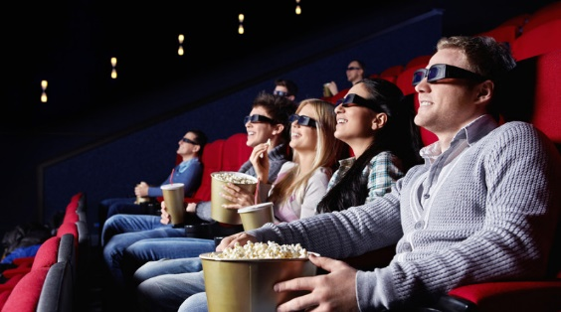This will either be:

* An advert
* A television program (an episode)
* A short film
* A feature length film
* A play
* A musical

You will be completing a review on this performance in the next lesson.  
  
You can look ahead in the booklet now, to see what you will have to write in your review.  
  
This should help you understand what you should be looking for when watching the performance.

**Lesson 9: Performance Review**

Now that you have watched the performance, you can complete a performance review.

Depending on your year group, you should choose the appropriate performance review sheet task to complete on the following pages.  
Each of these are different and have different requirements, so make sure you use the correct review guidance sheet for your year group!  
  
If you are working on this in class, you should create your review as if it were to be published in a:  
 - newspaper  
 - magazine  
 - website.  
  
If you are working on this from home, you can choose:  
 - any of the above (newspaper, magazine or website)  
 - PowerPoint  
 - Podcast  
 - Vlog

So long as your review covers all of the information required.  
  
If there are any areas in your review you are unsure of, you should ask your teacher for help or do some research on the internet about the performance (make sure you ask permission to do this if you are working on this in class).

**S1 Performance Review**

**Name of Performance:** ____________________________________________________________



**Who wrote it?**

**_______________________________________________________________________________________________________________________________**

**Who directed it?**

**_______________________________________________________________________________________________________________________________**

**Where is it set?**

**_______________________________________________________________________________________________________________________________**

**When is it set?**

**_______________________________________________________________________________________________________________________________**

**What is the performance about?**

**________________________________________________________________________________________________________________________________________________________________________________________________________________________________________________________________________________________________________________________________________________________________________________________________________________________________________________________________________________________________________________________________________________________________________________________________________________________________________________________________________________________________________________________________________________________________________________________________________________________________________________________________________________________________________________________________________________________________________________________________________________________________________________________**

**How has this impacted on your leadership learning?**

*Exploring a variety of small pilot programmes in the larger context of how animal assisted learning can be of benefit in the school environment has been extremely positive in allowing me to explore small tests of change and identify areas for development as well as tracking and monitoring impact in a sustainable and manageable way.*

*This approach has allowed me to gain confidence in how to structure projects in the future and has identified areas of future interest.*

*The programme has also grown as we have included more participants and this has enabled us to involve more staff and develop a team who are interested in taking these projects further and developing them in the future.*

**Choose an actor that stood out for you. Pick a moment where this actor used great voice and movement skills. You should describe how they used their voice and movement in the performance.**

**_____________________________________________________________**

**_____________________________________________________________**

**_____________________________________________________________**

**_____________________________________________________________**

**_____________________________________________________________**

**_____________________________________________________________**

**_____________________________________________________________**

**What was the mood and atmosphere of the performance?**

**______________________________________________________________**

**______________________________________________________________**

**______________________________________________________________**

**______________________________________________________________**

**______________________________________________________________**

**How did acting help create this mood and atmosphere?**

**______________________________________________________________**

**______________________________________________________________**

**______________________________________________________________**

**______________________________________________________________**

**______________________________________________________________**

**How did any production skills help create this mood and atmosphere?**

**______________________________________________________________**

**______________________________________________________________**

**______________________________________________________________**

**______________________________________________________________**

**______________________________________________________________**

**How many stars would you give it, as a performance review critic?**



**Explain why you gave the above review.**

**_____________________________________________________________**

**_____________________________________________________________**

**_____________________________________________________________**

**_____________________________________________________________**

**_____________________________________________________________**

**S1 Performance Review**

**Name of Performance:** ____________________________________________________________



**Who wrote it?**

**_______________________________________________________________________________________________________________________________**

**Who directed it?**

**_______________________________________________________________________________________________________________________________**

**Where is it set?**

**_______________________________________________________________________________________________________________________________**

**When is it set?**

**_______________________________________________________________________________________________________________________________**

**What is the performance about?**

**________________________________________________________________________________________________________________________________________________________________________________________________________________________________________________________________________________________________________________________________________________________________________________________________________________________________________________________________________________________________________________________________________________________________________________________________________________________________________________________________________________________________________________________________________________________________________________________________________________________________________________________________________________________________________________________________________________________________________________________________________________________________________________________**

**How has this impacted on your leadership learning?**

*Exploring a variety of small pilot programmes in the larger context of how animal assisted learning can be of benefit in the school environment has been extremely positive in allowing me to explore small tests of change and identify areas for development as well as tracking and monitoring impact in a sustainable and manageable way.*

*This approach has allowed me to gain confidence in how to structure projects in the future and has identified areas of future interest.*

*The programme has also grown as we have included more participants and this has enabled us to involve more staff and develop a team who are interested in taking these projects further and developing them in the future.*

**What impact did the performance have on you?**

**_____________________________________________________________**

**_____________________________________________________________**

**_____________________________________________________________**

**_____________________________________________________________**

**_____________________________________________________________**

**Explain how acting and/or production skills helped to create that impact?**

**_____________________________________________________________**

**_____________________________________________________________**

**_____________________________________________________________**

**_____________________________________________________________**

**_____________________________________________________________**

_____________________________________________________________

_____________________________________________________________

_____________________________________________________________

_____________________________________________________________

_____________________________________________________________

_____________________________________________________________

**What was the mood and atmosphere of the performance?**

**______________________________________________________________**

**______________________________________________________________**

**______________________________________________________________**

**______________________________________________________________**

**______________________________________________________________**

**Explain how acting and/or production skills helped to create the mood and atmosphere.**

**______________________________________________________________**

**______________________________________________________________**

**______________________________________________________________**

**______________________________________________________________**

**______________________________________________________________**

______________________________________________________________

______________________________________________________________

______________________________________________________________

______________________________________________________________

______________________________________________________________

______________________________________________________________

**Describe a moment where the use of a production skill really interested you or caught your attention. Describe what the moment was and how the production skill was used.**

**_____________________________________________________________**

**_____________________________________________________________**

**_____________________________________________________________**

**_____________________________________________________________**

**_____________________________________________________________**

**_____________________________________________________________**

**_____________________________________________________________**

**_____________________________________________________________**

**How many stars would you give it, as a performance review critic?**



**Explain why you gave the above review.**

**_____________________________________________________________**

**_____________________________________________________________**

**_____________________________________________________________**

**_____________________________________________________________**

**_____________________________________________________________**

**How many stars would you give it, as a performance review critic?**



**Explain why you gave the above review.**

**_____________________________________________________________**

**_____________________________________________________________**

**_____________________________________________________________**

**_____________________________________________________________**

**_____________________________________________________________**

**Describe a moment where the use of a production skill really interested you or caught your attention. Describe what the moment was and how the production skill was used.**

**_____________________________________________________________**

**_____________________________________________________________**

**_____________________________________________________________**

**_____________________________________________________________**

**_____________________________________________________________**

**_____________________________________________________________**

**_____________________________________________________________**

**_____________________________________________________________**

**Choose an actor that stood out for you. Pick a moment where this actor used great voice and movement skills. You should describe how they used their voice and movement in the performance.**

**_____________________________________________________________**

**_____________________________________________________________**

**_____________________________________________________________**

**_____________________________________________________________**

**_____________________________________________________________**

**_____________________________________________________________**

**_____________________________________________________________**

**What was your favourite moment? Explain why it was your favourite moment.**

**_____________________________________________________________**

**_____________________________________________________________**

**_____________________________________________________________**

**_____________________________________________________________**

**_____________________________________________________________**

**_____________________________________________________________**

**_____________________________________________________________**

**S3 Performance Review Essay**

Now that you have watched the performance, it’s now up to you to write a review on it.

Using the knowledge and understanding you have developed about drama over the last 3 years, as well as from the activities in the Performance Analysis Booklet, you should create a review essay, covering the following sections:

**Para 1 – Target Audience**

Who do you think is the target audience for this drama?

Do you think the target audience would relate to and/or understand the drama? Explain your answer.

**Para 2 - Impact**

What impact did the performance have on you?

Why do you think it had this impact?

Explain how performance concepts were used to help create this impact.

Explain why those performance concepts had this impact on you.

Explain how design concepts were used to help create this impact.

Explain why those design concepts had this impact on you.

**Introduction**

What is the name of the performance that you watched?

Who wrote it?

Who directed it?

Where is it set?

When is it set?

What is the performance about?

**Para 3 – Effective Moment**

What do you think was the most effective moment?

What made this moment so effective?

Explain how performance concepts were used in this moment to make it effective.

Explain what impact these performance concepts had on you.

Explain how design concepts were used in this moment to make it effective.

Explain what impact these design concepts had on you.

**Para 4 – Moment of Tension**

Describe a moment of tension.

What was it about this moment that made it tense?

Explain how performance concepts were used in this moment to make it tense.

Explain what impact these performance concepts had on you.

Explain how design concepts were used in this moment to make it tense.

Explain what impact these design concepts had on you.

**Conclusion**

Summarise your overall thoughts and feelings about the performance.

Would you recommend it to anyone? Explain your answer.

How many stars would you give it for a publicised review?

Explain why you would give it that many stars

**Para 5 – Performance of main character**

Who was the main character in the performance? Describe their personality.

Explain how the actor used performance concepts to make their personality clear.

Explain how the use of these concepts helped you to understand the character and their personality better.

Explain how design concepts were used to highlight this character’s personality.

Explain how the use of these design concepts helped you to understand the character and their personality better.



**Lesson 10: Poster**

Create your own poster for the performance you watched.  
It should include the information from section 1 in your review.   
It should also include some images – make it colourful!

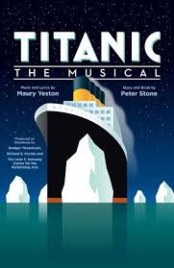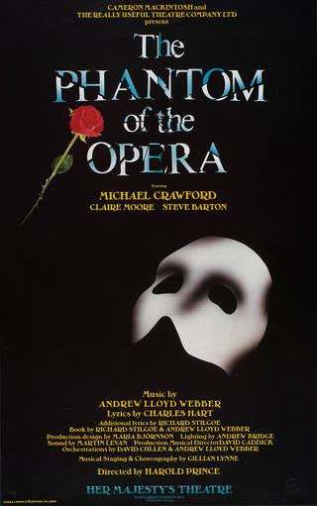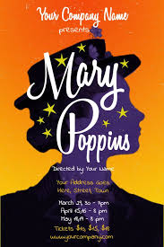Look at some examples below for inspiration!

Include a quote from a review and maybe how many stars it’s getting from those reviews!

Create an image which summarises what it’s about, so when people see that image they know what it’s to do with!

Make sure the name of the play and all of the key information stands out and is easy to read!

Think about design and colours – make it attractive to look at, so it would catch someone’s attention!