BGE Drama
OLHS CUMBERNAULD
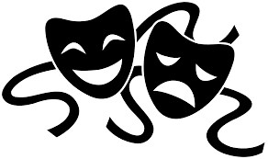

PRODUCTION SKILLS
INFORMATION AND ACTIVITIES BOOKLET
In this booklet you will find information and activities related to the study of Production Skills in drama.
Read the information and engage with study tasks in your jotter, on paper or on a computer.
If you are unsure of what to do for a task, just ask your teacher for help!

Lighting
What is the purpose of Lighting?
The use of theatrical Lanterns has 3 main purposes:
- To light the stage or focus on a particular area of the stage
- To create a mood and atmosphere
- To tell us information about the setting and time
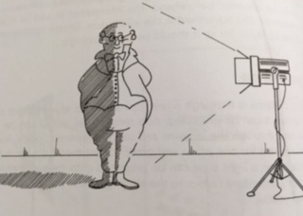
Use of lighting in Theatre
Lighting the actor
If an actor is only light from one side of the stage, then a shadow could be cast on the opposite side of the lantern, meaning half of the actor is in darkness. So ideally, the actor should light from all sides.
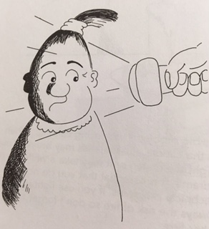
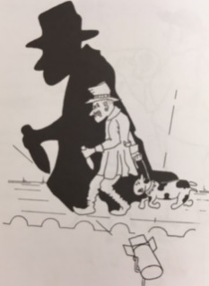
Uplighting
This means lighting the actor from below, creating a large shadow effect. This can help create tension or a melodramatic effect.
Lighting without lanterns
The use of candles or torches on stage can also help create a mood and atmosphere on stage. However the use of lanterns may still be needed in order for the audience to be able to see what is happening on stage. In order to make it appear as though the main source of light is from the candle or torch, the lanterns would need to be set at a low intensity.
Lighting Controls
Fade Up
To fade up, means to bring the lights up – i.e. to turn them on so they are projecting light on stage.
Fade Down
To fade down, means to bring the lights down – i.e. to turn them down so they stop projecting light on stage.
Blackout
To blackout means to cut the lights instantly, meaning there are no lights projected on stage.
Intensity
This refers to how bright or how dim the light is.
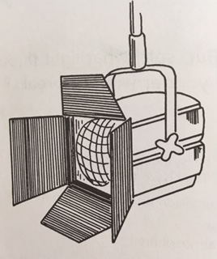
Lanterns
The wattage of lightbulbs in a general household are usually 60-100 watts. The wattage of the bulb used in a lantern can be 500-1000 watts, sometimes even stronger.

Types of Lighting and Effects used in Theatre
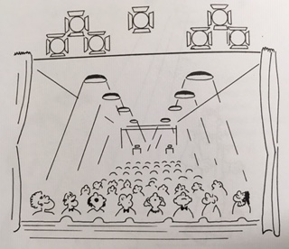
Houselights
The ordinary lights in the room/venue. Having the houselights dimmed can help create an atmosphere of anticipation before a performance. Turning the houselights off, indicates that the performance is about to begin.

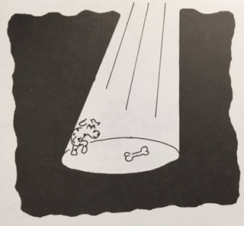
Profile
This lantern creates a hard edge beam of light in the shape of a circle.
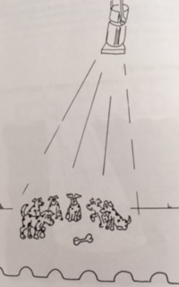
Fresnel
This lantern creates a soft edge beam of light, so the light blends into the darkness, instead of having a hard line like a profile lantern.
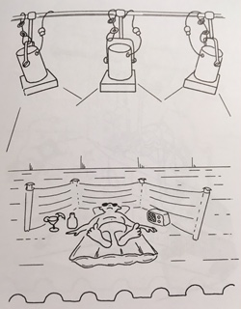

Flood
This lantern creates a general wash of light, allowing it to usually cover the whole acting area.
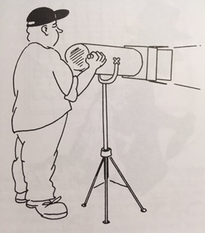
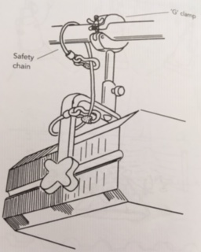
Follow spot
A large version of a profile, which creates a spotlight to project on the stage. It is on a large stand, allowing it to be manoeuvred to follow the actor’s movements.

Safety chain and G-clamp
These help secure the lantern to the lighting bar, in order to prevent the lantern from becoming loose and falling. The chain links through lantern and around the lighting bar, while the clamp is screwed onto the bar itself.
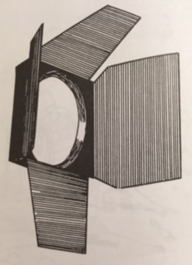
Barn Doors
These are small frames which have 4 metal flaps attached to it. The frame is slotted in front of the light and the flaps can be opened or closed to control or shape the beam of light.
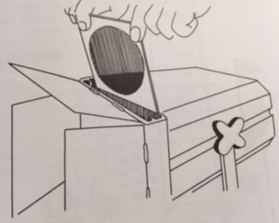
Gels
These are coloured plastic sheets that can be attached to the lantern in order to project a specific colour on to the stage. The use of colour, often helps create a mood and atmosphere. The plastic is specially made so that it won’t burn from the high wattage of the bulb.
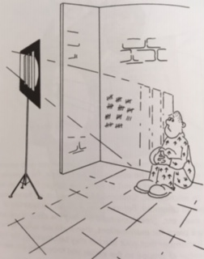

Gobos
These are metal cut-outs which can be placed at the front of the spotlight. The lantern then projects this shape onto the stage, creating a specific effect.

Planning the lighting for a drama
The lighting designer should create:
- a ground plan
- a plot sheet
- a cue sheet
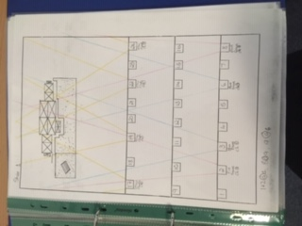
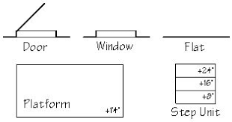
Ground plan
This helps indicate where actors and set are placed on stage during a scene. This will help the lighting designer work out what lights are needed for the opening of a scene. A ground plan has symbols drawn on it to represent set items, such as a door or a window.

Plot sheet
This helps indicate what lights are used, the direction they are pointing in and where the light will project to.
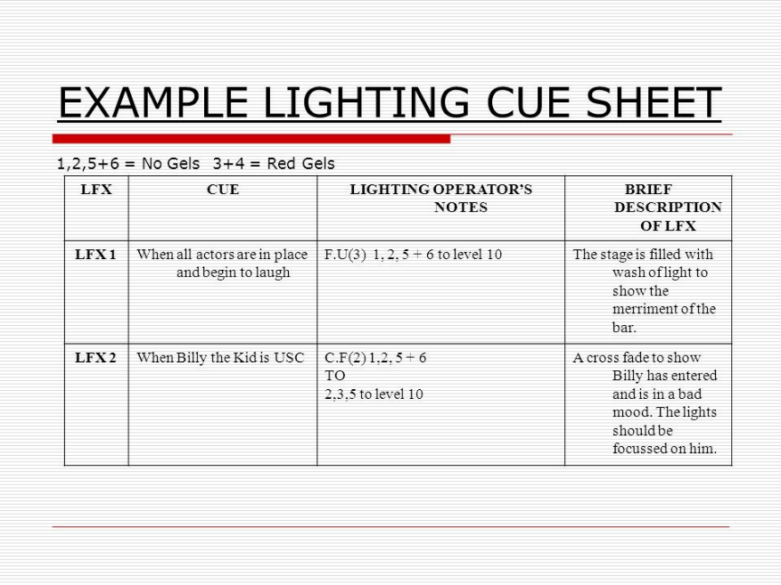

Cue sheet
This helps indicate what lights are used and when they are used – the lighting operator will follow this during the performance.

Lighting Tasks
Task 1: Read the above information and make notes on the following areas:
- The purpose of lighting in the theatre
- Use of lighting in theatre
- Lighting controls
- Types of light and effects used in theatre
- Planning the lighting for a drama

Task 2: Answer the following questions:
- What is the difference between a Profile and a Fresnel?
- What are the three main purposes of lighting?
- What are houselights?
- What type of light does a flood light create?
- Why is a safety chain and g-clamp necessary?
- What can barn doors do?
- What are gels?
- What is a gobo?
- Ideally, from how many sides should an actor be lit?
- What is a follow spot?
- What effect can you create by using uplighting?
- What does blackout mean?
- What might you have to do if you are using candles or torches?
- What is the general wattage of a bulb used in theatre?
- What is a plot sheet?

Task 3: If the use of colour can help represent a mood and atmosphere, what mood and atmosphere could each of these colours create…
1. Red
2. Blue
3. Pink
4. Green
5. Yellow

Task 4: Answer the following questions in order to create a drama and an idea for lighting for that drama:
Scenario: 2 people, sitting in the living room, talking about what happened the night before.
- Respond to the 5 W’s in order to expand the above scenario: who, what, where, when and why.
- What is the mood and atmosphere of the scene?
- How would you use lighting to enhance or change this mood and atmosphere? What lantern would you use? Would you use a gel? What colour? Would you use a gobo? What effect would this create?
Sound

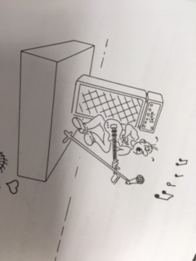
There are 2 different types of sound that can be used in the theatre:
- Music
- Sound effect

These 2 types of sound can be played in 2 different ways:
- Live sound
- Pre-recorded sound

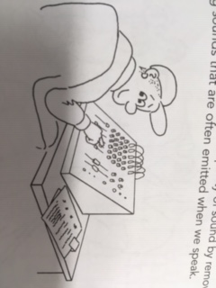
Sound can be used for different reasons
- Creating a mood and atmosphere
- During scene changes
- Start of opening scene
- End of closing scene
- During a scene
How sound is used
Volume The volume level it is played at must be correct. For example, if a sound is being played during a scene, it needs to be at the correct volume level so it is not louder than any dialogue happening on stage.
When it is played needs to be at the right moment, particularly if it is a sound effect
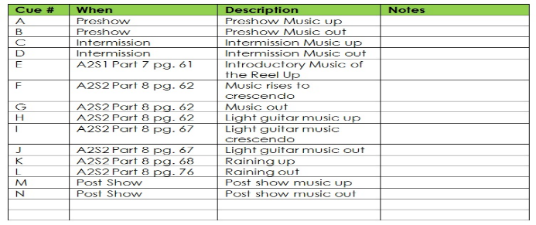
Planning for using sound in theatre
A cue sheet needs to be created.
This details:
- what sound is played
- when it is played
- how long it is to be played for

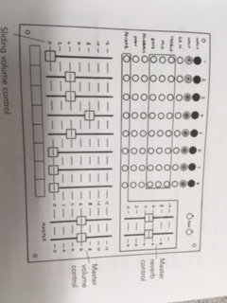
Back – Ups
It’s important to have back-ups ready in case of technical failure.
Usually, back-ups are:
- CD and CD player
- MP3 player
- Spare laptop/computer with soundtracks on a playlist
- Speakers

Task 1: Read the above information and make notes on the following areas:
- The 2 different types of sound that can be used in theatre
- The 2 different ways sound can be played in theatre
- The reasons sound is used in theatre
- How sound is used
- Planning for use of sound in theatre
- Back-Ups for sound

Task 2: Answer the following questions:
- State 3 reasons for why sound can be used in theatre
- Why do you think it is important to have a back-up plan for using sound?
- What are the 2 different ways sound can be played in theatre?
- What is detailed in a cue sheet?
- What are the 2 different types of sound that can be used in theatre?
- What do you need to focus on when you look at how you used sound in theatre?

Task 3: If sound can help create or enhance a mood and atmosphere, what mood and atmosphere could each of these sounds create…
1. Gunshot
2. Thunder and Lightning
3. A crowd cheering
4. The theme tune to “Jaws”
5. The theme tune to “Harry Potter”
6. The theme tune to “Friends”

Task 4: Answer the following questions in order to create a drama and an idea for sound for that drama:
Scenario: 2 people, sitting in the living room, talking about what happened the night before.
- Respond to the 5 w’s in order to expand the above scenario: who, what, where, when and why.
- What is the mood and atmosphere of the scene?
- How would you use sound to enhance or change this mood and atmosphere? What type of sound would you use? How would the sound be used? What effect would this create?

Props

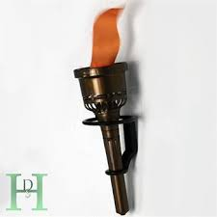
What are props?
Props are items that can either be added to the set or used by an actor.
Some props are held and used by an actor and can also be functional, such as a torch that can be switched on.
Some props are placed on set and not used, such as a lamp.
Some props are personal to a character, such as a piece of jewellery.
Because of the above reasons, props are therefore organised into 3 categories:
- Hand held props
- Set props
- Personal props

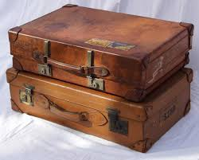
What does the props designer need to think about?
When choosing or designing a prop, the designer should consider the following:
- Style Does it work with the time period of the play? Does it suit the
character who owns/uses it?
- Durability Is it easily breakable? Will you need to have more than one of
these if this is the case?
- Colour Will it be seen from the back of the audience? Could it blend in
with set and costume and be missed?

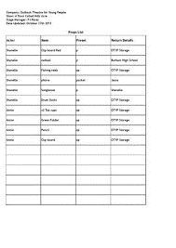
What is a props list?
A props list details the following:
- what the prop is
- what type of prop it is
- who it is used by
- when it is used
A props list is essential in order to understand what props are needed and when.
This will allow the props designer to be ready to give a prop to the actor or go and place a prop on set during a scene change.

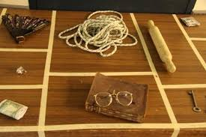
The role of the props designer:
- Make a list of props required for the production
- Collects necessary props
- Make or adapt a prop if necessary
- Complete props list
- Store props appropriately as they are sourced
- Organise props table on a scene by scene basis
- Put props in place before production, whether on set or on props table
- Supervise during the production, on hand to give props to actors
- Collect and return props at end of the production

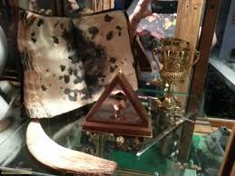
Why are props important in theatre?
- can make actions seem more realistic
- can give information on setting
- can give information on time period
- can give information on a character
- can enhance or change the mood and atmosphere of the
drama

Task 1: Read the information above and make notes on the following:
- What are props?
- What does the props designer need to think about?
- What is a props list?
- What does the props designer need to do?
- Why are props important in theatre?

Task 2: Answer the following questions:
- What are props?
- What is a set props?
- Give an example of a set prop.
- What is a hand held prop?
- Give an example of a hand held prop.
- What is a personal prop?
- Give an example of a personal prop.
- What is a props list?
- Why is a props list essential?
- What 3 things does a props designer need to think about?
- In your opinion, what are the 5 most important things a props designer needs to do?
- Why are props important in theatre?

Task 3: If props can help create or enhance a mood and atmosphere, what mood and atmosphere could each of these props create…
1. A man pulls a gun out of his pocket and threatens the cashier
2. A husband pulls out an engagement ring from his pocket and proposes to his girlfriend
3. A grandad gives his grand-daughter a locket with a picture of them together inside it
4. The ghost hunter uses a torch as they search inside the dark haunted mansion

Task 4: Answer the following questions in order to create a drama and an idea for a prop for that drama:
Scenario: 2 people, sitting in the living room, talking about what happened the night before.
- Respond to the 5 W’s in order to expand the above scenario: who, what, where, when and why.
- What is the mood and atmosphere of the scene?
- How would you use a prop to enhance or change this mood and atmosphere? What prop would you use? What type of prop is it? Who uses it? How is it used? When is it used? What effect would this create?

Costume

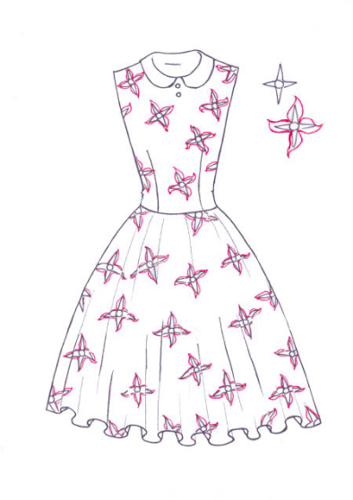
Costume Vocabulary
Costume
- Clothes worn by the actors for their character
Period Costume
- Clothing that reflects a time in history
Costume List
- List of all the costume for each character
Costume Template
- design created by costume designer on what costume should look like
Jewellery, Hats and Wigs
- These also make up part of the characters costume and can be the costume designer’s responsibility
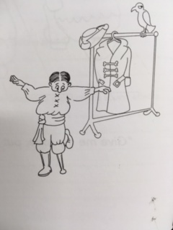
What does the Costume Designer need to do?
- Work with the director to find out what is required for the characters
- Research: time, place, style, etc. of the performance
- Research each character: their job, personality, status, etc.
- Measure the actors
- Create a costume list, detailing ideas for each aspect of costume for each character
- Design costume on template to visualise ideas
- Create, source and adapt costume appropriately
- Complete fittings with the actors to make sure everything fits appropriately
- Store costume appropriately
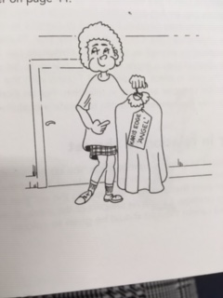
- Fit costumes on day of performance and be on hand for any fixings required

Areas the costume designer needs to consider
- The budget they have to work with
- The timeframe they have to source and create costume by
- The colours they choose – so it doesn’t clash with the set too much
- The costume is comfortable for the actors
- The durability of the material – will it last against costume changes, sweat, under the beam of the lights
- The costume works for the character and their personality, job, etc.
- Ensuring the material isn’t see-through underneath the lanterns
- Footwear to go with the costume – it’s appropriate and works with the costume

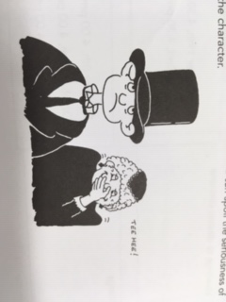
Why do you think Costume is important?
- Can give information about a character
- Can give information on time and setting of the drama
- Can help an actor get into character more
- Can enhance or change a mood and atmosphere

Task 1: Read the above information and make notes on the following areas:
- Costume Vocabulary
- What does the costume designer need to do?
- Areas the costume designer needs to consider
- Why costume is important

Task 2: Answer the following questions:
- What is Period costume?
- What is a costume template
- Why is it important that a designer create a costume template for a character?
- In your opinion, what are the 5 most important things a costume designer needs to do?
- How could lanterns affect costumes on stage?
- Why does the material of the costume need to be of good quality?
- Why is it important to choose appropriate footwear for the character?
- What are the 4 reasons for costume being important?

Task 3: Answer the following questions in order to create a drama and an idea for costume for the characters in that drama:
Scenario: 2 people, sitting in the living room, talking about what happened the night before.
- Respond to the 5 W’s in order to expand the above scenario: who, what, where, when and why.
- What is the mood and atmosphere of the scene?
- How could you use costume to enhance or change the mood and atmosphere? What is the character wearing? What effect would this create?

Task 4: Create a costume template for both of the characters in your above scenario. Try to make them as detailed as possible.

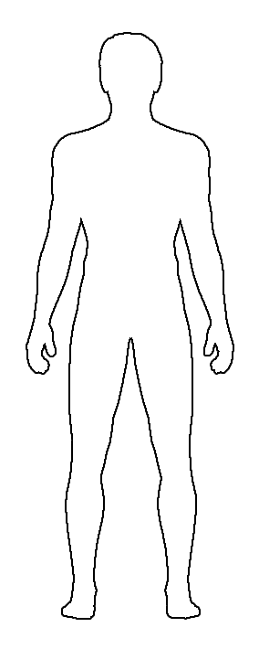

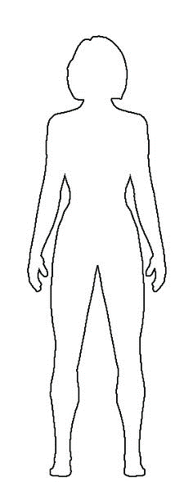

Make-Up

Two types of Make-Up used in theatre
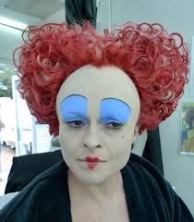
Character Make-Up: the use of foundation, powder etc. on the actors face
What can character make-up do?
- Changes the appearance of the actor – can make them look older, younger, different, etc.
- Allows the facial expressions of the character to stand out against the brightness of the lights
- Can tell us information about a character

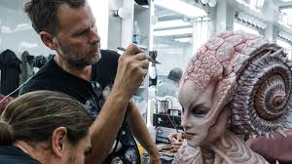
Special Effects Make-Up: the use of fake blood, latex etc.
What can special effects make-up do?
- Used to add effects on top of normal character make-up
- Can show specific characteristics like a wart, a large nose, a
bruise, a scar etc.
- Can be added during the performance by the make-up artist

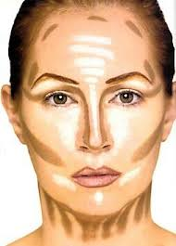
Make-Up and Utensils
Foundation
- base for the skin
Setting Powder
- used to help set the make-up to make it last
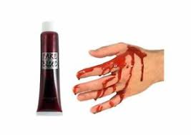
Highlighters
- used to make areas of the face stand out
Liners
- sticks of make-up in different colours to create lines, bruises, shading etc.
Fake Blood
- powder, liquid or capsules to create effect of bleeding
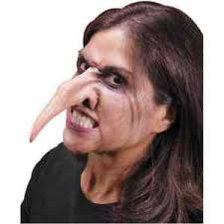
Tooth Varnish
- used to create the effect of a missing tooth by blacking out an existing one
Skull Cap
- plastic head-shaped covering to give appearance of baldness
Latex
- helps make wounds, warts etc. and can be added to other areas of the face to exaggerate features such as nose, ears and chin.
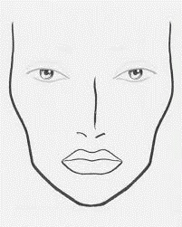
What does a Make-Up Designer have to do?
- Read through the script and understand the characters
- Make notes of any necessary special effects needed
- Discuss any allergies or issues with the actors
- Design make-up template
- Purchase the necessary make-up and utensils needed
- Practice Make-up template on the actor
- Make any necessary changes
- Ensure make-up and the utensils are cleaned and stored appropriately
between each use
- Apply character and special effects make-up before performance
- Be on hand during performance to top up make up or add/make any
necessary changes
- Be on hand after performance to help actors remove make-up,
especially and special effects make-up that may have been applied
Why is make-up important?
- Makes the actor stand out under the stage lights
- Can help give information about a character
- Can enhance or change the mood and atmosphere

Task 1: Read the above information and make notes on the following areas:
- 2 types of make-up used in theatre
- Make-up and utensils used
- What a make-up designer has to do
- Why make-up is important
Task 2: Answer the following questions:
- What is character make-up?
- What can character make-up do?
- What is special effects make-up?
- What can special effect make-up do?
- Why is setting powder used?
- What could you create if you applied latex?
- In your opinion, what are the 5 most important steps a make-up designer has to do?
- What are 3 reasons for make-up being important?
Task 3: Answer the following questions in order to create a drama and an idea for make-up in that drama:
Scenario: 2 people, sitting in the living room, talking about what happened the night before.
- Respond to the 5 W’s in order to expand the above scenario: who, what, where, when and why.
- What is the mood and atmosphere of the scene?
- How could you use make-up to enhance or change this mood and atmosphere? What make-up would you use? What effect would this create?
Task 4: Create a make-up template for the make-up effect you have described in the above task.

Set and Staging

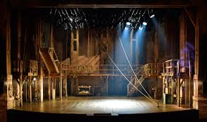
What is set?

Set is the items of furniture and items specific to the theatre which help make clear where a drama is set.

What is staging?

Staging is the design of stage used for the drama, which will influence what set is used and how the drama is performed.

Set Terminology

Backcloth – a large cloth, either painted or black that hangs at the back of the stage

Tabs – curtains that hang at the sides of stage to obscure the wings. They can also be a pair of curtains that meet in the middle of the stage and overlap. The house curtain is sometimes called front tabs
Entrance/Exit – a place onstage or within the set where a performer can enter or exit the acting area

Flat – a flat piece of scenery that can be freestanding or suspended. These can be painted to form part of the scenery or set. They can also have a window or a door cut out of them.

Rostra – a platform that can be used to create levels on stage

Strike – to strike the set means to remove, dismantle and store the set and scenery after a performance

Stage Areas
There are 9 areas of the stage. The director will refer to each area of the stage when directing actors on where they are to stand or move to.
These areas of the stage are also important for the set designer, in helping them communicate where a piece of set is to be placed on the stage.
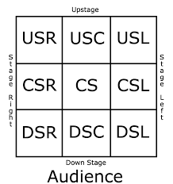
USR Up Stage Right
USL Up Stage Left
USC Up Stage Centre
DSR Down Stage Right
DSL Down Stage Left
DSC Down Stage Centre
CSR Centre Stage Right
CSL Centre Stage Left
CS Centre Stage
Sightlines
When designing the set for a production, the set designer must always take into consideration the sightlines of the audience.
A paying audience member must have a good view of what is happening on stage at all times.
Quite often, a stage will have a rake, meaning that the stage is sloped so that visibility for the audience will be better. However, if a stage does not have a rake, then the set designer must take this into consideration when placing set items at the back of the stage.

Ground Plan
A ground plan is a bird’s-eye view of set, showing furniture, entrances/exits and the position of the audience.
The set designer will draw one for every scene. This will help them decide where to place set on the stage and where things may need to be moved in between set changes.
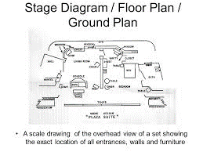
It is important that your ground plan shows:
the position and style of the stage
the audience and the direction they are facing
entrances and exits
set marked on stage
a key of symbols used on the plan

Styles of staging
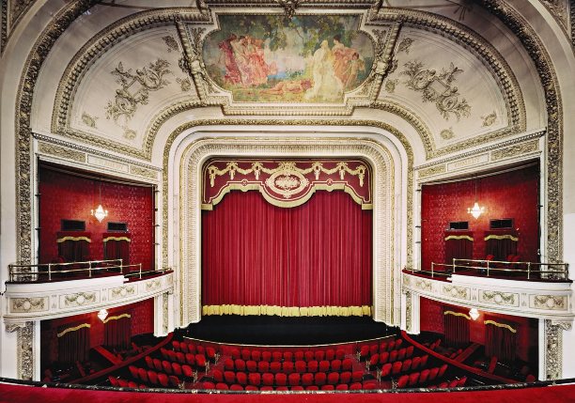
Proscenium Arch
- most traditional form of staging
- audience sit in front of the stage
- the stage has an arch around it and an apron (section of
the stage that comes out of the main stage area)
- as audience are in front of stage it makes it straightforward
for blocking and sight lines
- distance between the audience and performers means the
audience can feel removed from the action

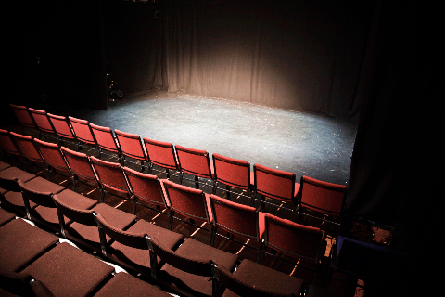
End on
- commonly used form of staging
- audience sit in front of the sage
- as audience are in front of stage it makes I straightforward for blocking
and sight lines
- distance between the audience and performers means the audience
can feel removed from the action

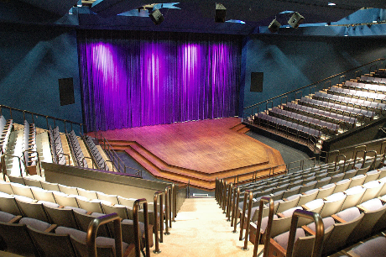
Thrust/Apron
- much like end on but the stage extends so that the audience are sitting
around 3 sides of the stage
- can allow the audience to feel more involved as they surround the 3
sides of the stage
- have to be careful with blocking

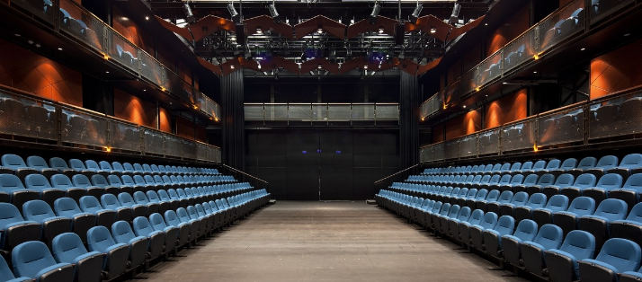
Traverse/Avenue
- audience sit on either side of the performance area,
facing each other
- type of staging used for a catwalk
- audience are close to the action and feel involved, so
creates an intimate atmosphere
- minimal set so as not to block sight lines
- need to make sure that the space is well lit so as not to
cast shadows on one side
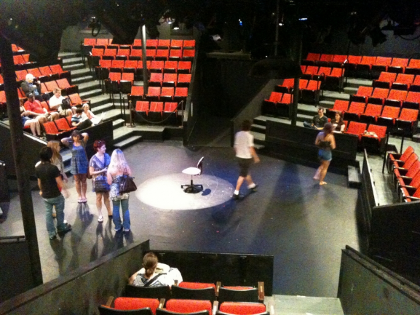
Theatre in the round
- audience are seated around all sides of the acting area
- creates an intimate atmosphere as the audience are close to the
action
- have to be careful with blocking to make sure that all members
of the audience get a good view of what’s going on

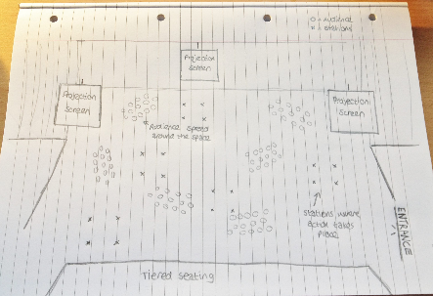
Promenade
- the audience move from stage to stage
- the stages could be set up within one large space, or could be at different
sites that the audience walk to
- very intimate for an audience because they have to participate by moving
around
- can sometimes not be accessible for all if there is too much moving
around from space to space

What does a set designer have to do?
- Read the script and make notes on where each scene takes place
- Make a note of stage directions that detail any entrances and exits at specific areas of the stage
- Research the drama, making sure you have notes on the time period, which may affect the style of set and furniture you choose
- Create a ground plan for each scene
- Source materials and build set pieces. You could also buy or borrow set.
- Practice set changes during rehearsals, making any adjustments as is necessary
- Strike the set at the end of every performance, ensuring set and furniture are stored safely.

Why is set and staging important in theatre?
- Can give information on the setting
- Can give information on the time period
- Can make something seem more realistic
- Can make the audience feel more involved in the drama, dependant on the type of staging
- Can give you more information about the drama
- Can enhance or change the mood and atmosphere

Task 1: Read the above information and make notes on the following:
- What is set?
- What is staging?
- Set Terminology
- Stage Areas
- Sightlines
- Ground Plan
- Styles of staging
- What a set designer has to do
- Why set is important in theatre?
Task 2: Answer the following questions:
- What is set?
- What is staging?
- State 3 reasons why set and staging is important in theatre.
- In your opinion, what are the 5 main things a set designer has to do?
- What does it mean to strike the stage?
- Why is it important for the set designer to think about the audience’s sightlines?
- What does CS stand for?
- What is a disadvantage to using a Proscenium Arch style of staging?
- What is an advantage for using an End On style of staging?
- What is a disadvantage for using a Thrust style of staging?
- What is an advantage for using an Avenue style of staging?
- What is a disadvantage for using a Theatre in the Round style of staging?
- What is an advantage for using a Promenade style of staging?
Task 3: Answer the following questions in order to create a drama and an idea for set for that drama:
Scenario: 2 people, sitting in the living room, talking about what happened the night before.
- Respond to the 5 W’s in order to expand the above scenario: who, what, where, when and why.
- What is the mood and atmosphere of the scene?
- How could you use set to enhance or change this mood and atmosphere? What set would you use in this scene? What effect would this create?
Task 4: Create a ground plan for the set you would use for the scenario you have created for Task 3. Check the ground plan section of this worksheet to check what should be included in your ground plan.

BGE – Production Skills: Set and Staging = Ground Plan Example + Instructions

Key:

Chair =

Sidetable =

Lamp =

Entrance/Exit =
AUDIENCE AUDIENCE AUDIENCE

Step 1: Draw out your stage area as above Step 2: Indicate where your audience are Step 3: Indicate where your entrances and
exits are

Step 4: Create a Key (either below or at the side of the ground plan) as you create your ground plan.
Your key will communicate what each shape represents. Below are some basic examples. Make your symbols easy and basic, you do not need to draw out what it actually looks like!

Sidetable Chair Table Bed

