BGE Drama
OLHS CUMBERNAULD

Characterisation
INFORMATION AND ACTIVITIES BOOKLET
In this booklet you will find information and activities related to the study of characterisation in drama.
Read the information and engage with study tasks in your jotter, on paper or on a computer.
If you are unsure of what to do for a task, just ask your teacher for help!

What are characterisation techniques?
Characterisation techniques are activities we use to understand our character better.
Why are characterisation techniques important?
They help us an actor portray our character more confidently because we know more about our character.
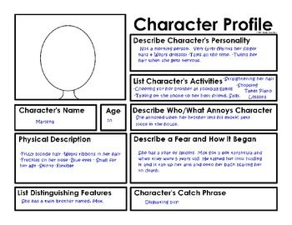
What is a Character Card?
Definition:
A Character Card is profile outlining basic information on a character.
“Basic Information” means detailing the name and age of your character. Where they are from, what their background is. Who their family and friends are.
Why do we do a Character Card?
Character cards contain basic information on our character.
This basic information gives us a solid foundation in understanding who our character is.
It is usually the first activity an actor would do to get to know their character better.
Task 1:
- Make notes on the above information.
- Why is completing a character card activity helpful for the actor?
- Complete a character card template.
This could be for:
- a character that you have already played
- a character that you have made up

Level 3 - Character Card

Name: ____________________________________________________

Age: __________

Occupation: ________________________________________________

Family: ____________________________________________________
__________________________________________________________
Friends: ___________________________________________________
__________________________________________________________

Likes and Dislikes: ___________________________________________
Personality Description: ______________________________________
__________________________________________________________
Physical Description: _________________________________________
__________________________________________________________
Relationship with one other character: __________________________
__________________________________________________________
__________________________________________________________
What is Writing in Role?
Definition:
Writing in role is when you think and write as your character.
It is quite often a diary entry or a letter which is written by the actor as if they are their character.
Why do we do Writing in Role?
This activity allows us to think and write like our character.
This therefore allows you to think about the characters thoughts and feelings about a person or an event that is happening in the play. This in turn helps us to understand our character better.
Task 2:
- Make notes on the above information.
- Why is completing a writing in role activity helpful for the actor?
- Complete a writing in role exercise.
This could be for:
- a character that you have already played
- a character that you have made up

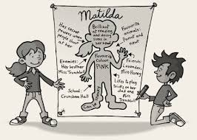
What is Role on the Wall?
Definition:
A role on the wall is an outline of a character which details information about that character.
On the inside of the outline, you write:
- information you know about the character
- what the character thinks about people and events within the drama
On the outside of the outline, you write:
- information you don’t know about the character
- what other characters think about this character
Why do we do Role on the Wall?
This activity allows us to figure out information we do and don’t know about a character.
From this, we can then make our own assumptions about the characters. This then informs how we play that character.
Task 3:
- Make notes on the above information.
- Why is completing a role on the wall activity helpful for an actor?
- Complete a role on the wall activity.
This could be for:
- a character that you have already played
- a character that you have made up

Role on the Wall – Characterisation Activity
Inside the gingerbread man = what we know about the character and what the character thinks about what is going on in the drama and about the other characters involved.
Outside the gingerbread man = what we don’t know about the character, what other characters think about that character and what they are doing in the drama.
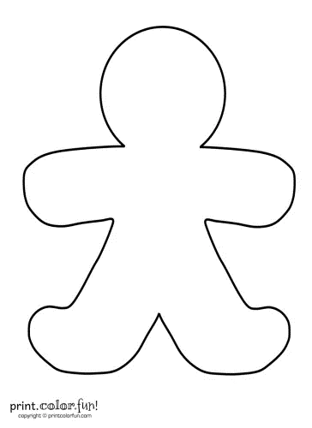

What is Hot Seating?
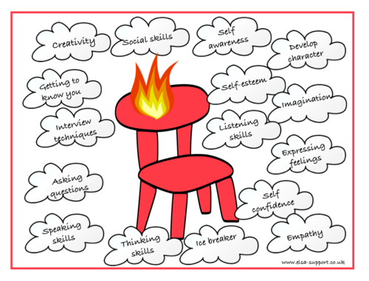
Definition:
Hot Seating is asking a character questions in order to find out more about them.
The actor must answer the questions in character. The questions should be asking about areas that we don’t already know. This makes the actor have to think on the spot and come up with their own ideas to answer these questions.
Question areas could be any of the following:
basic information, such as family, friends etc.
motivation to do or say something, relationship with other characters etc.
thoughts, feelings and opinions on another character or what is happening in the drama
Why do we do Hot Seating?
This activity helps the actor think on their feet as their character about subject areas they may not have thought about before.
In turn, this helps the other actors find out more about their character, heling them think about how their character feels about that character now knowing this new information.
Task 4:
- Make notes on the above information.
- Why is completing a hot seating activity helpful for an actor?
- Create 5 questions you would ask a character you would be playing.
This could be for:
- a character that you have already played
- a character that you have made up
- Create 5 questions you would ask another character.

