Stimulus 1 Worksheet

Task 1
Respond to the stimulus above with your ideas for a drama.
Use the speech bubbles to note your initial ideas.

Task 2
Use your ideas from task 1 to develop an initial idea you could take forward to create a drama.
Use the 5 W’s below to detail this:
WHO?

WHAT?

WHERE?

WHEN?

WHY?

Task 3
Now that you have developed an initial idea for a drama, you can start to develop your ideas on what you want to have happen in each part of the drama.
You should break this down into 3 key sections: beginning, middle and end.
Think about what’s important to include and make clear in your drama:
- Beginning: introduce characters, setting, what’s going on.
- Middle: the climax, something really interesting happens that grips the audience!
- End: the drama is resolved and comes to its end… or is it a cliff hanger?
The Beginning
The Middle

The End

Stimulus 2 Worksheet
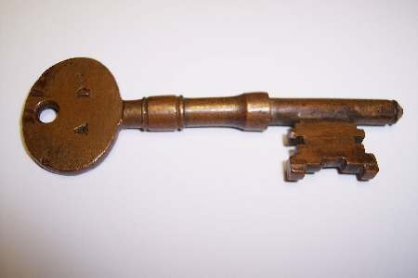

Task 1
Respond to the stimulus above with your ideas for a drama.
Use the speech bubbles to note your initial ideas.

Task 2
Use your ideas from task 1 to develop an initial idea you could take forward to create a drama.
Use the 5 W’s below to detail this:
WHO?

WHAT?

WHERE?

WHEN?

WHY?

Task 3
Now that you have developed an initial idea for a drama, you can start to develop your ideas on what you want to have happen in each part of the drama.
You should break this down into 3 key sections: beginning, middle and end.
Think about what’s important to include and make clear in your drama:
- Beginning: introduce characters, setting, what’s going on.
- Middle: the climax, something really interesting happens that grips the audience!
- End: the drama is resolved and comes to its end… or is it a cliff hanger?
The Beginning
The Middle

The End

Task 4
Now that you have developed your idea further and have an idea of what you want to have happen in each scene of the drama, you can start to visualise how your drama will look.
To help you do this, you should now create a storyboard for your drama.
It is up to you if you choose to draw your idea out first in the large boxes or if you choose to write out the key moments and then draw them.
Please don’t worry about your artistic skills here – this task is just to help you visualise what you want to have happen in the drama!
Once you have drawn and wrote out what happens in the drama, you should then try and colour it in so it is nice and colourful – it might even get displayed in the class…
Below is an example to give you an idea of how much detail you need to go into.
This is a storyboard for a film, where it makes a note of the type of shot they plan to use – you will see that your storyboard to fill in doesn’t have these as you’re creating a play instead of a film!
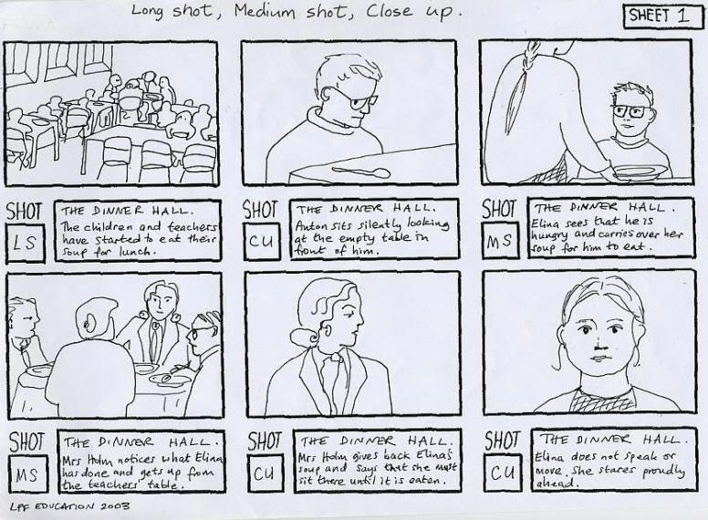

Storyboard for Drama
1. _______________________________________
________________________________________
________________________________________
________________________________________
2. _______________________________
_________________________________
_________________________________
_________________________________
3. _______________________________________
________________________________________
________________________________________
________________________________________

4. _______________________________
_________________________________
_________________________________
_________________________________
5._______________________________________
________________________________________
________________________________________
________________________________________
6. _______________________________
_________________________________
_________________________________
_________________________________

Stimulus 3 Worksheet

Task 1
Respond to the stimulus above with your ideas for a drama.
Use the speech bubbles to note your initial ideas.

Task 2
Use your ideas from task 1 to develop an initial idea you could take forward to create a drama.
Use the 5 W’s below to detail this:
WHO?

WHAT?

WHERE?

WHEN?

WHY?

Task 3
Now that you have developed an initial idea for a drama, you can start to develop your ideas on what you want to have happen in each part of the drama.
You should break this down into 3 key sections: beginning, middle and end.
Think about what’s important to include and make clear in your drama:
- Beginning: introduce characters, setting, what’s going on.
- Middle: the climax, something really interesting happens that grips the audience!
- End: the drama is resolved and comes to its end… or is it a cliff hanger?
The Beginning
The Middle

The End

Task 4
Now that you have developed your idea further and have an idea of what you want to have happen in each scene of the drama, you can start to develop your idea in detail for each scene.
To help you do this, you should now create a storyboard for each scene.
Each scene has its own page and 6 boxes for you to explore your idea further.
It is up to you if you choose to draw your idea out first in the large boxes or if you choose to write out the key moments and then draw them.
Please don’t worry about your artistic skills here – this task is just to help you visualise what you want to have happen in the scene!
Once you have drawn and wrote out what happens in the scene, you should then try and colour it in so it is nice and colourful – it might even get displayed in the class…
Below is an example to give you an idea of how much detail you need to go into.
This is a storyboard for a film, where it makes a note of the type of shot they plan to use – you will see that your storyboard to fill in doesn’t have these as you’re creating a play instead of a film!

Storyboard for Scene 1 – The Beginning
1. _______________________________________
________________________________________
________________________________________
________________________________________
2. _______________________________
_________________________________
_________________________________
_________________________________
3. _______________________________________
________________________________________
________________________________________
________________________________________

4. _______________________________
_________________________________
_________________________________
_________________________________
5._______________________________________
________________________________________
________________________________________
________________________________________
6. _______________________________
_________________________________
_________________________________
_________________________________

Storyboard for Scene 2 – The Middle
1. _______________________________________
________________________________________
________________________________________
________________________________________
2. _______________________________
_________________________________
_________________________________
_________________________________
3. _______________________________________
________________________________________
________________________________________
________________________________________

4. _______________________________
_________________________________
_________________________________
_________________________________
5._______________________________________
________________________________________
________________________________________
________________________________________
6. _______________________________
_________________________________
_________________________________
_________________________________

Storyboard for Scene 3 – The End
1. _______________________________________
________________________________________
________________________________________
________________________________________
2. _______________________________
_________________________________
_________________________________
_________________________________
3. _______________________________________
________________________________________
________________________________________
________________________________________

4. _______________________________
_________________________________
_________________________________
_________________________________
5._______________________________________
________________________________________
________________________________________
________________________________________
6. _______________________________
_________________________________
_________________________________
_________________________________

Stimulus 4 Worksheet
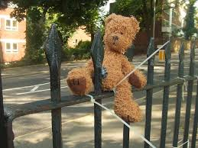

Task 1
Respond to the stimulus above with your ideas for a drama.
Use the speech bubbles to note your initial ideas.

Task 2
Use your ideas from task 1 to develop an initial idea you could take forward to create a drama.
Use the 5 W’s below to detail this:
WHO?

WHAT?

WHERE?

WHEN?

WHY?

Task 3
Now that you have developed an initial idea for a drama, you can start to develop your ideas on what you want to have happen in each part of the drama.
You should break this down into 3 key sections: beginning, middle and end.
Think about what’s important to include and make clear in your drama:
- Beginning: introduce characters, setting, what’s going on.
- Middle: the climax, something really interesting happens that grips the audience!
- End: the drama is resolved and comes to its end… or is it a cliff hanger?
The Beginning
The Middle

The End

Task 4
Now that you have developed your idea further and have an idea of what you want to have happen in each scene of the drama, you can start to develop your idea in detail for each scene.
To help you do this, you should now create a storyboard for each scene.
Each scene has its own page and 6 boxes for you to explore your idea further.
It is up to you if you choose to draw your idea out first in the large boxes or if you choose to write out the key moments and then draw them.
Please don’t worry about your artistic skills here – this task is just to help you visualise what you want to have happen in the scene!
Once you have drawn and wrote out what happens in the scene, you should then try and colour it in so it is nice and colourful – it might even get displayed in the class…
Below is an example to give you an idea of how much detail you need to go into.
This is a storyboard for a film, where it makes a note of the type of shot they plan to use – you will see that your storyboard to fill in doesn’t have these as you’re creating a play instead of a film!

Storyboard for Scene 1 – The Beginning
1. ______________________________________
________________________________________
________________________________________
________________________________________
________________________________________
2. _______________________________
_________________________________
_________________________________
_________________________________
_________________________________

3. ______________________________________
________________________________________
________________________________________
________________________________________
________________________________________

4. _______________________________
_________________________________
_________________________________
_________________________________
_________________________________

Storyboard for Scene 2 – The Middle
1. ______________________________________
________________________________________
________________________________________
________________________________________
________________________________________
2. _______________________________
_________________________________
_________________________________
_________________________________
_________________________________

3. ______________________________________
________________________________________
________________________________________
________________________________________
________________________________________

4. _______________________________
_________________________________
_________________________________
_________________________________
_________________________________

Storyboard for Scene 3 – The End
1. ______________________________________
________________________________________
________________________________________
________________________________________
________________________________________
2. _______________________________
_________________________________
_________________________________
_________________________________
_________________________________

3. ______________________________________
________________________________________
________________________________________
________________________________________
________________________________________

4. _______________________________
_________________________________
_________________________________
_________________________________
_________________________________

Stimulus 5 Worksheet
If a dog chews shoes, whose shoes does he choose?
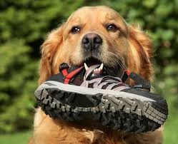

Task 1
Respond to the stimulus above with your ideas for a drama.
Use the speech bubbles to note your initial ideas.

Task 2
Use your ideas from task 1 to develop an initial idea you could take forward to create a drama.
Use the 5 W’s below to detail this:
WHO?

WHAT?

WHERE?

WHEN?

WHY?

Task 3
Now that you have developed an initial idea for a drama, you can start to develop your ideas further. To do this use the creative thinking strategy: Fortunately, Unfortunately.
Below is an explanation and example of how to complete this exercise before you do it yourself:
In the first box which above it says “start”, begin with stating a moment in your drama. So for example, you could start with the first thing that happens in your drama.
You will then come across your first “fortunately” box. This box allows you to continue to develop the moment you have decided to focus on.
You will then come across your first “unfortunately” box. So in this box, you can write the first problem that a character may come across. This could be anything!
You will then come across another “fortunately” box. This box gives you an opportunity to think about how that character may get around that problem.
You will then come across another “unfortunately” box, and so again, they encounter a problem. This could be a continuation of the first problem they encountered, or they could encounter a new problem.
And so on… here is an example:
Unfortunately,
The man who was robbing the shop started to run away!
START HERE
Jimmy was walking along the street to his grans.

Fortunately,
Jimmy was a fast runner and so decided to run after him.
Fortunately,
Jimmy had his mobile phone so he called the police.
Fortunately,
It was a sunny day, so this made him feel very cheery.

Unfortunately,
He couldn’t catch him and the police arrived too late
Unfortunately,
When he was in the shop, someone was trying to rob it!
Unfortunately,
He had left his sunglasses at home and was struggling to see.

Fortunately,
Jimmy had taken a picture of him so gave it to the police to help them find him.
Fortunately,
He passed by a shop so went in to go an buy a pair.

Hopefully the above explanation and example helps you understand what to do with this task.

START HERE
Unfortunately,

Fortunately,
Fortunately,

Fortunately,

Unfortunately,
Unfortunately,

Unfortunately,

Fortunately,
Fortunately,

Task 4
When responding to a stimulus and using creative thinking strategies to develop your drama you will come up with fantastic, imaginative ideas!
However, not all of the ideas you come up with will be as good or useful and some you might never come back to or use again but that is ok – it is all part of the creative process!!
Below I want you to pick the 2 best ideas that you came up with. I want you to tell me in detail what the idea was and why you think it would make your drama great!
These ideas can come from Task 1, 2 or 3.
IDEA 1
______________________________________________________________________________________________________________________________________________________________________________________________________________________________________________________________________________________________________________________________________________________________________________________________________________________________________________________________________________________________________________________________________________________________________________________________________________________________________________________________________________________________________________________________________________________________________________

IDEA 2
______________________________________________________________________________________________________________________________________________________________________________________________________________________________________________________________________________________________________________________________________________________________________________________________________________________________________________________________________________________________________________________________________________________________________________________________________________________________________________________________________________________________________________________________________________________________________________

Stimulus 6 Worksheet

TICK, TOCK, TICK, TOCK …. TIME IS RUNNING OUT!

Task 1
Respond to the stimulus above with your ideas for a drama.
Use the speech bubbles to note your initial ideas.

Task 2
Use your ideas from task 1 to develop an initial idea you could take forward to create a drama.
Use the 5 W’s below to detail this:
WHO?

WHAT?

WHERE?

WHEN?

WHY?

Task 3
Now that you have developed an initial idea for a drama, you can start to develop your ideas on what you want to have happen in each part of the drama.
You should break this down into 3 key sections: beginning, middle and end.
Think about what’s important to include and make clear in your drama:
- Beginning: introduce characters, setting, what’s going on.
- Middle: the climax, something really interesting happens that grips the audience!
- End: the drama is resolved and comes to its end… or is it a cliff hanger?
The Beginning
The Middle

The End

Task 4
Now that you have a detailed idea for what you want to happen in each scene, you should create a first draft of a script.
You will try this script out in class, so you must make sure it is clear for others to read and follow.
You will create a script for each scene in the drama.
You have been given 2 lined pages for each scene in the drama in this booklet. If you need more for any of the scenes, just use plain or lined paper to continue writing (make sure you make a note of what scene it is for and keep it with this booklet!)
Below is an example of a script. Please make note of…
- the fact the scene has been given a heading/name
- the extra information on the action the actors should use/do
- the clear way it is spread out and character names are clearly stated

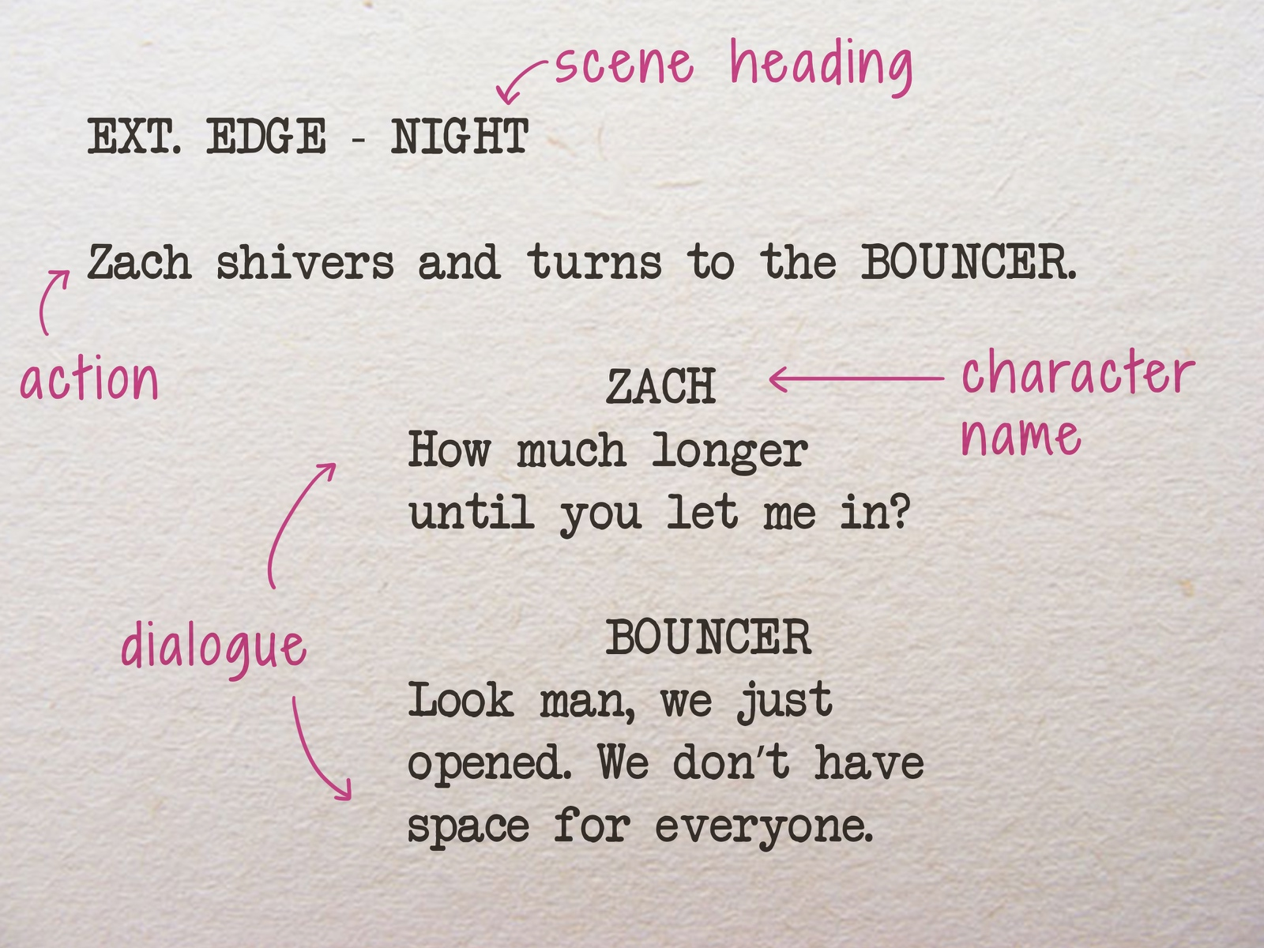

Title of the Drama:
________________________________________________________________________

Written by:
_________________________________________________________________________

Scene 1: _____________________________________________________________________

___________________________________________________________________________
___________________________________________________________________________
___________________________________________________________________________
___________________________________________________________________________
___________________________________________________________________________
___________________________________________________________________________
___________________________________________________________________________
___________________________________________________________________________
___________________________________________________________________________
___________________________________________________________________________
___________________________________________________________________________
___________________________________________________________________________
___________________________________________________________________________
___________________________________________________________________________
___________________________________________________________________________
___________________________________________________________________________
___________________________________________________________________________
___________________________________________________________________________
___________________________________________________________________________
___________________________________________________________________________
___________________________________________________________________________
___________________________________________________________________________
___________________________________________________________________________
___________________________________________________________________________
___________________________________________________________________________
___________________________________________________________________________
___________________________________________________________________________
___________________________________________________________________________
___________________________________________________________________________
___________________________________________________________________________
___________________________________________________________________________
___________________________________________________________________________
___________________________________________________________________________
___________________________________________________________________________
___________________________________________________________________________
___________________________________________________________________________
___________________________________________________________________________
___________________________________________________________________________
___________________________________________________________________________
___________________________________________________________________________
___________________________________________________________________________
___________________________________________________________________________
___________________________________________________________________________
___________________________________________________________________________
___________________________________________________________________________
___________________________________________________________________________
___________________________________________________________________________
___________________________________________________________________________
___________________________________________________________________________
___________________________________________________________________________
___________________________________________________________________________
___________________________________________________________________________
___________________________________________________________________________
___________________________________________________________________________
Scene 2: ____________________________________________________________________

___________________________________________________________________________
___________________________________________________________________________
___________________________________________________________________________
___________________________________________________________________________
___________________________________________________________________________
___________________________________________________________________________
___________________________________________________________________________
___________________________________________________________________________
___________________________________________________________________________
___________________________________________________________________________
___________________________________________________________________________
___________________________________________________________________________
___________________________________________________________________________
___________________________________________________________________________
___________________________________________________________________________
___________________________________________________________________________
___________________________________________________________________________
___________________________________________________________________________
___________________________________________________________________________
___________________________________________________________________________
___________________________________________________________________________
___________________________________________________________________________
___________________________________________________________________________
___________________________________________________________________________
___________________________________________________________________________
___________________________________________________________________________
___________________________________________________________________________
___________________________________________________________________________
___________________________________________________________________________
___________________________________________________________________________
___________________________________________________________________________
___________________________________________________________________________
___________________________________________________________________________
___________________________________________________________________________
___________________________________________________________________________
___________________________________________________________________________
___________________________________________________________________________
___________________________________________________________________________
___________________________________________________________________________
___________________________________________________________________________
___________________________________________________________________________
___________________________________________________________________________
___________________________________________________________________________
___________________________________________________________________________
___________________________________________________________________________
___________________________________________________________________________
___________________________________________________________________________
___________________________________________________________________________
___________________________________________________________________________
___________________________________________________________________________
___________________________________________________________________________
___________________________________________________________________________
___________________________________________________________________________
___________________________________________________________________________
___________________________________________________________________________
___________________________________________________________________________
___________________________________________________________________________
___________________________________________________________________________
___________________________________________________________________________
___________________________________________________________________________
Scene 3: ____________________________________________________________________

___________________________________________________________________________
___________________________________________________________________________
___________________________________________________________________________
___________________________________________________________________________
___________________________________________________________________________
___________________________________________________________________________
___________________________________________________________________________
___________________________________________________________________________
___________________________________________________________________________
___________________________________________________________________________
___________________________________________________________________________
___________________________________________________________________________
___________________________________________________________________________
___________________________________________________________________________
___________________________________________________________________________
___________________________________________________________________________
___________________________________________________________________________
___________________________________________________________________________
___________________________________________________________________________
___________________________________________________________________________
___________________________________________________________________________
___________________________________________________________________________
___________________________________________________________________________
___________________________________________________________________________
___________________________________________________________________________
___________________________________________________________________________
___________________________________________________________________________
___________________________________________________________________________
___________________________________________________________________________
___________________________________________________________________________
___________________________________________________________________________
___________________________________________________________________________
___________________________________________________________________________
___________________________________________________________________________
___________________________________________________________________________
___________________________________________________________________________
___________________________________________________________________________
___________________________________________________________________________
___________________________________________________________________________
___________________________________________________________________________
___________________________________________________________________________
___________________________________________________________________________
___________________________________________________________________________
___________________________________________________________________________
___________________________________________________________________________
___________________________________________________________________________
___________________________________________________________________________
___________________________________________________________________________
___________________________________________________________________________
___________________________________________________________________________
___________________________________________________________________________
___________________________________________________________________________
___________________________________________________________________________
___________________________________________________________________________
___________________________________________________________________________
___________________________________________________________________________
___________________________________________________________________________
___________________________________________________________________________
___________________________________________________________________________
___________________________________________________________________________

