BGE Drama
OLHS CUMBERNAULD
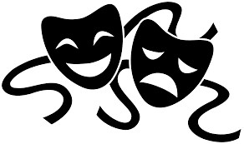

Performance Concepts
INFORMATION AND ACTIVITIES BOOKLET
In this booklet you will find information and activities on the study of voice in drama.
Read the information and engage with study tasks in your jotter, on paper or on a computer.
If you are unsure of what to do for a task, just ask your teacher for help!

Voice Concepts
The study of voice in drama is all to do with how we use our voice to become our characters and tell their story.
By changing our voice, we are able to sound less like ourselves and more like our character, which is important as it helps us make our character seem more believable.
As an actor, it’s important we understand what to use in order to learn how to do that.
In drama, we use the acronym TRAFICPPPPAVE to study voice.
Each letter stands for a different voice term.
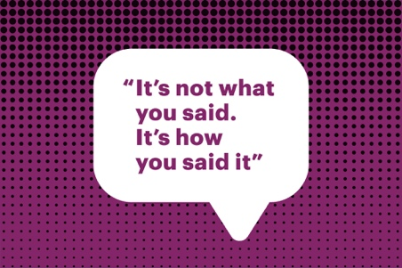
T = Tone
Emotion of the character, how they are feeling and how they put that across.
For example: “I plan to use an angry tone during the argument, in order to portray that my character is angry.”
R = Register
The way we speak to someone depending on who they are to us and our relationship with them.
For example: “I will speak to the Head Teacher using a formal register, as it is an important meeting and he is my boss, therefore I need to speak to him formally.”
A = Accent
The way we speak depending on where we come from.
For example: “I will use an Irish accent so that the audience understands my character is from Ireland.”
F = Fluency
The flow of our speech, often depends on how we are feeling.
For example: “I will have a poor fluency during the speech, because my character is feeling nervous, so what they say will be broken up in order to show how my character is feeling.”

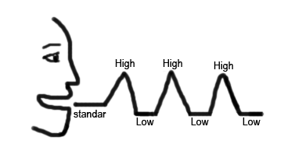
I = Intonation
The rise and fall of the voice.
For example: “I will use intonation to show that my character is interested during the conversation”
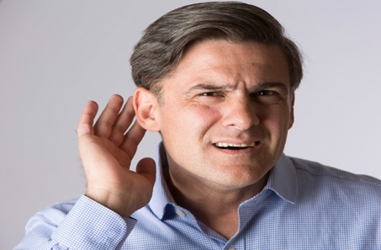
C = Clarity
How clear or unclear a person speaks.
For example: “I will speak clearly during the speech because my character is addressing the public as the Prime Minister, so what I am saying must be clear to understand.”
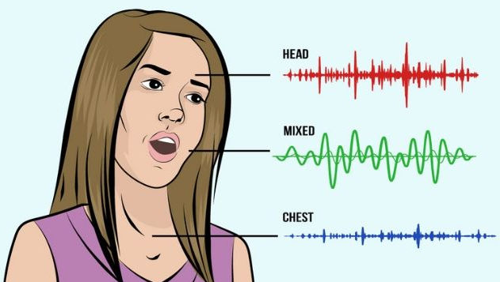
P = Projection
Pushing the voice out, loud and clear, in order for the audience to hear you.
EVERYONE should use projection when performing so that the audience can hear what is being said.
P = Pitch
How high or low the voice is.
For example: “I will use a high pitched scream to show that I am scared”
P = Pause
Stopping for dramatic effect.
For example: “I will use pause after the phrase “What did you say?” to create dramatic tension around what is happening. By doing so, the audience will be able to sense tension between these two character.”
P = Pace
How fast or slow someone speaks.
For example: “I will speak at a face pace to show that I am excited.”
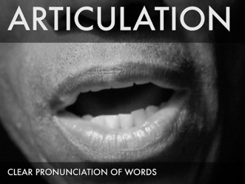
A = Articulation
How letters and words are pronounced.
For example: “My character will use poor articulation to help show that they have not had a good upbringing or education, where they will have learned to say or speak words properly.”
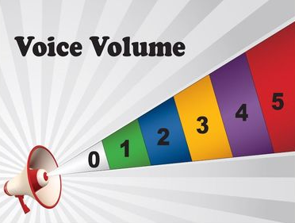
V = Volume
How loud or quiet someone speaks.
For example: “I will speak loudly during the argument to show I am passionate about what I am saying and want to be heard during the argument, as my character thinks that they are right and the other character is wrong.”
E = Emphasis
Placing stress on a word in order to focus on it, bring attention to it.
For example: “I will place focus on the word “dead” so that the other character understands what has happened to one of the other characters.”

Voice Tasks
- What is voice?
- Why is changing our voice when acting important?
- What does TRAFICPPPPAVE stand for?
- Make notes on each term within TRAFICPPPPAVE.
Think about a drama where you changed your voice to become your character.
- Describe what the drama was about.
- Explain how you used 2 TRAFICPPPPAVE terms in the drama.

- What 3 voice terms do you think are the most important?

- Explain why you think each one is important.

Movement Concepts
Naturalistic Movement
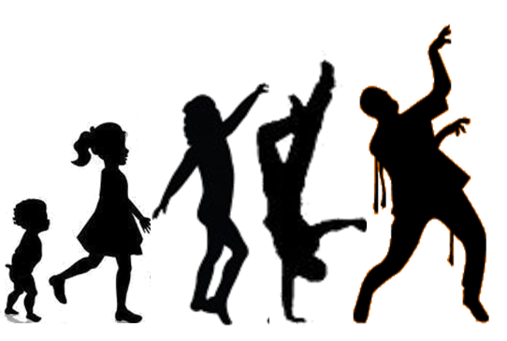
Naturalistic movement is movement that appears natural, as if it is how the person would act in real, everyday life.
Naturalistic movement is the type of movement most often used in dramas across theatre, film and TV, as it portrays real life.
This type of movement helps an actor portray their characters thoughts and feelings, communicating these to an audience so that they can understand what the character is experiencing.
The acronym used for Naturalistic Movement is BUGPEF.
B = Body Language
This is how the actor uses the whole of their body to communicate their thoughts and feelings. They can hold their body “open” or “closed”. For example, having their body closed would mean their body was “closed”. How they hold their body helps communicate the emotion they are feeling.
For example: “Lucy had a closed, angry body language by having her arms crossed in front of her. This helped communicate that she was angry and unhappy at the situation”.
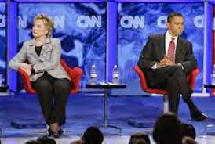
U = Use of Space
This is how the actor uses the space and why they used the space that way. It is not about using the whole stage space as that seems like the right thing to do, it’s about using the space in a way that communicates what your character is thinking, feeling or doing.
For example: “Lucy used a lot of space during the argument by pacing backwards and forwards. The use of the space in this way helped communicate that she was angry and frustrated during the argument”.
G = Gesture
This is when a part of the body is moved to express an idea or a meaning. It is usually the head or the hand. Gestures can be particularly hard to describe and write about if it’s a meaningless gesture, so only choose to discuss gesture if it’s specific and has a purpose.
For example: “Lucy gestured to Mark that she was upset by nodding her head when he asked her if she was upset. Instead of replying, the nodding gesture helped communicate her feelings – she was too upset to talk”.
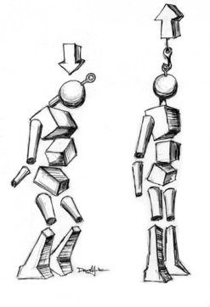
P = Posture
This is when the body is either held straight or slouched. Again, there must be a specific reason attached to the posture, to help the reader understand why their posture is held this way.
For example: “Lucy had a slouched posture which helped communicate that she was feeling upset.”
E = Eye Contact
This is how the actor looks at someone – either directly or indirectly. Directly means to look at them directly in the eye. Indirectly means to avoid all eye contact.
For example: “Lucy looked Mark directly in the eye when she was telling him she wanted a divorce. By looking him in the eye, this helped communicate that she meant what she was saying, that she was serious about it”.
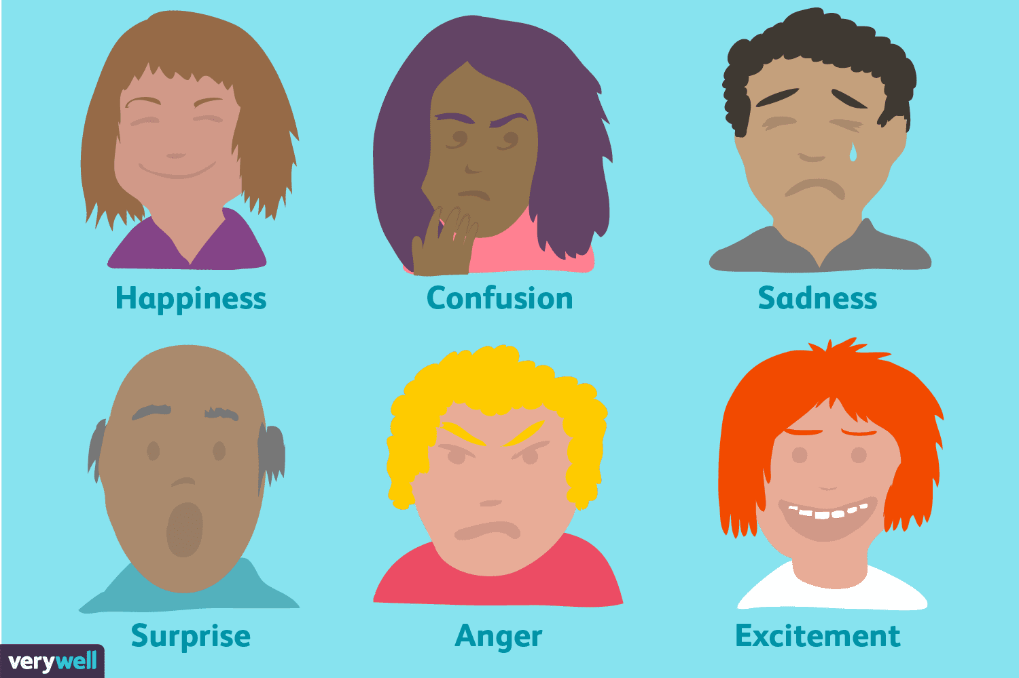
F = Facial Expression
The face is how a person communicates how they are feeling. Whether they are happy, sad, angry etc. It is what we look at first in order to understand what a person is thinking or feeling.
For example: “Lucy used an angry facial expression when Mark revealed he had had an affair. This helped communicate her emotions about what he had just told her”

Stylised Movement
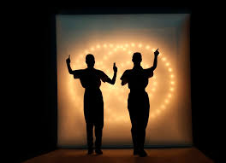
Stylised movement is movement that appears un-natural to do every day, as if the person is moving in a way they wouldn’t normally do.
Stylised movement is the use of mime, physical theatre and dance drama.
This type of movement can help portray moments of a drama in a stylised way, bringing more attention to the moment and what is happening within it. An example of this could be using slow motion at a particular moment in the drama, to bring the audience’s attention to it.
The acronym used for Stylised Movement is BSTPLS.

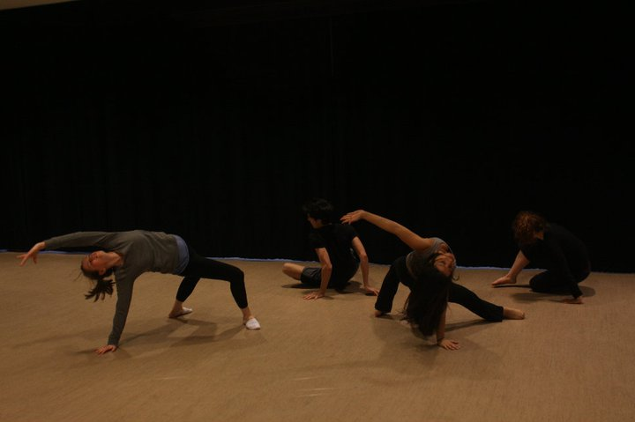
B = Balance
This is how balance is used during movement, to keep the actor steady, particularly if they are to hold a position for a great length of time
For example: “I used balance during the dance drama, in order to hold my position steady for the required length of time. By using balance, I was able to communicate what my character was doing to the audience, allowing them to understand my actions and the storyline.”

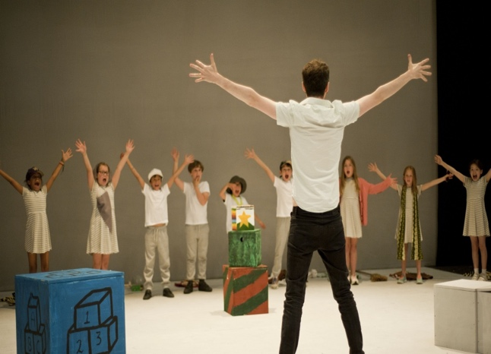
S = Stance
This is how the actor chooses to stand and hold their position within the drama, in order to communicate what they are doing.
For example: “I held a strong stance throughout the final scene in the drama. I did this by standing still, with my arms crossed. I took a wide stance, with my feet spread wide apart as I stood like this. This type of stance helped me communicate my high authority as a bodyguard for the prisoner.”

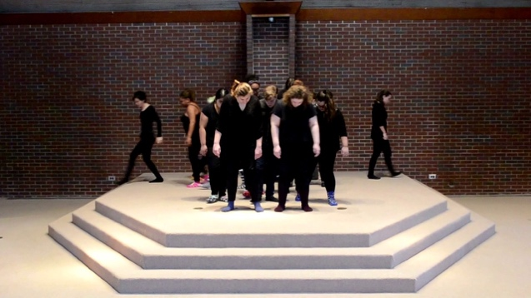
T = Timing
This is understanding when to make a movement. This could be important in telling the story.
For example: “I used timing in order to communicate what my character was doing and why. By timing my movement correctly, the audience were able to understand that my character did not want the other character to see what I was doing.”

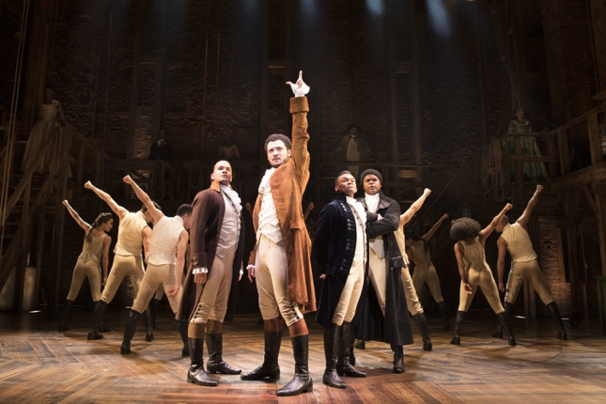
P = Position
This is related to the actor understanding where to stand and why to stand there. It can also be related to how they stand, and why they stand in that way.
For example: “I moved from my position, centre stage right, to my next position centre stage left, to stand behind the wardrobe that was positioned there on the stage. I did this quickly, in order to make clear that my character was trying to hide.”
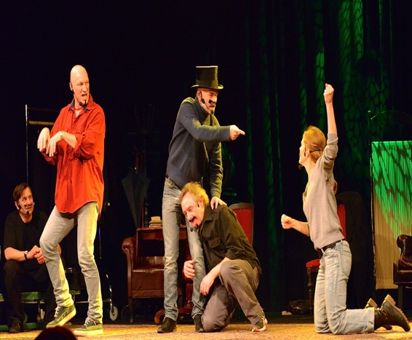
L = Use of Levels
This is where actors stand or sit at varying heights. This makes a scene more interesting to look at but can also help communicate different levels of status.
For example: “I made use of levels in this scene in order to communicate my high status to the audience. As my character has the highest status, I ensured that my character was standing and was the tallest in the scene, whilst the other characters were sitting down. The use of levels in this way would help communicate my characters importance and high status.”
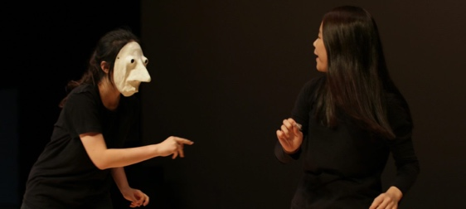
S = Use of Space
This is how the space is used and why the space is used in this way.
For example: “I made use of the full space available on stage during the dance drama. By moving in this way, backwards and forwards across the stage, through the use of dance drama, I was able to communicate my characters frantic emotions and feelings about what was happening in that moment.”
Movement Tasks
- What is Naturalistic movement?
- What can this type of movement help an actor portray?
- What does BUGPEF stand for?
- Make your own notes on each area of BUGPEF.
- What is Stylised movement?
- What can this type of movement help an actor portray?
- What does BSTPLS stand for?
- Make your own notes on each area of BTSPLS.
Think about a drama you have used Naturalistic movement in.
- Describe what the drama was about.
- Explain how you used 2 BUGPEF terms in that drama.
Think about a drama you have used Stylised movement in.
- Describe what the drama was about.
- Explain how you used 2 BTSPLS terms in the drama.
- What type of movement do you prefer, Naturalistic or stylised?
- Explain your answer.

