|  |
| --- |
| S2 Reading For Meaning:  Non - Fiction |

Our Lady’s High School

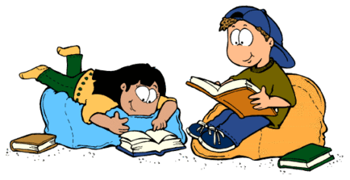

**THINKING SKILLS ACROSS THE CURRICULUM**

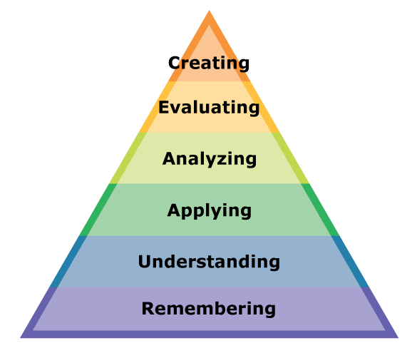

**COMPREHENSION STRATEGIES IN ENGLISH**

Prior Knowledge

Metalinguistic

Visualisation

Inference

Main Ideas

Summarising and Paraphrasing

**Introduction**

The aim of this booklet is to help to develop your Close Reading skills. These skills are very important and are a key part of English from S1 – S6.

**What will I Be Asked to do?**

Reading for Meaning tests how well you can read a passage. It tests that you can: **UNDERSTAND** the main ideas, **ANALYSE** how the writer portrays these and **EVALUATE** how successful the writer has been in doing so.

It does this by asking you different types of questions about the passage. You will be asked to read the passage and answer questions on it. You should attempt all questions and not leave any out. If you are unsure about any questions make sure you ask your teacher. Do not leave the homework until the night before to complete. You should answer in full sentences.

**Different Types of Questions**

You will be asked different types of questions. For example:

1. To put something from the passage into your own words.
2. To pick out an expression or a phrase from the passage.
3. To pick out one word from the passage.
4. To comment on the structure of a sentence.
5. To comment on the writer’s attitude or tone.
6. To identify techniques/figures of speech the writer has used.



|  |
| --- |
| **Checklist of Questions**  In order to answer these questions you must first understand what the question requires you to do. You should refer back to this checklist to remind yourself what different questions require you to do.   1. **Answer in your own words**   In order to answer this type of question you need to go back to the passage and find the correct sentence that you have been asked to put into your own words. Identify key words from the sentence, then try to change these into your own words.   1. **Pick out an expression or a phrase**   This type of question is testing you on two things. Firstly, it is testing your understanding of what an expression is. Secondly, it is testing whether you can pick out the correct expression. An expression or a phrase is a few words taken directly from the passage.   1. **Pick out one word from the passage**   This type of question is again testing you on two things. The first thing is how carefully you have read the question. You should realise that it is only one word that you have to pick out. The second thing is that you can pick out the correct word.   1. **Comment on the sentence structure**   This type of question is asking you to look at how a sentence has been written, not what the sentence means.  **The length of the sentences:**  Is there one big long sentence? If so, think about why it might be used. It could be used to show the size or length of something or it could show that a lot of things are happening quickly.  Are there lots of short sentences? If so, why have they been used? Sometimes short sentences can be used to create tension or suspense. Or they can be used to show that something is very short and does not take a lot of time.  **Punctuation:**  Another thing that you have to think about is the punctuation that is used.  The full stop. This is used to show that it is the end of a sentence.  This is used to divide words on a list.  The comma,  The exclamation mark! This is used to show that someone is speaking  loudly because they are angry, excited,   shocked or happy.  The question mark? This is used to show that a question has been asked.  Brackets ()  These are used to give extra information.  Direct speech marks  or quotation marks “ “  These are used to show that someone is speaking or because there is a quotation from someone.    **(4) Identify techniques the writer uses**  Sometimes you might be asked to pick out or comment on techniques that the writer has used. This type of question is testing how well you can analyse techniques used. It might also be looking for you to comment on length of sentences or punctuation.  **Figures of Speech**  **Alliteration**: This is when words in a sentence start with the same sound, for example **T**etley **t**eabags **t**ingle **t**aste buds. The repetition of the **t** sound is called alliteration. Often alliteration is used in newspaper headlines to create an eye-catching headline.  **Simile**: This is when the writer compares two things using like or as, for example **‘The night sky was as black as ink.’**  **Metaphor**: This is when the writer compares two things without using like or as. Instead they just say that the first thing is the second thing. **‘The man was a mountain.’**  **Onomatopoeia**: This is when words imitate the sound they describe, for example: **crash, smash, bang, whimper…**  **Personification**: This is a type of metaphor that makes objects sound as if they are alive. ‘**The angry sea swept the boat towards the rocks.’**  **Repetition**: This is simply when the writer repeats a word or phrase. This is usually done to draw attention to something.  **Tone** – Sometimes you might be asked to pick out the tone of a passage. When you are asked about tone, try to imagine someone speaking the lines and the tone of voice they might use. Common tones are: **happy, sad, sympathetic, hurtful,** **doubtful, fearful, sarcastic, humorous, angry, ironic…** |

Section B – Non-Fiction

Contents Page:

Exercise One: Diamond Dogs

Exercise Two: Teen Reading – A Contradiction in Terms?

Exercise Three: Why plastic is the scourge of sea life

Exercise Four: Spectacles? Cool? Can’t see it, myself

Exercise Five: Death Threat at the Olympics

Exercise Six: Only Snobs Sneer at McDiploma Graduates

Exercise Seven: Let adult fatties eat themselves to death

Exercise Eight: Save our Sundays – shut all the shops

Exercise Nine: Is Our children reading?

Exercise Ten: Scientists develop non-stick gum

**Exercise One**

‘Diamond Dogs’

From canine cocktail gowns to poochy perfumes- pampering your pet is now at a whole new level, says Danny Buckland  
 The elegant coat is designer indulgence, the diamonds are sparkling and, with the scent of a fine perfume lingering, there is more than a hint of diva in the air. Hair care is with organic products, naturally, and nail polish and a boutique handbag add a little extra glitz.  
 But this little vignette of super style has a surprising twist. For once, it is the celebrities who are under-dressed as dogs take centre stage in a fashion trend that is confounding market forces – and, some might say, common sense.  
 Barely a decade ago, the canine accessory list was functional rather than fashionable with leather leads, a rubber bone, flea powder with a tartan waistcoat fastened with Velcro forming the basic wardrobe. Now the inventory stretches across frontline design houses such as Hermes, Chanel, Aquascutum and Ralph Lauren.   
 It is easy to view pet pampering as the preserve of slightly mad celebrities adopting miniature dogs as fashion statements and, as some psychologists would contend, comfort blankets against a hostile world. But, whatever the motives of pooch-toting stars such as Paris Hilton, Nicole Richie, Sandra Bullock and Charlotte Church, it seems that it is not only the famous who are going crazy for canine couture.

Excerpt from The Sunday Express



**Questions**

1. What technique does the writer use in the title? [1]

2. Find another two examples of this from the passage. [2]

3. Find three words from paragraph one which suggest that only the very best is suitable for the dogs. [3]

4. What is the ‘surprising twist’ mentioned in paragraph 2? [2]

5. Why is a dash used at the end of paragraph 2? [2]

6. Explain in your own words what the difference is between ‘functional’ and ‘fashionable’. [2]

7. How does the writer show the extent of this trend at the end of paragraph three through sentence structure? [2]

8. Choose an expression from paragraph four which suggests that the dogs provide security for celebrities. [2]

9. Dictionary work: What does ‘vignette’ mean? [1]

10. Use this word in a sentence. [1]

**Exercise Two**

‘Teen Reading – A Contradiction in Terms?’

|  |
| --- |
| Today’s young people are exposed to a wider variety of reading material than any previous generation,” according to Honor Wilson-Fletcher, director of the National Year of Reading, because of the explosion of digital media.  A report: ‘Read up, Fed up: Exploring Teen Reading Habits in the UK today’ does seem to establish that young people are reading different things from previous generations, and responding in a different way. In the list of things they love to read, magazines and blogs feature higher than books and the loathed list is dominated by material teenagers are forced to read.  Song lyrics and computer game cheats may not rank alongside ‘War and Peace’ in terms of sustained reading but they do add to a picture of a varied reading diet which includes some old favourites and some surprises. A typical teenage perversity is evident in the lists. Although ‘Bliss’ and ‘Heat’ rank at the top of the “loved” material, the fourth most loathed item is “reading about skinny celebrities in magazines”. The Harry Potter series features in both the most loved list [at 6] and in the most loathed [at 8]. Old favourites like ‘The Lion, the Witch and the Wardrobe” are in the loved list while Facebook is loathed.  FED UP: THINGS TEENS LOATHE TO READ  1. Homework  2. Shakespeare  3. Books over 100 pages  4. Reading about skinny celebrities in magazines  5. The books I am made to read by school /my teachers  6. Encyclopaedias and dictionaries  7. The Beano  8. The Harry Potter series  9. Music [scores]  10. Maps/direction  11. Facebook  12. Financial Times  13. Anything in another language  READ UP: THINGS TEENS LOVE TO READ  1. Heat magazine  2. Bliss magazine  3. Song lyrics online  4. Computer game cheats online  5. My own online blog or fan fiction  6. The Harry Potter series  7. Anne Frank’s diary  8. Film scripts  9. Books by Antony Horowitz  10. The Lion, the Witch and the Wardrobe  11. BBC online  12. Books by Louise Rennison |

**Questions**

1. Read paragraph one. Explain, in your own words, why today’s young people are exposed to a wider variety of reading material than any previous generation. [2]

2. Read paragraph two. Why is a colon used after the word ‘report’? [1]

3. Explain, in your own words, what the report establishes. [2]

4. Quote one word from paragraph two which suggests the material teenagers are forced to read features heavily in the loathed list. [1]

5. What is ironic about the content of the ‘loved’ and ‘loathed’ lists? [2]

6. What is number six on the ‘things teens love to read’ list? [1]

7. Find out the meaning of the word ‘dominated’. [1]

8. Use it in a sentence. [1]

**Exercise Three**‘Why plastic is the scourge of sea life’

|  |
| --- |
| One cigarette lighter, a toothbrush and a toy robot. The list of plastic items recovered from the stomach of a Laysan albatross chick that died on a remote Pacific island reads like a random assortment of everyday household objects.  It is now clear this chick is among many thousands of seabirds that have died from ingesting plastic debris, and nowhere in the world seems to be too isolated for this deadly form of marine pollution.  Dutch scientists have found that more than nine out of ten European fulmars – seabirds that eat at sea – die with plastic rubbish in their stomachs. A study of 560 fulmars from eight countries revealed they had ingested an average of 44 plastic items. The stomach of one fulmar that died in Belgium contained 1,603 separate scraps of plastic.  Birds are not the only ones to suffer. Turtles, whales, seals and sea lions have all eaten plastic. It is estimated that much of the plastic rubbish that fell into the sea 50 years ago is till there today, either floating in the huge circulating “gyres” of the Pacific or sitting on the seabed waiting to be gobbled up by a passing sea creature.  It is estimated that the amount of plastic we are consuming will continue to grow substantially, by as much as a third in the space of a single decade in the case of each American consumer.  The only way to deal with the growing threat plastic poses to wildlife and the environment is to curb our consumption and to no longer treat plastic as an innocuous disposable commodity. Indeed, there is now a case for it to be treated as a potentially toxic waste product with the stiffest sanctions for its desultory disposal.  Extract from The Independent 5th Feb 2008 |

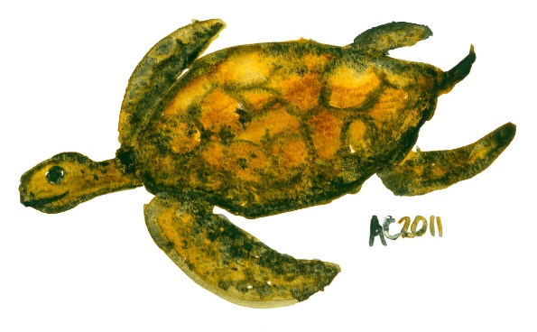

**Questions**

1. What three items were found in the chick’s stomach? [3]

2. Explain, in your own words, why ‘many thousands of seabirds…have died’. [Paragraph two] [1]

3. Explain why the writer has used parenthesis in paragraph three. [1]

4. How many scraps of plastic were found in the stomach of one fulmar that died in Belgium? [1]

5. How does the sentence structure emphasise the damage plastic causes in paragraph four? [2]

6. What phrase in the final paragraph means to lessen our use of? [1]

7. Dictionary work: What does ‘innocuous’ mean? [1]

8. What word used later in the passage means the opposite of ‘innocuous’? [1]

**Exercise Four**‘Spectacles? Cool? Can’t see it, myself’

|  |
| --- |
| One of the pivotal events of my school career occurred when I was seven.  My teacher, Mrs Soames, had noticed that I was struggling to read what she was writing on the blackboard. In fact, to get a decent view of what she was writing, I needed to get so near the blackboard I practically ended up with chalk on my nose. Soon she tired of my constant trips to the front of the class and my mother was informed that I needed a sight test. The optician prescribed me glasses- to be precise, one pair of standard issue National Health specs of the type specifically designed to maximise the humiliation for any child. They worked a treat. From being a kid with poor eyesight and moderately high esteem I became a kid with good eyesight and low self esteem.   I was at the time the only myopic pupil in the class, though soon I was joined by some of the other smaller, weedier pupils. In an instant my football career was almost dead. If I wanted to head the ball, it meant leaping athletically while removing my glasses in the same instant, then putting them back on to see where the ball had gone – this stuff never happened to Johann Cruyff.  Then there was the shape of the glasses. They were round – so was my name. This lead to some hilarious jokes. The jokes got even better a couple of years later when I switched to square frames [you could probably make up your own here].  Then there was the attitude of my classmates who now saw me as a swot. My teachers, unimpressed with my progress, had me down for a dunce. Glasses were ruining my life.  Thankfully, it seems that the current generation of children are not going through this experience. According to a new survey, kids with glasses are now seen as cool. Indeed, 43% of speccy four-eyed [I’m sorry – I mean bespectacled] children now claim that having the right pair of glasses make them more popular than their deprived un-myopic mates. They cite the influence of Johnny Depp and Harry Potter for making specs acceptable, which is ironic because Harry wears precisely the same kind of glasses which ruined my own image in the 70s. |

**Questions**

1. Which word from paragraph one tells us that this was an important event? [1]

2. What is the effect of the dash used in paragraph two? [2]

3. Comment on the sentence structure used in line ten. [2]

4. Explain, in your own words, the change the glasses brought about.   
[paragraph three] [2]

5. Which word from paragraph four means to be short sighted? [1]

6. Explain why the dash is used at the end of paragraph four. [2]

7. Read paragraph six. What contrasting views did the classmates and the teachers have of Simon Round? [2]

8. Which two celebrities have made glasses popular? [2]

9. What is ironic about these glasses? [2]

10. How would you describe the overall tone of the passage? [1]

**Exercise Five**Afghan girl defies death threats over Olympics By Tom Coghlan in Kabul

|  |
| --- |
| A teenage athlete has overcome a campaign of intimidation including death threats to become the only female member of the team to represent Afghanistan at the Beijing Olympics.  Mehboba Ahdyar, a shy 19-year-old from Kabul, will face the worlds best 1,500 metre runners in August wearing a veil and a baggy tracksuit.  While she is unlikely to mount the winner’s podium, few of her opponents will have endured such a perilous training regime to get them to the games. Training for Mehboba begins after nightfall. It is the only time when, as a woman, she can supplement her official training sessions without threats or harassment.   She recently had to destroy the Sim card on her mobile phone because the number had become known to fundamentalists who bombarded her with death threats.  “They say that they will not leave me alive,” she said, with a shrug.   In spite of the taunts and death threats, she insists she will run for national pride.  “I will compete against heroes,” she said, although she could not name any of the world’s leading middle-distance runners. “We have trained for three years. I hope for a medal or at least to break Afghan’s record.”  Daily Telegraph 29 March 2008 |



**Questions**

1. Read paragraph one. Explain, in your own words, what Mehboba Andyar has overcome. [2]

2. What will she be wearing at the Olympics? [2]

2b. Why do you think this is? [1]

3. Quote the word which shows that the training schedule was dangerous. [1]

4. Read paragraph three. What does the word ‘bombarded’ suggest about the number of death threats she received? [2]

5. “They say that they will not leave me alive,” she said, with a shrug. What does this suggest about her attitude? [2]

6a. What is interesting about Mehboba’s knowledge about the other competing athletes? [1]

6b. Can you think of an explanation for this? [1]

**Exercise Six**‘Only Snobs Sneer at McDiploma Graduates’

|  |
| --- |
| ‘Do you want fries with that A Level?’ First we had McJobs and now we have McDiplomas, with news that the burger giant has been accredited to give out qualifications.  Cue a welter of jokes about BScs in burger flipping, and accusations that the Qualifications and Curriculum Authority is dumbing down our education system. But all this hilarity has exposed a rich vein of snobbery in British society, not just about fast food and American business values but also about the lower reaches of the service industry. What McDonald’s will offer is a basic shift manager’s course – a qualification which shows that the young person has learned what needs to be known about the day to day running of a restaurant. Is this any different from the old idea of the butcher’s or baker’s apprentice learning the shop trade?  Now, some may say McDonald’s may not be the most wholesome of eateries, and there may be nutritional and ethical qualms about their products. But no one can argue that McDonalds is not a phenomenally successful business which has got that way by giving people something they want in the most efficient and cost-effective manner.  Extract from an article in the ‘Manchester Evening News’ 30th January 2008 |



**Questions**

1. Quote the expression in paragraph one which shows that McDonalds are a huge company. [1]

2. Read paragraph two. Explain, in your own words, what the reactions to the news of the qualifications have shown. [3]

3. Read paragraph three. Why do you think the writer uses a question here? [1]

4. Read paragraph four. Quote the word which shows there are concerns about McDonalds as a business. [1]

5. Explain in your own words the positive aspects of McDonalds. [2]

6a. Dictionary work - Find out the meaning of the word ‘ethical’. [1]

6b. Use this word in a sentence. [1]

**Exercise Seven**

‘Let adult fatties eat themselves to death. The kids we can save’

|  |
| --- |
| If the government really wants to tackle obesity, it should channel all its resources into getting the young fit and healthy.  According to our Prime Minister, obesity is ‘one of the biggest threats’ we face. For some time now politicians have employed the same terminology to talk about health issues as they do about waging wars – which generally entails maiming and killing people. Being fat isn’t acceptable – it’s talked about as an ‘epidemic’ or a ‘battle’ that must be fought, just like operations in Afghanistan and Iraq.  It does seem a bit rich to use such emotive language to describe nothing more than a plethora of love handles or beer guts. And I’m not sure that spending millions of pounds on public service advertising telling us what we all know already – if you eat too much you pile on the pounds – isn’t a complete waste of time.  The latest bit of armoury to be deployed against fatties is the extraordinary notion of offering cash or vouchers for leisure centres for successful dieting. The British Heart Foundation is running a competition called The Biggest Loser, which hands out £130 gift vouchers for the entrant who loses the most weight.  Extract from an article in ‘The Independent’ 27 January 2008 |

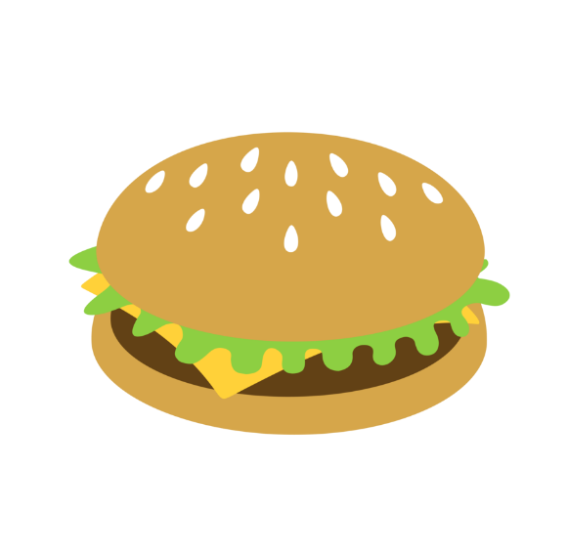

**Questions**

1. Read paragraph one. What does the writer think the government should do to tackle obesity? [2]

2a. What figure of speech is used when referring to being fat as a ‘battle’? Provide further evidence of this technique. [1]

2b. What does this suggest about the government’s attitude towards obesity? [2]

3. Why is parenthesis used in paragraph three? [2]

4. Quote the word used in paragraph four which continues the idea of war. [1]

5a. Dictionary work: Find out the meaning of ‘plethora’. [1]

5b. Use this word in a sentence. [1]

**Exercise Eight**  
‘Save our Sundays – shut all the shops’

|  |
| --- |
| In Bilbao recently for a weekend, it took me a little while to figure out why the atmosphere was so different to back home. Then I realised it was a Sunday and that all the shops were closed.  In this country, whether its Chinese New Year or Christmas, Easter or Halloween, we’re out there answering the call of the high street. And if M&S profits go down, it’s a crisis in the economy. We’ve created a system in which our future depends on our ability to shop until we drop.  It makes our talk about global warming just hot air. I’m still not over the cost of Halloween and the Guy Fawkes Day. With pumpkins, fancy dress, fireworks and sweets, the nation’s bill must be in the high millions.  When I was a kid in Ireland, Halloween meant snipping up an old sheet and wafting around the streets in search of pennies from the neighbours. Nowadays, even toddlers wouldn’t be seen dead in a home-made ghoul costume. The streets were littered with children dolled up in the finest fancy dress that money can buy.  The streets and parks of Bilbao were full of families, parents and pushchairs, teenagers and grandparents all strolling about enjoying the sunny winter’s day. If sharing quality time with those we love reduces the stress of modern life, a real day off makes perfect sense.  In the UK by midday on a Sunday, we’re armed with plastic and ready for our next assault on the high street. Maybe it’s time we asked why.  The Observer 11 November 2007 |



**Questions**

1. Read paragraph one. Why was the atmosphere different in Bilbao? [2]

2. How does the sentence structure at the beginning of paragraph two emphasise the extent of our shopping hours? [2]

3a. ‘…we’re out there answering the call of the high street.’ What figure of speech is used here? [1]

3b. What does this image suggest? [2]

4. Quote the word from paragraph two which suggests less profits can have disastrous consequences. [1]

5a. ‘It makes our talk about global warming just hot air.’ What figure of speech

is used here? [1]

5b. What does this image suggest? [2]

6. Read paragraph four. What does the word ‘littered’ suggest about the number of children dressed up? [2]

7. Read paragraph five. Explain in your own words, the effect of sharing quality time with those we love. [2]

8. What is the effect of the final sentence? [2]

**Exercise Nine**‘Is Our children reading?’ By Steven Poole

|  |
| --- |
| As George Bush nearly asked: “Is our children reading?” The answer appears to be no, according to the 2006 report of the International Literacy Study. As the Guardian summarises its findings: “England has plummeted from third to 19th in an international league table of children’s literacy as pupils replace books with computer games.”  Imagine the headlines 100 years ago: “Children spending too much time playing outdoors with hoops and sticks, says minister; should be forcibly enclosed to study improving literature.” There’s always some apparently pointless youth activity to scapegoat.  As has always been the case, though, the adult paranoia expressed here about the supposedly harmful influence of videogames depends on a sublime ignorance of the form. In fact, you’re not going to get far in most modern videogames if you can’t read. And some of the make you read an awful lot.  So if children are not so much interested in picking up a paperback, maybe that says more about the quality of books currently being foisted upon them than it does about the evils of digital entertainment. Children are, after all, quite discriminating. If someone writes a new Harry Potter, they’ll curl up with it for days. If not, there’s always the games console.  Extract from an article in The Guardian 1 December 2007 |



**Questions**

1. What should George Bush have asked? [1]

2. Why is a colon used after ‘findings’ in paragraph one? [2]

3. What are children meant to be replacing books with? [1]

4. Read paragraph two. Quote the word which suggests children’s activities are used as an excuse for them not reading. [1]

5. Read paragraph three. Quote the word which suggests that the writer is not convinced by the argument against videogames. [1]

6. Read paragraph four. Explain in your own words, the reasons given by the writer for children reading less. [2]

7. Quote the word which suggests that children make informed decisions about their reading. [1]

**Exercise Ten**‘Scientists develop non-stick gum’

|  |
| --- |
| Non-stick chewing gum which cannot glue itself to pavements, seats or shoes – and with the added bonus of being completely bio-degradable – has been invented by a British scientist in what is thought to be a world first.  The gum contains a new kind of rubber-like polymer that lacks the stickiness of conventional chewing gums, which have become a costly environmental problem for local councils because of the millions of discarded cuds which remain glued to pavements and buildings for years.  Professor Terence Cosgrove of Bristol University said that tests have demonstrated that the non-stick gum can be easily removed from public places by natural processes and that it degrades easily in the presence of water.  Trials in public places have confirmed that the gum is either easy to remove or does not stick at all to pavements and seats. Tasting tests have also shown that it performs just as well as conventional gum.  It is estimated that local councils in Britain spend about £150m a year on removing chewing gum cuds from public places. Meanwhile, chewing gum products are one of the fastest growing areas of the confectionary business, growing by 7% over the past three years.  Extract from The Independent 14 September 2007 |

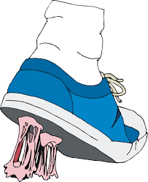

**Questions**

1. How does the sentence structure of the first line emphasise the damage chewing gum causes? [2]

2. Read paragraph one. Why is parenthesis used here? [2]

3. Read paragraph two. Explain in your own words, what is different about the new chewing gum? [2]

4. Read paragraph three. Quote the word which shows the chewing gum breaks down into nothing. [1]

5. Read paragraph four. Summarise the three main advantages of the new chewing gum. [3]

6a. Dictionary work. Find out what the word ‘estimated’ means. [1]

6b. Use this word in a sentence. [1]