Our Lady’s High School

English

S2

Knowledge
About
Language

We can understand K.A.L .

Saw, Seen Did, Done

Saw and Seen
The word ‘saw’ can be used on its own in a sentence.
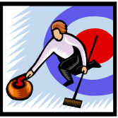
For example: Peter saw the curling match.
The word ‘seen’ cannot be used alone in a sentence.
It has to have an auxiliary verb with it.
For example: Peter has seen the curling match.

Task
Fill in either saw or seen in the five sentences below.
- Mary and I __________ that film last week.
- Both of us had __________ it before you did.
- I ________ you at the disco.
- You were also ___________ by Mary.
- Jim _________ us before we had __________ him.

Did and Done
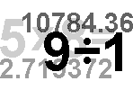
The word ‘did’ can be used on its own in a sentence.
For example: Peter did the maths homework.
The word ‘done’ cannot be used alone in a sentence.
It has to have an auxiliary verb with it.
For example: Peter has done the maths homework.

Task
Fill in either did or done in the five sentences below.

- Kate __________ the work by herself and ________ it well.
- After she had ________ the work, she went out.
- We _________ the shopping quickly.
- I have _____________ my work early this week.
- I think I have __________ better in the test this week.
The Placing of Relative Pronouns

Relative pronouns (who, whom, whose, which) should be put as close as possible to the noun that they are attached to.
If you don’t do this, the sentence can seem muddled and strange.
Example
Wrong: The bride was given away by her father, who wore a white
silk dress.
This is wrong because it seems to suggest that it was the father, not the bride, who wore the white silk dress.
Correct: The bride, who wore a white silk dress, was given away by
her father.
Task
Write the sentences below again, correctly, as in the example.

- The antique chair cost a thousand pounds, which Dad handled carefully.
______________________________________________________________________________________________
- The girl married a soldier who was the Major’s daughter.
_______________________________________________

- The pet shop manager kept a parrot who had a long beard.
_______________________________________________
- The football crowd helped the team win who shouted until they were hoarse.
______________________________________________________________________________________________
- My aunt’s new baby slept peacefully in my car who normally cries for half of the night.
______________________________________________________________________________________________
Relative Pronouns

Relative Pronouns are words such as who, whose, whom and which.
These words are relative pronouns when they are used to join two small sentences together.
They come in the middle of sentences, not at the start.

Who and Which

Who is used for people.
Which is used for animals and things.
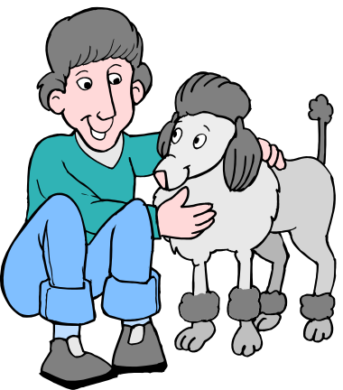
Examples
I’m not talking to my brother. He is a pest.
I’m not talking to my brother who is a pest.

I’m walking my dog. It is a poodle.
I’m walking my dog which is a poodle.

Task
Join the sentences below using who or which.

- I spent £5. I found it in the park.
_______________________________________________
- I bought pink and yellow sweets. They were disgusting.
_______________________________________________
- I gave them to my little sister. She likes disgusting sweets.
_______________________________________________
- She got sick and told my Mum. She was not pleased.
_______________________________________________

Whose

Whose can be used as a Relative Pronoun.
It is used to join two short sentences into one long one.
It comes in the middle of the long sentence.
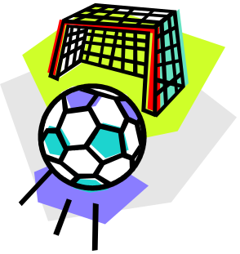

Example
I know the boy. His clothes are dirty and torn.
I know the boy whose clothes are dirty and torn.

Task
In the sentences below, fill in either who or whose.

- We found a football shirt and wondered _________ it was.
- It belonged to the new goalkeeper ________ had just joined the team.
- We were all pleased with the new goalkeeper _________ managed to save a really good shot at goal.
- He passed the ball to a defender _________ was fouled by the big Number 10 and who was given a free kick.
- There was an argument about _________ free kick it was.
- The Number 10 _________ foul had caused a slight injury was sent off.
- The Referee ______ sent him off was mobbed by the players.
- The other team _________ man had been sent off were furious.
- The new goalkeeper _____ helped us win the game was a hero.
Those and Them

It is important to use the correct word, those or them.

You use those in front of a noun.
For example: I like those CDs.

You use them when there is no noun.
For example: I like them.

Task

Fill is those or them in the sentences below.

- I don’t know _______________ boys.
- I have seen _______________.
- We are going to see _______________ films.
- They don’t want to see _____________.
- Do you like _____________?
- I prefer _____________ films that are exciting.
- What do you think of _____________?
- We are not thinking about ____________ exams.
- When do you have to sit ____________?
- I hope that you pass ______________.


The Possessive Apostrophe,
the keyboard of Fiona = Fiona’s keyboard 

Rule Find the owner Fiona
Add the apostrophe Fiona’
Add s if there isn’t one Fiona’s

Some plural nouns will need s to be added but most of them will already have one.
the car of my parents = my parents’ car 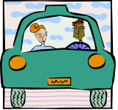

Rule Find the owner my parents
Add the apostrophe my parents’
Add s if there isn’t one my parents’ car
(There is!)

the boats of the fishermen = the fishermen’s boats

Rule Find the owner the fishermen
Add the apostrophe the fishermen’
Add s if there isn’t one the fishermen’s boats

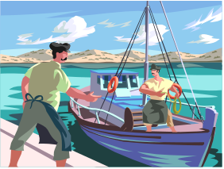
The Possessive Apostrophe

Exercise 1

Each sentence below needs one possessive apostrophe.

1. Policemens uniforms are being updated.
2. Why are childrens departments so often on the second floors of big stores?
3. The small childs handwriting was untidy but the letters were well formed.
4. Holidays Unlimited have been inundated with holidaymakers complaints.
5. Farmers incomes have been severely affected by the cut in subsidies.

Exercise 2

Put the apostrophes in the following sentences. Five apostrophes are needed altogether. Some sentences may not need any!

1. It’s my parents wedding anniversary on Monday.
2. The childrens party was a great success. There were fifteen girls and twelve boys.
3. The boxes of books were stacked at the end of the corridor.
4. Mrs Doak groaned, “Girls voices are so much shriller than boys voices. I have such a headache!”
5. Year 7s outing has been postponed.

The Possessive Apostrophe (continued)

You use an apostrophe with an s (‘s) to show that someone or something owns something. Remember the rules!

Examples
Rover is Tom’s dog. Richard’s pen is broken.
The restaurant’s food is awful. The hut’s roof is leaking.

Exercise


Re-write these sentences in your jotter
Example The feathers of the bird are black.
The bird’s feathers are black.

- The car of the teacher is parked in the street.
- The bag that John has is blue and white.
- We don’t like the food of this café.
- The headmaster of the school is called Mr. Green.
The sister of the girl is younger than she is.
- The captain of the team is called Paul Turner.

Exercise 3 Proof Reading

There are twenty errors in the extract below from Flat Stanley that have been deliberately introduced for you to identify and correct.

Breakfast was ready.
“I will go and wake the boy’s” Mrs Lambchop said to her husband, George Lambchop.
Just then their younger sun, Arthur, called from the bedroom he shared with his Brother Stanley in their new york home.
“Hey! Come and look! Hey!”
Mr and Mrs Lambchop were both very much in favour of pliteness and careful speech. Hay is for horse’s, Arthur, not people,” Mr Lambchop said as they entered the bedroom. “Try to remember that.”
“Excuse me,” Arthur said. “But look!”
He pointed to Stanleys bed. Across it lay the enormous bulletin bored that Mr Lambchop had given the boys a Christmas ago, so that they could pin up pictures and massages and mops. It had fallen, during the might, on top of Stanley. But Stanley was not hurt. In fact he would still have been sleeping if he had not been woken by his brothers shout.
“What’s going on here?” he called out cheerfully from beneath the enormous board.
Mr and Mrs Lambchop hurried to lift it from the bad.
“Hevens!” said Mrs Lambchop.
“Gosh!” said Arthur. “Stanley’s flat!”

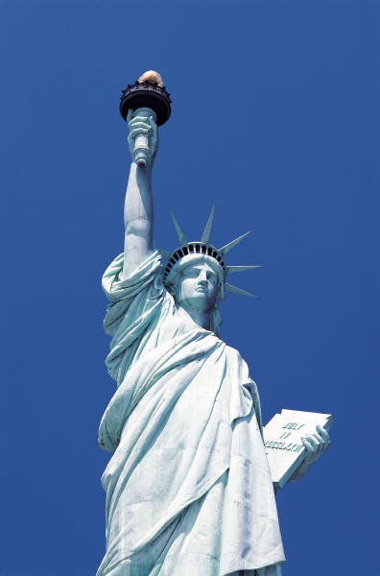
The ‘Shortening’ Apostrophe

Sometimes when we speak we shorten what we say.

For example, we don’t usually say “I am …”
We shorten it to “I’m …”

When we write this, we put the two words together and put an apostrophe in instead of one (or sometimes two) of the letters.

I am We are They are are not
I‘ m We‘ re They‘ re aren’ t

Some other shortened words are
you are - you’re is not - isn’t who is – who’s
has not – hasn’t was not – wasn’t you have – you’ve
cannot – can’t will not – won’t how is – how’s

Task
Write the long version of these shortened words:
1. they’re ______________________

2. can’t ______________________
3. she’s ______________________
4. haven’t ______________________
5. weren’t ______________________

Write the short version of these:

1. is not ______________________

2. he is ______________________
3. you are ______________________
4. they have ______________________
5. I have ______________________

It’s Who’s

It’s (with an apostrophe) means it is or it has.
Example It’s been a long, hard day.
Its (without an apostrophe) means belonging to it.
Example Its coat is dark and glossy.

Task
In the sentences below, fill in either it’s or its.

- _________ time for us to go home.
- The dog chases __________ own tail.
- I think _________ an eagle.
- ___________ got long feathers and a strong beak.
- _________ claws look dangerous.

Who’s (with an apostrophe) means who is or who has.
Example Who’s got a good job?
Whose (no apostrophe and an e at the end) means belonging to who.
Example Jake is a boy whose clothes are always dirty.

Task
In the sentences below, fill in either who’s or whose.

- I know _____________ coming to the party.
- _____________ bag is this?
- _____________ got a joke they can tell us?
- Can you tell me ______________ marks were best?
- _____________ right and _____________ wrong?

You’re and Your There’s and Theirs

You’re and Your
You’re (with an apostrophe and an e at the end) means You are.
Example You’re going to be late!
Your means belonging to you
Example Your glasses are in your pocket!

Fill in either you’re or your in the sentences below.

- _____________ in a hurry today!
- I haven’t seen _____________ homework yet.
- Where is ____________ football kit?
- I don’t know what _____________ doing.
- _____________ next in the queue.

There’s and Theirs

There’s (with an apostrophe) means there is or there has.
Example There’s a cold wind tonight.
Theirs (different spelling and no apostrophe) means belonging to them.
Example I’ve seen my bicycle but I haven’t seen theirs.

Fill in either there’s or theirs in the sentences below.
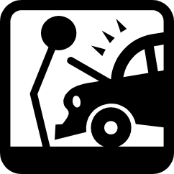
- _______________ no time to play any more.
- These sweets are not ______________.
- I’ll do my homework and they can do _____________.
- I don’t think _____________ any Coke left.
- _____________ been an accident in the town centre.

Mystery Words

O N I G
B U C N

Example

The word bouncing is written so that it looks like a ball bouncing.

Write the words below in your jotter so that they look like what they mean.

Circular Splash

Upside down Pond

Slippery Slope Flattened

Reflection Long

Mountainous Dead

Hot Heavy

Water Light

Ripples Double

Either and Neither Each and Anyone

Either and Neither.


You always us the word or after either.
Either Celtic or Rangers will win the League.
You always use the word nor after neither.
Neither Hearts nor Hibs won the League.
Fill in or or nor in the sentences below.

- Either John _____ Jim will win the 100 metres.
- Neither Amy _______ Anne drinks tea.
- I haven’t seen either Kelly _____ he sister today.
- Neither the apples ________ the pears look good.
- We don’t like either French ______ German in school.

Each, Anyone, Anybody, Nobody, Everyone, Everybody

The words each, anyone, anybody, nobody, everyone and everybody always have a singular verb after them.


Example Nobody goes to school on Sunday.
not Nobody go to school on Sunday.

Underline the correct verb in the sentences below.

- Everyone come/comes to my parties.
- Nobody wants/want to do too much homework.
- Each pupil like/likes Craft and Design.
- I don’t know anyone who hates/hate snowboarding.
- Everybody know/knows who is the best football team in Scotland.

Double Negatives
Negative words are
no, not, nobody, nothing, nowhere, never, no-one, neither.

You should not put two negative words together in a sentence.
One is enough.

Example:
‘I don’t know nothing’ is not correct.
It should be either ‘I don’t know anything’
or ‘I know nothing’

Task
Tick the correct sentence in each pair of sentences below.

1. We don’t like nobody in the class.
We don’t like anybody in the class.

2. I haven’t been anywhere nice today.
I haven’t been nowhere nice today.

3. Nobody tells me anything.
Nobody tells me nothing.

4. She hasn’t done nothing to be ashamed of.
She hasn’t done anything to be ashamed of.

5. I never told nobody nothing.
I never told anybody anything.

6. I haven’t seen either of them for a week.
I haven’t seen neither of them for a week.

Can and May e.g and i.e.

Can and May

- Use can when you know how to do something.
’I can go to the Sports Centre because I know the way.’
- Use may when someone gives you permission to do something.
’I may have a chocolate biscuit and a glass of orange.’

Fill in either can or may in the sentences below.

- __________ I have an ice cream, please?
- __________ you play the guitar or the drums?
- We __________ go to the match. Mum said so.
- I __________ do all the questions in the test.
- _________ we swim? Of course we _________.

e.g. and i.e.

e.g. means ‘for example’.

i.e. means ‘that means’

Fill in e.g. or i.e. in the sentences below.

1. We have lots of old records _____ the Beatles and the Stones.
2. You are not going to the disco ____ I am not giving you permission to go.
3. There are lots of types of dog ___ spaniels, boxers, beagles.
4. I like all kinds of ice cream ___ strawberry, vanilla, chocolate.
5. I’m not fond of basketball ____ I hate it.
May and Might Former and Latter

May and Might

Use may if the thing is quite possible.
’I may come and see you tonight if it is not too late.’
Use might if the thing will probably not happen.
He might pass the French test.

Fill in either may or might in the sentences below.

- Everyone in the class ____________ learn to swim.
- We __________ go to Ibrox if we can get tickets.
- I ___________ be ten minutes late for school today.
- We _____________ manage to win the match.
- The girls ___________ all get a computer for Christmas.


Former and Latter

The former is the first thing that is mentioned.
The latter is the last thing that is mentioned.


Answer the questions below. Write either the former or the latter.

- You could win a car or a holiday. Which would you prefer?
__________________
- You could study Spanish or Italian. Which would you prefer?
__________________
- You could go on holiday to India or to Australia. Which would you prefer?
__________________
To Too Two

- To is the little word that fits into sentences.
’I want to go to town this Saturday to do my shopping at a quarter to nine’.
- Too is used to emphasise something. Too can mean ‘also’
’We always get too much homework and it is too difficult.’

- Two is the number 2.
’I want two mugs of coffee, please.’

Fill in either to, too or two in the sentences below.

- I am going _____ see Celtic play Rangers on Saturday.
- I want _____ see that match. Can I come _______?
- Yes, if you want _____. I’ll get _____ tickets.
- Rangers won their last _____ games by _____ clear goals.
- Celtic is a good team _____ but they will have _____ improve a lot if they are going _____ beat Rangers.
- No! Celtic is much _____ good a team for that!
- Don’t you believe it! Celtic will be number _____ again!

Fill in either to, too or two in the story below.

“Why do you have _____ go _____ ______ meetings in the same evening?” Janet asked her husband.
”It was just how it worked out” replied Jim. “Why is it such a problem _____ you?”
“I want _____ go out and I can’t find a baby-sitter,” said Janet. “It is _____ bad that you’ve make such a poor arrangement. I have only _____ evenings left before I have _____ go _____work on the night shift at the hospital”.
No Know Now

Examples:

No I’ve got no idea.
Know I don’t know the answer.
Now I’m going out now, not later this evening.
NO SMOKING
Put either no, know or now into the blank spaces in the sentences below.

  - __________ person is allowed to go into that room.
  - I want to watch television __________.
  - I did not __________ all the answers to the quiz questions.
  - I don’t want you to talk to me, _______ or ever again.
  - The notice on the door said ‘________ Entry’.
  - The football match is on the television ___________.
  - Do you __________ who won?
  - ________ I don’t ___________ but I’ll find out.
  - When should I finish my homework, ________ or later?
  - I’ve said before that I don’t ________ how to draw figures.

