Business Environment

External Factors – these are changes that happen outside the business (and that are beyond their control) which can have an impact on the future of the business.

External factors are usually known as PESTEC:

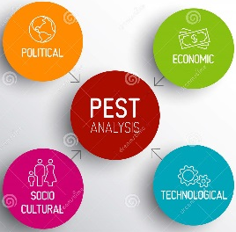
Political
Economic
Social
Technological
Environmental
Competitive

POLITICAL | Change in Government
This can impact on a business because…

POLITICAL | Change in Legislation
This can impact on a business because…

POLITICAL | Change in Taxation Levels
This can impact on a business because…

ECONOMIC | Change in Interest Rates
This can impact on a business because…

ECONOMIC | Change in Exchange Rate
This can impact on a business because…

ECONOMIC | Recession
This can impact on a business because…

ECONOMIC | Boom
This can impact on a business because…

SOCIAL | Change in Society’s Tastes
This can impact on a business because…

SOCIAL | Changes in Demographics of Society
This can impact on a business because…

ENVIRONMENTAL | Changes in Environmental Awareness
This can impact on a business because…

ENVIRONMENTAL | Weather Conditions
This can impact on a business because…

TECHNOLOGICAL | Introduction of New Technology
This can impact on a business because…

COMPETITIVE | Competitor Introduces New Product
This can impact on a business because…

COMPETITVE | Competitor Introduces New Offer
This can impact on a business because…

