As an administrative assistant you may be asked to create a variety of different documents such as letters, memorandums and notices.

However, you may also be asked to create some more unusual documents, this booklet will take you through some of these documents.
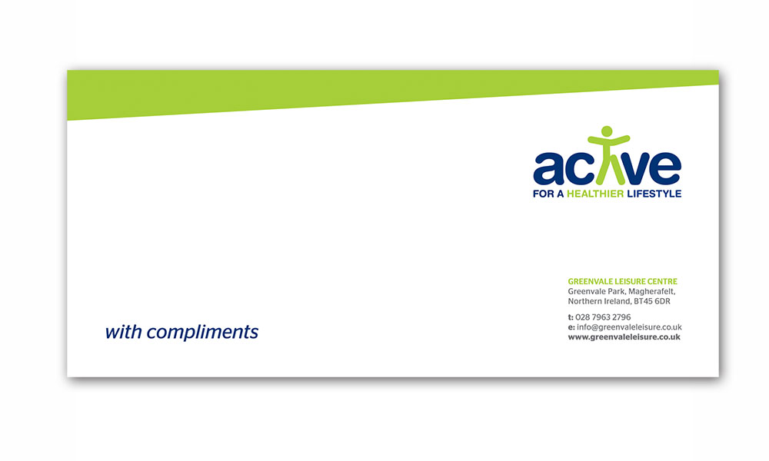
Compliments Slip

When an organisation sends a brochure or tickets to a customer they may also include a compliments slip.

This slip should contain the organisation’s name, contact details and logo.

The compliments slip should use a variety of formats so that it looks attractive and creates a good impression of the organisation.

However, remember that sometimes less is more when creating business documents!

To create a compliments slip:

1 Open MS Word and create a new blank document.

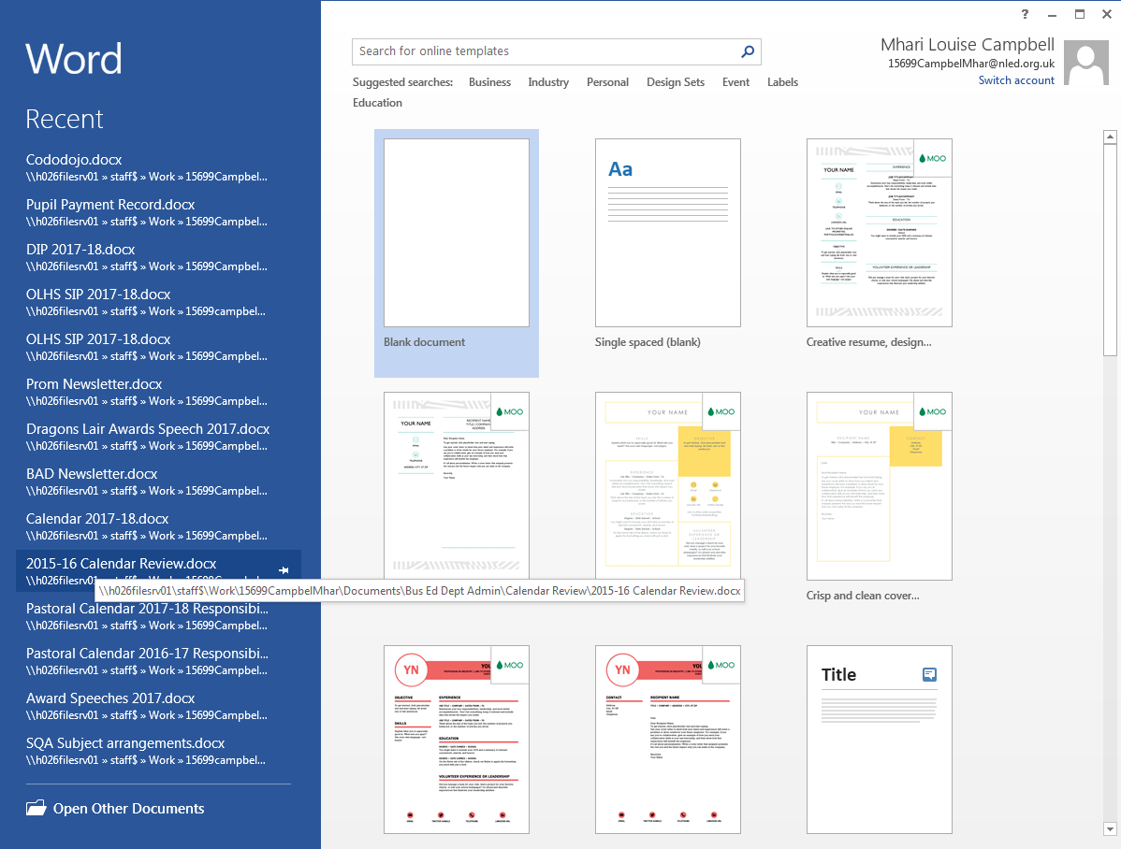

Remember! For each new document you create, check your page setting to make sure it matches the department’s house style.

2 Change the page orientation to LANDSCAPE using the PAGE LAYOUT tab.

3 From the INSERT tab chose the Text Box option.

4 Then chose the Draw Text Box option at the bottom of the page.

5 Use your cursor to draw a text box on your page.

When you do this the ribbon at the top of the page will change and a new orange DRAWING TOOLS tab will appear.

Click on this new tab and use the size option at the end to change the size of the text box to 10 cm high by 20 cm wide.

6 Now you can fill in the organisation’s details.
Top Tip! Use your normal house style font and size to enter the organisation’s details into the compliments slip and then change to a more attractive font – this will make it easier for you proof read and spell check.

You should make good use of the full text box and try to use at least 2 text alignments. You should also limit the number of fonts used (it’s only a small document!) Any graphic included should be appropriate and sized/placed attractively.
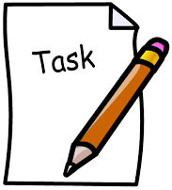
Try it yourself to create a new compliments slip to be used by the school.

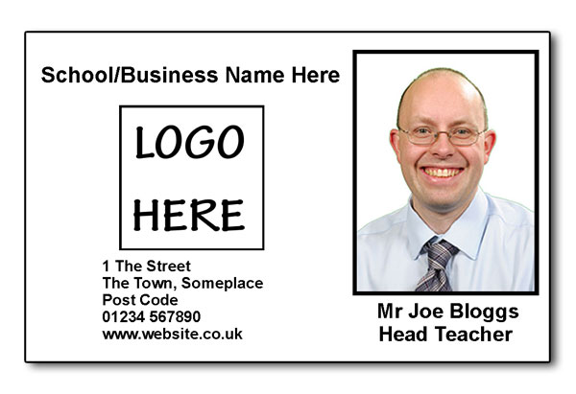
Staff ID Badge/Pass

As part of their health, safety and security policy, many organisations insist that all staff wear and ID badge when in the building. This ensures that people who are authorised to be in the building are easily identified.

These passes can then be laminated and worn around the neck with a lanyard or clipped onto a pocket.
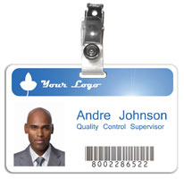
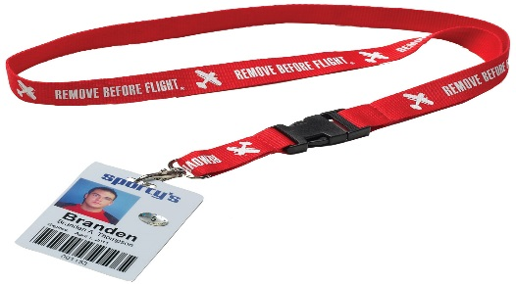

To create a staff ID pass:

1 Open MS Word and create a new blank document.

Remember! For each new document you create, check your page setting to make sure it matches the department’s house style.

2 For this document you can keep the page orientation at PORTRAIT.

3 Draw a text box as described earlier in the booklet, but this time set the height to 6 cm and the width to 9 cm.

4 Now you can fill in the badge details.
Top Tip! Use your normal house style font and size to enter the details and then change to a more attractive font – this will make it easier for you proof read and spell check.

You should make good use of the full text box and try to use at least 2 text alignments. You should also limit the number of fonts used (it’s only a small document!) Any graphic included should be appropriate and sized/placed attractively.
Try it yourself to create a backstage pass that could be used for a school show so that only authorised people can go backstage.

You should include:

the name of the school

the name of the show (Guys & Dolls)

the date of the show (the last Monday in June)

the type of pass

Wristband

Many events may involve issuing wristbands to participants. It is the admin assistant’s job to create the design of the wristband.

It is important that all the necessary information is included on the wristband – which can be quite difficult as you don’t have a lot of space!!

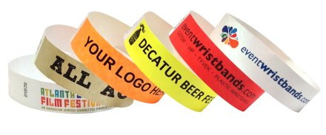

To create a staff ID pass:

1 Open MS Word and create a new blank document.

Remember! For each new document you create, check your page setting to make sure it matches the department’s house style.

2 For this document change the page orientation to LANDSCAPE.
3 Draw a text box as described earlier in the booklet, but this time set the height to 2 cm and the width to 20 cm.

4 Now you can fill in the wristband details.
Top Tip! Use your normal house style font and size to enter the details and then change to a more attractive font – this will make it easier for you proof read and spell check.

You should make good use of the full text box and try to use at least 2 text alignments. You should also limit the number of fonts used to 3 (it’s only a small document!) Any graphic included should be appropriate and sized/placed attractively.
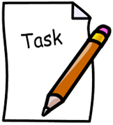
Try it yourself to create a wristband for the school feast day activities.

You should include:

the name of the school

the name of the event (School Feast Day)

the date (8th September)

an appropriate graphic

Extension Task 1
Your company, Sounds on the Shore, is organising a music festival.
You will be working as an Admin Assistant with Mitch Goodwin, the Festival Organiser, and he has asked you to organise and support this event.

Sounds on the Shore is taking place on the South Beach, Aberdeen, for the first time on Friday 29 July and Saturday 30 July 2016.

Contact details are as follows:
Sounds on the Shore
453 Union Street
Aberdeen
AB11 6DB

Phone: 07725381221
E-mail: sos@fastmail.co.uk
Web: www.sos.co.uk

The wristband should contain the following information:

*Logo
*Dates of festival
*Price of a weekend ticket (£75)

The following slogan should be inserted at the bottom of the wristband:

Sun, sea and live music, what’s not to like?

Extension Task 2

Extension Task 3

You work as an Admin Assistant at Scotland Cares, a charity raising funds for the young people of Scotland. You will be working with Mr George Sullivan, the Head Office Manager.
CONTACT DETAILS:
Scotland Cares
56 St Andrew Square
Edinburgh
EH2 2AD

PHONE: 07241669798
WEB: www.scotlandcares.org
TWITTER: @scotlandcares
Our Lady’s High School Cumbernauld

Administration & IT

Miscellaneous Documents

