Our Lady’s High School Cumbernauld

Administration & IT

Desktop Publishing – Certificates & Business Cards

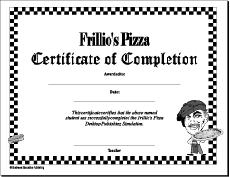

So far in the S3 Administration & IT course you have been developing your Word Processing skills by creating a variety of business documents such as notices, memorandums and letters.

For most of these documents you were given a strict layout you had to follow, you didn’t get the chance to design the document yourself – that’s all about to change!

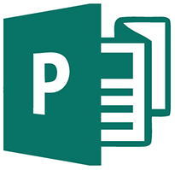
Along with formal documents such as memorandums and letters, businesses have to create a wide variety of documents such as business cards to give out to customers and certificates to give out to employees who have completed training.

These documents are created using Desk Top Publishing software.

Business Cards
Small cards that display the employee name and business contact details – easy to carry around and give out to customers.

Open Microsoft Publisher

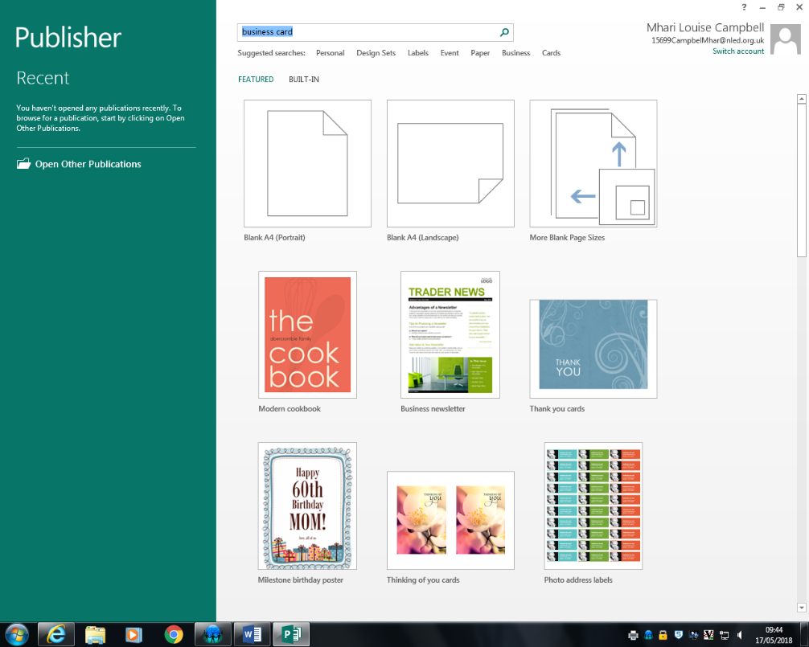
On the welcome screen
key in business card in
the search bar at the
top.

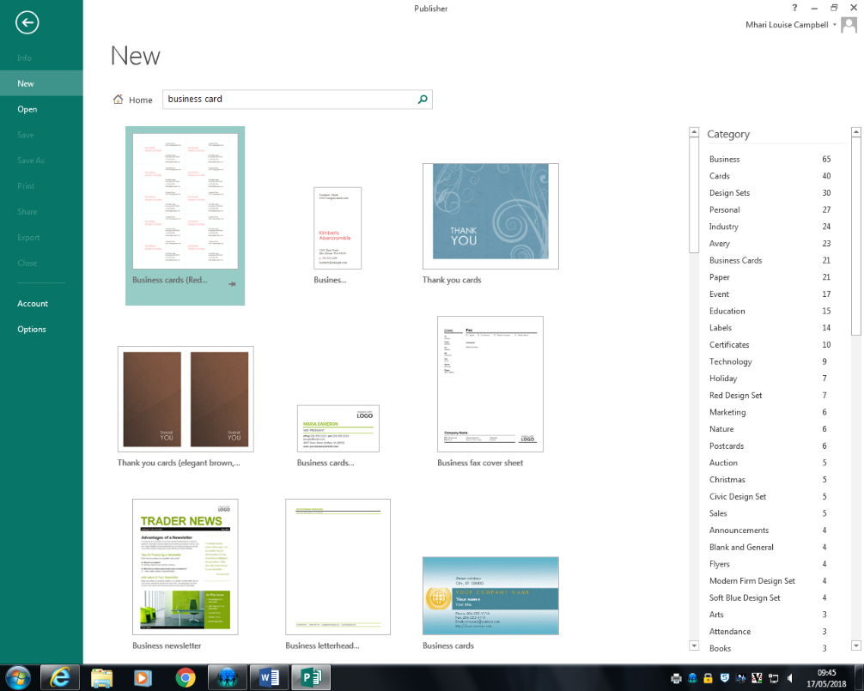
You will then be given a choice of templates to choose from

A template is a readymade document that can be adapted to suit your needs.

Using a template is good as it saves time in having to design the document.

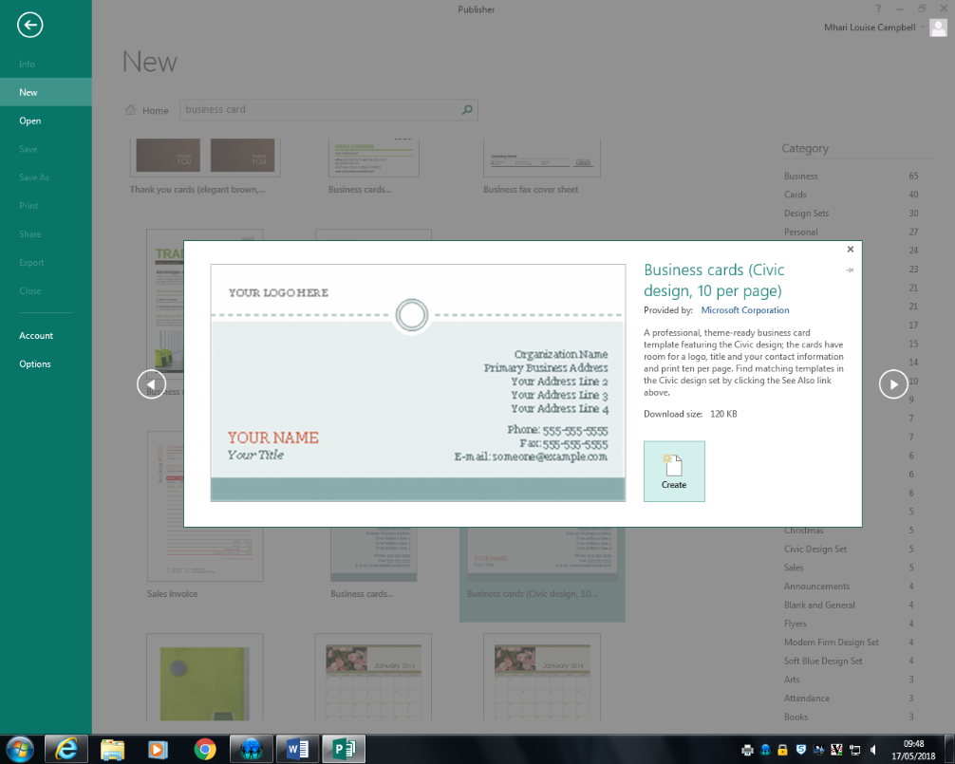
Choose a template you
like and click on create.

Use the template you have chosen to create a business card for yourself.

Choose a job title and use the school contact details (google them if you don’t know them already!)

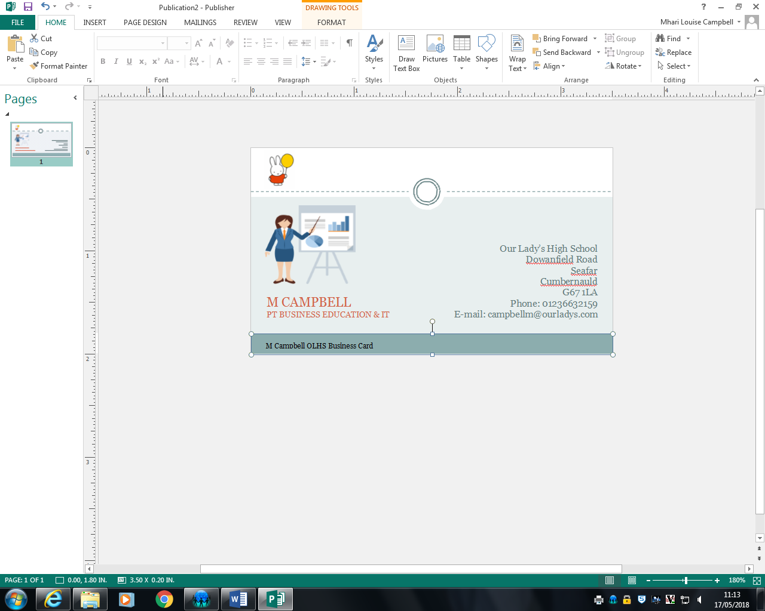
You can also use the
zoom control at the
bottom of the page
if you need to.

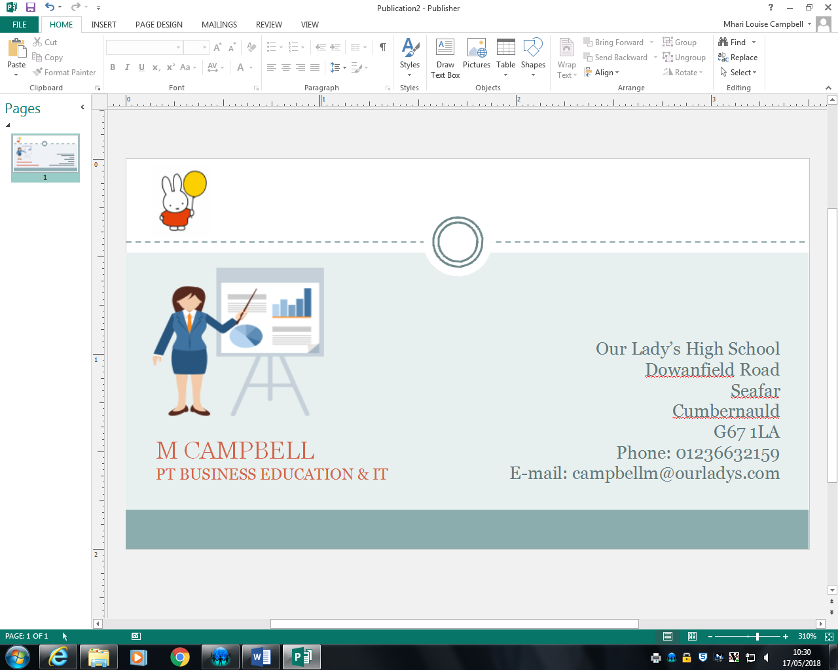
Remember you can
change the size,
font and colour of
text to make it
more attractive.
You can also include
graphics too such
as the business logo.

You will have to include a footer to your business card.

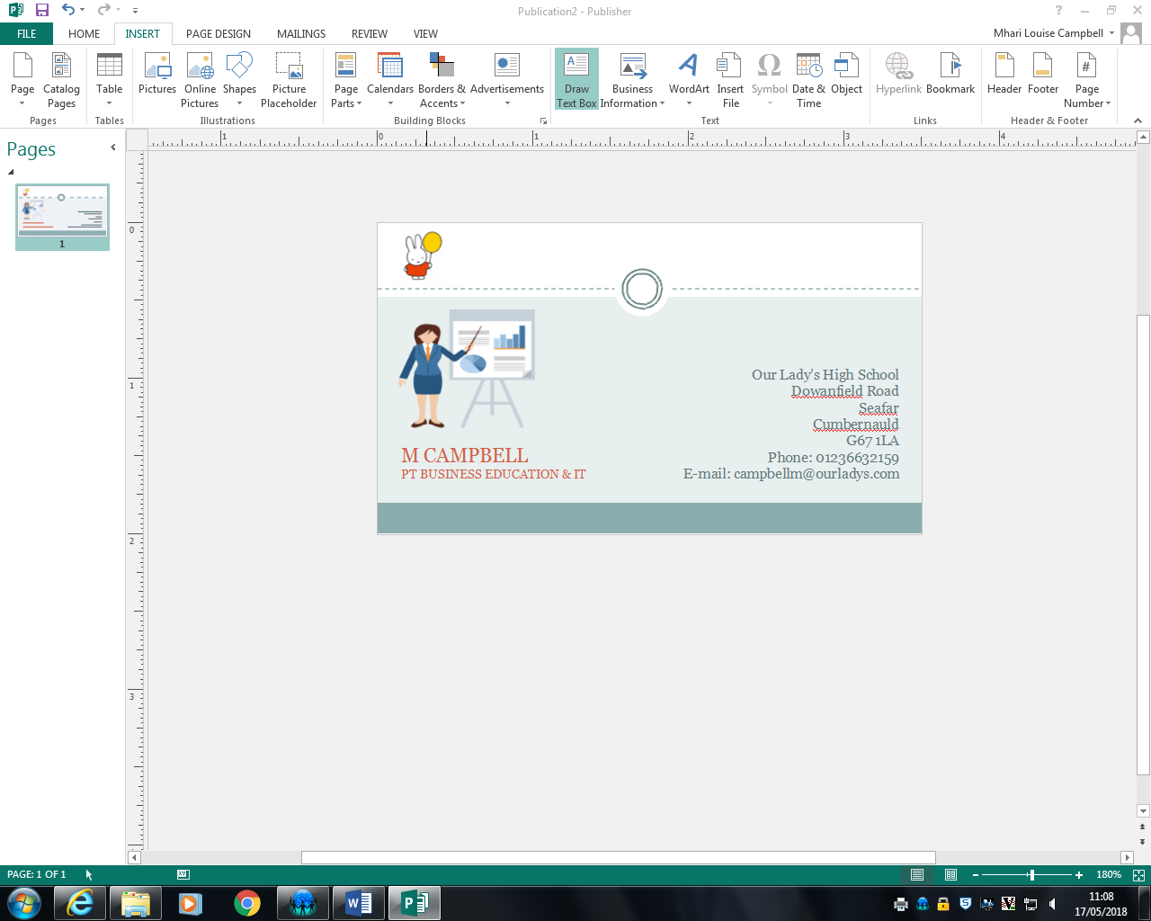
The easiest way to do
this is to go to the Insert
tab and choose Draw
Text Box.

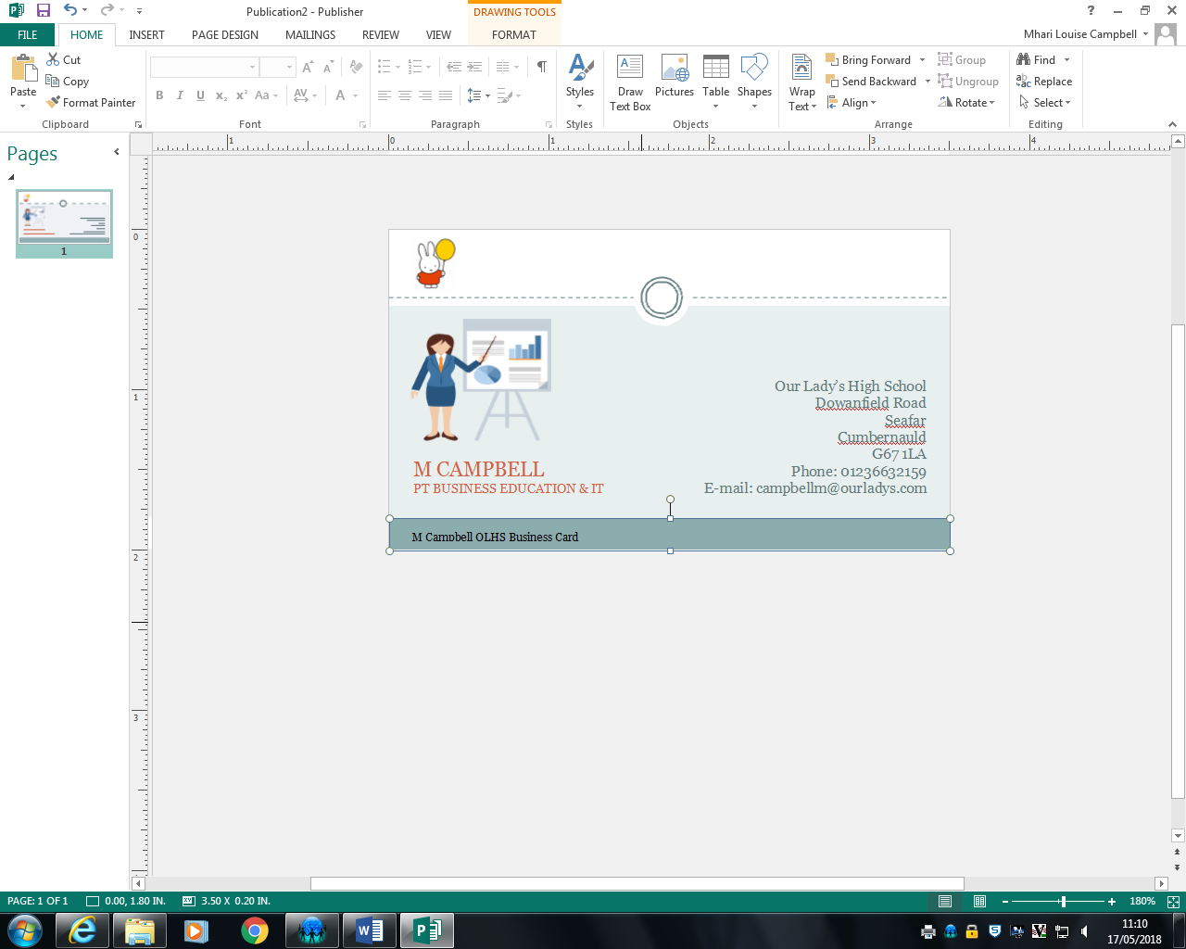
Key your name and OLHS
Business Card in the footer.
You might have to change
the size of your text so
that it can all be seen.

Save your business card at OLHS Business Card into your S3 Admin & IT folder.

You can now print your business card. Depending on the template you have chosen when you go to the print screen you may see more than one business card.
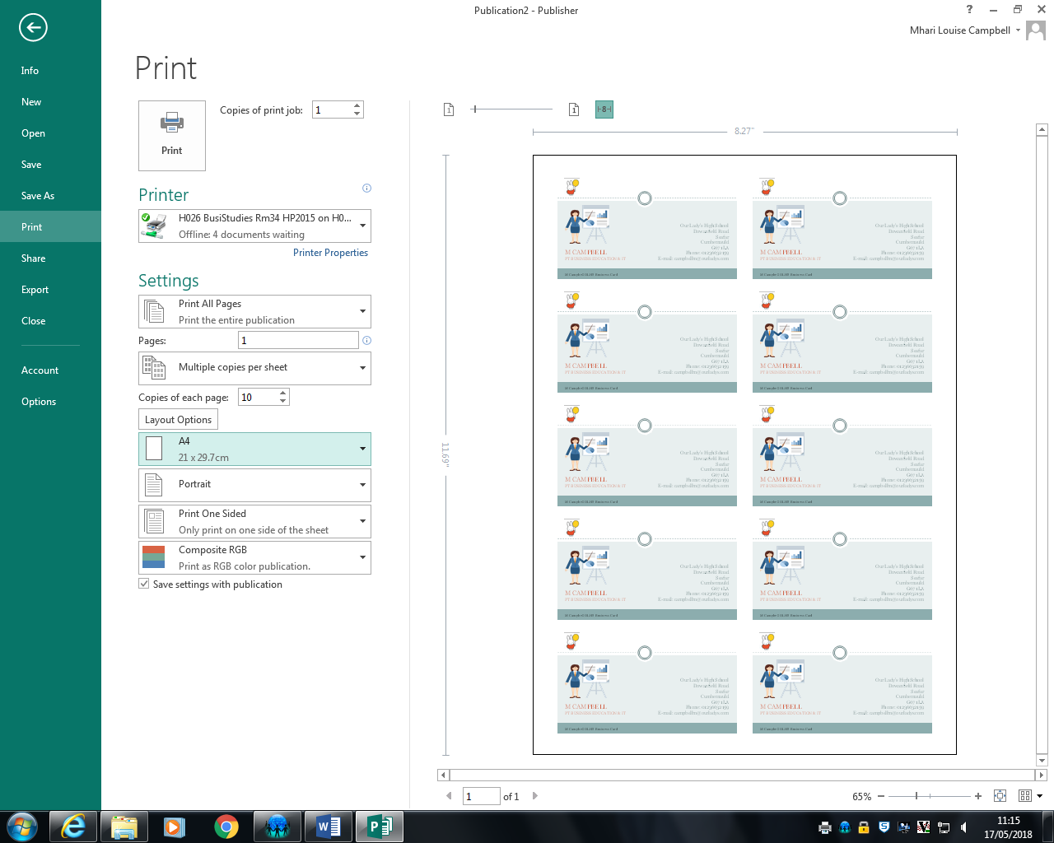
Make sure the paper
size is set to A4.

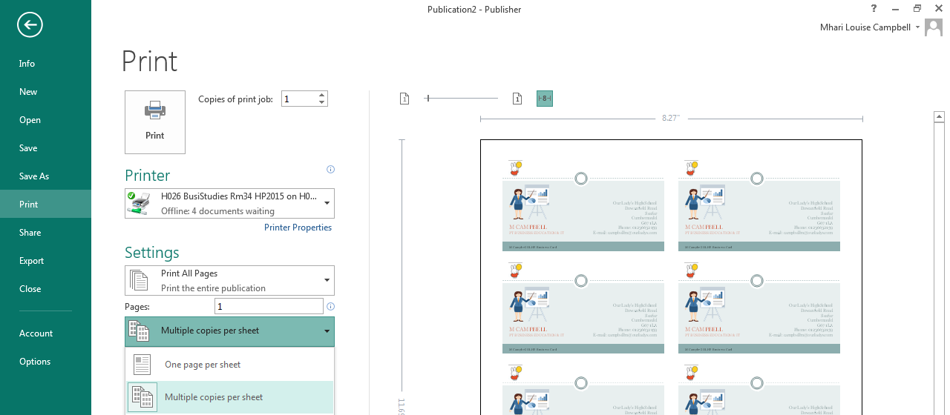
You can change the
number of cards
printed by using the
options on the print
screen.

Well done! Time to try another on your own.

You work for Morven’s Cake Place
Contact details for the business are as follows:
Morven’s Cake Place
122 Cathedral Street
Glasgow
G1 2TG

Phone: 01413535444
E-mail: morvens@mailit.com
Web: www.morvenscakeplace.co.uk

Design and print a business card for Morven to distribute at the Good Food Exhibition.
Insert an appropriate logo onto the card.
Print out 8 cards on a page.

Certificates
Certificates may be given out by a business for many
reasons – a school may give them out to pupils who have
achieved good exam results or with good attendance,
while an office may award them to employees who have
completed training.

Open Microsoft Publisher

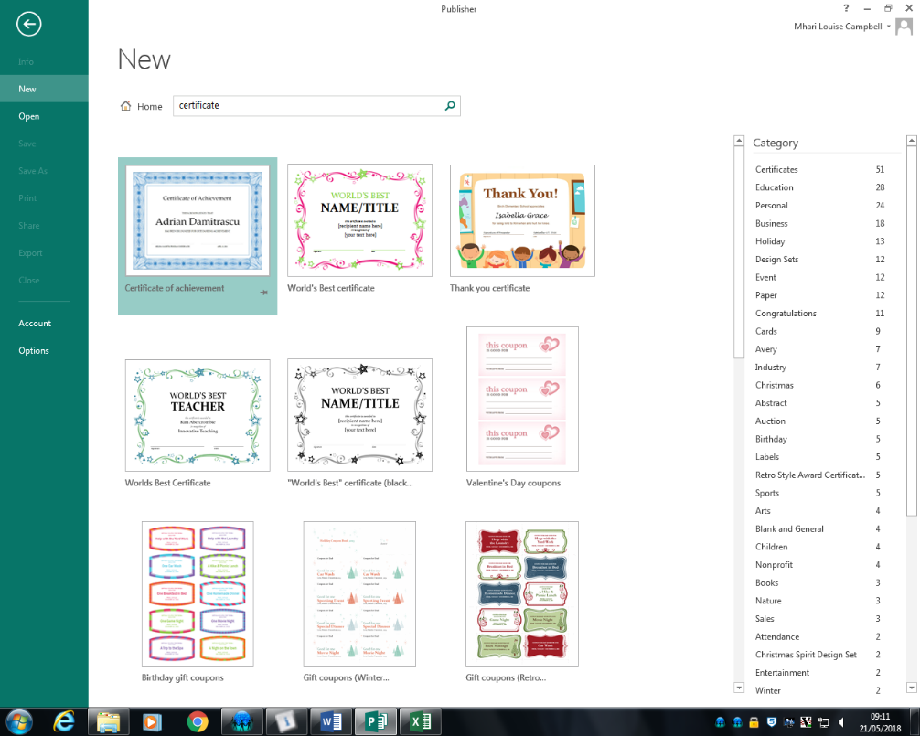
On the welcome screen
key in certificate in
the search bar at the
top.

You will then be given a
choice of templates to
choose from.

A template is a readymade
document that can be
adapted to suit your needs.

Using a template is good
as it saves time in having
to design the document.
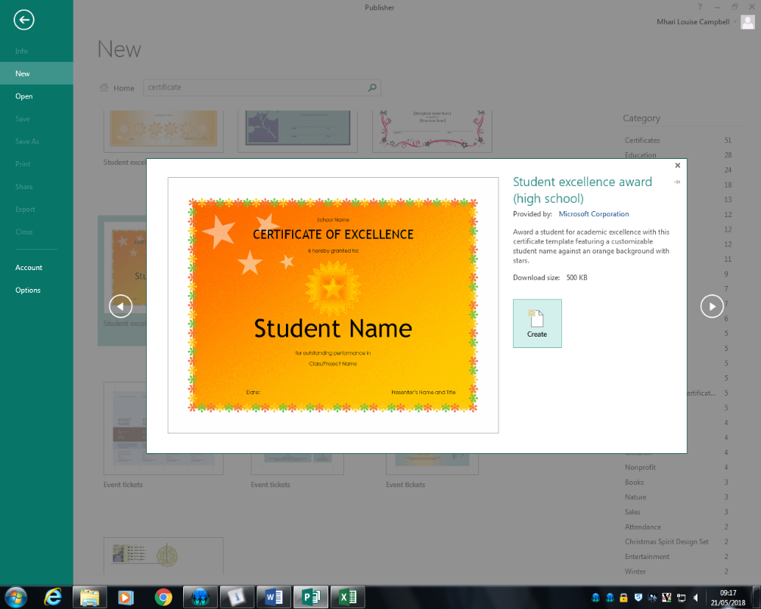
Choose a template you
like and click on create.

Use the template you have chosen to create a certificate for yourself for the school award ceremony.

Choose a category that you think you should win and fill in the rest of the details as appropriate.
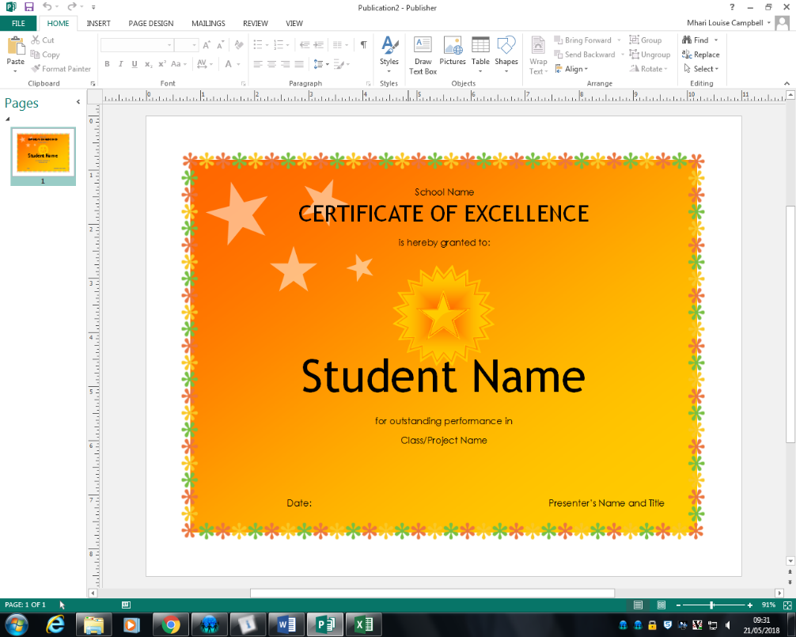
You can also use the
zoom control at the
bottom of the page
if you need to.

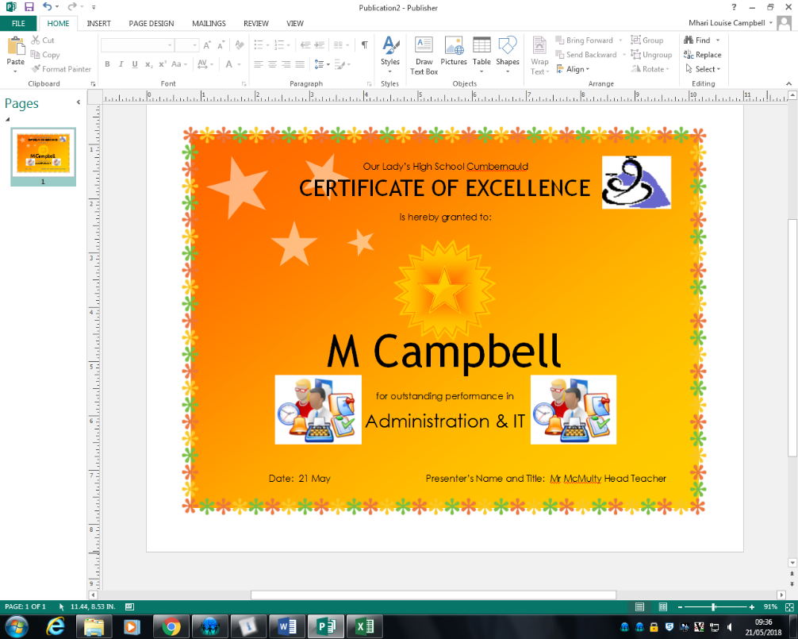
Remember you can
change the size,
font and colour of
text to make it
more attractive.
You can also include
graphics too such
as the business logo.

You will have to include a footer to your certificate.
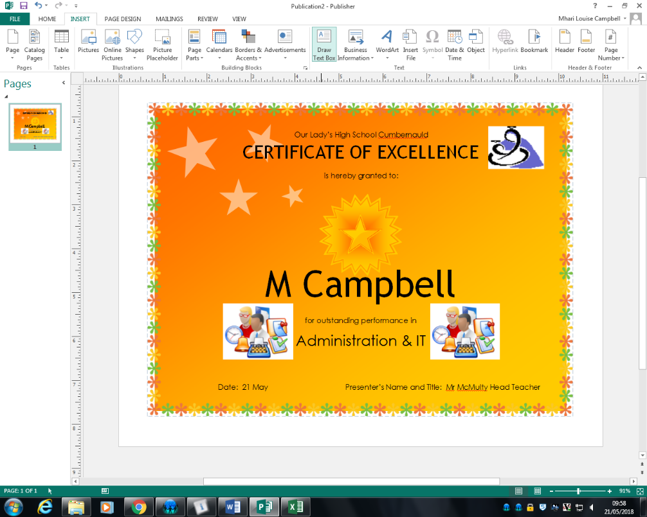
The easiest way to do
this is to go to the Insert
tab and choose Draw
Text Box.

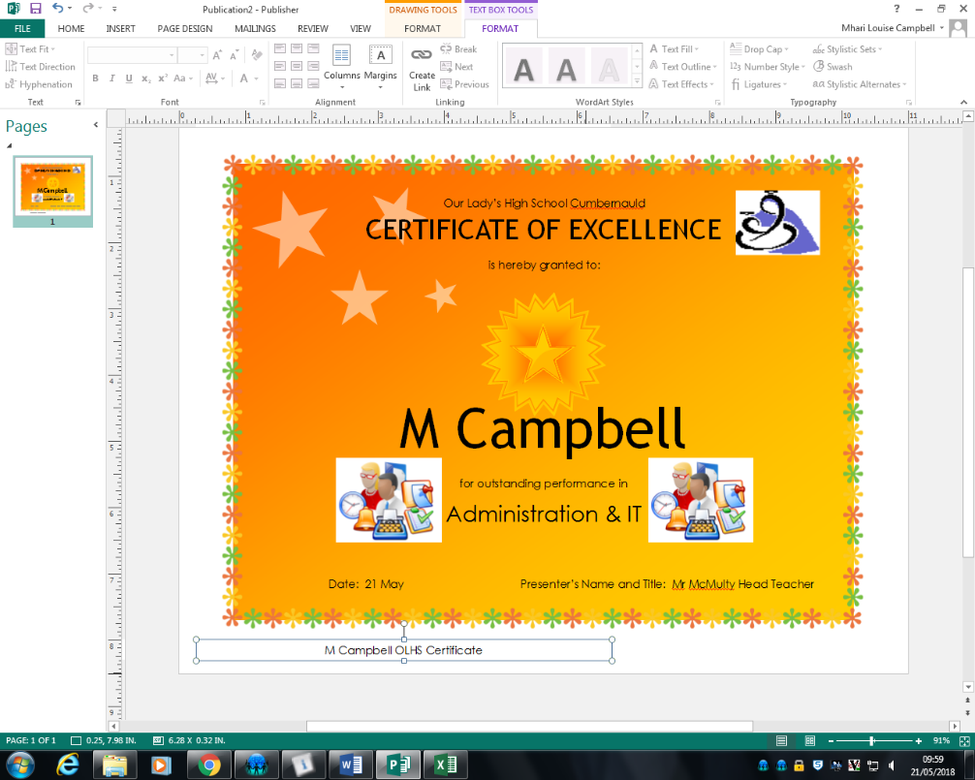
Key your name and OLHS
Certificate in the footer.
You might have to change
the size of your text so
that it can all be seen.

Save your business card at OLHS Certificate into your S3 Admin & IT folder.

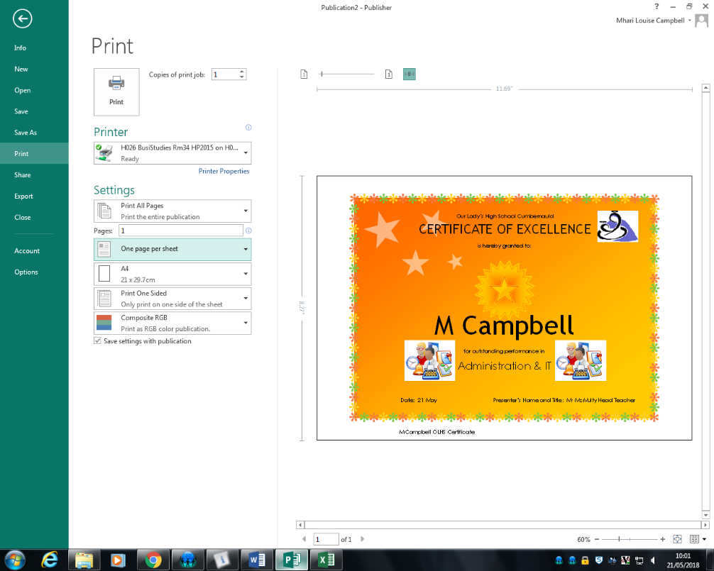
You can now print your
certificate.
Make sure the paper
size is set to A4 and
that the Page is set to
One page per sheet..

Well done! Time to try another on your own.

You work as an Admin Assistant at Park View High School.

You will be working with Mrs Durnan she is the teacher in charge of organising this year’s school trip to Paris, France.

